Special cases in circular motion
- If a plane does a loop-the-loop at the right speed, the pilot and plane both have a centripetal acceleration equal to gravity so there is no force on the pilot from the plane.
- Race tracks are banked (angled) so that a component of the normal force from the track provides part of the necessary centripetal force inwards. The vehicle can then travel faster without sliding.
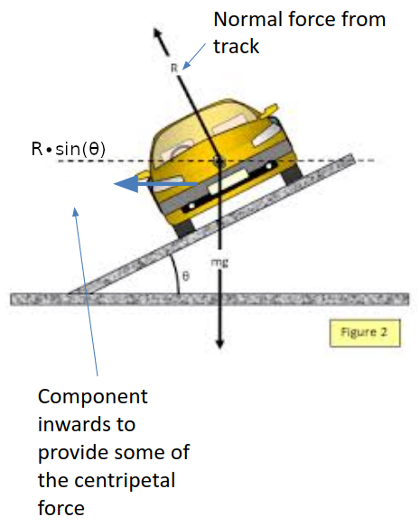
- Conical pendulum:
  - The horizontal component of the string tension provides the centripetal force.
  - The vertical component balances the weight.
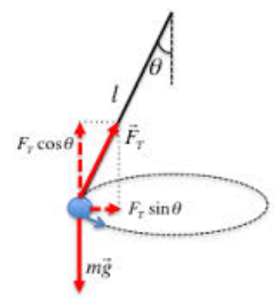
  - This results in this relation

