Chapter 17 – Damping
- Damping of oscillations = when some of the kinetic energy is converted to heat by applying an extra force, which reduces the amplitude of the amplitude of the vibrations
- With damped oscillations, the amplitude normally decreases exponentially
- Example of damping:
  - Vehicle suspensions = to give them a smooth ride without too many large oscillations
  - Covers of vibrating machinery = to stop the making a noise
  - Electric meters = to prevent the needle oscillating about
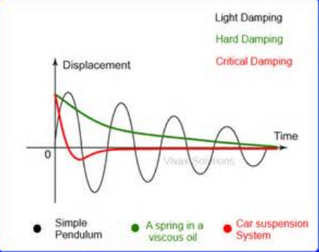
- Free oscillations = where the oscillator vibrates at its natural frequency (resonant frequency) – the frequency it will vibrate at
- Forced oscillations = where the oscillator is made to go by an outside force at any frequency (the driving frequency)
- The amplitude of forced oscillations system depends very much on the driving frequency - when the driving force is high or low, the amplitude is small; resonance occurs when the driving frequency is equal to the natural frequency (the amplitude is maximum)
- The amplitude-frequency curve is therefore bell-shaped and this effect is called resonance
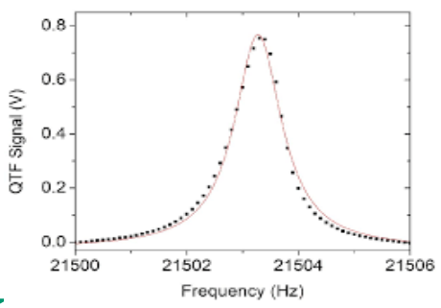
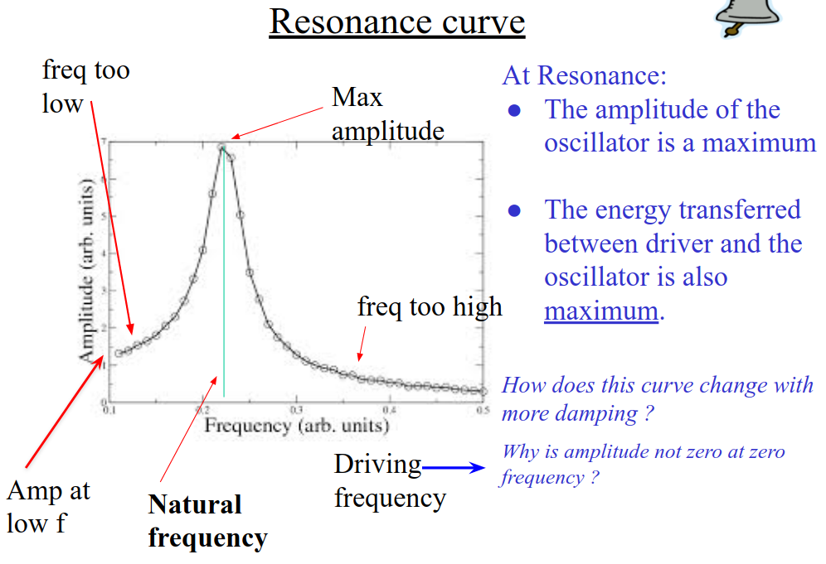
- Resonance= the phenomenon
- To resonate=something responds with a large amplitude
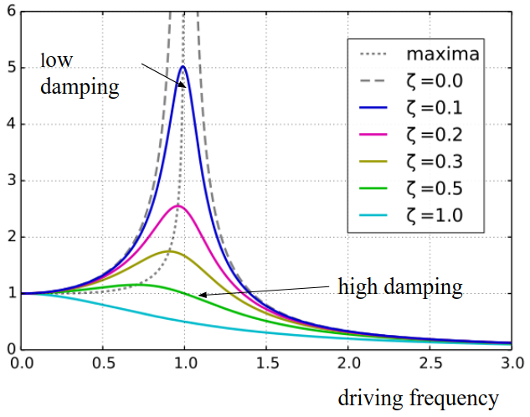
- Examples of resonance…
  - Child’s swing
  - Tuning of a radio = all radios and TVs need tuned circuits in order to pick out the frequency of one radio station out of hundreds; the tuned circuit is made from a variable capacitor and an inductor
  - Quartz watch = the quartz watch has a small crystal of quartz which resonates at a very high exact frequency in an electric field
  - Suspension bridges (resonated by the wind)
  - Microwave oven = microwaves with a frequency of about 2400 MHz are used to heat up the food as that is a key resonant frequency of the water molecule; this makes it efficient cooking because only the food is heated and not the plates
- Reducing damage caused by earthquakes…
  - Friction pendulum bearings to allow for movement
  - Large cross struts or shear walls to make walls stiffer, so avoiding resonant frequencies
  - Pendulum masses moved by motor to keep centre of mass at the same place

