Simple Harmonic Motion
- Angular frequency (rad / s) = angular velocity of the rotating phasor which traces out the wave

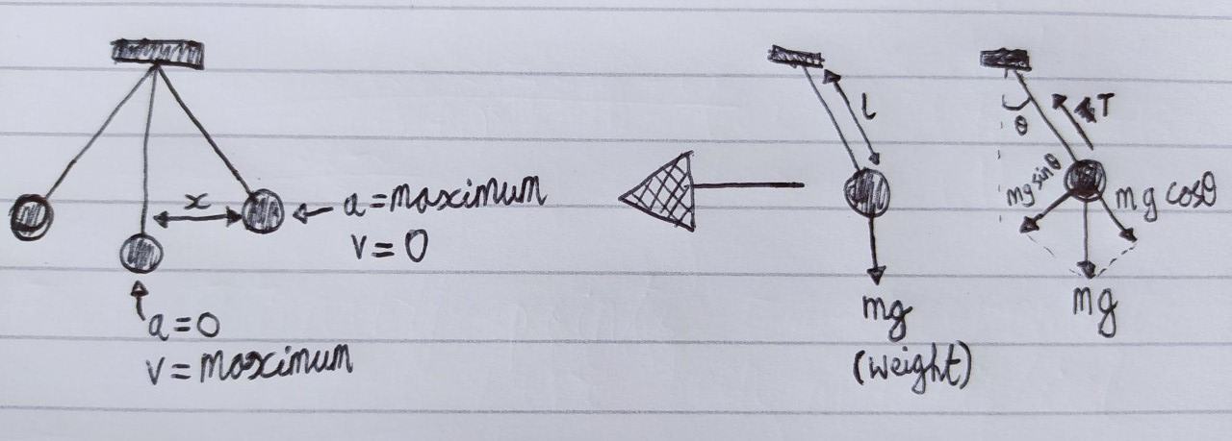
- Simple Harmonic Motion (SHM) = acceleration is directly proportional to the negative displacenet from the equilibrium line; the acceleration and restoring force are always directed towards equilibrium.

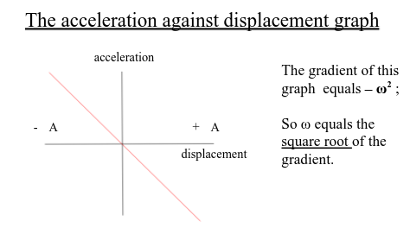
- Restoring force = Every harmonic oscillator system has a restoring force which is always directed towards the equilibrium position. ()
- For a pendulum, the restoring force is a component of the weight acting along the path of the bob.
- For a mass on a spring, the restoring force is the spring force upwards combined with the weight downwards.
