Chapter 18 – Gravitation
- A field = an area where a force acts (e.g. the area around a magnet is a magnetic field)
- Field lines = show the directions of the forces
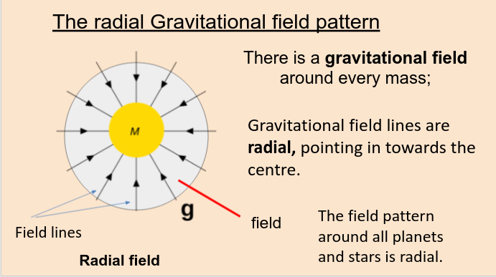
- Uniform field approximation = because the Earth is so large, for a small part of the Earth’s surface, the field can be approximated as a uniform field (parallel lines) even though it is actually radial
- Gravitation:
  - Gravity acts between all masses
  - It is very weak (only matters for very heavy objects)
  - Is only an attractive force (i.e. pulls things in)
- Gravitational field strength = is the force on each kilogram at some place
- (for a small test mass)
- has an average value of 9.8 N/kg
- Each planet has a different value of
- is only an average! - the physical value varies depending on where you are

- Newton’s Law of gravitation (1667):
  - Isaac Newton’s law of gravitation states that gravity is an attractive force between every pair of masses which follows this law:
- Universal Gravitation Constant, = 6.67 x 10⁻¹¹ Nm² kg⁻²
- is said to be the same anywhere in the universe
- All distances are measured from the centres of each body.
- is very small, so it only matters for extremely large masses (i.e. planets and stars)
- Newton’s Law of gravitation in words:
  - “Every mass attracts every other mass with a force proportional to the product of their masses and inversely proportional to the square of their distances”
  - This is an example of an inverse square law
- Inverse Square Law, ISL =
- Remember from Newton’s Third Law of Motion, that the force of on is the same size but opposite direction as on (i.e. even though the moon appears to orbit the earth, they are both moving but the moon has a lighter mass so it has more effect on it)
- In the situation that there are multiple masses, you have to add up all the force vectors (tip to tail) to find the resultant force
- Examples of the gravitational force between...
  - Two protons close together = 1.8 x 10⁻³⁶ N (this is negligible)
  - Two people = 1.4 x 10⁻⁷ N (this is small)
  - Saturn and Sun = 3.8 x 10²² N (this is large)
- The gravitational force on an object is known as it’s weight:
  - therefor the Gravitational Field Strength,, is given by the formula(inverse square law)
  - In the formula, is the mass of the planet (larger mass),is the mass of the object (smaller mass) andis the distance between both of their centres
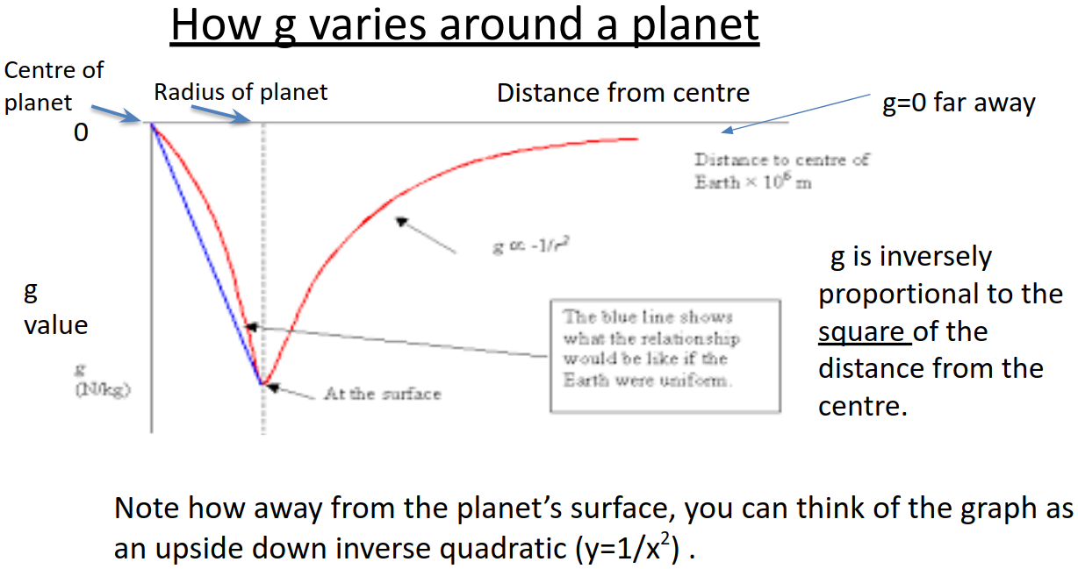
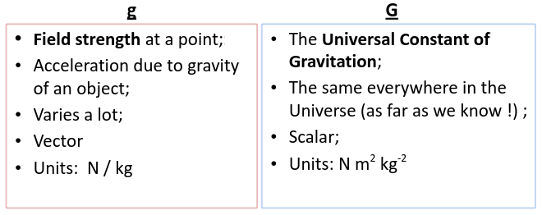
- Questions 18.3
  - 1)
- d

