Gravitational potential energy
- can be written as , noteis the potential energy (borrowed from electricity)
- The only difference in space is that potential energies get larger by getting less negative as you go higher.
- Gravitational potential wells:
  - Potential energy of a satellite with distancefrom the centre of Earth because of the attractive force of gravity.
  - So the higher the orbit (larger the radius), the more energy it requires to get there – to change orbits of a satellite, small rockets are needed on the satellite.
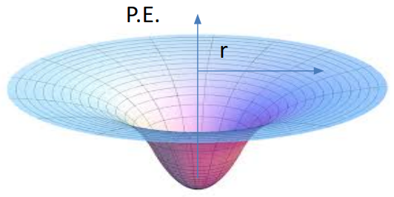
- Gravitational potential as a given point = work done per kilogram to move an object from infinity to that point
- Unit of Gravitational potential is J/kg
- Potential is a scalar so just add values at one point
- All Gravitational potentials are negative because the potential is zero at deep Space and the Gravitational attraction means points close to the masses are at lower energy.
- where is the mass at the centre, r is the radius from the centre.
- A mass moving in towards a planet results in a decrease in potential (and hence a decrease in potential energy).
- A mass moving away from a planet results in an increase in potential (and hence an increase in potential energy).
