Gravitational Potential Energy
- Gravitational Potential Energy (GPE) of an object in a gravitational field is the object’s mass multiplied by the Potential at that point
- (whereis the mass of the object andis the potential)
- (where is the mass of the planet,is the mass of the object and is the distance from centre of planet)
- To calculate the change in potential energy for a mass moving between places, multiply the mass of the object by the change in potential

- A spacecraft passing by a planet can exchange momentum with the planet; This saves fuel.
- So most spacecrafts going to other planets loop round various other planets on the way to increase their velocity.
- The Voyager missions in the 1970s used the rare line up of all planets to get to edge of solar system and are now heading out into interstellar space at a fast speed.
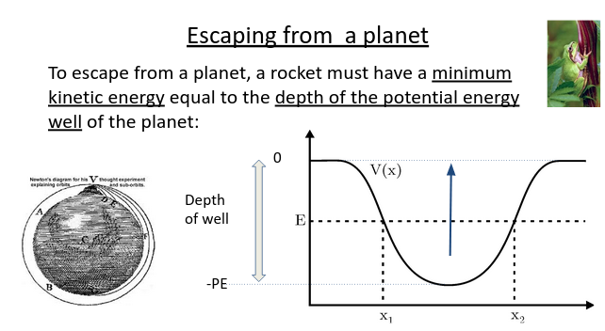
- To find the speed needed to escape a planet (escape velocity), put the two energies equal to each otherwhere
- whereis the total energy of a spacecraft. The total energy will always stay the same – ifhalves thenwill double.

