Kepler’s Laws of Planetary Motion
- Kepler’s Laws of Planetary Motion:
  - 1st Law = All planets orbit in ellipses
  - 2nd Law = The line joining a planet to the Sun sweeps out in equal times
  - 3rd Law = The orbit period squared is proportional to mean orbit radius cubed; like so
- Kepler ‘s 3rd Law:
  - Centripetal force on planet = gravitational attraction from sthe Sun
  - then substituting the speed of the planet () gives which then becomes therefore
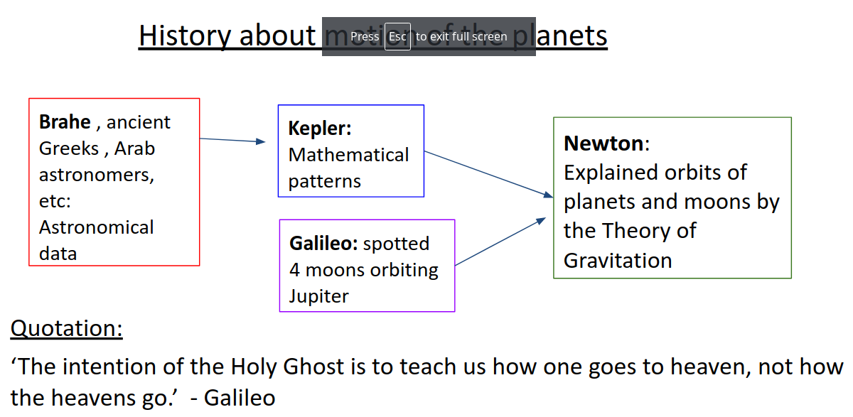
- Satellites are launched into a low orbit at very high speed (more than 8 km/s). They are constantly ‘falling around the Earth’.
- Each satellite has a centripetal acceleration to keep it in its orbit; so the size of the centripetal acceleration is equal to the field strength at its orbit:
  - therefore so
- Satellite orbits:
  - Low orbit = fast
  - High orbit = slow
  - Satellite orbit radius = height above Earth + Earth’s radius
- Uses of satellites:
  - taking astronomical photos
  - military surveillance
  - satellite gravimetry
  - agriculture
  - communications
  - navigation
  - weather
  - mapping
- Geostationary satellites:
  - Orbit at a height (about 36,000 km) above the Equator so that they stay in line with one point on the Earth (time period of 24 hours)
  - They also need to be travelling West to East like the Earth and be above the Equator
  - All regular communication systems (e.g. transmitting TV signals so they stay in line with the receiver)

