Chapter 19 – Stars
- Luminosity, L, of a star = it’s total radiant power output
- Luminosity of the Sun, L☉ is about
- Hertzsprung-Russel (H-R) diagram:
  - The H-R diagram is a a log graph of stars’ Luminosity against their surface temperature
  - Main sequence stars sit on a diagonal while White Dwarf and Red Giant stars are in seperate areas
  - Giant stars have a high Luminosity because of their large surface area
  - As main sequence stars evolve they move across the diagram
  - Note that the x-axis is backwards!!!!
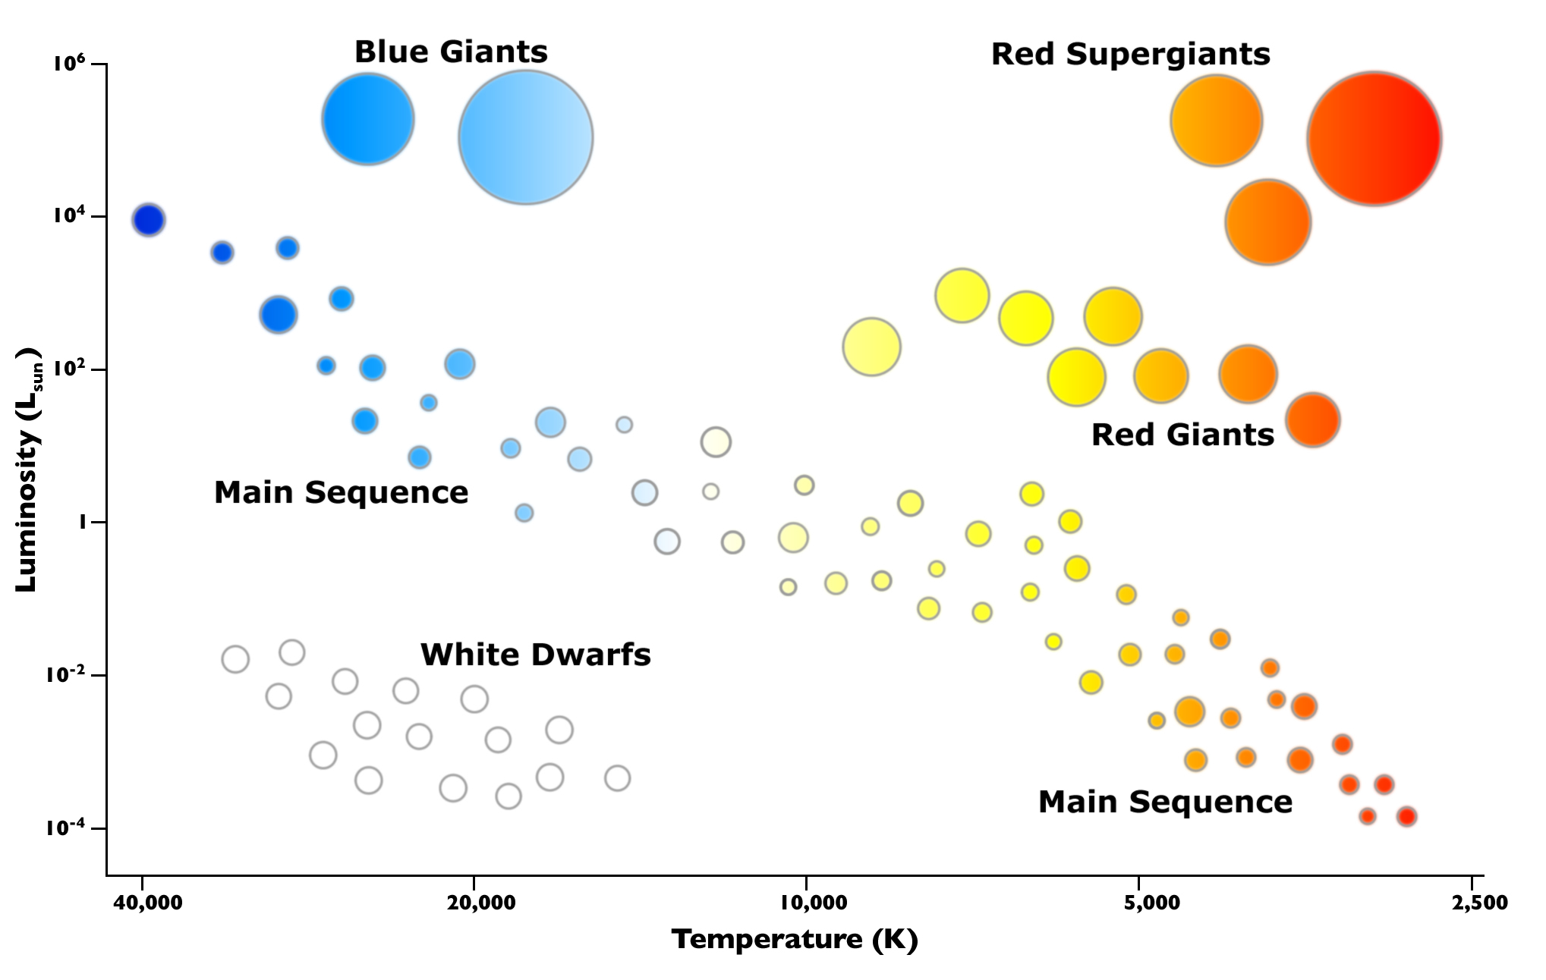
- In nuclear fusion, mass is converted to energy.
- How long a star emits light can be estimated from the formula if the rate of mass of Hydrogen consumed in a star and its power output is known:
  - (assuming a comstant rate of conversion of Hydrogen in its fusion)

