Chapter 19 – Spectra
- Due to Quantum Theory , the electrons in atoms can only have certain definitive energies; Energy Levels.
  - Each chemical element has a different set of energy levels
  - The lowest level is the Ground State
  - Other states are excited states
  - All energy levels are negative because it takes energy to escape the atom
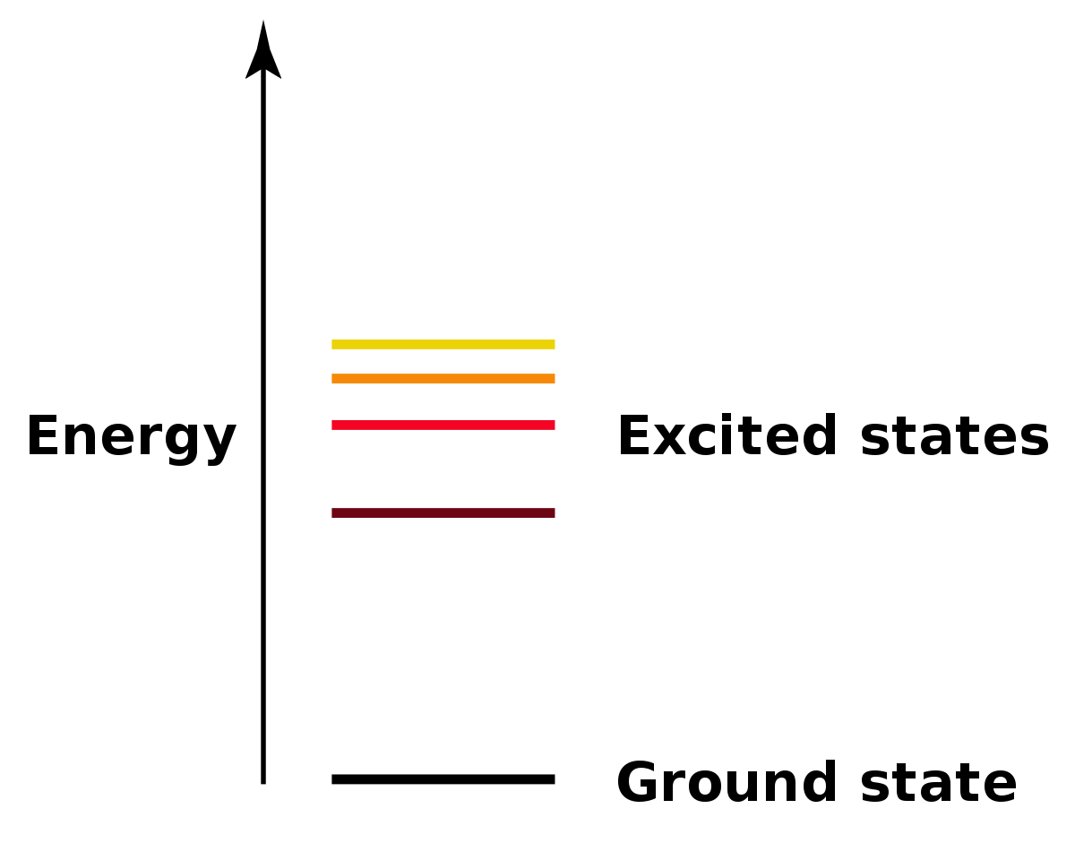
- Emission Line Spectra:
  - An electron on a higher energy level can fall down to a lower level and a photon will be emitted which has an energy equal to the difference in energy of the two levels
  - As each element has a different set of energy levels, every element has a unique set of spectral lines in its emission line spectrum
  - This can be used to distinguish one element from another
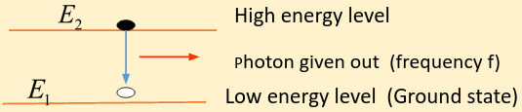
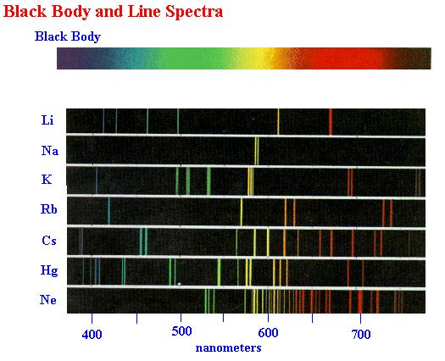
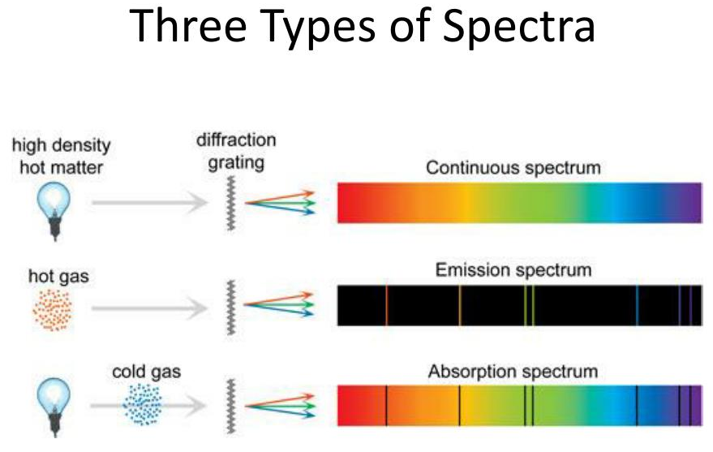
- The three types of Spectra:
  - Colours are merged together (Continuous spectrum – from hot solid objects)
  - Coloured lines on a dark background (Emission spectrum – from hot gases)
  - Dark lines on a continuous spectrum (Absorption spectrum – from light passing through cooler gas)

- Absorption Line Spectra:
  - Dark lines when light with a continuous spectrum passes through a cold gas
  - Photons with energy equal to the energy level difference are absorbed and the electron moves up to a higher energy level
  - As the energy differences are the same, the emission line wavelengths are the same as the absorption line wavelengths for one element

