- Black body radiation:
  - Blackbody = a very hot object which absorbs all radiation (e.g. a furnace)
  - Stars do not reflect any light so they emit black body radiation
- Wien’s Displacement Law:
  - Wien’s Displacement Law = the peak wavelengt h in the spectrum and so the colour of a star depends directly on its surface temperature
  - Stars with the highest temperature are blue to white (e.g. Vega)
  - Stars with the coolest temperature are red (e.g. Betelgeuse)
  - Wien’s displacement law iswhenis in Kelvin

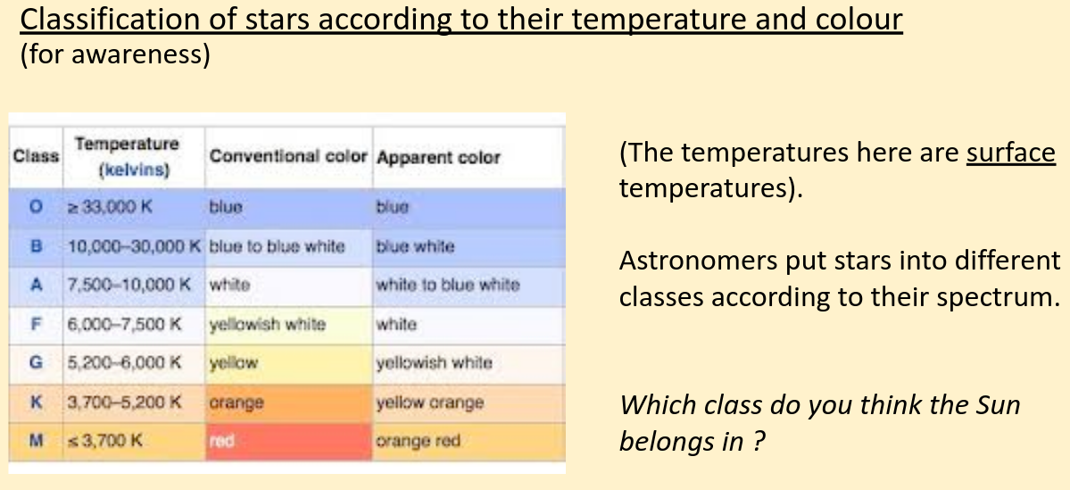
- The colour pattern (blue to white being highest temperature and red being coolest temperature) applies to light bulbs
- Stefan’s Law:
  - Stefan’s Law = the total power radiated by a blackbody very strongly depends on its surface temperature and is proportional to its surface area
  - whereis luminosity,is radius,is the Stefan constant andis temperature
  - Stefan constant,= 5.67 x 10⁻⁸ Wm⁻²K⁻⁴
  - his rule and the
- Stefan’s Law and Wien’s Law allows the radius of stars to be eliminated

