PAG 5.1 – Determining the wavelengths of light with a diffraction grating
- Aim:
  - To determine the wavelength of light emitted by a laser.
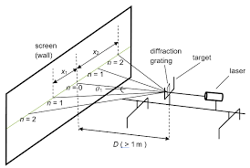
- Equipment:
  - Pen laser, class 2, <1mW to share
  - Diffraction grating of known lines per mm
  - Holder to support diffraction grating
  - 2 metre rules
  - Wooden board
  - Clamp stand
  - Blu tac
- Procedure:
  - Fix a piece of graph paper onto the wooden board
  - Fix the pen laser in a clamp stand so that it is shining on onto a board leaning on the wall
  - Fix a diffraction grating so the laser beam passes perpendicularly through it
  - Measure the distance D from the diffraction grating to the screen
  - Measure the distance x_1 from the central bright spot to the first bright spot (n = 1)
  - Calculate the angle %theta^1 using these two measurements
  - Average the angles for each side (left and right)
  - Calculate the distance d, for the soacing of the slits in the diffration grating based on the data given for your particular grating (lines per mm)
  - Now use the formula n %lambda = d sin{ %theta } to calculate the wavelength %lambda
  - Repeat the caclulations for second brightest spot (n = 2)
- Values

