Title: Trees

Author: Tolga Han Arslan

ID: 22003061

Section: 1

Assignment: 2

Description: HW2 Report

Question 1:
Give the prefix, infix, and postfix expressions obtained by preorder, inorder, and postorder traversals, respectively, for the expression tree below:

Question 2:
Draw the initially empty Binary Search Tree after operations as follows (show all intermediate steps):
insert 43, 28, 32, 20, 90, 83, 101, 84, 23, 76, 53, 13, 73, 91; then delete 53, 23, 43.

Question 3 (Sample output):
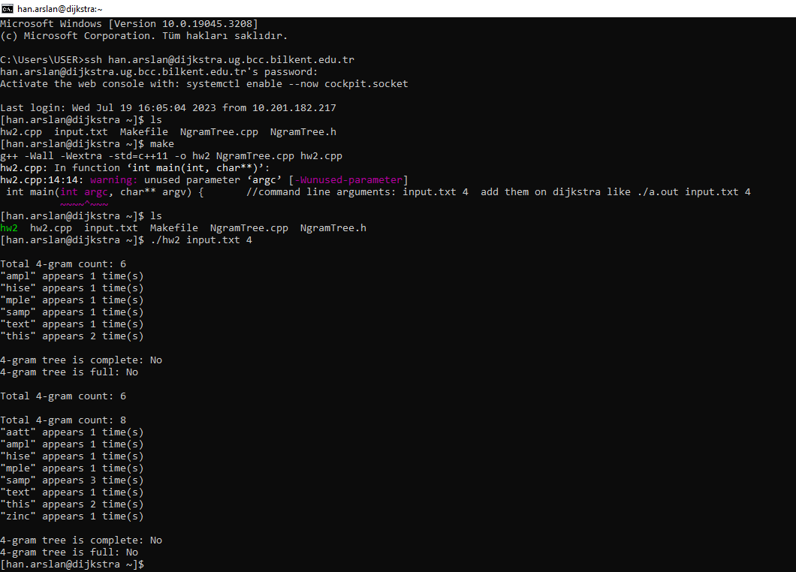

Question 4:

addNgram:
void NgramTree::addNgram(const string& ngram ){
TreeNode* node = nullptr;
bool exist = retrieveItem(root, ngram, node);
if(exist){
node->count++;
}
else{
insertItem(root, ngram);
}
}

void NgramTree::insertItem(TreeNode *& treePtr, const string& newItem){
if(treePtr == nullptr){
treePtr = new TreeNode(newItem, nullptr, nullptr);
if(treePtr == nullptr){
cout << "Insertion failed" << endl;
}
}
else if(newItem.compare(treePtr->item) < 0){ //search for left subtree
insertItem(treePtr->leftChildPtr, newItem);
}
else{ //search for right subtree
insertItem(treePtr->rightChildPtr, newItem);
}
}

bool NgramTree::retrieveItem(TreeNode * treePtr, string ngram, TreeNode *& treeItem){
if(treePtr == nullptr){
return false;
}
else if(ngram.compare(treePtr->item) == 0){
treeItem = treePtr;
return true;
}
else if(ngram.compare(treePtr->item) < 0){
return retrieveItem(treePtr->leftChildPtr, ngram, treeItem);
}
else{
return retrieveItem(treePtr->rightChildPtr, ngram, treeItem);
}
}

- addNgram function uses two helper functions insertItem and retrieveItem from the binary search tree class provided in the lecture slides. It first checks if the given ngram is present in the tree with retrieveItem, and do insertion or simple increment accordingly. Since both retrieveItem and insertItem are O(n) algorithms in the worst case (when the tree’s height is n, and therefore they both search all the nodes of the tree), addNgram is also O(n) in the worst case.

operator<<:
//prints each Ngram alphabetical order, uses inorder traversal
ostream& operator<<(ostream& out, const NgramTree& tree) {
tree.printInorder(tree.root, out);
return out;
}
void NgramTree::printInorder(TreeNode * treePtr, ostream& out) const{
if(treePtr != nullptr){
printInorder(treePtr->leftChildPtr, out);
out << "\"" << treePtr->item << "\" " << "appears " << treePtr->count << " time(s)" << endl;
printInorder(treePtr->rightChildPtr, out);
}
}

- Operator<< uses helper function called printInorder to print the ngrams in the tree in alphabetical order. Since NgramTree is a binary search tree, inorder traversal will visit its nodes in sorted (alphabetical, in this case) search-key order. Since the traversal must visit all the nodes of the tree, best case, average case and worst case behaviour of inorder traversal is O(n), the worst case behaviour of operator<< is also O(n).

