Title: Heaps and AVL Tree

Author: Tolga Han Arslan

ID: 22003061

Section: 1

Assignment: 3

Description: HW3 Report

Question 1:
a) (10 points) Show the result of inserting 10, 3, 1, 8, 2, 13, 7, 4, 5 and 9 in that order into an initially empty AVL tree. Show the tree after each insertion, clearly labeling which tree is which.
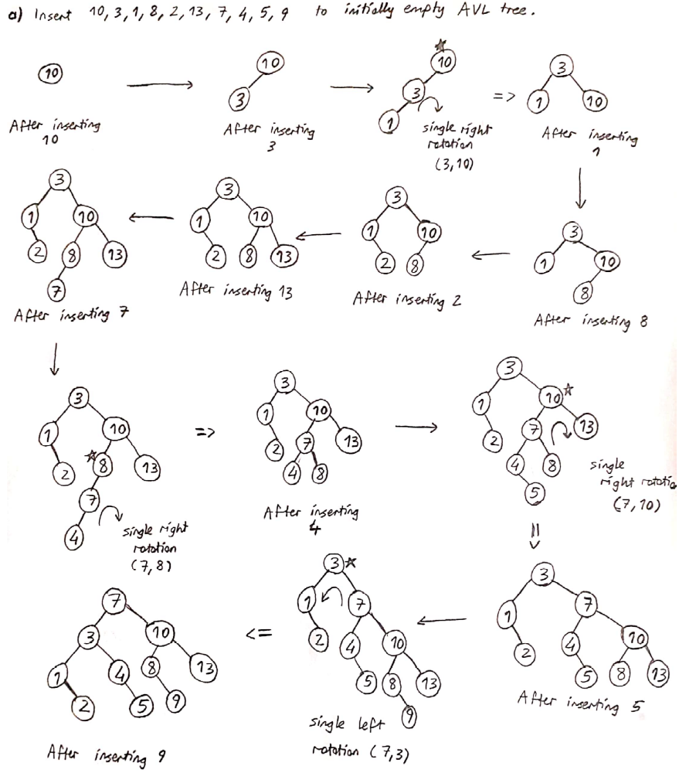

b) (10 points) This problem gives you some practice with the basic operations on binary min heaps. Make sure to check your work.
● Starting with an empty binary min heap, show the result of inserting, in the following order, 5, 1, 6, 20, 2, 4, 16, 25, 30, 13 and 8, one at a time, into the heap. By show, we mean, “draw the tree resulting from each insert.”
● Now perform two deleteMin operations on the binary min heap you constructed in part (a). Show the binary min heaps that result from these successive deletions, again by drawing the binary tree resulting from each delete.
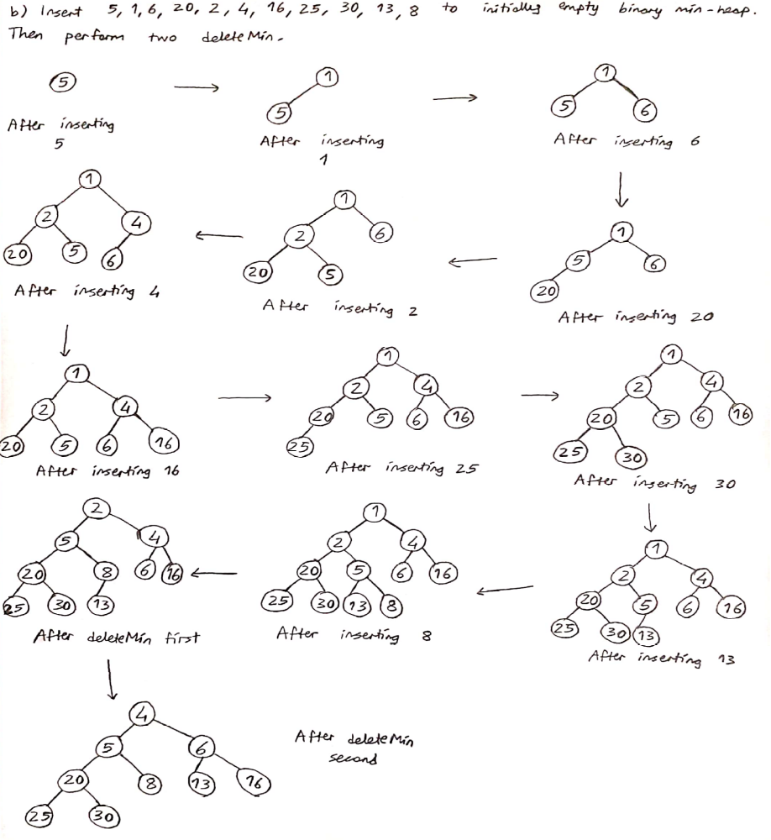
c) (10 points) Consider a binary heap. Print the keys as encountered in preorder traversal. Is the output sorted? Justify your answer. Attempt the same question for inorder and postorder traversals.

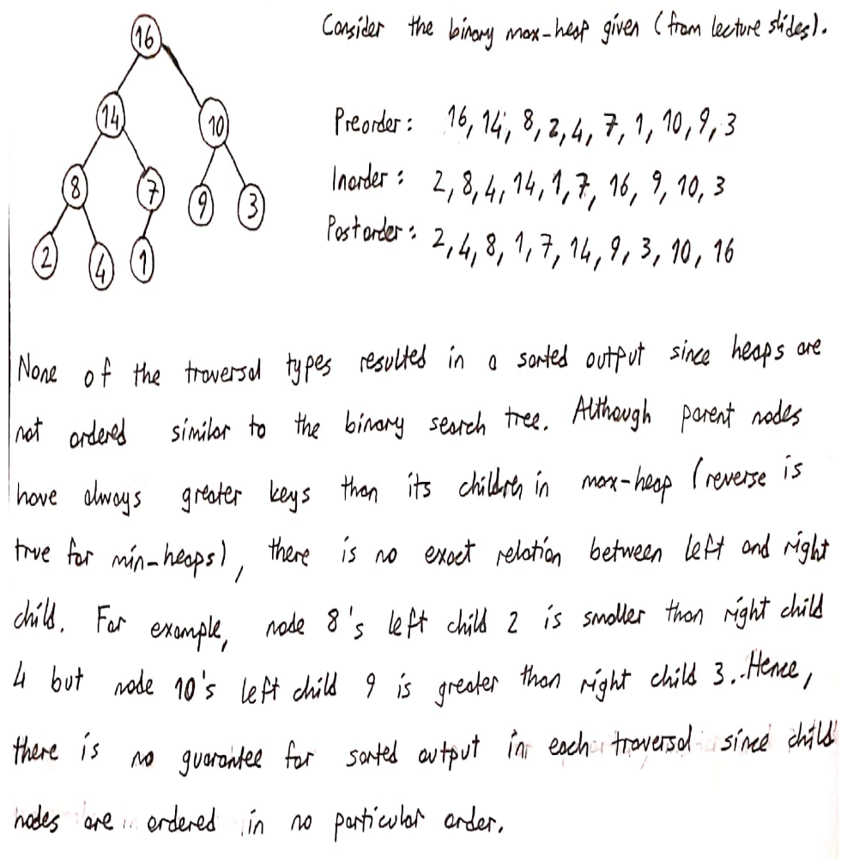

d) (10 points)
● Give a precise expression for the minimum number of nodes in an AVL tree of height h.
● What is the minimum number of nodes in an AVL tree of height 15?
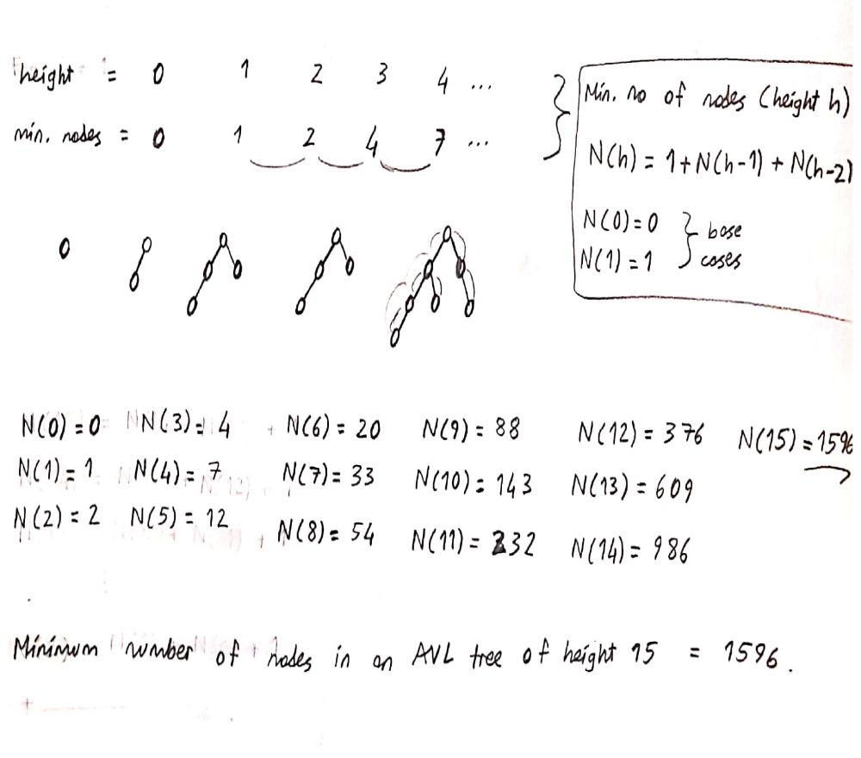

e) (10 Points) Write a function in pseudocode that determines whether a given binary tree is a minheap.

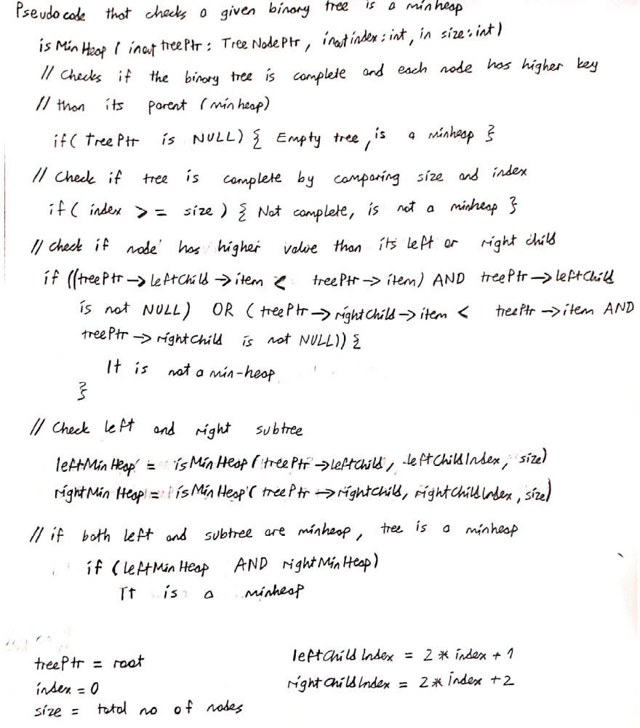

Question 2:

In this assignment a max-heap data structure is used to implement the heap sort algorithm. Max-heap is a complete binary tree that each node has greater key values than their respective children. On the other hand, there is no relation between child nodes key values, unlike binary search trees. This max-heap data structure has following member functions:
- isEmpty(): This function checks if the heap is empty.
- Insert(): This function is for inserting an item to heap, it puts the given item to the last location in the array and trickle it up to the its proper location in the heap. This procedure requires O(log(n)) comparisons since heap’s height is approximately log(n).
- Maximum(): This function retrieves maximum value of the heap (root).
- popMaximum(): This function is for deleting maximum value from the heap. It retrieves and deletes the root item, moves the last item into the root, and trickles it down to its proper position by comparing parent and child nodes respectively. This procedure also requires O(log(n)) comparisons since heap’s height is approximately log(n).
- heapRebuild(): This is the helper function for popMaximum function. It transforms semiheap into a heap.
In the heap sort algorithm, first step is creating a heap from the given array. This is done by inserting array elements to the heap structure. Then, the root item and last element in the heap will be swapped to place the maximum item to its correct position in the array. After this, last index of heap will be decremented and heapRebuild function converts the remaining semiheap into a heap by comparing and swapping child nodes with their parent nodes respectively. This step requires O(log(n)) comparisons since heap’s height is approximately log(n). Overall, this procedure is repeated until there is 1 item left in the heap part.
Input Size (n) | Comparison count theoretical | Comparison count experimental
1000 | 17954 | 12280
2000 | 39906 | 27665
3000 | 63810 | 43883
4000 | 87810 | 61327
5000 | 113618 | 78567
Figure 1.1: Theoretical and experimental comparison counts of heapsort

Heapsort is O(n*log(n)) algorithm since n items in the array must construct a heap and heap property must be maintained after swapping mentioned before. By looking at figure 1.1, theoretical values are compatible with this O(n*log(n)) growth rate. For example, when the input size is getting larger, comparison count growth is relative to the n*log(n) rate.
Theoretical comparison counts can be calculated by considering the heapsort algorithm as a two step process: constructing the heap and using rebuild function to converting semiheaps into a heap. For constructing, n elements must be inserted to heap and since the heap’s height is approximately log(n), this leads to $\sum_{i=2}^{N}{\log\left(i\right)}$ comparisons. Variable i starts from 2 here since inserting root does not require any comparison. In the heapRebuild process, comparisons are in one path from node to the root. It requires approximately $\sum_{i=1}^{N}{\log\left(i\right)}$ comparisons, as similar reasoning of heap’s height is approximately log(n).

