Entrysat test REPORT
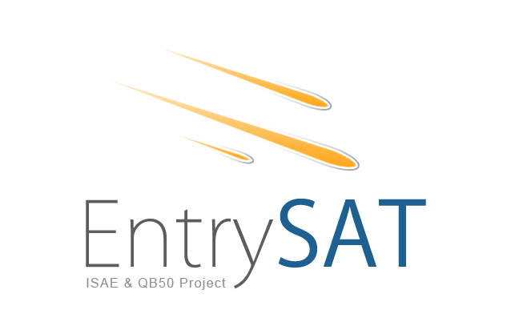

Quantify Iridium Debit in different configurations

ENT-COM-101

[SUB]= SY (SYSTEM), PL (PAYLAOD), SS (STRUCTURAL), AC (ATTITUDE CONTROL), EP (ELECTRICAL AND POWER), DH (DATA HANDLING), CO (COMMUNICATION), TH (THERMAL CONTROL)

FILENAME = TESTID_V*.DOC

Document
Date | 22/01/2015
Issue | V1
Author | Raphael F. Garcia
Checker

Table of contents
1 Reference Documents 3
2 TestID – Test title 4
2.1 Test objective 4
2.2 Date and place 4
2.3 List and tasks of the operators 4
2.4 Material 4
2.4.1 Hardware configuration 4
2.4.2 Software configuration 4
3 Framework 5
3.1 Set-up 5
3.2 Test procedure 5
4 Results 6
4.1 Outputs 6
4.2 Analysis 6
5 Conclusion 7
APPENDIX 1 - 8
APPENDIX 2 - 9

Reference Documents

ID | Author | Document title | Reference
[RD1]
[RD2]

ENT-COM-101 Quantify Iridium Debit in different configurations

Test objective
Quantify the debit (number of messages per seconds) of the iridium connexion in various configurations

Date and place
22/01/2015

List and tasks of the operators

Name | Status | Task
Raphael F. Garcia | IC | Test manager
Anthony Sournac | IC | Test Electronic and software support

Material

Hardware configuration

Name | Reference
Iridium modem | IMEI 300234062200280
Iridium 9601 emulation interface card | 016081A
USB to serial connector | E188601-I
PC of R.F. Garcia | EliteBook portable-rafgarcia
Circular iridium Dual-band Antenna from Multiband Antenna
Home made serial to iridium interface card connector
Car like iridium only black antenna

Software configuration
Name | Version
iridium_command_messages_22102015.m

Framework

Set-up
Go to Apps-> instrument control on matlab.
Open test & measurement tools
check for COM port in Material – Serial - /dev/ttyUSB0
in configure set Baud Rate to 19200
set terminator to CR/LF
test on which port the modem is connected by sending 'ait0' command + Query, if it works, should return 2400.
test quality of signal by sending 'at+csq' command + query (0 to 5)
Then modify the connected port in the matlab code if necessary.

Material is installed in the forum.

New setup for a test in 61.007, with iridum (car like) antenna outside. Circle multiband antenna was not as good as the car like antenna.

Test procedure
Various program testing was performed.
Connexion with the modem was ensured. Modem replied to checks of the iridium network connexion. (+CSQ=5). However, message sending was not possible in binary, neither in text.
After lowering of CSQ=0 during 1 mn. Test was stopped.

With new setup, matlab code corrected to set into the configuration #0 the good parameters.
Entered a list of 10, and then 22 messages sent by a single 'at+sbdi' command.
Outputs of at+sbds and at+sbdi commands fully understood (first number = 1 means all the messages in the queue have been sent successfully, 2 = error).

First test (not quantified) when sending 22 messages was quite short (less than 20 seconds).
=> shoudl test :
- send a text 340 bytes long message
- send a binary 340 bytes long message
- find a way to determine the message sending duration (at+sbdi) as a function of length of message queue.
- find better testing conditions for such a test

Results

Outputs

New version of matlab code modified for date.
Problem related to scan of the port buffer. Keep memory of many events.
=> problems solved the day after in 61.007

The day after 23/01/2015:
22 messages sent in less than 20 seconds

Analysis

Questions:
- let some time in between two commands sbdwt + (?) + sbds ?
- number of bytes in text and binary (to test) → test with maximum number of bytes
- loop on 20 messages (how many time) with maximum size?
- power consumption profile 'start -radio on – sending message periods' approximate.

Conclusion

22/01/2015:
Test failed.

23/01/2015:
22 messages sent in less than 20 seconds.

APPENDIX 1 -

APPENDIX 2 -

