Entrysat test REPORT


Quantify Iridium Debit in different configurations together with the GPS unit

ENT-COM-103

[SUB]= SY (SYSTEM), PL (PAYLAOD), SS (STRUCTURAL), AC (ATTITUDE CONTROL), EP (ELECTRICAL AND POWER), DH (DATA HANDLING), CO (COMMUNICATION), TH (THERMAL CONTROL)

FILENAME = TESTID_V*.DOC

Document
Date | 05/02/2015
Issue | V2
Author | Alvaro Sampayo, Raphael F. Garcia
Checker

Table of contents
1 Reference Documents 3
2 TestID – Test title 4
2.1 Test objective 4
2.2 Date and place 4
2.3 List and tasks of the operators 4
2.4 Material 4
2.4.1 Hardware configuration 4
2.4.2 Software configuration 4
3 Framework 5
3.1 Set-up 5
3.2 Test procedure 5
4 Results 6
4.1 Outputs 6
4.2 Analysis 6
5 Conclusion 7
APPENDIX 1 - 8
APPENDIX 2 - 9

Reference Documents

ID | Author | Document title | Reference
[RD1]
[RD2]

ENT-COM-103 Quantify Iridium Debit in different configurations with the GPS unit

Test objective
Quantify the debit (number of messages per seconds) of the iridium connection in various configurations

Date and place
05/02/2015
outside in front of ISAE administration building

List and tasks of the operators

Name | Status | Task
Raphael F. Garcia | IC | Test manager
Alvaro Martin-Sampayo | student | GPS sub-system

Material

Hardware configuration

Name | Reference
Iridium modem | IMEI 300234062200280
Iridium 9601 emulation interface card | 016081A
USB to serial connector | E188601-I
PC of A. Martin-Sampayo | Macbook Pro
Squared Antcom iridium/GPS Dual-band Antenna FM
2 USB/serial connectors
GPS (connected or not) mounted on Novatel Developemnt board and connected to the same antenna (when used)
Home made Iridium comm+power board with switch to turn on/off the iridium modem
12V battery

Software configuration
Name | Version
iridium_command_messages_05022015.m
Quickterm of serial messages to GPS
Matlab for serial communication and iridium program

Framework

Set-up
Go to Apps-> instrument control on matlab.
Open test & measurement tools (see Figure below)
check for COM port in Material – Serial - /dev/cu.usbserial-FTVSGL5O
in configure set Baud Rate to 19200
set terminator to CR/LF
test on which port the modem is connected by sending 'ait0' command + Query, if it works, should return 2400.
test quality of signal by sending 'at+csq' command + query (0 to 5)
Then modify the connected port in the matlab code if necessary.
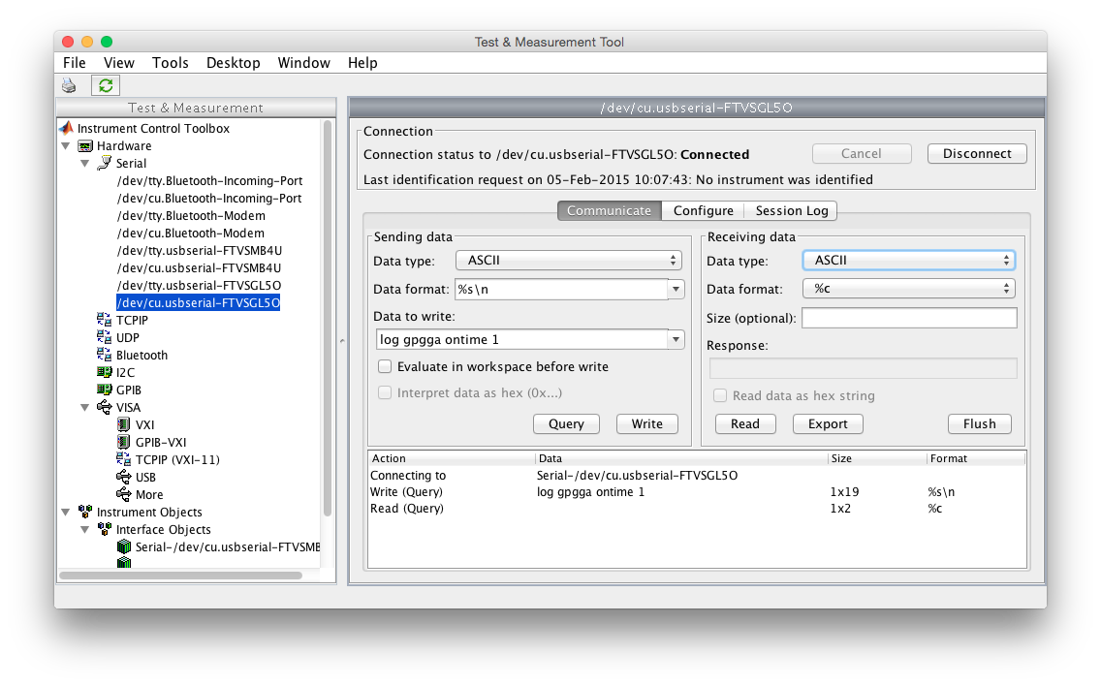

Material is installed in front of the Clement Ader building. The set up includes the Iridium modem, connected to the computer via the new in-house connection board. The board connects to the computer via a serial to usb cable. The GPS is connected to the computer via a serial-to-usb cable as well.
Both Iridium modem and GPS are powered by the same battery.
In the initial set up, the antenna is directly connected to the Iridium modem IN port. Then, the GPS antenna input is connected to the output connection in the iridium modem board.
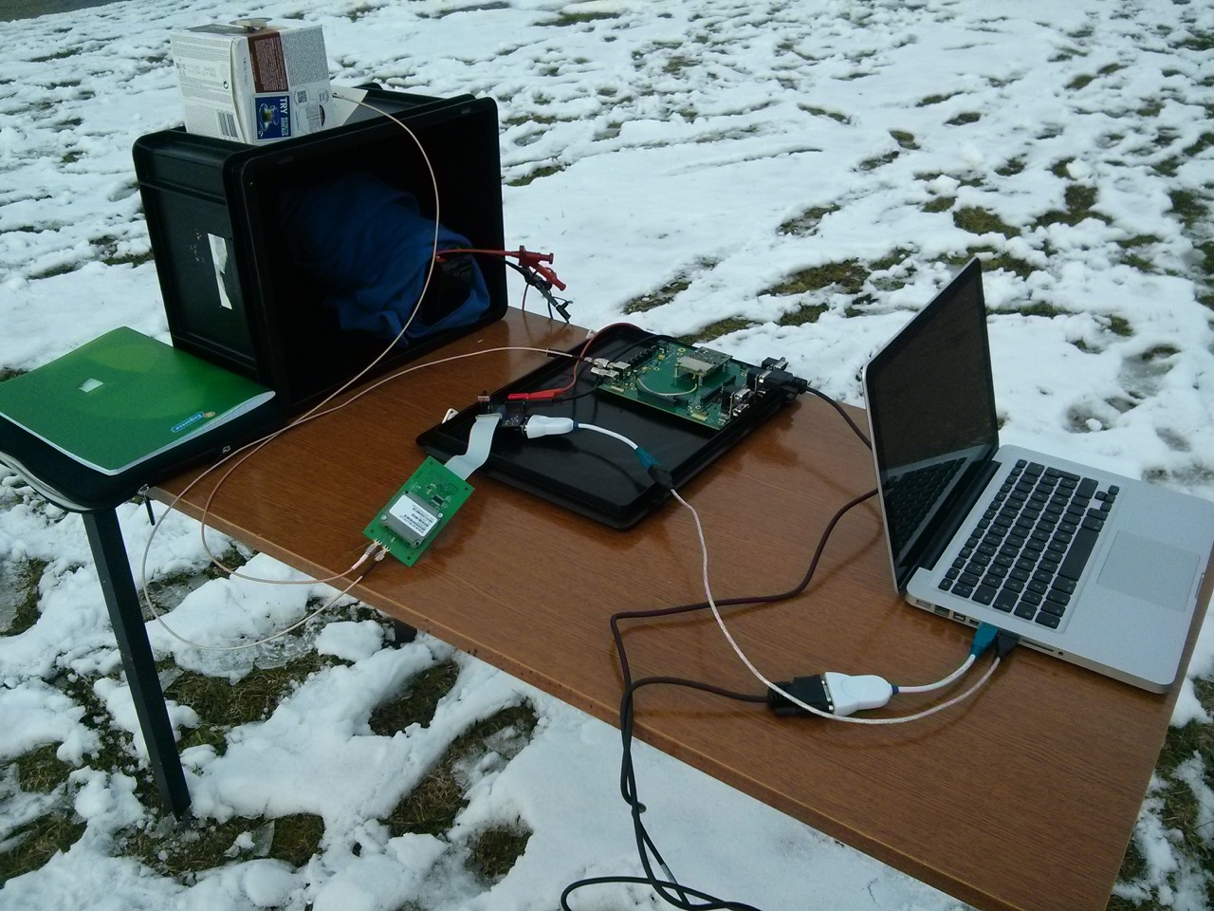
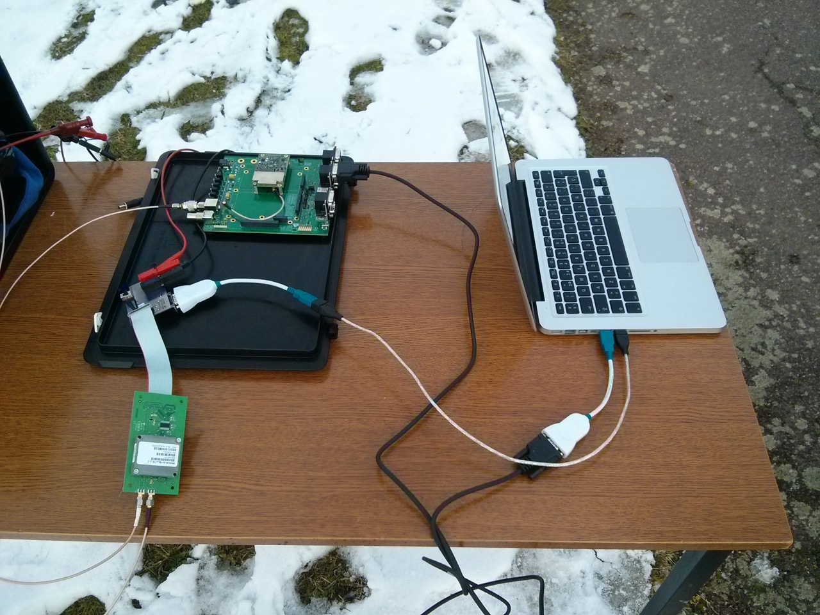
Pictures of the setup

Test procedure

Test first iridium alone: (Refer to Annex 1 for the full log)

Test 1 : send 10 text messages with a timeout of 13s

Test 2: send 10 text messages with a timeout of 10s

Test 3: send 10 text messages with a timeout of 8 s

Test 4: send 10 text messages with a timeout of 6 s

Test 5.

Switch off power of Iridium and GPS, restart following procedure:
- Power up Iridium, with the Iridium modem switch OFF.
- Power up GPS
- Start acquisition of GPS signal
- Measure cold start acquisition time of GPS
- Switch on Iridium when GPS is on and try to send Iridium message while GPS is working, check if GPS is meanwhile able to provide the position.
  - Test 5.1: send 10 text messages with a timeout of 10s with GPS ON

Results

Outputs

New version of matlab code modified for date.
Iridium messages received containing the date of their creation by matlab (not the date of sending or email received) ~ date of first try to send ~ date of sending of previous message .
A modification in the matlab code now includes in the string sent in the message the timeout setup.

Analysis

All outputs of the tests 1, 2, 3, 4 and 5 can be seen in the Appendix I.

Test 1: (timeout 13s) CSQ=5 initially. Never sent a message at first try. Sent 5 out of 10 messages.
Messages 4,7,8,9,10 are missing, possibly due to a low CSQ at the end of the message script.

Test 2: (timeout 10s) Signal strength weak. First 0, then transmission starts at a CSQ=2 value. Sent 5 out of 10 messages, never at the first try.
Messages 2,3,4,5,9 are missing, possibly due to a low CSQ at the beginning of the test

Test 3: (timeout 8s) CSQ=3. 1 out of 10 messages sent at the 3rd out of 3 tries.
Only 1 message received.

Test 4: (timeout 6s) CSQ=0 Initially, then 2. 4 out of 10 messages sent, one of them at the first try.
Only messages 1,2,4,6 are received. => indicate that 6s timeout may work if CSQ is good enough

Test 5: The GPS serial connection is established. The GPS is not able to retrieve position or time information for about 2 minutes.
The Iridium modem is then switched on, and is able to send 4 out of 10 messages with a timeout of 10s, while the GPS is on and working trying to establish a connection. None of the 4 iridium sent messages was sent at the first try. Times of Iridium messages: First:11:17:31 Tenth: at 11:20:58.
Only messages 1,2,3,4 (timeout=10s) were received, indicating that the CSQ was too low at the end of the test.
=> Worse antenna than for previous test is suspected

The GPS did not establish a connection at any moment throughout the whole test, not even the GPS time.
At the end of the test, the antenna was connected directly to the GPS, and no GPS signal was received.
Because in the test ENT-COM-102, we succeeded to catch GPS time even when iridium was working, it suggests that the cause of failure comes from the Antenna.

Care should be taken in future tests with RF emitters around the setup (phones, wifi connexions of laptops...). The devices should be in “plane mode” in order to have a test more representative.

Conclusion

The setup for this test used a different antenna than the previous test ENT-COM-102. The objectives that were set in ENT-COM-102 regarding Iridium connection performance could not be attained due to the noticeably worse connection. In ENT-COM-102, it was proposed to:
“Should be tested outside (with CSQ=5), going down to a timeout of 10s, 8s and 6s, with the same code including date.”

This was performed with a quality CSQ lower than necessary. Success rates such as those in ENT-COM-102 (around 9 out of 10 successful transmissions) could not be replicated.
However, the sending of 4 messages with a timeout of 6 seconds shows that 6s of timeout is possible.

Binary messages were not sent.

During the whole test, the GPS was not able to retrieve any data. This might be attributed to the antenna, as it is different from the larger circular one used in the previous test ENT-COM-102.
In addition, the Iridium connections were not robust for any timeout setup. The quality in a scale of 0 to 5 was regularly dropping back to 0 and did not reach further than 5 except for the test 1.
It was not possible to estimate the data rate of iridium from that test due to low CSQ.

Recommendations for future tests and activities:
- Improve the Antcom Antenna by using a background plane
- Redo this test with an improved Antcom Antenna

Still to do for iridium:
- define test process to send binary messages of 340 bytes (max size expected)
- code driver library including switch on of iridium power and switch on of iridium modem (two switches)

Still to do for GPS:
- Investigate the GPS configuration parameters stored in the receiver (GPS alone test)
- Test functions and code drivers while connected to an effective GPS antenna (Labo Sat CAS)
- Test cold/hot start times
- Check how to input into GPS the expected position (from orbit computation by ADCS) for a hot start.
- Insert different configurations (nominal one with another number + two additional ones) for redundancy in case of failure → define a TC for that configuration change + related driver.

APPENDIX 1 – MATLAB SCRIPT OUTPUT

ident =

2400

Iridium connected
-------------------------------------------
00-Jan-0000 00:00:00
00

str =

+CSQ:5

Signal strength =5
05

str =

+SBDS:0,67,0,-1

unread : 0 - unsent : 0
mesg 1 - 05-Feb-2015 10:47:48 timeout = 13 s
Tentative 1 de 3
Warning: Unsuccessful read: A timeout occurred before the Terminator was reached..

str =

''

Tentative 2 de 3
Warning: Unsuccessful read: A timeout occurred before the Terminator was reached..

str =

''

Tentative 3 de 3

str =

+SBDI:1,67,0,0,0,0

Message envoye a la date.
00-Jan-0000 00:00:37
OK
mesg 2 - 05-Feb-2015 10:48:19 timeout = 13 s
Tentative 1 de 3
Warning: Unsuccessful read: A timeout occurred before the Terminator was reached..

str =

''

Tentative 2 de 3

str =

+SBDI:1,68,0,0,0,0

Message envoye a la date.
00-Jan-0000 00:01:02
OK
mesg 3 - 05-Feb-2015 10:48:43 timeout = 13 s
Tentative 1 de 3
Warning: Unsuccessful read: A timeout occurred before the Terminator was reached..

str =

''

Tentative 2 de 3

str =

+SBDI:1,69,0,0,0,0

Message envoye a la date.
00-Jan-0000 00:01:24
OK
mesg 4 - 05-Feb-2015 10:49:05 timeout = 13 s
Tentative 1 de 3
Warning: Unsuccessful read: A timeout occurred before the Terminator was reached..

str =

''

Tentative 2 de 3
Warning: Unsuccessful read: A timeout occurred before the Terminator was reached..

str =

''

Tentative 3 de 3

str =

+SBDI:2,70,2,0,0,0

mesg 5 - 05-Feb-2015 10:49:36 timeout = 13 s
Tentative 1 de 3
Warning: Unsuccessful read: A timeout occurred before the Terminator was reached..

str =

''

Tentative 2 de 3
Warning: Unsuccessful read: A timeout occurred before the Terminator was reached..

str =

''

Tentative 3 de 3

str =

+SBDI:1,70,0,0,0,0

Message envoye a la date.
00-Jan-0000 00:02:25
OK
mesg 6 - 05-Feb-2015 10:50:06 timeout = 13 s
Tentative 1 de 3
Warning: Unsuccessful read: A timeout occurred before the Terminator was reached..

str =

''

Tentative 2 de 3

str =

+SBDI:1,71,0,0,0,0

Message envoye a la date.
00-Jan-0000 00:02:48
OK
mesg 7 - 05-Feb-2015 10:50:29 timeout = 13 s
Tentative 1 de 3
Warning: Unsuccessful read: A timeout occurred before the Terminator was reached..

str =

''

Tentative 2 de 3
Warning: Unsuccessful read: A timeout occurred before the Terminator was reached..

str =

''

Tentative 3 de 3
Warning: Unsuccessful read: A timeout occurred before the Terminator was reached..

str =

''

mesg 8 - 05-Feb-2015 10:51:08 timeout = 13 s
Tentative 1 de 3

str =

+SBDI:2,72,2,0,0,0

Tentative 2 de 3

str =

+SBDI:2,72,2,0,0,0

Tentative 3 de 3

str =

+SBDI:2,72,2,0,0,0

mesg 9 - 05-Feb-2015 10:51:20 timeout = 13 s
Tentative 1 de 3
Warning: Unsuccessful read: A timeout occurred before the Terminator was reached..

str =

''

Tentative 2 de 3
Warning: Unsuccessful read: A timeout occurred before the Terminator was reached..

str =

''

Tentative 3 de 3
Warning: Unsuccessful read: A timeout occurred before the Terminator was reached..

str =

''

mesg 10 - 05-Feb-2015 10:51:59 timeout = 13 s
Tentative 1 de 3

str =

+SBDI:2,72,2,0,0,0

Tentative 2 de 3

str =

+SBDI:2,72,2,0,0,0

Tentative 3 de 3

str =

+SBDI:2,72,2,0,0,0

>>

——————————————————————— 10——————

ident =

2400

Iridium connected
-------------------------------------------
00-Jan-0000 00:00:00
00

str =

+CSQ:0

Signal strength =0
06

str =

+CSQ:0

Signal strength =0
10

str =

+CSQ:0

Signal strength =0
19

str =

+CSQ:2

Signal strength =2
23

str =

+SBDS:1,72,0,-1

unread : 0 - unsent : 1
efface ancien message a la date:
05-Feb-2015 10:54:09
OK a la date
00-Jan-0000 00:00:24
mesg 1 - 05-Feb-2015 10:54:09 timeout = 10 s
Tentative 1 de 3
Warning: Unsuccessful read: A timeout occurred before the Terminator was reached..

str =

''

Tentative 2 de 3
Warning: Unsuccessful read: A timeout occurred before the Terminator was reached..

str =

''

Tentative 3 de 3
Warning: Unsuccessful read: A timeout occurred before the Terminator was reached..

str =

''

mesg 2 - 05-Feb-2015 10:54:39 timeout = 10 s
Tentative 1 de 3
Warning: Unsuccessful read: A timeout occurred before the Terminator was reached..

str =

''

Tentative 2 de 3

str =

+SBDI:2,72,2,0,0,0

Tentative 3 de 3
Warning: Unsuccessful read: A timeout occurred before the Terminator was reached..

str =

''

mesg 3 - 05-Feb-2015 10:55:08 timeout = 10 s
Tentative 1 de 3
Warning: Unsuccessful read: A timeout occurred before the Terminator was reached..

str =

''

Tentative 2 de 3
Warning: Unsuccessful read: A timeout occurred before the Terminator was reached..

str =

''

Tentative 3 de 3

str =

+SBDI:1,72,0,0,0,0

Message envoye a la date.
00-Jan-0000 00:01:51
OK
mesg 4 - 05-Feb-2015 10:55:36 timeout = 10 s
Tentative 1 de 3
Warning: Unsuccessful read: A timeout occurred before the Terminator was reached..

str =

''

Tentative 2 de 3
Warning: Unsuccessful read: A timeout occurred before the Terminator was reached..

str =

''

Tentative 3 de 3
Warning: Unsuccessful read: A timeout occurred before the Terminator was reached..

str =

''

mesg 5 - 05-Feb-2015 10:56:06 timeout = 10 s
Tentative 1 de 3
Warning: Unsuccessful read: A timeout occurred before the Terminator was reached..

str =

''

Tentative 2 de 3
Warning: Unsuccessful read: A timeout occurred before the Terminator was reached..

str =

''

Tentative 3 de 3

str =

+SBDI:2,73,2,0,0,0

mesg 6 - 05-Feb-2015 10:56:30 timeout = 10 s
Tentative 1 de 3
Warning: Unsuccessful read: A timeout occurred before the Terminator was reached..

str =

''

Tentative 2 de 3
Warning: Unsuccessful read: A timeout occurred before the Terminator was reached..

str =

''

Tentative 3 de 3

str =

+SBDI:1,73,0,0,0,0

Message envoye a la date.
00-Jan-0000 00:03:11
OK
mesg 7 - 05-Feb-2015 10:56:56 timeout = 10 s
Tentative 1 de 3
Warning: Unsuccessful read: A timeout occurred before the Terminator was reached..

str =

''

Tentative 2 de 3
Warning: Unsuccessful read: A timeout occurred before the Terminator was reached..

str =

''

Tentative 3 de 3

str =

+SBDI:1,74,0,0,0,0

Message envoye a la date.
00-Jan-0000 00:03:31
OK
mesg 8 - 05-Feb-2015 10:57:16 timeout = 10 s
Tentative 1 de 3
Warning: Unsuccessful read: A timeout occurred before the Terminator was reached..

str =

''

Tentative 2 de 3
Warning: Unsuccessful read: A timeout occurred before the Terminator was reached..

str =

''

Tentative 3 de 3

str =

+SBDI:1,75,0,0,0,0

Message envoye a la date.
00-Jan-0000 00:03:58
OK
mesg 9 - 05-Feb-2015 10:57:43 timeout = 10 s
Tentative 1 de 3
Warning: Unsuccessful read: A timeout occurred before the Terminator was reached..

str =

''

Tentative 2 de 3
Warning: Unsuccessful read: A timeout occurred before the Terminator was reached..

str =

''

Tentative 3 de 3

str =

+SBDI:2,76,2,0,0,0

mesg 10 - 05-Feb-2015 10:58:11 timeout = 10 s
Tentative 1 de 3
Warning: Unsuccessful read: A timeout occurred before the Terminator was reached..

str =

''

Tentative 2 de 3

str =

+SBDI:1,76,0,0,0,0

Message envoye a la date.
00-Jan-0000 00:04:46
OK
>>

————————————— 8—————————————————

ident =

2400

Iridium connected
-------------------------------------------
00-Jan-0000 00:00:00
00

str =

+CSQ:3

Signal strength =3
05

str =

+SBDS:0,77,0,-1

unread : 0 - unsent : 0
mesg 1 - 05-Feb-2015 10:59:56 timeout = 8 s
Tentative 1 de 3
Warning: Unsuccessful read: A timeout occurred before the Terminator was reached..

str =

''

Tentative 2 de 3
Warning: Unsuccessful read: A timeout occurred before the Terminator was reached..

str =

''

Tentative 3 de 3

str =

+SBDI:1,77,0,0,0,0

Message envoye a la date.
00-Jan-0000 00:00:26
OK
mesg 2 - 05-Feb-2015 11:00:16 timeout = 8 s
Tentative 1 de 3
Warning: Unsuccessful read: A timeout occurred before the Terminator was reached..

str =

''

Tentative 2 de 3
Warning: Unsuccessful read: A timeout occurred before the Terminator was reached..

str =

''

Tentative 3 de 3
Warning: Unsuccessful read: A timeout occurred before the Terminator was reached..

str =

''

mesg 3 - 05-Feb-2015 11:00:40 timeout = 8 s
Tentative 1 de 3
Warning: Unsuccessful read: A timeout occurred before the Terminator was reached..

str =

''

Tentative 2 de 3
Warning: Unsuccessful read: A timeout occurred before the Terminator was reached..

str =

''

Tentative 3 de 3

str =

+SBDI:2,78,2,0,0,0

mesg 4 - 05-Feb-2015 11:00:58 timeout = 8 s
Tentative 1 de 3
Warning: Unsuccessful read: A timeout occurred before the Terminator was reached..

str =

''

Tentative 2 de 3
Warning: Unsuccessful read: A timeout occurred before the Terminator was reached..

str =

''

Tentative 3 de 3
Warning: Unsuccessful read: A timeout occurred before the Terminator was reached..

str =

''

mesg 5 - 05-Feb-2015 11:01:23 timeout = 8 s
Tentative 1 de 3

str =

+SBDI:2,78,2,0,0,0

Tentative 2 de 3
Warning: Unsuccessful read: A timeout occurred before the Terminator was reached..

str =

''

Tentative 3 de 3

str =

+SBDI:2,78,2,0,0,0

mesg 6 - 05-Feb-2015 11:01:38 timeout = 8 s
Tentative 1 de 3
Warning: Unsuccessful read: A timeout occurred before the Terminator was reached..

str =

''

Tentative 2 de 3
Warning: Unsuccessful read: A timeout occurred before the Terminator was reached..

str =

''

Tentative 3 de 3
Warning: Unsuccessful read: A timeout occurred before the Terminator was reached..

str =

''

mesg 7 - 05-Feb-2015 11:02:02 timeout = 8 s
Tentative 1 de 3

str =

+SBDI:2,78,2,0,0,0

Tentative 2 de 3
Warning: Unsuccessful read: A timeout occurred before the Terminator was reached..

str =

''

Tentative 3 de 3
Warning: Unsuccessful read: A timeout occurred before the Terminator was reached..

str =

''

mesg 8 - 05-Feb-2015 11:02:20 timeout = 8 s
Tentative 1 de 3

str =

+SBDI:2,78,2,0,0,0

Tentative 2 de 3
Warning: Unsuccessful read: A timeout occurred before the Terminator was reached..

str =

''

Tentative 3 de 3

str =

+SBDI:2,78,2,0,0,0

mesg 9 - 05-Feb-2015 11:02:33 timeout = 8 s
Tentative 1 de 3
Warning: Unsuccessful read: A timeout occurred before the Terminator was reached..

str =

''

Tentative 2 de 3
Warning: Unsuccessful read: A timeout occurred before the Terminator was reached..

str =

''

Tentative 3 de 3

str =

+SBDI:2,78,2,0,0,0

mesg 10 - 05-Feb-2015 11:02:56 timeout = 8 s
Tentative 1 de 3
Warning: Unsuccessful read: A timeout occurred before the Terminator was reached..

str =

''

Tentative 2 de 3
Warning: Unsuccessful read: A timeout occurred before the Terminator was reached..

str =

''

Tentative 3 de 3
Warning: Unsuccessful read: A timeout occurred before the Terminator was reached..

str =

''

>>

—6—

ident =

2400

Iridium connected
-------------------------------------------
00-Jan-0000 00:00:00
00
Warning: Unsuccessful read: A timeout occurred before the Terminator was reached..

str =

''

Signal strength =
06

str =

+CSQ:0

Signal strength =0
07
Warning: Unsuccessful read: A timeout occurred before the Terminator was reached..

str =

''

Signal strength =
14

str =

+CSQ:2

Signal strength =2
15

str =

+CSQ:2

unread : - unsent :
mesg 1 - 05-Feb-2015 11:04:48 timeout = 6 s
Tentative 1 de 3

str =

+SBDS:1,78,0,-1

Tentative 2 de 3
Warning: Unsuccessful read: A timeout occurred before the Terminator was reached..

str =

''

Tentative 3 de 3

str =

+SBDI:1,78,0,0,0,0

Message envoye a la date.
00-Jan-0000 00:00:28
OK
mesg 2 - 05-Feb-2015 11:04:59 timeout = 6 s
Tentative 1 de 3
Warning: Unsuccessful read: A timeout occurred before the Terminator was reached..

str =

''

Tentative 2 de 3
Warning: Unsuccessful read: A timeout occurred before the Terminator was reached..

str =

''

Tentative 3 de 3
Warning: Unsuccessful read: A timeout occurred before the Terminator was reached..

str =

''

mesg 3 - 05-Feb-2015 11:05:17 timeout = 6 s
Tentative 1 de 3
Warning: Unsuccessful read: A timeout occurred before the Terminator was reached..

str =

''

Tentative 2 de 3

str =

+SBDI:1,79,0,0,0,0

Message envoye a la date.
00-Jan-0000 00:00:57
OK
mesg 4 - 05-Feb-2015 11:05:28 timeout = 6 s
Tentative 1 de 3
Warning: Unsuccessful read: A timeout occurred before the Terminator was reached..

str =

''

Tentative 2 de 3
Warning: Unsuccessful read: A timeout occurred before the Terminator was reached..

str =

''

Tentative 3 de 3
Warning: Unsuccessful read: A timeout occurred before the Terminator was reached..

str =

''

mesg 5 - 05-Feb-2015 11:05:46 timeout = 6 s
Tentative 1 de 3

str =

+SBDI:1,80,0,0,0,0

Message envoye a la date.
00-Jan-0000 00:01:16
OK
mesg 6 - 05-Feb-2015 11:05:48 timeout = 6 s
Tentative 1 de 3
Warning: Unsuccessful read: A timeout occurred before the Terminator was reached..

str =

''

Tentative 2 de 3
Warning: Unsuccessful read: A timeout occurred before the Terminator was reached..

str =

''

Tentative 3 de 3

str =

+SBDI:1,81,0,0,0,0

Message envoye a la date.
00-Jan-0000 00:01:29
OK
mesg 7 - 05-Feb-2015 11:06:00 timeout = 6 s
Tentative 1 de 3
Warning: Unsuccessful read: A timeout occurred before the Terminator was reached..

str =

''

Tentative 2 de 3
Warning: Unsuccessful read: A timeout occurred before the Terminator was reached..

str =

''

Tentative 3 de 3
Warning: Unsuccessful read: A timeout occurred before the Terminator was reached..

str =

''

mesg 8 - 05-Feb-2015 11:06:18 timeout = 6 s
Tentative 1 de 3
Warning: Unsuccessful read: A timeout occurred before the Terminator was reached..

str =

''

Tentative 2 de 3
Warning: Unsuccessful read: A timeout occurred before the Terminator was reached..

str =

''

Tentative 3 de 3
Warning: Unsuccessful read: A timeout occurred before the Terminator was reached..

str =

''

mesg 9 - 05-Feb-2015 11:06:36 timeout = 6 s
Tentative 1 de 3
Warning: Unsuccessful read: A timeout occurred before the Terminator was reached..

str =

''

Tentative 2 de 3
Warning: Unsuccessful read: A timeout occurred before the Terminator was reached..

str =

''

Tentative 3 de 3
Warning: Unsuccessful read: A timeout occurred before the Terminator was reached..

str =

''

mesg 10 - 05-Feb-2015 11:06:54 timeout = 6 s
Tentative 1 de 3
Warning: Unsuccessful read: A timeout occurred before the Terminator was reached..

str =

''

Tentative 2 de 3
Warning: Unsuccessful read: A timeout occurred before the Terminator was reached..

str =

''

Tentative 3 de 3

str =

+SBDI:2,82,2,0,0,0

>>

————————— iridium t 10 — gps on - not acquiring—

ident =

2400

Iridium connected
-------------------------------------------
00-Jan-0000 00:00:00
00

str =

+CSQ:1

Signal strength =1
02

str =

+SBDS:0,82,0,-1

unread : 0 - unsent : 0
mesg 1 - 05-Feb-2015 11:17:31 timeout = 10 s
Tentative 1 de 3
Warning: Unsuccessful read: A timeout occurred before the Terminator was reached..

str =

''

Tentative 2 de 3
Warning: Unsuccessful read: A timeout occurred before the Terminator was reached..

str =

''

Tentative 3 de 3

str =

+SBDI:1,82,0,0,0,0

Message envoye a la date.
00-Jan-0000 00:00:25
OK
mesg 2 - 05-Feb-2015 11:17:53 timeout = 10 s
Tentative 1 de 3
Warning: Unsuccessful read: A timeout occurred before the Terminator was reached..

str =

''

Tentative 2 de 3
Warning: Unsuccessful read: A timeout occurred before the Terminator was reached..

str =

''

Tentative 3 de 3

str =

+SBDI:1,83,0,0,0,0

Message envoye a la date.
00-Jan-0000 00:00:46
OK
mesg 3 - 05-Feb-2015 11:18:14 timeout = 10 s
Tentative 1 de 3
Warning: Unsuccessful read: A timeout occurred before the Terminator was reached..

str =

''

Tentative 2 de 3

str =

+SBDI:1,84,0,0,0,0

Message envoye a la date.
00-Jan-0000 00:00:59
OK
mesg 4 - 05-Feb-2015 11:18:27 timeout = 10 s
Tentative 1 de 3
Warning: Unsuccessful read: A timeout occurred before the Terminator was reached..

str =

''

Tentative 2 de 3
Warning: Unsuccessful read: A timeout occurred before the Terminator was reached..

str =

''

Tentative 3 de 3

str =

+SBDI:1,85,0,0,0,0

Warning: Unsuccessful read: A timeout occurred before the Terminator was reached..
Message envoye a la date.
00-Jan-0000 00:01:29
OK
mesg 5 - 05-Feb-2015 11:18:57 timeout = 10 s
Tentative 1 de 3

str =

+SBDI:2,86,2,0,0,0

Tentative 2 de 3
Warning: Unsuccessful read: A timeout occurred before the Terminator was reached..

str =

''

Tentative 3 de 3

str =

+SBDI:2,86,2,0,0,0

mesg 6 - 05-Feb-2015 11:19:19 timeout = 10 s
Tentative 1 de 3
Warning: Unsuccessful read: A timeout occurred before the Terminator was reached..

str =

''

Tentative 2 de 3
Warning: Unsuccessful read: A timeout occurred before the Terminator was reached..

str =

''

Tentative 3 de 3

str =

+SBDI:2,86,2,0,0,0

mesg 7 - 05-Feb-2015 11:19:47 timeout = 10 s
Tentative 1 de 3
Warning: Unsuccessful read: A timeout occurred before the Terminator was reached..

str =

''

Tentative 2 de 3
Warning: Unsuccessful read: A timeout occurred before the Terminator was reached..

str =

''

Tentative 3 de 3

str =

+SBDI:2,86,2,0,0,0

mesg 8 - 05-Feb-2015 11:20:09 timeout = 10 s
Tentative 1 de 3
Warning: Unsuccessful read: A timeout occurred before the Terminator was reached..

str =

''

Tentative 2 de 3
Warning: Unsuccessful read: A timeout occurred before the Terminator was reached..

str =

''

Tentative 3 de 3

str =

+SBDI:2,86,2,0,0,0

mesg 9 - 05-Feb-2015 11:20:32 timeout = 10 s
Tentative 1 de 3
Warning: Unsuccessful read: A timeout occurred before the Terminator was reached..

str =

''

Tentative 2 de 3
Warning: Unsuccessful read: A timeout occurred before the Terminator was reached..

str =

''

Tentative 3 de 3

str =

+SBDI:2,86,2,0,0,0

mesg 10 - 05-Feb-2015 11:20:58 timeout = 10 s
Tentative 1 de 3
Warning: Unsuccessful read: A timeout occurred before the Terminator was reached..

str =

''

Tentative 2 de 3
Warning: Unsuccessful read: A timeout occurred before the Terminator was reached..

str =

