Entrysat test REPORT
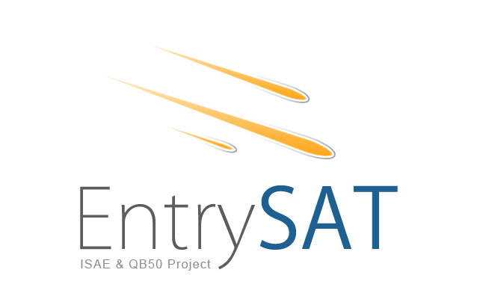

ENT-COM-107_V1

[SUB]= SY (SYSTEM), PL (PAYLAOD), SS (STRUCTURAL), AC (ATTITUDE CONTROL), EP (ELECTRICAL AND POWER), DH (DATA HANDLING), CO (COMMUNICATION), TH (THERMAL CONTROL)

FILENAME = TESTID_V*.DOC

Document
Date | 26/05/2015
Issue | IRIDIUM-Test Driver: communication between OBC and Iridium
Author | Harleen Kaur MANN
Checker | GARCIA Raphael

Table of contents
1 Reference Documents 3
2 TestID – Test title 4
2.1 Test objective 4
2.2 Date and place 4
2.3 List and tasks of the operators 4
2.4 Material 4
2.4.1 Hardware configuration 4
2.4.2 Software configuration 4
3 Framework 5
3.1 Set-up 5
3.2 Test procedure 5
4 Results 6
4.1 Outputs 6
4.2 Analysis 6
5 Conclusion 7
APPENDIX 1 - 8
APPENDIX 2 - 9

Reference Documents

ID | Author | Document title | Reference
[ENT-COM-103_V1] | GARCIA Raphael | Quantify Iridium Debit
[IRDIUM-GUIDE] | Iridium communications and beam communications | Iridium 9602 SBD transceiver developer's guide

ENT-COM-107-V1 Test Iridium Driver

Test objective

To check the communication of Iridium modem with OBC and note the time taken by different routines. Check the maximum size of message that could be sent.

Date and place
26/05/2015, between the IT building and the main building upstairs

List and tasks of the operators

Name | Status | Task
GARCIA Raphael | IC | Test manager
Harleen Kaur MANN | Student | Test the required things

Material

Hardware configuration

Name | Reference
Iridium modem | IMEI 300234062200280
Iridium 9601 emulation interface card | 016081A
USB to serial connector | E188601-I
Laptop for testing purposes | Windows OS, i7 processor
Squared iridium Passive Antenna from Antcom
Home made serial to iridium interface card connector
Home made Iridium comm+power board with switch to turn on/off the iridium modem

Software configuration
Name | Version
VirtualBox:cubesat/devboard/src/iridium | May 26
iridium.c | May 26
Main.c | May 26

Framework

Set-up
Connect Power Supply of 5V
Connect Power Supply of 10V
Open Virtual Machine

Test procedure

1. Connect development board with 5V power supply.
2. Connect the interface board with both the power supplies.
3. Connect the olimex USB to the laptop.
4. Switch on the power , verify the current values, as shown in pictures
5. Click on peripheriques (top left) and verify that the Olimex usb is connected and verify that the USB for console is connected,if not click on it and connect.
6. Run dev OpenOcd
7. Go to debug and select dev iridium
8. Choose the necessary breakpoints
9. Read the value of variables on window Variables
10. See the commands sent and the responses received from the modem on the console.

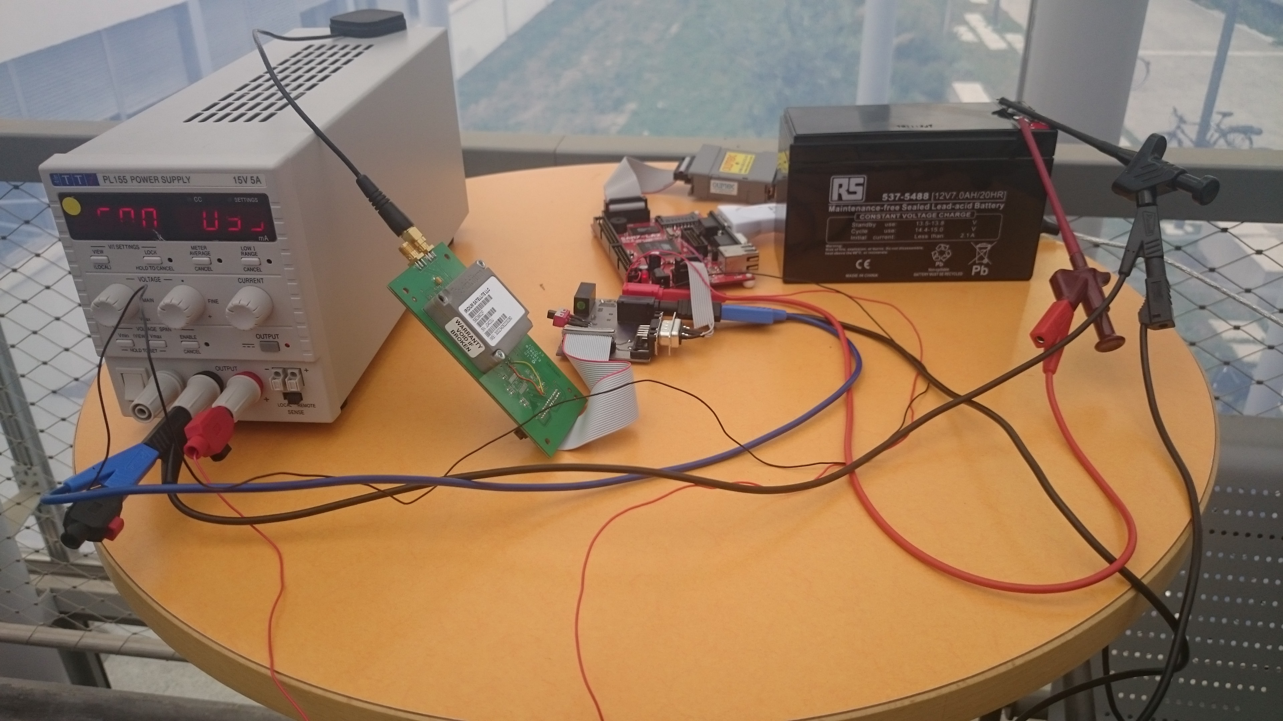

Figure1: Connections between modem, interface board and development board

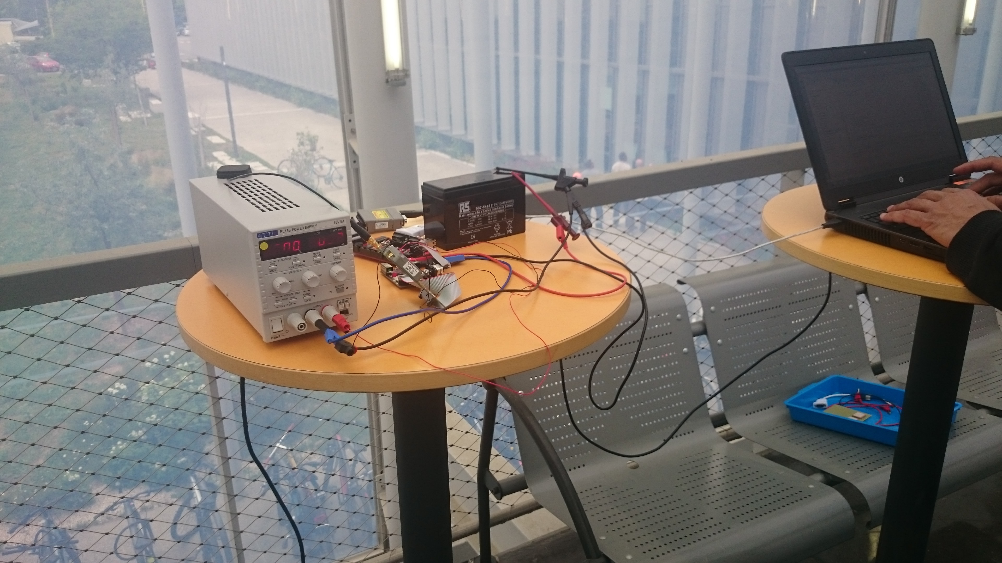

Figure2: The whole Test setup

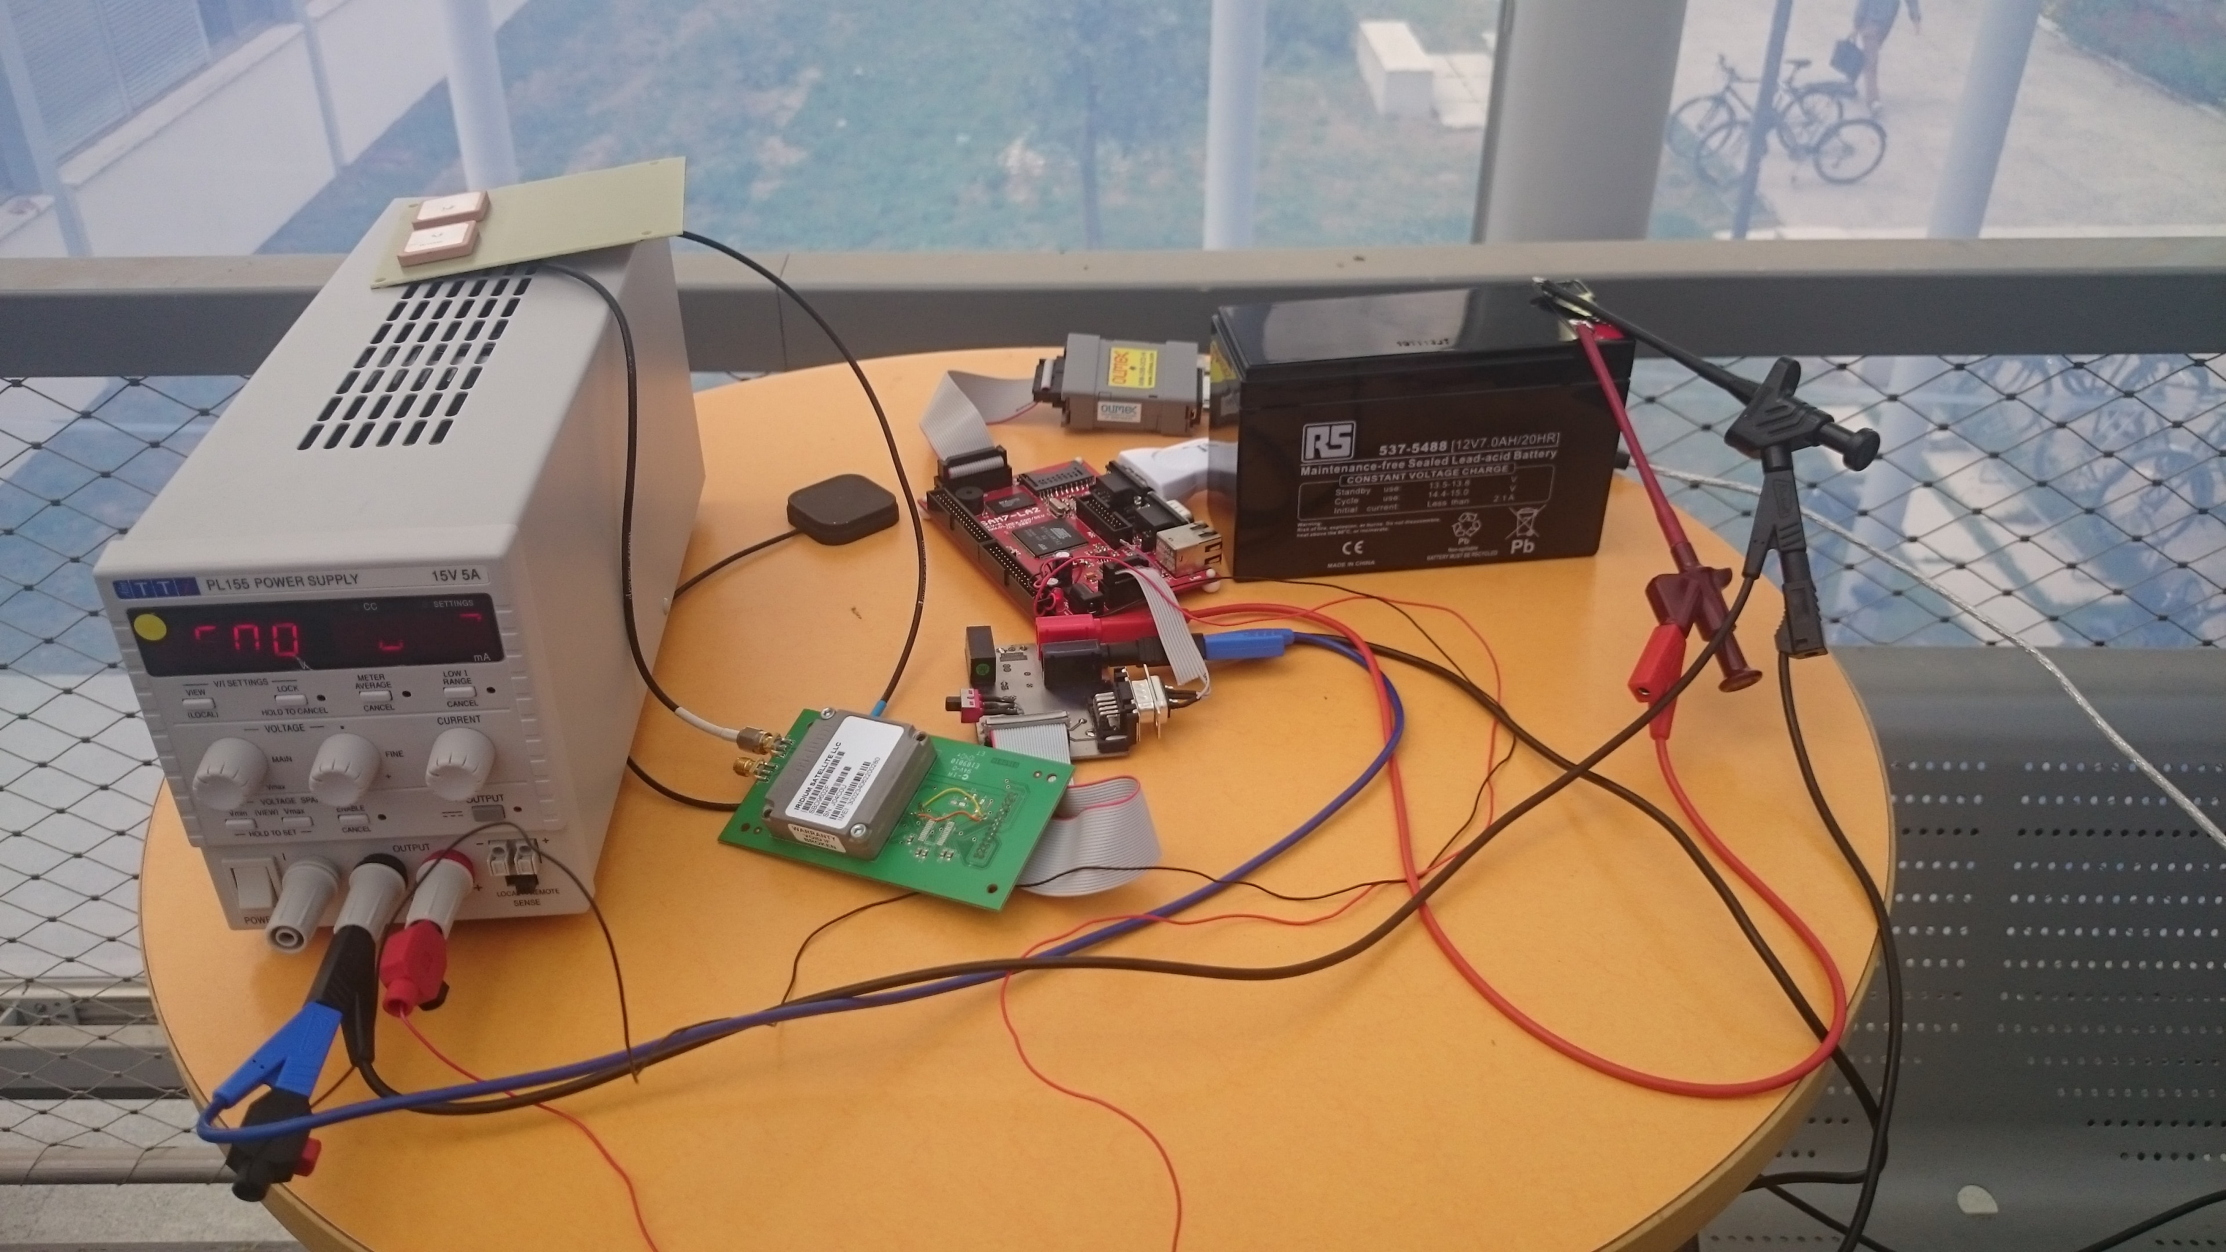

Figure3: The whole Test setup with real antenna

Results

Outputs
-The communication of Iridium modem with OBC was validated and it gave expected resulted for all the functions.
-The time taken by the Init_Check function was 3 seconds and for the Irdm_SendMessage ( ) it was 8 seconds for each try if modem replies and 60 seconds maximum if the modem doesn’t reply.
-Initially black passive antenna was used with a small message size and the message passed in one try itself with two tries the second time.
-The message size was changed to 340 bytes which required some changes in the declaration of variable messageSize in atoi( ),sendMessage( ) function.Ultimately the message was written in a for loop and it also passed.
-After these successful tries with this antenna, the test was done using real antenna and it passed.
-The minimum message size(1 byte) and maximum message size(340 bytes) were tested using the real antenna and it was successful.

Analysis
-The CSQ command is not required anymore as the communication with modem is good and the message could be sent outside,the information about the message being sent or not is given by the variables on debug screen.
-The time taken by each function was noted and updated at the end of the test.
-The value of timeout is suggested to be 20 seconds.

5. Conclusion
-Iridium driver needs to be validated with original gomspace library functions
-FM antenna hardware to be validated and 5 m long SMA cable for test through a window needs to be validated.
Future steps:
-Configuration storage or settings need to be done as required.
- Hardware validation:
– Test on the driver on the FM OBC
– Two antennas + coupler
– Iridium cubesat card with coupler
-More intensive test needs to be done taking care of the actual data packet.
-Configuration storage or settings need to be done as required.

