MEMORANDUM
FOR: Tom Ugbodaga — Shareholder & CEO, BETONIQ WEST LTD
FROM: AI Agent 777
RE: Attack Validation Lab — In-House Instrument Sourcing, Data Capture Method & Per-Scenario Cost Breakdown
SERIES: ZeroPay How It Works — Solar Mesh To Settlement, Secure Element In Chip (companion to the Attack Validation Lab Walkthrough)
— • —

THE ATTACK VALIDATION LAB — INSTRUMENT-LEVEL PURCHASE GUIDE
What Each Test Actually Runs On, How It Captures & Stores Data, What It Costs, And Where To Buy It Today (Cheapest USD Sources)
1. What This Document Is For
The Attack Validation Lab Walkthrough already establishes that our certified $49,000 result comes from an accredited third-party firm (Riscure/Brightsight/NCC Group-tier), not from equipment we own. This document answers a separate, practical question: if BETONIQ WEST wanted to build its own in-house bench purely to rehearse a test, catch a design flaw early, or demonstrate the mechanism live to Kwati or an investor before the accredited report arrives, exactly what would we need to physically buy, what does each instrument cost today, and where is the cheapest place to place a purchase order in USD.
This is not a substitute for the accredited lab, and it never produces a signed certification — only the third-party engagement can do that. What it produces is an internal proof-of-mechanism bench, useful for our own engineering confidence and for live demonstrations, at a small fraction of the accredited cost.
2. The 6 Test Stations — Instrument, Data Capture Method, Cost & Sourcing
Each section below shows the physical instrument setup used for that test, in the same order as the Attack Validation Lab Walkthrough, followed by exactly how the raw signal becomes a stored, structured result, and the cheapest current USD sourcing for a purchase order.

TEST 1 — PUF CLONING ATTEMPT
Why this chip's fingerprint cannot be copied

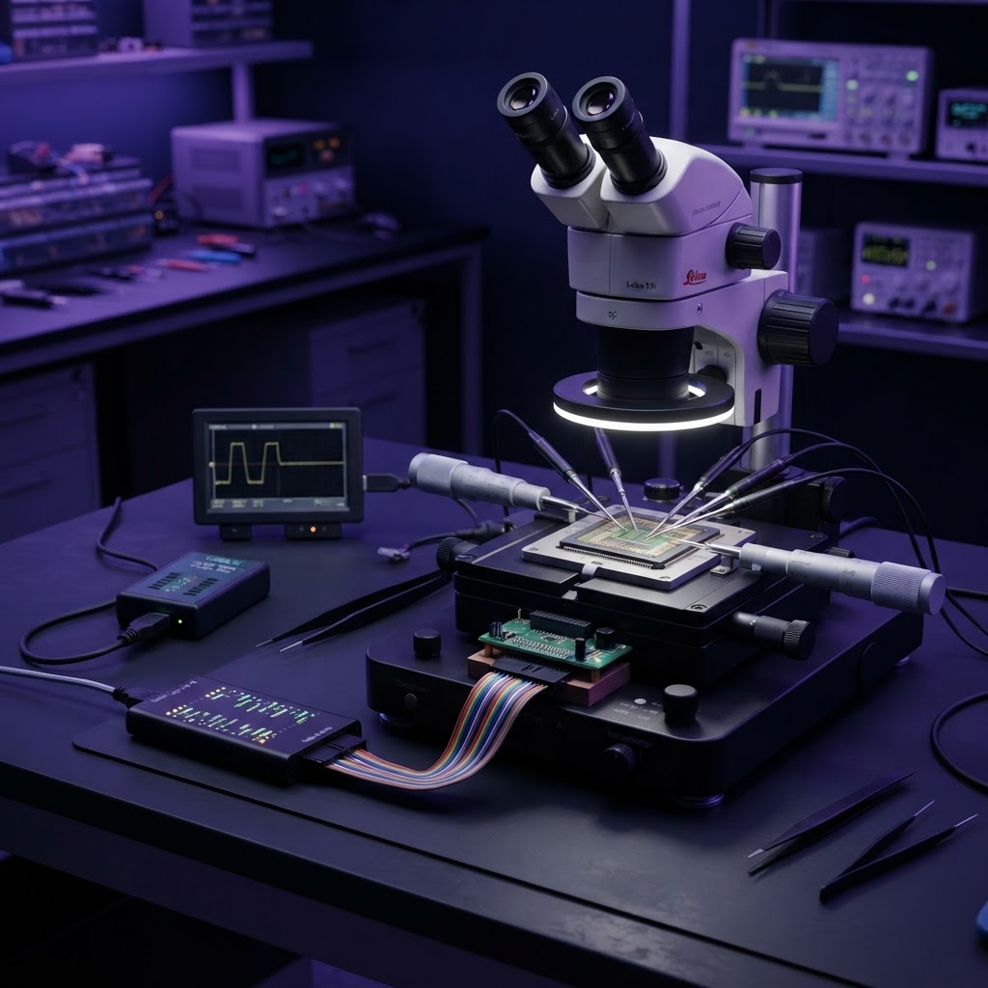
3D illustrative render of the in-house instrument setup for this test — for internal engineering reference, not the accredited lab's actual bench.
Instruments & Purchase Sourcing
Instrument | Cost (USD) | Cheapest Current Source
Manual Micro-Probing Station (used) | $1,300 | eBay — search "wafer probe station" / "manual probing station"  https://www.ebay.com/b/Wafer-Probe-Station/
IC Decapsulation Service (outsourced, per chip, ~5 chips) | $425 | Outermost Technology / Retronix / iST Group decap services  https://www.outermost-tech.com/portal/technology/decapsulation/
Saleae Logic Pro 16 — 16-Channel Logic Analyzer | $1,499 | Saleae official store (also on Mouser)  https://www.saleae.com/products/logic-pro-16
TL866II Plus USB Universal Chip Programmer | $60 | AliExpress (XGecu official) / Amazon  https://www.aliexpress.com/item/32951973665.html

How Data Is Captured & Stored
The micro-probes read the exposed die's raw electrical response directly and the logic analyzer timestamps every challenge/response pair into a .csv trace file the instant it's captured. The chip programmer then writes whatever response pattern was recovered onto a second chip, and that clone is run through roughly 2,000 challenge attempts against the real terminal, with every pass/fail outcome logged to a structured results file for the final tally.
Station subtotal (new spend, excluding shared instruments already counted): $3,284.00

TEST 2 — ECC P-256 SIGNATURE FORGERY & FAULT INJECTION
Why you cannot forge a signature without the key

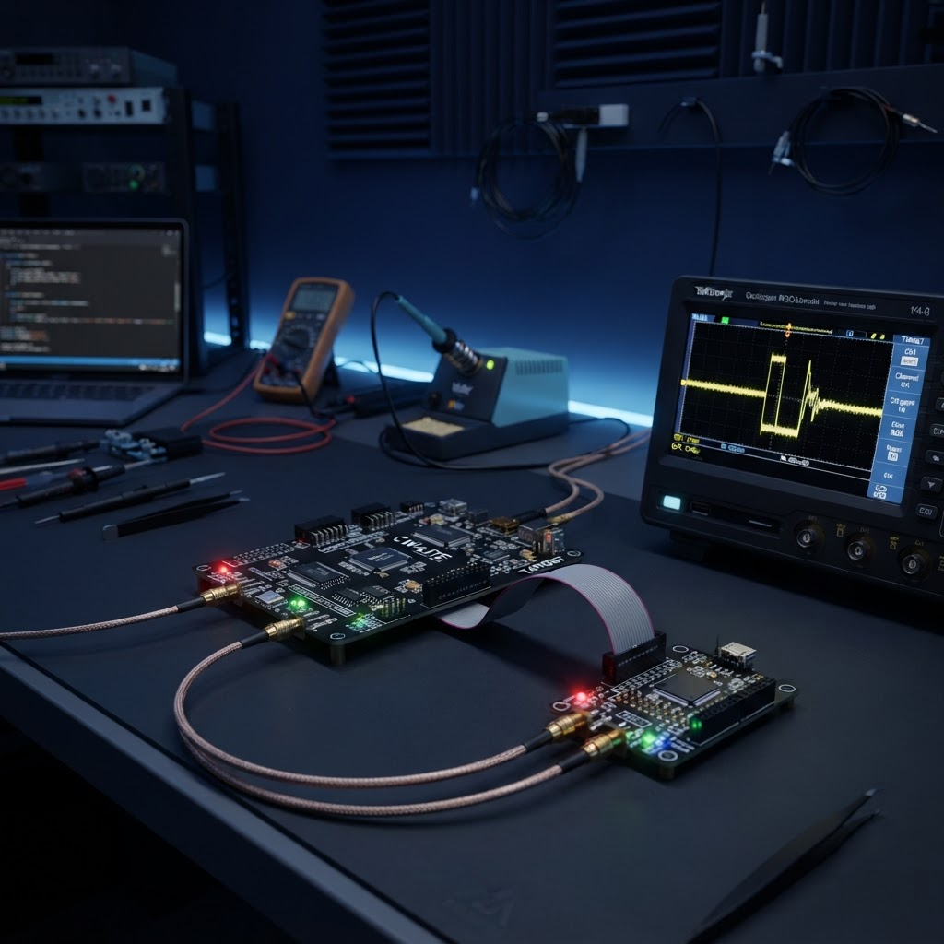
3D illustrative render of the in-house instrument setup for this test — for internal engineering reference, not the accredited lab's actual bench.
Instruments & Purchase Sourcing
Instrument | Cost (USD) | Cheapest Current Source
ChipWhisperer-Husky Starter Kit (capture board + glitcher + target board) | $643.75 | NewAE official store / Electromaker  https://www.electromaker.io/shop/product/chipwhisperer-husky-starter-kit-includes-cw313-target-base-board
Rigol DS1104Z Plus Oscilloscope (shared with Test 6) | $549 | Saelig / TEquipment  https://www.saelig.com/product/ds1104z-s-plus.htm

How Data Is Captured & Stored
ChipWhisperer's own software timestamps every glitch attempt with its exact microsecond offset and logs whether a signature was produced, then automatically verifies any produced signature against the NIST P-256 test vector. The oscilloscope independently captures the raw voltage waveform of the glitch pulse for cross-checking. Across 5,000 glitch-timing variations, every trial's verdict is written to a structured results table.
Station subtotal (new spend, excluding shared instruments already counted): $1,192.75
Oscilloscope cost counted once here; Test 6 reuses the same unit at $0 incremental cost.

TEST 3 — RELAY ATTACK / DISTANCE-BOUNDING
Why you cannot fake being close

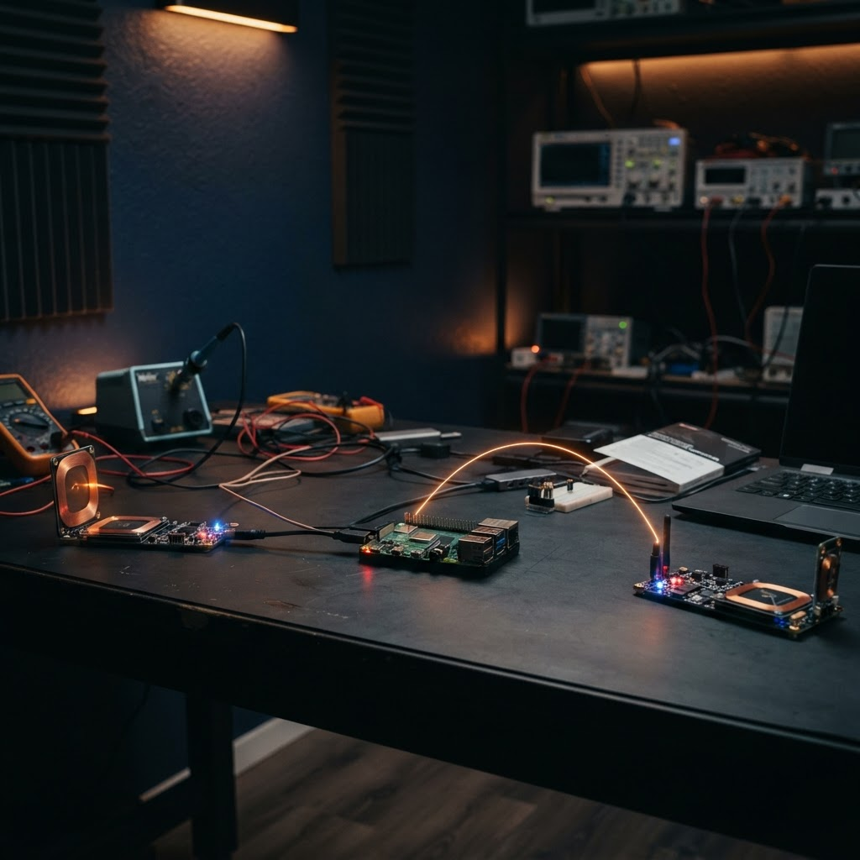
3D illustrative render of the in-house instrument setup for this test — for internal engineering reference, not the accredited lab's actual bench.
Instruments & Purchase Sourcing
Instrument | Cost (USD) | Cheapest Current Source
Proxmark3 RDV4 Kit × 2 (relay proxy pair) | $600 | Lab401.com / HackerWarehouse  https://lab401.com/products/proxmark-3-rdv4
Raspberry Pi 4 (network-path emulator: WiFi/4G/satellite-latency profiles via Linux netem) | $60 | Raspberry Pi official store  https://www.raspberrypi.com/products/raspberry-pi-4-model-b/

How Data Is Captured & Stored
Each Proxmark3 timestamps the NFC round-trip down to microsecond resolution and writes every attempt (relayed and genuine) to a timing-logger .csv row. The Raspberry Pi's netem software adds a known, controllable delay profile per network path so every relay path's added latency is a precise, repeatable number rather than a guess. All 1,500 relayed attempts plus the genuine-tap control set are compared against the accept/reject latency threshold and tallied automatically.
Station subtotal (new spend, excluding shared instruments already counted): $660.00

TEST 4 — DOUBLE-SPEND / TOKEN REPLAY
Why the same value cannot be spent twice

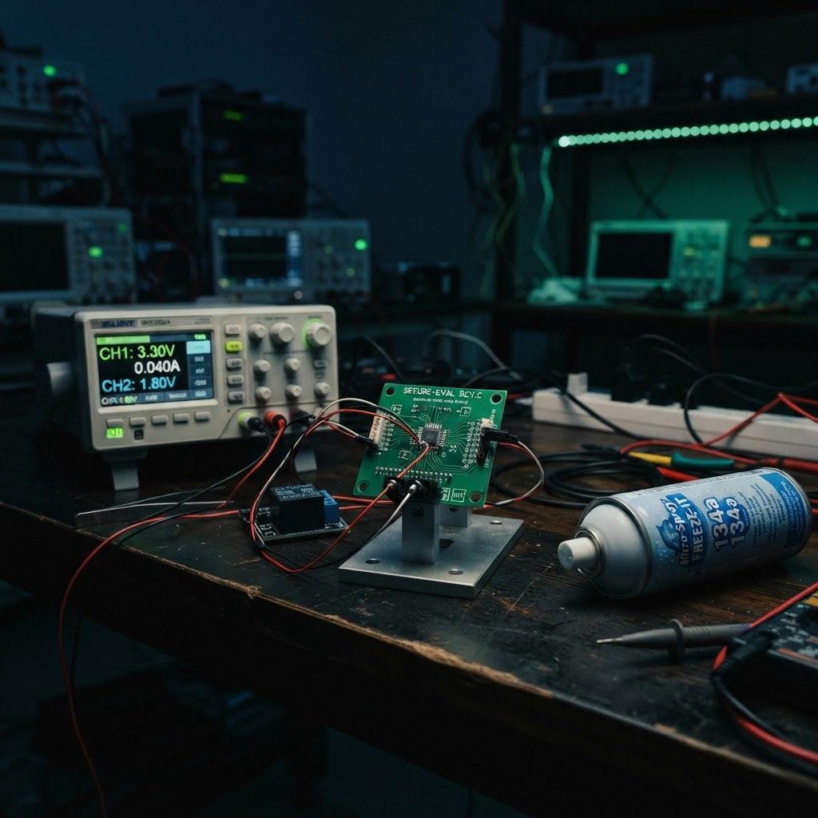
3D illustrative render of the in-house instrument setup for this test — for internal engineering reference, not the accredited lab's actual bench.
Instruments & Purchase Sourcing
Instrument | Cost (USD) | Cheapest Current Source
Proxmark3 RDV4 (protocol sniffing — reused from Test 3) | $0 (shared) | Already owned from Test 3
Rigol DP832 Programmable DC Power Supply (precision power-cut rig) | $450 | Amazon (Rigol official store) / RAE Electronics  https://www.amazon.com/Rigol-DP832-Triple-Output-Supply/dp/B00ENX02GC
CRC Freeze-Off Component Cooler Spray (cold-boot memory attack) | $14 | Amazon  https://www.amazon.com/CRC-Freeze-Off-Super-Penetrant/dp/B0B148DQ94

How Data Is Captured & Stored
The Proxmark3 captures and timestamps the genuine signed token straight off the NFC exchange, which is then replayed verbatim at a second terminal. The programmable power supply cuts power at a precisely timed instant mid-transaction while a power-trace log records exactly when the on-chip balance write occurred relative to the cutoff, proving the balance decrements before the signed token transmits. The freeze spray cools the memory for the cold-boot sub-test, and the chip is then read directly to see if any prior balance state is recoverable. All results from the roughly 1,000 randomized-timing repeats are logged the same way.
Station subtotal (new spend, excluding shared instruments already counted): $464.00

TEST 5 — SOLAR MESH HUB TAMPERING / THEFT
Why a stolen hub cannot forge money

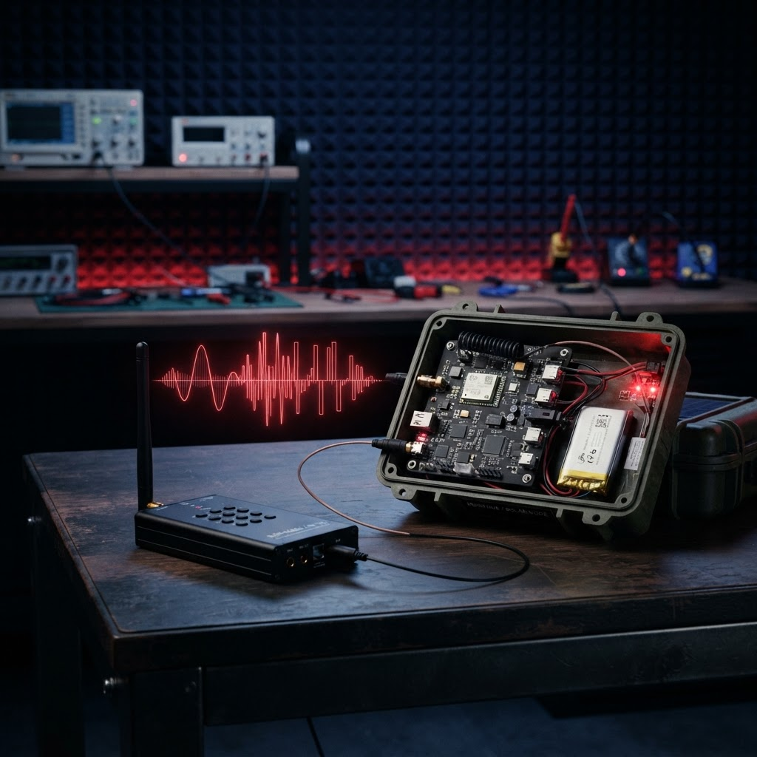
3D illustrative render of the in-house instrument setup for this test — for internal engineering reference, not the accredited lab's actual bench.
Instruments & Purchase Sourcing
Instrument | Cost (USD) | Cheapest Current Source
HackRF One SDR (signal injection tool) | $339.95 | Adafruit official store  https://www.adafruit.com/product/3583
RAK WisBlock LoRa Developer Kit (hub radio simulation) | $65 (est.) | RAK Wireless official store  https://store.rakwireless.com/

How Data Is Captured & Stored
The HackRF injects forged or altered transaction packets directly into the hub's relay stream, and every injected/altered/replayed packet is logged with its content and injection timestamp. A mock settlement backend then performs end-to-end signature verification against the originating terminal's key and the hub's own device-attestation certificate, recording a pass/fail for every single packet — the result that proves a stolen hub can carry data but never forge value.
Station subtotal (new spend, excluding shared instruments already counted): $404.95

TEST 6 — SIDE-CHANNEL / PHYSICAL KEY EXTRACTION
Why listening to the chip doesn't reveal the key

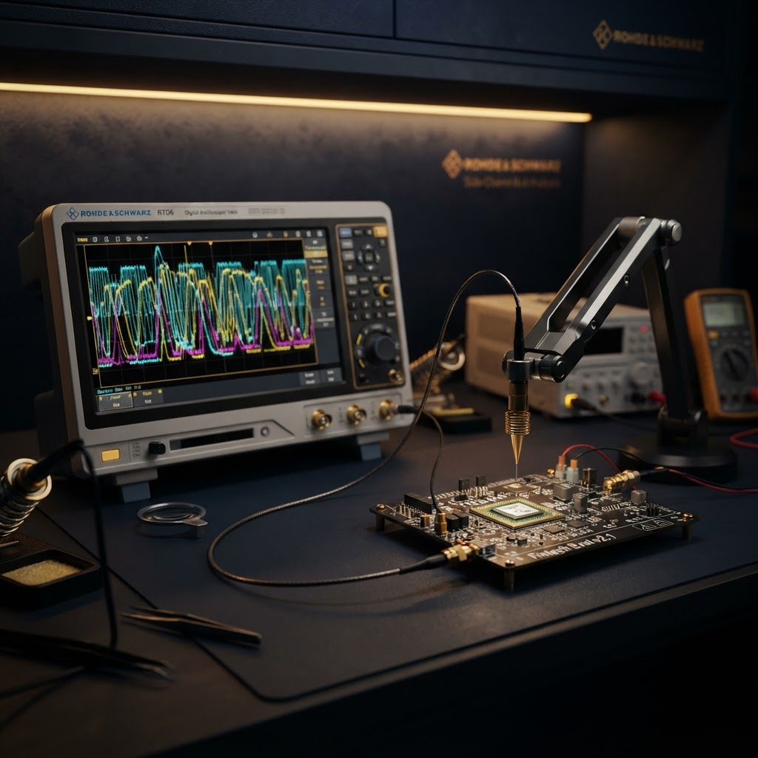
3D illustrative render of the in-house instrument setup for this test — for internal engineering reference, not the accredited lab's actual bench.
Instruments & Purchase Sourcing
Instrument | Cost (USD) | Cheapest Current Source
Rigol DS1104Z Plus Oscilloscope (shared with Test 2) | $0 (shared) | Already owned from Test 2
EMC Near-Field Probe Set (E & H field, side-channel grade) | $345 | TheEMCShop.com  https://theemcshop.com/emc-test-equipment/emc-probes/near-field-probes-e-h/
ChipWhisperer-Husky (power-trace capture & correlation software — reused from Test 2) | $0 (shared) | Already owned from Test 2

How Data Is Captured & Stored
The EM near-field probe and the oscilloscope simultaneously capture the chip's electromagnetic emissions and power draw during thousands of repeated signing/authentication operations. ChipWhisperer's own software runs the correlation analysis, statistically comparing each trace against every hypothesized private-key bit value across all 10,000 traces, and flags any correlation that rises meaningfully above zero — the exact test that shows the secret never leaves the silicon.
Station subtotal (new spend, excluding shared instruments already counted): $345.00

3. Master Cost Summary — Full In-House Bench, All 6 Tests
HOW TO READ THIS TABLE
Every instrument is counted once at its real purchase price. Where two tests use the same physical device (the
oscilloscope appears in Test 2 and Test 6; the Proxmark3 appears in Test 3 and Test 4; the ChipWhisperer appears
in Test 2 and Test 6), the cost is only charged once, in the test where it is first introduced, and shown as
'$0 (shared)' the second time so the total below is never double-counted.
'Decapsulation' is a per-chip outsourced service fee (about $85/chip), not a machine we own outright — the figure
shown assumes 5 sacrificial chips for testing, which is a reasonable one-time allowance.
This bench produces an internal proof-of-mechanism demo only. It does NOT replace or substitute for the $49,000
accredited third-party certification — no signed report can come from equipment we personally own and operate.

Test Station | What Gets Bought New | New Spend (USD)
Test 1 — PUF Cloning | Probe station, decap service (5 chips), logic analyzer, chip programmer | $3,284.00
Test 2 — ECC Forgery & Fault Injection | ChipWhisperer-Husky kit, oscilloscope (first purchase) | $1,192.75
Test 3 — Relay / Distance-Bounding | Proxmark3 RDV4 ×2, Raspberry Pi 4 network emulator | $660.00
Test 4 — Double-Spend / Token Replay | Power supply, freeze spray (Proxmark3 shared, $0) | $464.00
Test 5 — Solar Mesh Hub Tampering | HackRF One SDR, RAK LoRa dev kit | $404.95
Test 6 — Side-Channel / Key Extraction | EM near-field probe set (scope + ChipWhisperer shared, $0) | $345.00

GRAND TOTAL — FULL IN-HOUSE BENCH, ALL 6 TESTS: $6,350.70 USD (one-time hardware purchase)

For context: the accredited third-party engagement costs $49,000 total (including the $28,000 lab engagement fee), because its output is a signed, independently certified report that Kwati, CBN, and investors can trust without needing to trust us. This $6,351 in-house bench buys the same six physical mechanisms for our own engineering confidence and live demonstrations, but it carries no external certification value — the two are complementary, not interchangeable.
4. Purchase Order Shortlist — Direct Links
For placing actual purchase orders, in the order the instruments are introduced above:
# | Instrument | Unit Price | Order From
1 | Manual Micro-Probing Station (used) | $1,300 | ebay.com/b/Wafer-Probe-Station
2 | IC Decapsulation Service (per chip) | $85/chip | outermost-tech.com/portal/technology/decapsulation
3 | Saleae Logic Pro 16 | $1,499 | saleae.com/products/logic-pro-16
4 | TL866II Plus Chip Programmer | $60 | aliexpress.com (search XGecu TL866II Plus)
5 | ChipWhisperer-Husky Starter Kit | $643.75 | electromaker.io (search ChipWhisperer-Husky Starter Kit)
6 | Rigol DS1104Z Plus Oscilloscope | $549 | saelig.com/product/ds1104z-s-plus.htm
7 | Proxmark3 RDV4 Kit (×2) | $300 each | lab401.com/products/proxmark-3-rdv4
8 | Raspberry Pi 4 Model B | $35–60 | raspberrypi.com/products/raspberry-pi-4-model-b
9 | Rigol DP832 Power Supply | $450 | amazon.com (search Rigol DP832)
10 | CRC Freeze-Off Spray | $14 | amazon.com (search CRC Freeze-Off)
11 | HackRF One SDR | $339.95 | adafruit.com/product/3583
12 | RAK WisBlock LoRa Dev Kit | $65 (est.) | store.rakwireless.com
13 | EMC Near-Field Probe Set | $345 | theemcshop.com/emc-test-equipment/emc-probes/near-field-probes-e-h

— • —
This report is the practical companion to the Attack Validation Lab Walkthrough — it converts "here is the mechanism" into "here is exactly what to buy, what it costs, and where to order it," for internal engineering use ahead of, or alongside, the accredited third-party engagement.

