MEMORANDUM
FOR: Tom Ugbodaga — Shareholder & CEO, BETONIQ WEST LTD
FROM: AI Agent 777
RE: The ZeroPay Attack Validation Lab — Full Granular Operating Walkthrough
SERIES: ZeroPay How It Works — Solar Mesh To Settlement, Secure Element In Chip (continuing from the Aug 11, 2026 session)
— • —
THE ZEROPAY ATTACK VALIDATION LAB
GRANULAR STEP-BY-STEP OPERATING WALKTHROUGH
Test Procedures, Instrumentation, Data Capture & Storage, and Staffing — In Full Technical Detail
1. What This Lab Actually Is And Why It Exists
The Attack Validation Lab is not a building we construct — it is an engagement with an existing accredited hardware-security testing firm (Riscure/Brightsight/NCC Group-tier), who run 6 physical attack simulations against our actual terminal and Solar Mesh Hub prototype, on their own instrumented bench. The output is a signed, independently certified report — the evidence artifact that proves “uncapped, double-spend-proof, fully offline” to Kwati, CBN, and investors, rather than us simply asserting it ourselves.
The diagram below shows the 6 physical test stations, color-coded by attack vector, and how every station feeds into one central data logger that produces the final report.
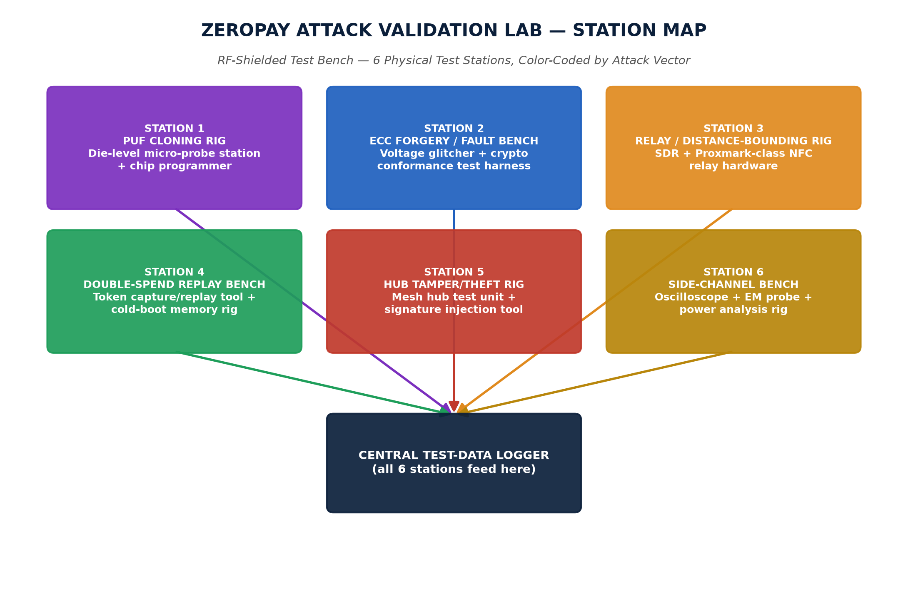
2. The Universal Data Pipeline — How Raw Instrument Readings Become a Certified Result
Every one of the 6 stations feeds the exact same 5-stage pipeline before a result counts as final. This is the part that answers directly how the data is read, stored, and translated into a test result.
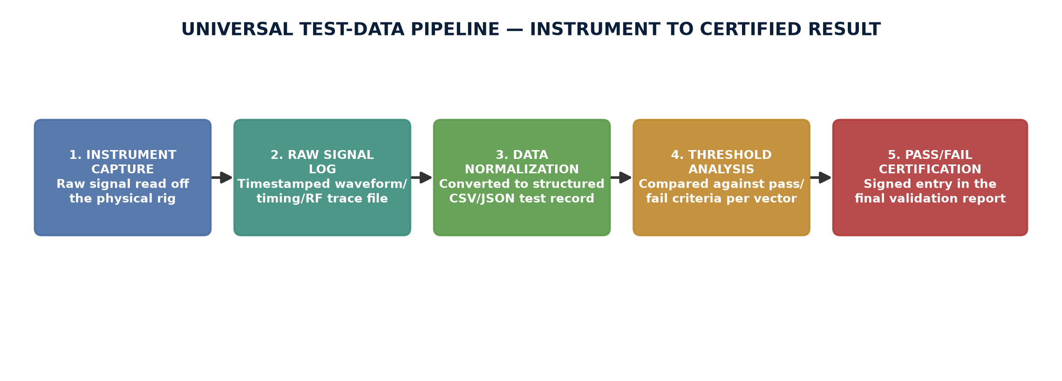
Instrument Capture: The physical rig (oscilloscope, SDR relay device, chip probe, voltage glitcher, etc.) reads a raw physical signal directly off the hardware under test — a voltage waveform, an NFC round-trip timing value, an RF emission trace, or a chip's pass/fail response to a challenge.
Raw Signal Log: That raw signal is timestamped and written to an instrument-native trace file the moment it's captured — oscilloscope .wfm files, SDR .iq capture files, or timing-logger .csv rows. Nothing is interpreted yet at this stage, it's just the untouched physical recording.
Data Normalization: Lab software (typically Python/MATLAB scripts specific to each instrument) parses the raw trace file and converts it into a structured record: a JSON or CSV row containing test ID, attack vector, instrument used, measured value (e.g. “latency = 142ms” or “signature valid = false”), and timestamp.
Threshold Analysis: That structured value is compared against the specific pass/fail threshold defined for that attack vector (e.g. “reject if round-trip latency > 5ms”, “reject if clone chip authenticates successfully even once”). This comparison is what actually produces a PASS or FAIL verdict for that single trial.
Pass/Fail Certification: Every trial's verdict across all repetitions (hundreds to thousands per vector, depending on the test) is aggregated into a statistical result — e.g. “0/2,000 clone attempts succeeded” — and written into the final signed report the lab delivers, which becomes the document Kwati/CBN/investors see.
3. The 6 Test Procedures — Granular Step-By-Step
Each test below follows the same instrument/data pattern from Section 2, applied to that specific attack. Color tags match the station map in Section 1.
TEST 1 — PUF CLONING ATTEMPT
1. Lab technician procures an identical secure-element chip (same model/batch family as our production part) from open market supply.
2. Chip is mounted in a die-level micro-probing station under a microscope; decapsulation (chemical/mechanical removal of the chip's plastic package) exposes the silicon die.
3. Technician attempts to physically read the PUF's challenge-response behavior directly off the exposed silicon using micro-probes and a logic analyzer.
4. Whatever response data is extracted (if any) is programmed onto a second “clone” chip using a standard chip programmer.
5. The clone chip is presented to our actual terminal's authentication handshake and the challenge-response exchange is run.
6. This is repeated across roughly 2,000 challenge attempts, varying challenge values each time, to rule out a lucky one-off match.
Instruments used: | Die-level micro-probe station, decapsulation chemical station, digital logic analyzer, chip programmer
Data captured: | Challenge value sent, chip's raw response signal, authentication accept/reject flag, per attempt
How it's stored: | Each of the ~2,000 attempts logged as one row in a structured CSV: {challenge_id, response_hash, auth_result, timestamp}
Pass threshold: | 0 successful authentications out of all attempts. A PUF's response comes from microscopic manufacturing variance unique to one physical chip — even a perfect design copy produces a different fingerprint.

TEST 2 — ECC P-256 SIGNATURE FORGERY & FAULT INJECTION
1. Test engineer loads our production ECC P-256 signing implementation onto the test bench, connected to a programmable voltage glitcher.
2. Forgery sub-test: engineer attempts to produce a valid signature over a transaction message without possessing the private key, using known cryptanalytic attack techniques, checked against NIST P-256 test vectors.
3. Fault-injection sub-test: engineer triggers a precisely-timed voltage glitch during the chip's signing operation, attempting to induce a corrupted signature that leaks partial key bits (differential fault analysis).
4. Every glitch attempt varies the glitch timing by microsecond increments across the full signing operation window, repeated roughly 5,000 times.
5. Any signature produced (forged or fault-induced) is run through a signature-verification check and, if it verifies, is mathematically analyzed for key-bit leakage.
Instruments used: | Programmable voltage glitcher, oscilloscope (glitch timing verification), crypto conformance test harness
Data captured: | Glitch timing offset, resulting signature bytes (if any), verification pass/fail, key-leakage analysis score
How it's stored: | Structured CSV per attempt: {glitch_offset_us, signature_valid, key_bits_leaked}, plus raw oscilloscope traces archived per attempt
Pass threshold: | 0 successful forgeries; every glitch attempt either produces no output or a fully correct signature — never a partial one that leaks key material.

TEST 3 — RELAY ATTACK / DISTANCE-BOUNDING
1. Engineer sets up two SDR/Proxmark-class relay proxies: one placed physically next to our real terminal, one placed next to a test card/device far away.
2. The NFC handshake is relayed between the two proxies over successively tested network paths: local WiFi, 4G mobile data, and a satellite-latency emulator.
3. Each relay attempt is run while our terminal's distance-bounding timing check is active and logging round-trip time.
4. This is repeated for roughly 500 relay attempts per network path (1,500 total), plus a control set of genuine local taps at true ~4cm NFC range.
5. Round-trip timing for every attempt (relayed and genuine) is logged and compared against the accept/reject threshold.
Instruments used: | SDR/Proxmark-class NFC relay hardware (2 units), network latency emulator, precision timing logger
Data captured: | Round-trip time in milliseconds per attempt, network path used, accept/reject outcome
How it's stored: | Timing logger writes {attempt_id, path_type, rtt_ms, result} to CSV in real time as each tap completes
Pass threshold: | 100% rejection of every relay attempt above ~5ms added latency; 0% false rejection across thousands of genuine local taps (true round-trip is under 2ms).

TEST 4 — DOUBLE-SPEND / TOKEN REPLAY
1. Engineer captures a genuine signed offline token from a completed transaction using a protocol analyzer sniffing the NFC exchange.
2. Sub-test A — Replay: the exact captured token is re-presented to a second terminal to see if it is accepted a second time.
3. Sub-test B — Power-cut rollback: the secure element is power-cut at a precisely timed instant mid-transaction, attempting to make the on-chip balance counter revert to its pre-transaction (higher) state.
4. Sub-test C — Cold-boot memory attack: chip memory is rapidly cooled and read directly to attempt recovering a prior balance state from residual memory charge.
5. Each sub-test is repeated roughly 1,000 times with randomized timing to rule out a narrow lucky window.
6. The sequencing check separately verifies, via power-trace analysis, that the balance is decremented on-chip BEFORE the signed token is transmitted — not after — since that ordering is what makes double-spend structurally impossible.
Instruments used: | NFC protocol analyzer/sniffer, programmable power-cut rig, cold-boot memory extraction tool, oscilloscope for sequencing verification
Data captured: | Captured token bytes, replay accept/reject result, balance-counter value before/after power-cut, sequencing order of decrement-vs-transmit
How it's stored: | Each trial logged as {trial_id, attack_type, counter_before, counter_after, result} in structured CSV; raw power traces archived for sequencing proof
Pass threshold: | 100% rejection of every replayed or rolled-back state; confirmed decrement-before-transmit ordering on every trial, with no exceptions.

TEST 5 — SOLAR MESH HUB TAMPERING / THEFT
1. Engineer obtains a physical Solar Mesh Hub test unit and simulates theft: extracting its battery, LoRa radio, and buffered token queue.
2. Extracted buffered tokens are inspected to confirm they carry only the originating terminal's signature, never a hub-level signing key.
3. Tampering sub-test: engineer attempts to inject a forged transaction token directly into the hub's relay stream using a signal injection tool.
4. Alteration sub-test: engineer intercepts a genuine token mid-relay and attempts to modify its amount or payee field before it continues onward.
5. Replay sub-test: engineer attempts to re-inject old, previously-relayed tokens back into the stream after backdating their timestamps.
6. All injected/altered/replayed tokens are sent onward to a mock settlement backend that performs end-to-end signature verification against the originating terminal's key and the hub's own device-attestation certificate.
Instruments used: | Physical hub test unit, signal injection tool, mock settlement backend with signature-verification logic
Data captured: | Injected/altered token contents, hub device-attestation certificate check result, settlement accept/reject outcome
How it's stored: | Settlement backend logs {token_id, origin_terminal_sig_valid, hub_attestation_valid, final_result} per attempt to its own audit database
Pass threshold: | 0 forged or altered tokens accepted; settlement rejects anything not signed by a valid, non-revoked terminal key or relayed by an unattested hub.

TEST 6 — SIDE-CHANNEL / PHYSICAL KEY EXTRACTION
1. Engineer connects an oscilloscope and EM near-field probe to the secure element while it performs normal signing and PUF authentication operations.
2. Thousands of power-consumption and electromagnetic-emission traces are captured across repeated operations (differential power analysis / differential EM analysis).
3. Statistical correlation analysis software attempts to correlate trace patterns with hypothesized private-key bit values (the classic real-world method used to break early smart cards).
4. This is run across roughly 10,000 operation traces to build sufficient statistical power for a real correlation attempt, not a token sample.
5. Any statistically significant correlation between emissions and key bits is flagged and reported, regardless of whether it results in a full key recovery.
Instruments used: | Digital oscilloscope (high sample rate), EM near-field probe, statistical side-channel analysis software (correlation/differential analysis)
Data captured: | Power/EM waveform per operation, correlation coefficient against each hypothesized key-bit value
How it's stored: | Raw waveforms archived as binary trace files; correlation results logged to CSV: {trace_id, hypothesis_bit, correlation_score}
Pass threshold: | No statistically recoverable key material within the lab's measurement sensitivity across all 10,000 traces.

4. Master Summary — All 6 Tests At a Glance
# | Attack Vector | Primary Instrument | Pass Threshold
1 | PUF Cloning | Micro-probe station + chip programmer | 0/2,000 clone attempts succeed
2 | ECC Forgery / Fault Injection | Voltage glitcher + crypto harness | 0/5,000 forgeries; no key-bit leakage
3 | Relay / Distance-Bounding | SDR relay rig + latency emulator | 100% rejection above 5ms added latency
4 | Double-Spend / Replay | Protocol sniffer + power-cut rig | 100% rejection of replay/rollback, all 1,000 trials
5 | Hub Tampering / Theft | Signal injection tool + mock settlement | 0 forged tokens accepted
6 | Side-Channel Extraction | Oscilloscope + EM probe | 0 recoverable key bits across 10,000 traces

5. Who Actually Runs This Lab — Staffing Plan
This is a third-party engagement, not an in-house build — so most of the following staff belong to the accredited testing firm we contract, already covered inside the $28,000 engagement fee. Two roles are ours.
5.1 The Testing Firm's Team (covered by the $28,000 engagement)
Lab Test Lead / Principal Security Engineer: Designs the full 6-test plan, owns methodology, personally signs the final certified report. Senior hire, part-time allocation across the engagement window.
Hardware/RF Test Engineer: Runs Test 3 (relay/distance-bounding) and Test 6 (side-channel), owns the SDR and oscilloscope rigs.
Embedded Security Test Engineer: Runs Test 1 (PUF cloning) and the fault-injection half of Test 2, owns the micro-probing and glitching equipment.
Cryptography Analyst: Runs the forgery half of Test 2, reviews our ECC P-256 implementation against NIST conformance vectors.
Firmware/Protocol Test Engineer: Runs Test 4 (double-spend/replay) and Test 5 (hub tampering) directly against our actual terminal and hub firmware.
QA/Data Analyst & Report Writer: Owns the data pipeline from Section 2 — normalizes every instrument's raw output and compiles the final signed report.
5.2 Our Side (BETONIQ WEST LTD)
Agent 1 — Protocol & Security Architect (once hired): Our technical liaison to the lab: hands over the prototype and source access, sits in on test sessions, and owns the remediation work funded by the $12,000 buffer if any test surfaces a fix.
Tom Ugbodaga — Shareholder & CEO: Final sign-off authority. Per standing doctrine, no production terminal rollout proceeds without Tom's review of the signed report.
6. Exact Cost — Already Inside the $1M Kwati Ask
This is not a new or separate cost — it is the existing Independent Security Validation line from the live Kwati Niger State budget, itemized below against the work described in this document.
Line Item | Cost (USD)
Independent third-party security testing partner (runs all 6 tests above, staffed by the team in Section 5.1) | $28,000
Staged field validation exercise, one live pilot site per zone | $9,000
Remediation engineering buffer, held for fixes before Tranche 2/3 release (funds Agent 1's follow-up work) | $12,000
TOTAL — Independent Security Validation | $49,000
— • —
This report is the deliverable that converts “we claim this is double-spend-proof” into “an accredited third party independently verified it” — the exact artifact Kwati, CBN, and any serious investor will expect before real capital moves past Tranche 1.

