BUSINESS PLAN & INVESTMENT CASE
THE 77 GOLF & COUNTRY ESTATE
Bwari, Abuja — Federal Capital Territory, Nigeria
“Live on the Greens, Work in Comfort, Heal in Serenity and Relax in Luxury.”

Conceptual illustration — final masterplan subject to architectural & survey approval

Prepared for: BETONIQ WEST LTD
Sponsor: Tom Ugbodaga, Shareholder & CEO
September 2026 | Strictly Private & Confidential

Table of Contents
1. Executive Summary
2. Vision, Concept & Design Philosophy
3. Location & Site Overview
4. Master Plan & Project Description
5. Development Phasing & Timeline
6. Market Analysis & Target Buyers
7. Financial Plan
8. Profitability Analysis
9. Legal, Regulatory & Land Title Framework
10. Marketing & Sales Strategy
11. Organizational Structure & Management
12. SWOT Analysis
13. Risk Analysis & Mitigation
14. Exit Strategy & Long-Term Value Creation
15. Implementation Roadmap & Conclusion
Appendix: Key Assumptions & Notes

1. Executive Summary
The 77 Golf & Country Estate is a proposed mixed-use luxury development on 77 hectares of land in Bwari Area Council, Abuja, Federal Capital Territory. The project combines a golf-anchored residential community with phased hospitality, retail and healthcare facilities, positioning it as a landmark destination in the FCT for luxury living, leisure and commerce.
The development is structured as a phased, self-funding model: early revenue from the sale of site-and-serviced land parcels is used to finance the golf course, clubhouse, and subsequent phases, reducing upfront capital exposure and reliance on external financing before the project demonstrates market traction.

Key Highlights
Metric | Value
Total Land Area | 77 hectares
Location | Bwari, Abuja, FCT, Nigeria
Golf Course | 27 hectares (18-hole executive-style layout)
Luxury Duplex Units (Phase 1) | 100 units — 4-bedroom, 500 sqm plots
Land Acquisition Cost | ₦2.5 billion
Total Duplex Construction Cost | ₦15 billion (₦150M/unit to carcass level)
Projected Revenue — Site & Serviced Land Sales | ₦50 billion
Minimum Target ROI | 20%
Projected ROI (stated-cost basis) | ≈186%
Sponsor | BETONIQ WEST LTD — Tom Ugbodaga, Shareholder & CEO

Even under a conservative scenario that allocates the maximum possible buffer toward golf course construction, clubhouse, site infrastructure and contingency, the project comfortably clears the 20% minimum return threshold on Phase 1 land sales alone — before counting additional upside from duplex sales, hospitality and healthcare revenue introduced in later phases (see Section 8, Profitability Analysis).

2. Vision, Concept & Design Philosophy
Golf Country Estate is envisioned as a world-class destination where luxury living, recreation, healthcare, hospitality and commerce converge — a single integrated community rather than a conventional housing estate.
“Live on the Greens, Work in Comfort, Heal in Serenity and Relax in Luxury.”

Four Pillars of the Estate
- Live — Luxury 4-bedroom duplex residences directly fronting the golf course, offering privacy, security and premium finishes.
- Work — Commercial and retail space within the shopping village, supporting on-site business and convenience for residents.
- Heal — A Phase 3 hospital and wellness facility, giving residents and the surrounding community access to premium healthcare.
- Relax — The golf course, clubhouse and hotel anchor a lifestyle of leisure, hospitality and recreation.
This four-pillar structure is the organizing logic for the entire masterplan and phasing strategy that follows, and gives the estate a distinct identity beyond a standard gated residential development.

3. Location & Site Overview
The estate is sited in Bwari Area Council, on the northern edge of the Federal Capital Territory. Bwari has become one of Abuja's fastest-growing residential corridors, benefiting from proximity to the city centre, more readily available large contiguous land parcels than the FCT core, and an expanding network of arterial roads connecting it to the rest of Abuja. This combination of accessibility and land availability makes it a natural location for a large-format, golf-anchored estate of this scale.
The full 77-hectare site is allocated across residential, recreational, commercial and infrastructure uses as summarized below and illustrated in Figure 1.

Figure 1: Land Use Allocation
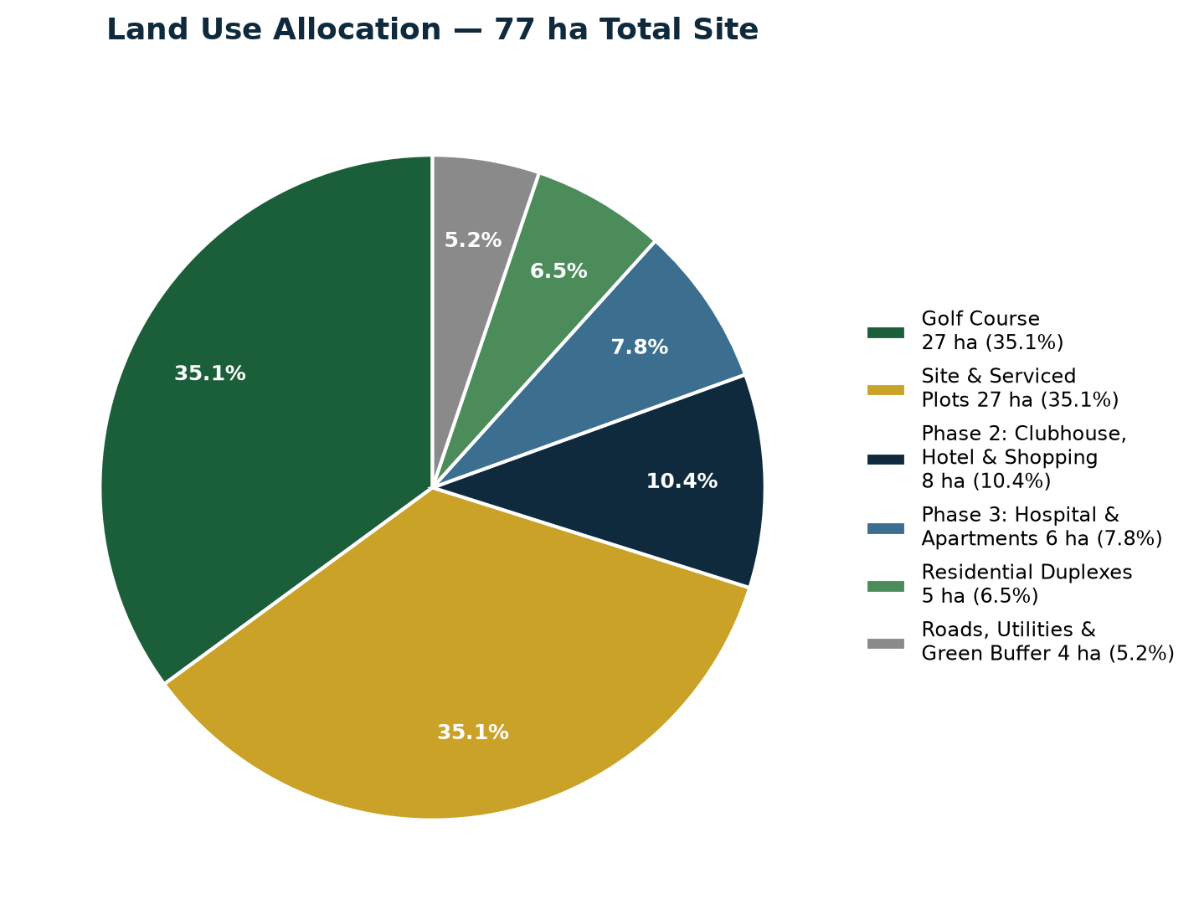
Figure 1 — Illustrative land use split across the 77-hectare site
Land Use | Area (ha)
Golf Course | 27 ha
Site & Serviced Plots (for direct sale) | 27 ha
Phase 2 — Clubhouse, Hotel & Shopping Village | 8 ha
Phase 3 — Hospital & Apartments | 6 ha
Residential Duplexes (100 units) | 5 ha
Roads, Utilities & Green Buffer | 4 ha
Total | 77 ha
Note: the land use split above is an illustrative allocation consistent with the parameters provided; the precise boundaries will be finalized once the topographical survey and architectural masterplan are completed.

4. Master Plan & Project Description

4.1 Golf Course & Clubhouse
The 27-hectare allocation is designed as a full 18-hole golf course, using a compact executive-style layout (shorter par-3/par-4 holes and tighter routing) rather than a full championship-length course, which typically needs 45–60+ hectares. This design approach keeps all 18 holes on-site within the confirmed land parcel, alongside a signature clubhouse, practice range and pro-shop, without compromising playability or the safety buffers required around residential plots.

4.2 Luxury Duplex Residences
Phase 1 residential product is 100 units of 4-bedroom luxury duplexes, each on a 500 sqm plot, including:
- Minimum 2 dedicated car parking spaces per unit
- Private back garden
- Landscaped front lawn
- Direct or near-direct frontage onto the golf course where plot layout allows
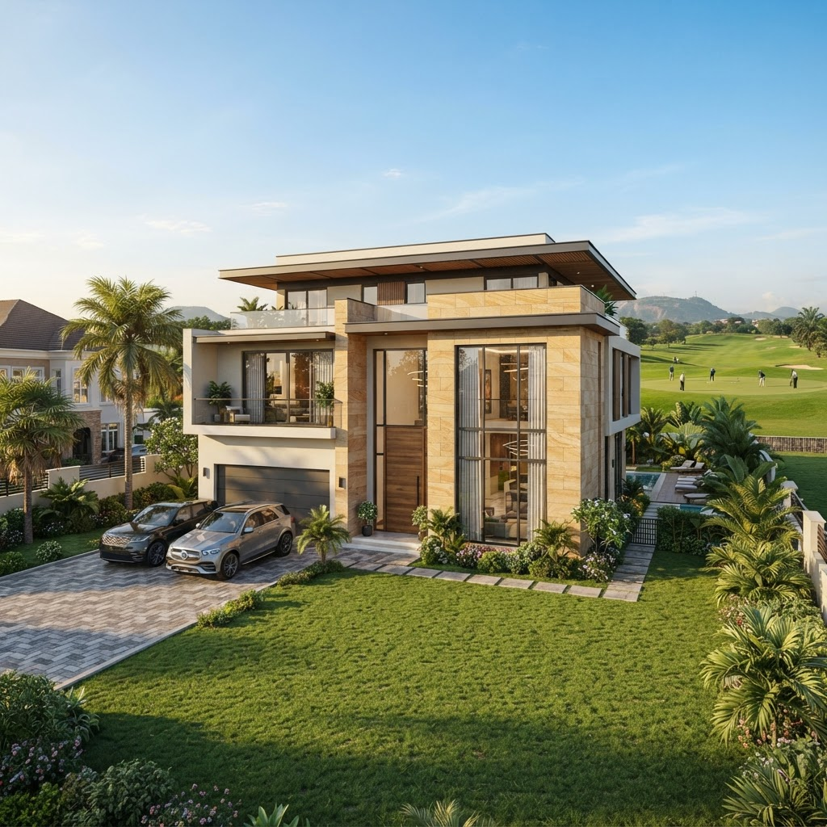
Figure 2 — Conceptual render of a finished 4-bedroom duplex villa (indicative only)

4.3 Phase 2 — Hotel & Shopping Village
A boutique hotel and open-air shopping village provide hospitality and retail amenity for residents, golf visitors and the surrounding catchment, and generate a recurring commercial income stream once operational.

4.4 Phase 3 — Hospital, Apartments & Expansion
A private hospital/wellness facility and additional apartment blocks complete the estate's four-pillar concept, extending the addressable market to healthcare users and smaller-household buyers not served by the Phase 1 duplex product.

5. Development Phasing & Timeline
The project is deliberately phased to reduce upfront capital exposure and let early property and land sales finance later construction — rather than requiring the full development cost upfront.

Phase 1 (Months 0–12)
Golf course construction, clubhouse, site infrastructure (roads, drainage, power, water) and the first tranche of luxury duplexes. Site-and-serviced plots are marketed and sold in parallel to generate early cash flow.

Phase 2 (Months 10–22)
Development of the boutique hotel and shopping village, funded substantially from Phase 1 land sale proceeds and initial duplex handovers.

Phase 3 (Months 20–34)
Hospital/wellness facility, additional apartment blocks and any further expansion, funded from cumulative estate revenue and operating income from Phase 2 hospitality/retail assets.
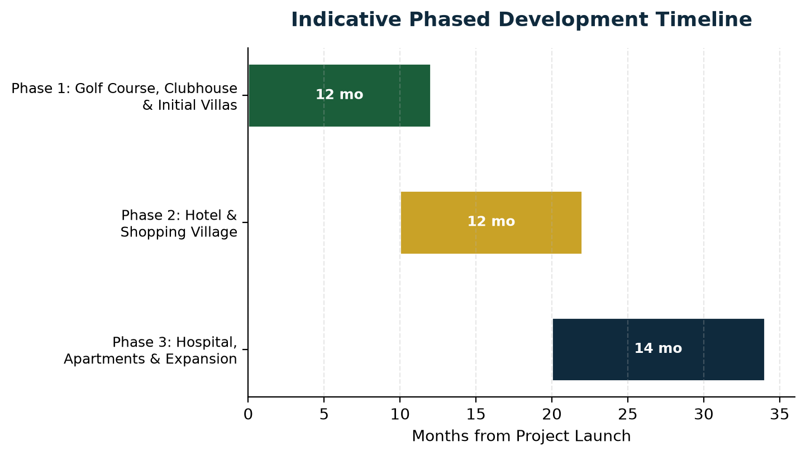
Figure 3 — Indicative phased development timeline (months from project launch)

6. Market Analysis & Target Buyers

6.1 Demand Drivers
- Abuja's persistent housing deficit at the upper end of the market, particularly for large-format, secure, amenity-rich residences.
- Scarcity of genuine golf-anchored residential estates in Nigeria, limiting direct like-for-like competition.
- Growing demand among Nigerian diaspora, senior professionals and business owners for a lifestyle-led, gated community within reach of the capital.
- Bwari's expanding infrastructure and relative land availability compared to the congested FCT core.

6.2 Target Buyer Segments
- High-net-worth individuals and senior executives resident in Abuja seeking a premium, secure, lifestyle-oriented address.
- Nigerian diaspora investors purchasing a home or investment property for eventual return or rental income.
- Land and site-and-service plot investors seeking capital appreciation within a master-planned, amenity-backed estate.
- Golf and leisure enthusiasts drawn to the clubhouse, hotel and recreational offering.
- Corporate and retail tenants for the Phase 2 shopping village, and healthcare users for the Phase 3 hospital.

6.3 Positioning
The estate is positioned above conventional gated-estate competitors in Abuja on the strength of its golf-course anchor and integrated four-pillar (Live/Work/Heal/Relax) concept, rather than competing purely on unit price. This supports premium pricing on both the serviced land parcels and the finished duplex units relative to standard residential-only estates in the same corridor.

7. Financial Plan
The financial plan below is built directly from the parameters supplied for this business case. Figures marked with an asterisk (*) are illustrative estimates included to complete the cost picture and should be firmed up with a full quantity-surveyor costing and site infrastructure design before financial close.

7.1 Cost Structure
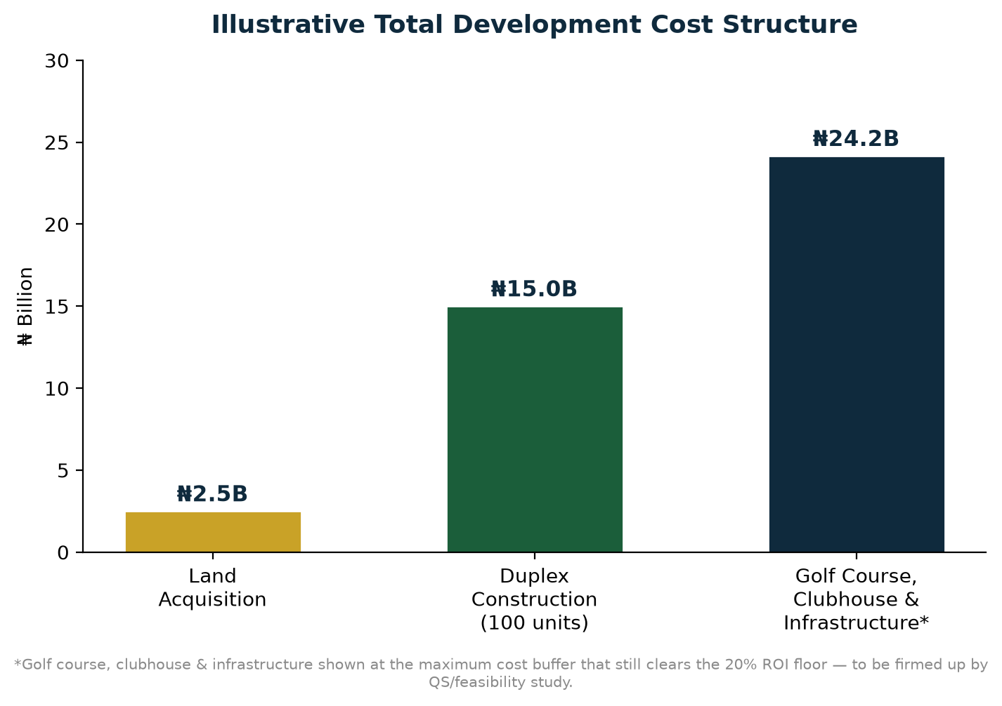
Figure 4 — Illustrative total development cost structure
Cost Item | Amount
Land Acquisition (77 ha) | ₦2.5 billion
Duplex Construction — 100 units × ₦150M (to carcass level) | ₦15 billion
Subtotal — Stated Costs | ₦17.5 billion
Golf Course, Clubhouse, Site Infrastructure & Contingency* | up to ₦24.17 billion
Maximum Total Cost while still clearing the 20% ROI floor | ₦41.67 billion

7.2 Revenue Plan
Revenue Item | Amount
Site & Serviced Land Sales (Phase 1) | ₦50 billion
Duplex Unit Sales (100 units)* | Additional upside — not included in base case
Phase 2 Hotel & Shopping Village Income* | Additional upside — not included in base case
Phase 3 Hospital & Apartments Income* | Additional upside — not included in base case
The ₦50 billion Phase 1 land-sale revenue figure is treated as the base-case, conservative revenue line for this plan. Duplex sales and Phase 2/3 hospitality, retail and healthcare income are real, additional revenue streams but are deliberately excluded from the base-case ROI calculation in Section 8 so that the headline return is not overstated.

8. Profitability Analysis

8.1 Base-Case Return (Stated Costs Only)
Using only the costs explicitly stated in the brief — land acquisition (₦2.5B) and duplex construction (₦15B), total ₦17.5B — against the ₦50B Phase 1 land-sale revenue target:
Metric | Value
Total Stated Cost | ₦17.5 billion
Revenue (Site & Serviced Land Sales) | ₦50 billion
Gross Profit | ₦32.5 billion
Return on Investment | ≈185.7%
Profit Margin (Profit / Revenue) | 65%

8.2 Stress-Tested Return (Maximum Cost Buffer)
To test how much room the project has for costs not itemized in the brief — golf course construction, clubhouse, roads, drainage, power, water, marketing and contingency — the analysis solves for the maximum total cost that still clears the 20% minimum ROI, holding revenue fixed at ₦50B:
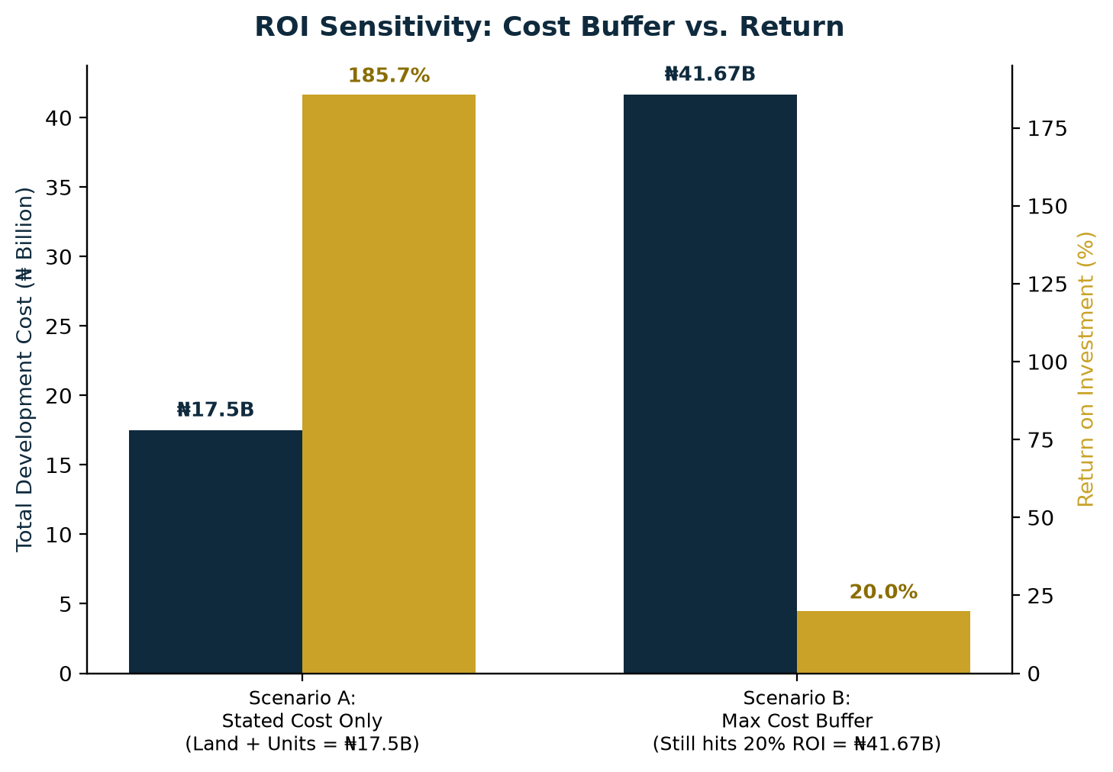
Figure 5 — Total cost vs. ROI: stated-cost scenario vs. maximum cost buffer at the 20% floor
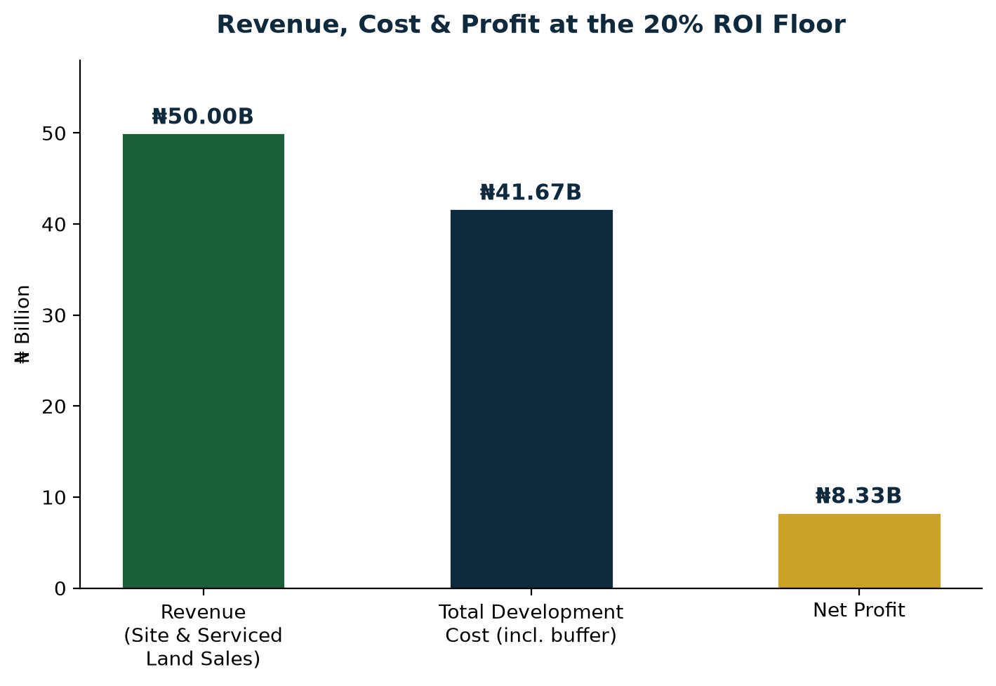
Figure 6 — Revenue, total cost and net profit at the 20% ROI floor
Metric | Value
Revenue (fixed) | ₦50 billion
Maximum Total Cost at 20% ROI floor | ₦41.67 billion
Available Cost Buffer above Stated Costs | ₦24.17 billion
Implied Profit at 20% ROI floor | ₦8.33 billion
In other words, the project can absorb up to ₦24.17 billion in additional, currently unquantified development costs — golf course construction, clubhouse, site infrastructure, marketing and contingency — and still deliver at least the 20% minimum return the sponsor has set, based on Phase 1 land sales alone. Any revenue from duplex sales or Phase 2/3 hospitality, retail and healthcare operations sits entirely on top of this floor as additional upside.

8.3 Payback Period
Given the phased sales strategy — with site-and-serviced plot sales beginning early in Phase 1 (months 0–12) — initial capital recovery on the land-sale revenue stream is expected within approximately 12–18 months of launch, well ahead of the Phase 2 and Phase 3 capital commitments, which are themselves designed to be substantially self-funded from Phase 1 proceeds.

9. Legal, Regulatory & Land Title Framework
A project of this scale in the FCT requires a clean legal and regulatory foundation before any public sales launch. This section sets out the core requirements the business case assumes will be satisfied ahead of Phase 1 groundbreaking.

9.1 Land Title
- Perfection of title over the full 77-hectare parcel (Right of Occupancy / Certificate of Occupancy) in the name of the development entity.
- Independent search and due diligence at the Bwari Area Council and FCT land registry to confirm the site is free of competing claims, encumbrances or overlapping allocations.
- Survey plan registration and beacon verification consistent with FCDA requirements.

9.2 Regulatory Approvals
- FCDA (Federal Capital Development Authority) development approval for the masterplan, including the golf course, residential layout and Phase 2/3 land uses.
- Environmental Impact Assessment (EIA) covering golf course landscaping, water use and drainage, ahead of construction commencement.
- Building plan approvals for the clubhouse, duplex typologies, hotel, shopping village and hospital as each phase reaches design completion.

9.3 Sales & Consumer Protection Compliance
- Structuring of site-and-serviced plot sale agreements and duplex sale/off-plan contracts in line with FCT real estate regulation.
- Escrow or milestone-based payment structures for off-plan buyers to build market confidence and support the phased self-funding model.
These items are treated as pre-conditions to the Phase 1 launch date used in the timeline in Section 5, and should be tracked on a dedicated compliance checklist owned by the project's legal counsel.

10. Marketing & Sales Strategy

10.1 Positioning & Messaging
Marketing leads with the estate's four-pillar identity — Live, Work, Heal, Relax — and its scarcity value as a genuine golf-anchored community in Abuja, rather than competing on price against conventional gated estates.

10.2 Sales Channels
- Direct sales office and show-villa on site, opened as soon as the first duplex reaches finishing stage.
- Diaspora-focused marketing (Nigerians in the UK, US, UAE and elsewhere) for both serviced plots and finished duplexes, leveraging virtual tours and the 3D renders in this business case.
- Licensed real estate agents and property investment platforms operating in the Abuja market.
- Golf industry and lifestyle media partnerships to reinforce the estate's recreational identity ahead of clubhouse completion.

10.3 Pricing & Release Strategy
- Site-and-serviced plots released in tranches rather than all at once, supporting price appreciation across the ₦50 billion Phase 1 land-sale target as early tranches sell out.
- Early-bird pricing for the first tranche of duplex units to build initial momentum and cash flow ahead of full Phase 1 completion.
- Flexible payment plans (deposit plus installments tied to construction milestones) to widen the buyer pool and support the phased self-funding structure described in Section 5.

11. Organizational Structure & Management

11.1 Sponsor
The project is sponsored by BETONIQ WEST LTD, led by Tom Ugbodaga, Shareholder & CEO. Tom holds an MSc in Computer Systems Security from the University of Gloucestershire, England (2011), and brings a technology-and-execution-led management approach to BETONIQ WEST LTD's ventures, of which this estate forms the flagship real estate development.

11.2 Delivery Team
- Project Sponsor / Development Lead — BETONIQ WEST LTD (Tom Ugbodaga, Shareholder & CEO).
- Golf Course Architect — to be engaged for the 18-hole executive-layout design referenced in Section 4.
- Masterplanning & Architectural Consultant — responsible for the residential, hospitality and healthcare typologies across all three phases.
- Quantity Surveyor / Cost Consultant — responsible for firming up the cost buffer identified in Section 8.
- Legal Counsel — responsible for the land title and regulatory workstream in Section 9.
- Sales & Marketing Lead — responsible for executing the strategy in Section 10.
This structure is designed to be built out progressively as the project moves from concept (this business case) into detailed design and Phase 1 execution, rather than requiring a full team from day one.

12. SWOT Analysis
Strengths  - Genuine golf-course anchor — rare in the Abuja market  - Phased, self-funding structure limits upfront capital exposure  - Four-pillar concept (Live/Work/Heal/Relax) broadens the buyer base | Weaknesses  - 27 ha golf course requires a compact executive design, not full championship length  - Several revenue lines (duplex sales, Phase 2/3 income) are not yet priced  - Dependent on land title perfection and FCDA approvals before launch
Opportunities  - Scarcity of comparable golf estates in Nigeria supports premium pricing  - Diaspora demand for lifestyle-led investment property  - Phase 2/3 hospitality, retail and healthcare income as recurring revenue | Threats  - Currency depreciation / construction cost inflation  - Competing land releases in the Bwari corridor  - Delays in infrastructure or regulatory approvals slowing Phase 1 launch

13. Risk Analysis & Mitigation
Risk | Potential Impact | Mitigation
Land title & regulatory | Delays or disputes over title perfection in Bwari could stall launch | Complete title perfection, C-of-O/right-of-occupancy processing and FCDA approvals before public sales launch
Construction cost overrun | Golf course, clubhouse & infrastructure costs exceed the ₦24.17B buffer | Lock in costs via a detailed QS costing and fixed-price contracts before Phase 1 groundbreaking
Sales/off-take risk | Site-and-serviced plots or duplexes sell slower than the 12-month Phase 1 target | Phased release of plots/units rather than a single launch; pre-sales and diaspora marketing ahead of construction completion
Infrastructure & utilities | Off-site power, water or road access delays impact handover timelines | Engage FCT/Bwari authorities early; budget for independent solar/borehole solutions as a fallback
Financing & cash flow | Timing mismatch between land-sale receipts and construction payment schedules | Structure buyer payment plans (deposit + installments tied to construction milestones) to smooth cash flow
Market/macroeconomic | Currency depreciation or inflation raises input costs faster than sales prices adjust | Price a portion of units/plots in USD-indexed terms where legally permissible; review pricing quarterly

14. Exit Strategy & Long-Term Value Creation
The primary value-realization route is direct sale of site-and-serviced plots and finished duplex units to end buyers and investors, as modeled in Sections 7 and 8. Beyond Phase 1, the project has several additional paths to realize or compound value:
- Retained income from Phase 2 hotel and shopping village operations, either operated directly or leased to a hospitality/retail operator for a stabilized income stream.
- Retained or leased income from the Phase 3 hospital/wellness facility, potentially in partnership with a healthcare operator.
- Capital appreciation on any plots or units retained rather than sold, as the estate matures and amenities (golf course, clubhouse, hotel) come online.
- Potential for a partial or full institutional sale of the completed, income-generating hospitality and healthcare assets once stabilized, crystallizing value for the sponsor while the residential land-sale program continues.
Because the residential land-sale program (Section 7–8) is designed to clear the 20% ROI floor on its own, the sponsor retains full flexibility on the timing and structure of any exit from the Phase 2/3 income-producing assets, rather than needing to sell them to meet the project's core return target.

15. Implementation Roadmap & Conclusion

15.1 Roadmap
- Complete topographical survey and land title perfection for the full 77-hectare site.
- Finalize architectural masterplan and golf course design; obtain FCDA/Bwari development approvals.
- Commission detailed QS costing for golf course, clubhouse and site infrastructure to firm up the cost buffer in Section 8.
- Launch site-and-serviced plot pre-sales alongside Phase 1 groundbreaking.
- Commence golf course, clubhouse and first-tranche duplex construction.
- Progress to Phase 2 (hotel & shopping village) and Phase 3 (hospital & apartments) as Phase 1 sales proceeds are realized.

15.2 Conclusion
The 77 Golf & Country Estate combines a scarce, high-demand product — a genuine golf-anchored luxury community in Abuja — with a financing structure designed to minimize upfront capital risk. Based on the parameters in this business case, the project clears its 20% minimum ROI target with a wide margin even after allowing for a substantial, currently unquantified cost buffer, and carries meaningful additional upside from duplex sales and Phase 2/3 hospitality, retail and healthcare revenue not counted in the base case. Subject to title perfection, detailed costing and phased pre-sales execution, this is a strong candidate for the next stage of due diligence and capital raising.

Appendix: Key Assumptions & Notes
- Unit count of 100 luxury duplexes is derived from ₦15B total construction cost ÷ ₦150M per unit (to carcass level), as stated in the brief.
- Land use allocation (Section 3) is an illustrative split consistent with the stated parameters; it is not yet based on a surveyed site plan.
- The golf course is designed as a full 18-hole course fitted onto the confirmed 27 hectares using a compact, executive-style routing (shorter holes, tighter layout) rather than a full championship-length course, which would typically require 45–60+ ha. This keeps the 18-hole feature the user requires while remaining honest about the land-area trade-off; final hole-by-hole routing should be confirmed by a golf course architect.
- The ₦24.17B cost buffer (golf course, clubhouse, infrastructure, marketing, contingency) is a derived ceiling — the maximum spend that still clears the 20% ROI floor on ₦50B revenue — not a bottom-up cost estimate. A full QS costing is recommended before relying on this number for financing decisions.
- Duplex sale prices and Phase 2/3 (hotel, shopping village, hospital, apartments) revenue were not specified in the brief and are therefore excluded from the base-case ROI in Section 8, and should be added once pricing is defined.
- All renders in this document (Figures 1–6 and the cover/villa images) are AI-generated conceptual illustrations for presentation purposes only and do not represent an approved architectural design.
- All monetary figures are in Nigerian Naira (₦) unless otherwise stated.
Prepared by Agent 777 for BETONIQ WEST LTD — Strictly Private & Confidential.

