BUSINESS PLAN & INVESTMENT CASE
THE 77 GOLF & COUNTRY ESTATE
CORRECTED VERSION — Sep 13, 2026: This revision fixes a material land-use gap in the original draft. The FCDA requires a minimum 25% of gross site area (19 ha of this 77 ha site) reserved for statutory infrastructure (roads, drainage, utilities, public open space) before layout approval — the original draft only allocated 8 ha to this. Correcting it shrinks the Golf Estate Residential zone from 22 ha to 11 ha, cuts the modeled serviced-plot count from 500 to 120, and for the first time brings duplex unit sales into the base-case revenue line (previously excluded) to keep the project viable. Revised Phase 1 base-case revenue: ₦40 billion (was ₦50 billion). Revised ROI: ≈128.6% (was ≈186%). See Section 3 and Section 9–10 for full detail.
Bwari, Abuja — Federal Capital Territory, Nigeria
“Live on the Greens, Work in Comfort, Heal in Serenity and Relax in Luxury.”

Conceptual illustration — final masterplan subject to architectural & survey approval

Prepared for: BETONIQ WEST LTD
Founder & Executive Vice Chairman: Air Vice Marshal Monday Riku Morgan (Rtd) | Managing Director (this project): Tom Ugbodaga
September 2026 | Strictly Private & Confidential

Table of Contents
1. Executive Summary
2. Vision, Concept & Design Philosophy
3. Location & Site Overview
4. Master Plan & Project Description
5. World-Class Amenities, Security & Infrastructure
6. International & Local Investor Proposition
7. Development Phasing & Timeline
8. Market Analysis & Target Buyers
9. Financial Plan
10. Profitability Analysis
11. Legal, Regulatory & Land Title Framework
12. Marketing & Sales Strategy
13. Organizational Structure & Management
14. SWOT Analysis
15. Risk Analysis & Mitigation
16. Exit Strategy & Long-Term Value Creation
17. Implementation Roadmap & Conclusion
Appendix: Key Assumptions & Notes

1. Executive Summary
The 77 Golf & Country Estate is a proposed mixed-use luxury development on 77 hectares of land in Bwari Area Council, Abuja, Federal Capital Territory. The project combines a golf-anchored residential community with phased hospitality, retail and healthcare facilities, positioning it as a landmark destination in the FCT for luxury living, leisure and commerce.
The development is structured as a phased, self-funding model: early revenue from the sale of site-and-serviced land parcels is used to finance the golf course, clubhouse, and subsequent phases, reducing upfront capital exposure and reliance on external financing before the project demonstrates market traction.

Key Highlights
Metric | Value
Total Land Area | 77 hectares
Location | Bwari, Abuja, FCT, Nigeria
Golf Course | 27 hectares — 18-hole, with lakes, fairways & greens
Luxury Duplex Units (Phase 1) | 100 units — 4-bedroom, 500 sqm plots, each with a 2-bedroom self-contained BQ
Land Acquisition Cost | ₦2.5 billion
Total Duplex Construction Cost | ₦15 billion (₦150M/unit to carcass level)
Projected Phase 1 Revenue (Plot + Duplex Sales) | ₦40 billion
Minimum Target ROI | 20%
Projected ROI (stated-cost basis) | ≈128.6%
Founder & Executive Vice Chairman | Air Vice Marshal Monday Riku Morgan (Rtd), BETONIQ WEST LTD
Managing Director (this project) | Tom Ugbodaga

Even under a conservative scenario that allocates the maximum possible buffer toward golf course construction, clubhouse, site infrastructure and contingency, the project comfortably clears the 20% minimum return threshold on Phase 1 land sales alone — before counting additional upside from duplex sales, hospitality and healthcare revenue introduced in later phases (see Section 10, Profitability Analysis).

2. Vision, Concept & Design Philosophy
Golf Country Estate is envisioned as a world-class destination where luxury living, recreation, healthcare, hospitality and commerce converge — a single integrated community rather than a conventional housing estate.
“Live on the Greens, Work in Comfort, Heal in Serenity and Relax in Luxury.”

Four Pillars of the Estate
- Live — Luxury 4-bedroom duplex residences directly fronting the golf course, offering privacy, security and premium finishes.
- Work — Commercial and retail space within the shopping village, supporting on-site business and convenience for residents.
- Heal — A Phase 3 hospital and wellness facility, giving residents and the surrounding community access to premium healthcare.
- Relax — The golf course, clubhouse and hotel anchor a lifestyle of leisure, hospitality and recreation.
This four-pillar structure is the organizing logic for the entire masterplan and phasing strategy that follows, and gives the estate a distinct identity beyond a standard gated residential development.

3. Location & Site Overview
The estate is sited in Bwari Area Council, on the northern edge of the Federal Capital Territory. Bwari has become one of Abuja's fastest-growing residential corridors, benefiting from proximity to the city centre, more readily available large contiguous land parcels than the FCT core, and an expanding network of arterial roads connecting it to the rest of Abuja. This combination of accessibility and land availability makes it a natural location for a large-format, golf-anchored estate of this scale.
The full 77-hectare site is allocated across residential, recreational, commercial, healthcare, education and infrastructure uses as summarized below and illustrated in Figure 1. This allocation has been cross-checked against an independent conceptual spatial layout and matches it closely, with the golf course, hotel and shopping village areas confirmed at identical hectare figures.

Figure 1: Land Use Allocation
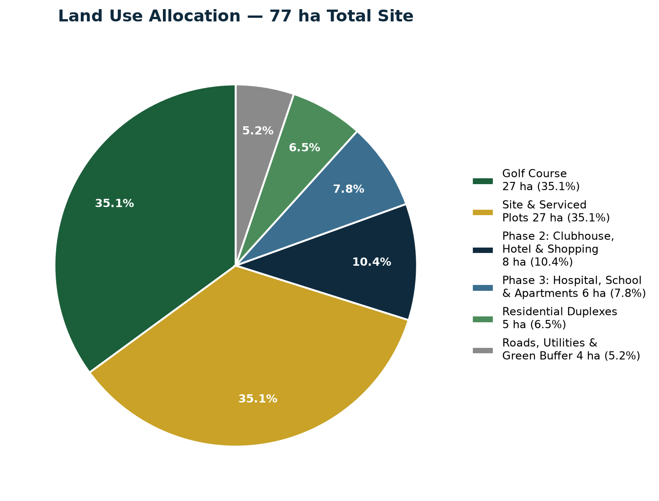
Figure 1 — Illustrative land use split across the 77-hectare site
Land Use | Area (ha)
18-Hole Golf Course (Lakes, Fairways & Greens) | 27 ha
Golf Estate Residential (100 duplexes + serviced plots) | 11 ha
Clubhouse, Sports & Golf Academy | 6 ha
Hotel & Resort | 4 ha
Shopping & Lifestyle Village | 4 ha
Hospital & Wellness | 3 ha
International School | 3 ha
Statutory Infrastructure Reserve (FCDA min. 25% — roads, drainage, utilities, main gate, security & public open space) | 19 ha
Total | 77 ha
Note: the golf course, hotel and shopping village figures match Tom's independently produced conceptual spatial layout exactly (27 ha / 4 ha / 4 ha). The golf estate residential zone is corrected from Tom's original 22 ha to 11 ha to make room for a proper 19-hectare Statutory Infrastructure Reserve (25% of the 77-hectare site), which the FCDA requires as a condition of layout approval and which the original layout under-allocated (only 8 ha was set aside for roads and gatehouse/security). The clubhouse & sports, hospital and international school figures are reasonable planning allocations for the remaining land and should be confirmed once the topographical survey and architectural masterplan are completed.

4. Master Plan & Project Description

4.1 Golf Course & Clubhouse
The 27-hectare allocation is a full 18-hole golf course featuring lakes, fairways and greens, confirmed against Tom’s own conceptual spatial layout. Fitting all 18 holes into 27 hectares is achieved through a resort-style routing — shorter fairway lengths and strategic use of the lakes as water hazards — rather than a full long-championship layout, which would typically require 45–60+ ha. The adjoining 6-hectare zone houses the clubhouse, sports facilities and a golf academy (practice range, teaching pro, pro-shop), kept as a distinct precinct from the fairways themselves.

4.2 Luxury Duplex Residences
The Golf Estate Residential zone was originally conceived at 22 hectares, but is corrected in this version to 11 hectares once the FCDA's mandatory statutory infrastructure reserve (a minimum 25% of the full 77-hectare site — roads, drainage, utilities, public open space — Section 3) is properly accounted for. This 11-hectare zone houses the Phase 1 duplex product together with additional site-and-serviced plots released for direct sale (Section 12). Phase 1 residential product itself is 100 units of 4-bedroom luxury duplexes, each on a 500 sqm plot, including:
- Minimum 2 dedicated car parking spaces per unit
- A 2-bedroom, fully self-contained servant quarters (BQ) per duplex, with its own kitchenette, bathroom and private entrance, separate from the main house
- Private back garden
- Landscaped front lawn
- Direct or near-direct frontage onto the golf course where plot layout allows
Fitting a 2-bedroom self-contained BQ onto the same 500 sqm plot as the main 4-bedroom duplex is achievable with careful massing (a compact single-storey BQ block to the rear or side of the plot), but it will meaningfully reduce garden/lawn area versus a BQ-free layout. This trade-off should be confirmed with the architect at detailed design stage; if more generous outdoor space is required, the plot size may need to increase beyond 500 sqm for some or all units.
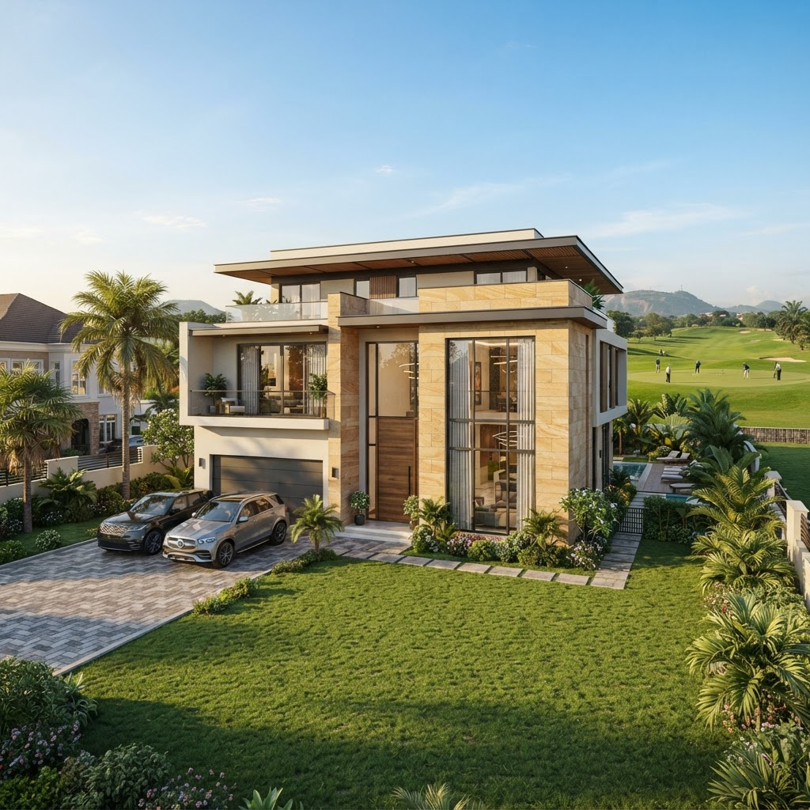
Figure 2 — Conceptual render of a finished 4-bedroom duplex villa (indicative only)

4.3 Phase 2 — Hotel & Shopping Village
A boutique hotel and open-air shopping village provide hospitality and retail amenity for residents, golf visitors and the surrounding catchment, and generate a recurring commercial income stream once operational.

4.4 Phase 3 — Hospital, School & Expansion
A 3-hectare private hospital/wellness facility and a 3-hectare international-standard school complete the estate's four-pillar concept, extending the addressable market to healthcare users and families with school-age children who would not otherwise be served by the Phase 1 duplex product alone. Together with the golf course, clubhouse, hotel and shopping village, this gives the estate the full amenity set expected of a world-class luxury community rather than a purely residential development.

5. World-Class Amenities, Security & Infrastructure
To compete for both international and local capital, the estate is designed to match the amenity and security standard of benchmark luxury golf estates globally, not just the local Abuja market.

5.1 Perimeter Security & Access Control
- Full perimeter wall and fencing around the entire 77-hectare site, with anti-climb detailing and CCTV coverage.
- A landmark, architecturally distinctive gatehouse at the main entrance, manned 24/7, with visitor registration, vehicle screening and a dedicated staff/service entrance separate from the resident/visitor gate.
- Estate-wide security patrols, perimeter lighting and a central security control room linked to the clubhouse, hotel and residential zones.
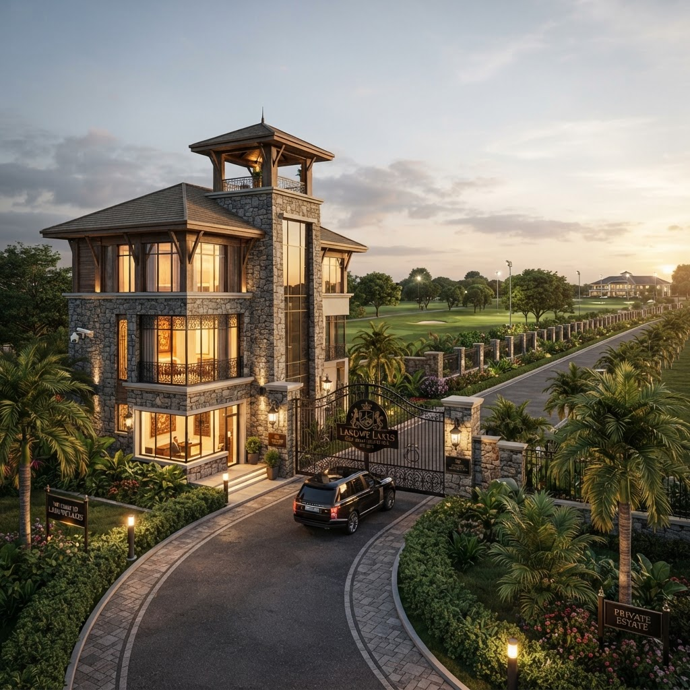
Figure 7 — Conceptual render of the estate's gatehouse and main entrance (indicative only)

5.2 Parking & Vertical Infrastructure
- Basement car parking beneath the clubhouse, hotel and shopping village, reducing surface parking footprint and preserving landscaped and recreational areas at ground level.
- Each duplex retains a minimum of 2 dedicated surface parking spaces as specified in Section 4.2, in addition to estate-wide visitor parking near the gatehouse and clubhouse.

5.3 Full Lifestyle & Community Amenity Set
- Golf course, clubhouse, practice range and pro-shop (Phase 1).
- Boutique hotel and open-air shopping village (Phase 2).
- Private hospital/wellness facility and an international-standard school (Phase 3), so residents' healthcare and education needs are met within the estate.
- Swimming pool, gymnasium/spa, sports courts, children's play areas, jogging and cycling trails, and an event/banquet centre for weddings and functions.
- Estate-wide landscaping, green buffers and a dedicated facilities-management team for ongoing maintenance, security and utilities once phases are handed over.
This full amenity set is what elevates the project from a residential estate with a golf course attached, to a genuine self-contained, world-class luxury destination — the positioning basis for the investor proposition in Section 6.

6. International & Local Investor Proposition
The estate is being brought to market to attract both international and local capital, and the proposition is deliberately built to appeal to both audiences at once rather than treating them as separate products.

6.1 For International Investors & Diaspora
- A globally-benchmarked lifestyle asset in Nigeria's capital region — golf course, hotel, international school and hospital — comparable in amenity standard to golf estates diaspora investors already know from the UK, US, UAE and South Africa.
- A tangible, income-generating real asset (land, villas, hospitality and retail income) as a diversification option outside of equities and venture-style risk.
- Full self-contained security and infrastructure (Section 5) addressing the safety and reliability concerns that are typically the biggest hesitation for diaspora and foreign buyers investing in Nigerian real estate.

6.2 For Local Investors & High-Net-Worth Nigerians
- A rare, credible golf-anchored address in the FCT, at a stage (pre-construction/early Phase 1) where site-and-serviced land and early duplex releases are priced ahead of the value uplift that comes once the golf course, clubhouse and hotel are visibly under construction.
- A four-pillar community (Live/Work/Heal/Relax) that reduces dependence on off-estate infrastructure for healthcare, schooling, retail and hospitality — a strong differentiator versus purely residential estates in the same corridor.

6.3 Structuring the Ask
- Direct plot and duplex sales (Section 9) remain the primary entry point for both audiences.
- A structured investment/partnership route (equity or profit-share in the Phase 2/3 income-producing assets — hotel, shopping village, hospital, school) can be offered to institutional or larger-ticket international and local investors who want exposure to the estate's recurring income rather than a single unit or plot.
This dual-track approach lets the project raise capital broadly across retail buyers (plots/duplexes) and larger investors (Phase 2/3 income assets) without relying on any single investor class to reach the ₦40 billion Phase 1 revenue target in Section 9.

7. Development Phasing & Timeline
The project is deliberately phased to reduce upfront capital exposure and let early property and land sales finance later construction — rather than requiring the full development cost upfront.

Phase 1 (Months 0–12)
Golf course construction, clubhouse, site infrastructure (roads, drainage, power, water) and the first tranche of luxury duplexes. Site-and-serviced plots are marketed and sold in parallel to generate early cash flow.

Phase 2 (Months 10–22)
Development of the boutique hotel and shopping village, funded substantially from Phase 1 land sale proceeds and initial duplex handovers.

Phase 3 (Months 20–34)
Hospital/wellness facility, additional apartment blocks and any further expansion, funded from cumulative estate revenue and operating income from Phase 2 hospitality/retail assets.
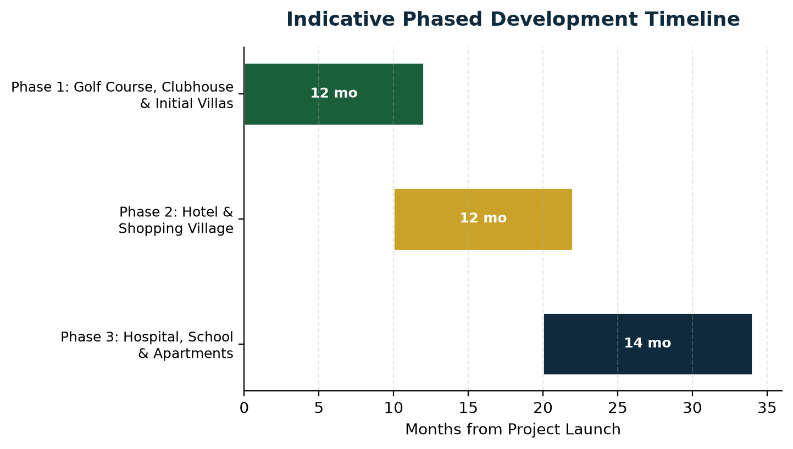
Figure 3 — Indicative phased development timeline (months from project launch)

8. Market Analysis & Target Buyers

6.1 Demand Drivers
- Abuja's persistent housing deficit at the upper end of the market, particularly for large-format, secure, amenity-rich residences.
- Scarcity of genuine golf-anchored residential estates in Nigeria, limiting direct like-for-like competition.
- Growing demand among Nigerian diaspora, senior professionals and business owners for a lifestyle-led, gated community within reach of the capital.
- Bwari's expanding infrastructure and relative land availability compared to the congested FCT core.

6.2 Target Buyer Segments
- High-net-worth individuals and senior executives resident in Abuja seeking a premium, secure, lifestyle-oriented address.
- Nigerian diaspora investors purchasing a home or investment property for eventual return or rental income.
- Land and site-and-service plot investors seeking capital appreciation within a master-planned, amenity-backed estate.
- Golf and leisure enthusiasts drawn to the clubhouse, hotel and recreational offering.
- Corporate and retail tenants for the Phase 2 shopping village, and healthcare/education users for the Phase 3 hospital and international school.

6.3 Positioning
The estate is positioned above conventional gated-estate competitors in Abuja on the strength of its golf-course anchor and integrated four-pillar (Live/Work/Heal/Relax) concept, rather than competing purely on unit price. This supports premium pricing on both the serviced land parcels and the finished duplex units relative to standard residential-only estates in the same corridor.

9. Financial Plan
The financial plan below is built directly from the parameters supplied for this business case. Figures marked with an asterisk (*) are illustrative estimates included to complete the cost picture and should be firmed up with a full quantity-surveyor costing and site infrastructure design before financial close.

9.1 Cost Structure
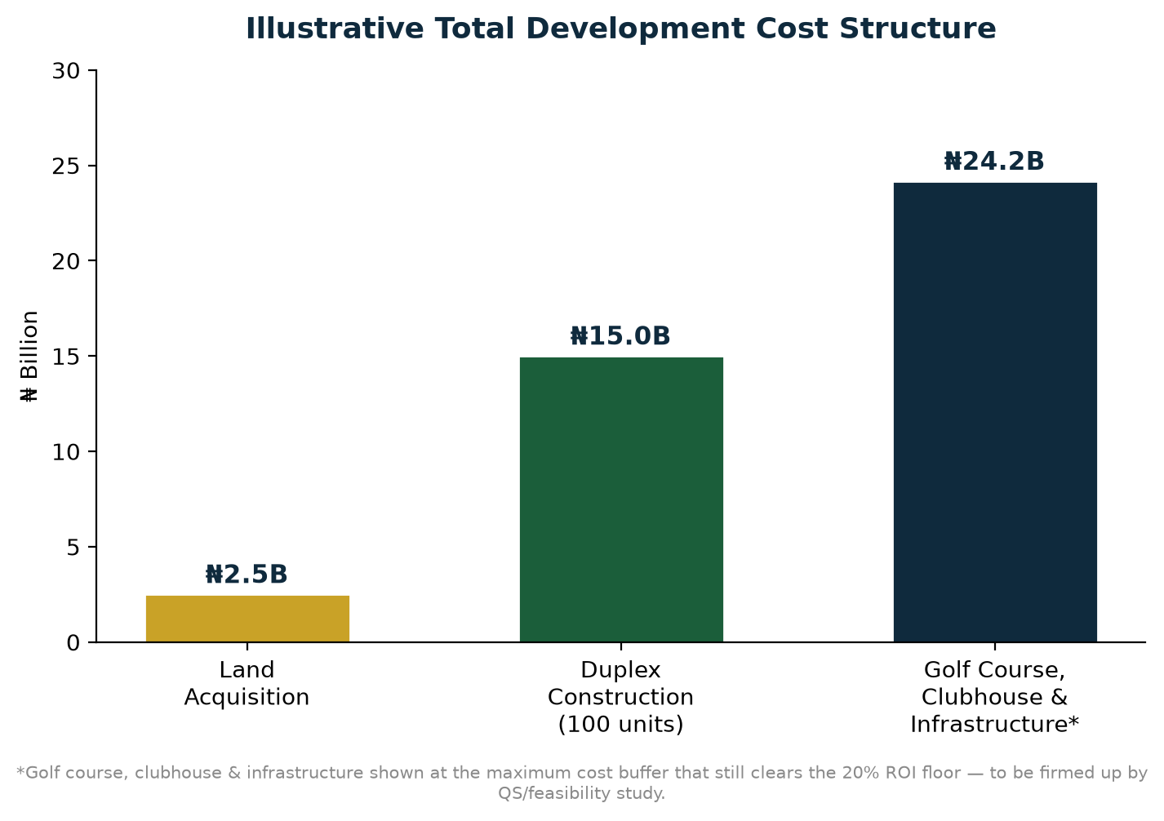
Figure 4 — Illustrative total development cost structure
Cost Item | Amount
Land Acquisition (77 ha) | ₦2.5 billion
Duplex Construction — 100 units × ₦150M (to carcass level) | ₦15 billion
Subtotal — Stated Costs | ₦17.5 billion
Golf Course, Clubhouse, Site Infrastructure & Contingency* | up to ₦15.83 billion
Maximum Total Cost while still clearing the 20% ROI floor | ₦33.33 billion

9.2 Revenue Plan
Revenue Item | Amount
Site & Serviced Land Sales — 120 plots × ₦100M (Phase 1, corrected for FCDA-compliant 11 ha residential zone) | ₦12 billion
Duplex Unit Sales — 100 units × ₦280M illustrative* (now included in base case, see note below) | ₦28 billion
Total Phase 1 Base-Case Revenue | ₦40 billion
Phase 2 Hotel & Shopping Village Income* | Additional upside — not included in base case
Phase 3 Hospital, School & Apartments Income* | Additional upside — not included in base case
The ₦40 billion Phase 1 revenue figure (₦12 billion from 120 serviced plots + ₦28 billion from 100 duplex unit sales) is the base-case revenue line for this plan. Duplex sales are now included in the base case for the first time in this corrected version, because the FCDA-compliant 25% statutory infrastructure reserve cuts the net residential land available for plot sales from 500 plots to 120 — plot sales alone are no longer sufficient to cover stated costs, so duplex sale revenue (previously held back as pure additional upside) is now needed to make the base case work, and is priced conservatively (Section 9.2 note). Phase 2/3 hospitality, retail and healthcare income remain real, additional revenue streams but stay excluded from the base-case ROI calculation in Section 10 so the headline return is not overstated.

10. Profitability Analysis

10.1 Base-Case Return (Stated Costs Only)
Using only the costs explicitly stated in the brief — land acquisition (₦2.5B) and duplex construction (₦15B), total ₦17.5B — against the ₦40B Phase 1 revenue target (120 plots × ₦100M per 500 sqm plot + 100 duplexes × ₦280M illustrative, Section 9.2):
Metric | Value
Total Stated Cost | ₦17.5 billion
Revenue (Plot + Duplex Sales) | ₦40 billion
Gross Profit | ₦22.5 billion
Return on Investment | ≈128.6%
Profit Margin (Profit / Revenue) | 56.3%

10.2 Stress-Tested Return (Maximum Cost Buffer)
To test how much room the project has for costs not itemized in the brief — golf course construction, clubhouse, roads, drainage, power, water, marketing and contingency — the analysis solves for the maximum total cost that still clears the 20% minimum ROI, holding revenue fixed at ₦40B:
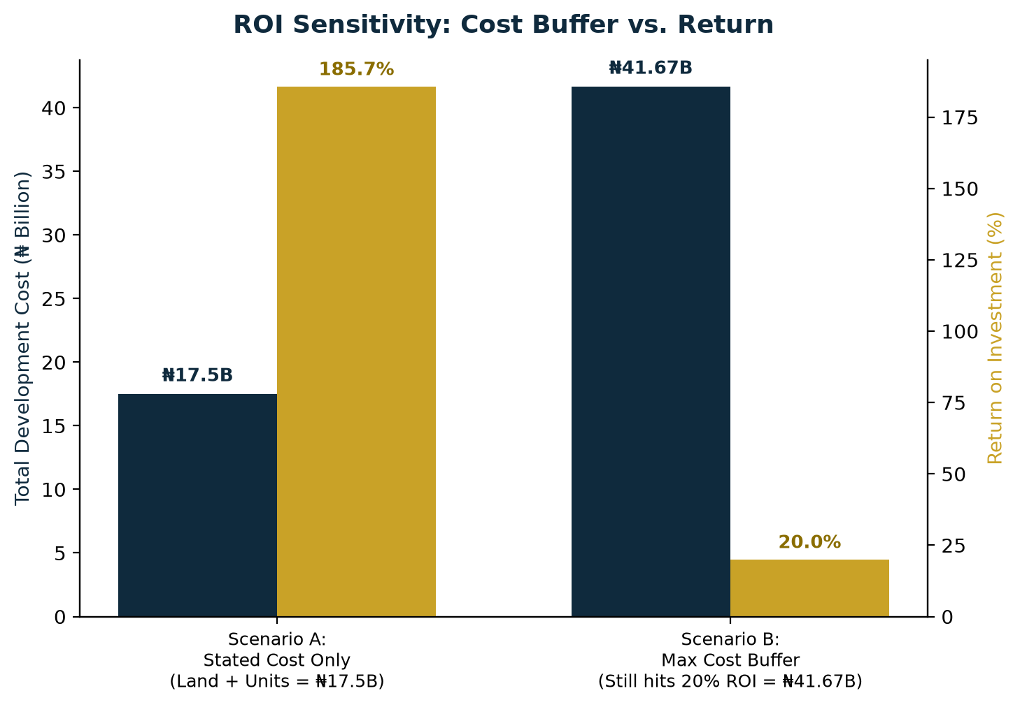
Figure 5 — Total cost vs. ROI: stated-cost scenario vs. maximum cost buffer at the 20% floor
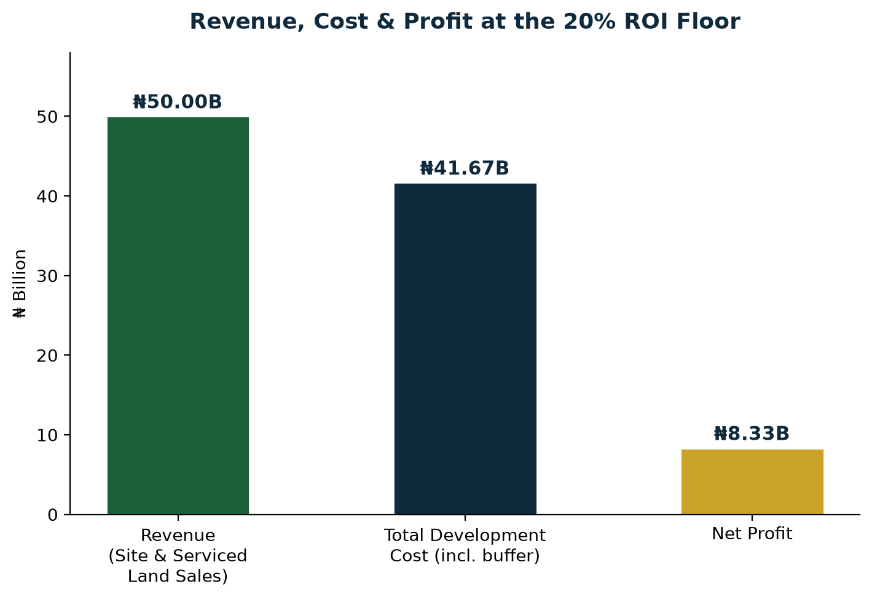
Figure 6 — Revenue, total cost and net profit at the 20% ROI floor
Metric | Value
Revenue (fixed) | ₦40 billion
Maximum Total Cost at 20% ROI floor | ₦33.33 billion
Available Cost Buffer above Stated Costs | ₦15.83 billion
Implied Profit at 20% ROI floor | ₦6.67 billion
In other words, the project can absorb up to ₦15.83 billion in additional, currently unquantified development costs — golf course construction, clubhouse, site infrastructure (beyond the statutory 25% reserve already carved out in Section 3), marketing and contingency — and still deliver at least the 20% minimum return the sponsor has set, based on Phase 1 plot and duplex sales. Any revenue from Phase 2/3 hospitality, retail and healthcare operations sits entirely on top of this floor as additional upside.

10.3 Payback Period
Given the phased sales strategy — with site-and-serviced plot sales beginning early in Phase 1 (months 0–12) — initial capital recovery on the land-sale revenue stream is expected within approximately 12–18 months of launch, well ahead of the Phase 2 and Phase 3 capital commitments, which are themselves designed to be substantially self-funded from Phase 1 proceeds.

10.4 Combined Sensitivity: Cost Overrun × Revenue Shortfall
Sections 10.1–10.2 stress-test cost and revenue one variable at a time. To make the viability case robust to scrutiny, the matrix below tests both simultaneously — what happens if costs run over the stated budget AND Phase 1 revenue falls short of the ₦40B target at the same time. Green cells clear the 20% ROI floor; amber cells are still profitable but below the floor; red cells are loss-making.
Revenue Achieved vs. Total Cost | Stated Cost ₦17.5B | +50% Cost ₦26.25B | 20% ROI Floor ₦33.33B | +100% Cost ₦35B
Revenue 100% (₦40B) | +128.6% PASS | +52.4% PASS | +20.0% PASS | +14.3% MARGINAL
Revenue 90% (₦36B) | +105.7% PASS | +37.1% PASS | +8.0% MARGINAL | +2.9% MARGINAL
Revenue 80% (₦32B) | +82.9% PASS | +21.9% PASS | -4.0% LOSS | -8.6% LOSS
Revenue 70% (₦28B) | +60.0% PASS | +6.7% MARGINAL | -16.0% LOSS | -20.0% LOSS
Revenue 60% (₦24B) | +37.1% PASS | -8.6% LOSS | -28.0% LOSS | -31.4% LOSS
Figure 6b — ROI outcome by combined cost-overrun and revenue-shortfall scenario
Reading the matrix: with only stated costs (₦17.5B), the project clears the 20% floor even if revenue falls all the way to ₦30B (60% of target) — a wide margin of safety. The floor is only breached when BOTH shocks compound: cost overruns of 50%+ combined with revenue shortfalls of 30%+ simultaneously. The precise combined break-even point (ROI = 0%, i.e. the project stops losing money but also stops profiting) sits at Revenue ≈ Total Cost — for example ₦35B revenue against ₦35B cost (a 100% cost overrun exactly matched by a 30% revenue shortfall).

10.5 Market Benchmark Cross-Check
The confirmed ₦100,000,000 price for a 500 sqm site-and-serviced plot (₦200,000/sqm, Section 9.2) is the basis for the ₦12 billion plot-sale component of the ₦40 billion Phase 1 revenue target: 120 such plots sold within the corrected, FCDA-compliant 11-hectare residential zone, after the mandatory 25% statutory infrastructure reserve (Section 3) and the 100 duplexes' own 5-hectare footprint are both accounted for. The illustrative ₦280,000,000 duplex sale price (Section 9.2 note) is built up as ₦100M land-value basis + ₦150M carcass-construction cost + a conservative ₦30M (12%) developer margin — comfortably above the ₦150M duplex carcass-construction cost alone, as expected, since a fully-built structure should price well above raw serviced land on the same footprint.
Against the broader FCT land market, raw/unserviced land in peri-urban corridors like Bwari typically trades far below this (roughly ₦20,000–₦80,000/sqm), while prime central districts (Maitama, Asokoro, Wuse 2) trade well above it (₦300,000–₦600,000+/sqm). The ₦200,000/sqm assumption sits comfortably within the premium, amenity-anchored estate band — well below prime-district pricing, yet a credible premium over raw peri-urban land, consistent with golf course, hospital, school, hotel and full security driving the pricing rather than location alone. This is the core commercial logic behind the pricing, and it is a more conservative figure than initial estimates suggested, but it should still be confirmed against actual Bwari-corridor comparables by a licensed valuer before the plots are priced and released.

10.6 Structural Safeguards Behind the Viability Case
- The realistic base case, even allowing for a 50% cost overrun (≈52%–129% ROI, first two columns of the matrix above), sits above the 20% survival floor — the floor is a stress-test boundary, not the expected outcome, though the margin of safety is narrower than in the pre-correction model given the reduced plot count.
- Phased, tranche-based land release (Section 12.3) means capital is not all at risk at once: early tranches fund later construction, so a slow sales start can be managed by pacing spend rather than committing the full cost buffer up front.
- Duplex sales and Phase 2/3 hotel, retail, hospital and school income are real revenue streams held back entirely from the base case — they exist purely as additional margin of safety on top of every scenario modeled above.
- The land-sale revenue stream is realized within 12–18 months (Section 10.3), well before major Phase 2/3 capital is committed, limiting the window in which a combined cost/revenue shock could actually occur.
Taken together — a wide realistic-case margin, phased capital exposure, uncounted upside streams, and an early revenue-recovery window — the project's viability is not dependent on any single favorable assumption holding true. It is designed to remain investable across a wide range of adverse outcomes, with the specific combined-shock threshold in Section 10.4 given transparently rather than glossed over.

11. Legal, Regulatory & Land Title Framework
A project of this scale in the FCT requires a clean legal and regulatory foundation before any public sales launch. This section sets out the core requirements the business case assumes will be satisfied ahead of Phase 1 groundbreaking.

11.1 Land Title
- Perfection of title over the full 77-hectare parcel (Right of Occupancy / Certificate of Occupancy) in the name of the development entity.
- Independent search and due diligence at the Bwari Area Council and FCT land registry to confirm the site is free of competing claims, encumbrances or overlapping allocations.
- Survey plan registration and beacon verification consistent with FCDA requirements.

11.2 Regulatory Approvals
- FCDA (Federal Capital Development Authority) development approval for the masterplan, including the golf course, residential layout and Phase 2/3 land uses.
- Environmental Impact Assessment (EIA) covering golf course landscaping, water use and drainage, ahead of construction commencement.
- Building plan approvals for the clubhouse, duplex typologies, hotel, shopping village and hospital as each phase reaches design completion.

11.3 Sales & Consumer Protection Compliance
- Structuring of site-and-serviced plot sale agreements and duplex sale/off-plan contracts in line with FCT real estate regulation.
- Escrow or milestone-based payment structures for off-plan buyers to build market confidence and support the phased self-funding model.
These items are treated as pre-conditions to the Phase 1 launch date used in the timeline in Section 7, and should be tracked on a dedicated compliance checklist owned by the project's legal counsel.

12. Marketing & Sales Strategy

12.1 Positioning & Messaging
Marketing leads with the estate's four-pillar identity — Live, Work, Heal, Relax — and its scarcity value as a genuine golf-anchored community in Abuja, rather than competing on price against conventional gated estates.

12.2 Sales Channels
- Direct sales office and show-villa on site, opened as soon as the first duplex reaches finishing stage.
- Diaspora-focused marketing (Nigerians in the UK, US, UAE and elsewhere) for both serviced plots and finished duplexes, leveraging virtual tours and the 3D renders in this business case.
- Licensed real estate agents and property investment platforms operating in the Abuja market.
- Golf industry and lifestyle media partnerships to reinforce the estate's recreational identity ahead of clubhouse completion.

12.3 Pricing & Release Strategy
- Site-and-serviced plots released in tranches rather than all at once, supporting price appreciation across the ₦40 billion Phase 1 target (plots + duplexes) as early tranches sell out.
- Early-bird pricing for the first tranche of duplex units to build initial momentum and cash flow ahead of full Phase 1 completion.
- Flexible payment plans (deposit plus installments tied to construction milestones) to widen the buyer pool and support the phased self-funding structure described in Section 7.

13. Organizational Structure & Management

13.1 Founder & Executive Vice Chairman
Air Vice Marshal Monday Riku Morgan (Rtd) is the Founder and Executive Vice Chairman of BETONIQ WEST LTD. His military and institutional pedigree provides board-level authority and credibility for the estate's investor and partnership engagements.

13.2 Managing Director (This Project)
Tom Ugbodaga serves as Managing Director (MD) for this project, overseeing day-to-day execution, investor engagement and delivery on behalf of BETONIQ WEST LTD. Tom holds an MSc in Computer Systems Security from the University of Gloucestershire, England (2011), and brings a technology-and-execution-led management approach to BETONIQ WEST LTD's ventures, of which this estate forms the flagship real estate development.

13.3 Delivery Team
- Founder & Executive Vice Chairman, BETONIQ WEST LTD — Air Vice Marshal Monday Riku Morgan (Rtd).
- Managing Director (this project) — Tom Ugbodaga.
- Golf Course Architect — to be engaged for the 18-hole, lakes-and-fairways layout referenced in Section 4.
- Masterplanning & Architectural Consultant — responsible for the residential, hospitality and healthcare typologies across all three phases.
- Quantity Surveyor / Cost Consultant — responsible for firming up the cost buffer identified in Section 10.
- Legal Counsel — responsible for the land title and regulatory workstream in Section 11.
- Sales & Marketing Lead — responsible for executing the strategy in Section 12.
This structure is designed to be built out progressively as the project moves from concept (this business case) into detailed design and Phase 1 execution, rather than requiring a full team from day one.

14. SWOT Analysis
Strengths  Genuine golf-course anchor — rare in the Abuja market  Phased, self-funding structure limits upfront capital exposure  Four-pillar concept (Live/Work/Heal/Relax) broadens the buyer base  ₦40B Phase 1 revenue target (₦12B plot sales + ₦28B duplex sales) is anchored in concrete, benchmarked unit pricing (Section 9.2), and the land use is now fully FCDA-compliant (25% statutory infrastructure reserve) | Weaknesses  27 ha golf course uses a resort-style routing, not full championship length  Phase 2/3 income (hotel, retail, hospital, school) is not yet priced  Dependent on land title perfection and FCDA approvals before launch  Correcting the FCDA-compliant 25% infrastructure reserve cut net residential land from 22 ha to 11 ha, shrinking the modeled serviced-plot count from 500 to 120 — offset by counting duplex sales in the base case for the first time
Opportunities  - Scarcity of comparable golf estates in Nigeria supports premium pricing  - Diaspora demand for lifestyle-led investment property  - Phase 2/3 hospitality, retail and healthcare income as recurring revenue | Threats  - Currency depreciation / construction cost inflation  - Competing land releases in the Bwari corridor  - Delays in infrastructure or regulatory approvals slowing Phase 1 launch

15. Risk Analysis & Mitigation
Risk | Potential Impact | Mitigation
Land title & regulatory | Delays or disputes over title perfection in Bwari could stall launch | Complete title perfection, C-of-O/right-of-occupancy processing and FCDA approvals before public sales launch
Construction cost overrun | Golf course, clubhouse & infrastructure costs exceed the ₦15.83B buffer | Lock in costs via a detailed QS costing and fixed-price contracts before Phase 1 groundbreaking
Sales/off-take risk | Site-and-serviced plots or duplexes sell slower than the 12-month Phase 1 target | Phased release of plots/units rather than a single launch; pre-sales and diaspora marketing ahead of construction completion
Infrastructure & utilities | Off-site power, water or road access delays impact handover timelines | Engage FCT/Bwari authorities early; budget for independent solar/borehole solutions as a fallback
Financing & cash flow | Timing mismatch between land-sale receipts and construction payment schedules | Structure buyer payment plans (deposit + installments tied to construction milestones) to smooth cash flow
Market/macroeconomic | Currency depreciation or inflation raises input costs faster than sales prices adjust | Price a portion of units/plots in USD-indexed terms where legally permissible; review pricing quarterly

16. Exit Strategy & Long-Term Value Creation
The primary value-realization route is direct sale of site-and-serviced plots and finished duplex units to end buyers and investors, as modeled in Sections 7 and 8. Beyond Phase 1, the project has several additional paths to realize or compound value:
- Retained income from Phase 2 hotel and shopping village operations, either operated directly or leased to a hospitality/retail operator for a stabilized income stream.
- Retained or leased income from the Phase 3 hospital/wellness facility and international school, potentially in partnership with a healthcare operator and an education operator respectively.
- Capital appreciation on any plots or units retained rather than sold, as the estate matures and amenities (golf course, clubhouse, hotel) come online.
- Potential for a partial or full institutional sale of the completed, income-generating hospitality and healthcare assets once stabilized, crystallizing value for the sponsor while the residential land-sale program continues.
Because the residential land-sale program (Section 9–10) is designed to clear the 20% ROI floor on its own, the sponsor retains full flexibility on the timing and structure of any exit from the Phase 2/3 income-producing assets, rather than needing to sell them to meet the project's core return target.

17. Implementation Roadmap & Conclusion

17.1 Roadmap
- Complete topographical survey and land title perfection for the full 77-hectare site.
- Finalize architectural masterplan and golf course design; obtain FCDA/Bwari development approvals.
- Commission detailed QS costing for golf course, clubhouse and site infrastructure to firm up the cost buffer in Section 10.
- Launch site-and-serviced plot pre-sales alongside Phase 1 groundbreaking.
- Commence golf course, clubhouse and first-tranche duplex construction.
- Progress to Phase 2 (hotel & shopping village) and Phase 3 (hospital, school & apartments) as Phase 1 sales proceeds are realized.

17.2 Conclusion
The 77 Golf & Country Estate combines a scarce, high-demand product — a genuine golf-anchored luxury community in Abuja — with a financing structure designed to minimize upfront capital risk. Based on the parameters in this business case, the project clears its 20% minimum ROI target with a wide margin even after allowing for a substantial, currently unquantified cost buffer, and carries meaningful additional upside from duplex sales and Phase 2/3 hospitality, retail and healthcare revenue not counted in the base case. Subject to title perfection, detailed costing and phased pre-sales execution, this is a strong candidate for the next stage of due diligence and capital raising.

Appendix: Key Assumptions & Notes
- Unit count of 100 luxury duplexes is derived from ₦15B total construction cost ÷ ₦150M per unit (to carcass level), as stated in the brief. The illustrative ₦280M/unit sale price (₦100M land-value basis + ₦150M carcass cost + ₦30M/12% developer margin) is a conservative cost-plus estimate, not a market comparable, and should be firmed up against actual finished-duplex sales in the Bwari/Guzape/Katampe corridor by a licensed valuer before pricing is finalized.
- Land use allocation (Section 3) keeps Tom’s own conceptual spatial layout for the golf course, hotel and shopping village (27 ha / 4 ha / 4 ha) unchanged; the golf estate residential zone is corrected from 22 ha to 11 ha, and a dedicated 19-hectare Statutory Infrastructure Reserve (25% of the 77-hectare site, per FCDA layout-approval requirements) replaces the previous informal 8-hectare roads/gatehouse allocation. This is now a compliance-driven allocation, not just a planning placeholder, and should still be confirmed once the topographical survey and architectural masterplan are completed.
- The golf course is a full 18-hole course fitted onto the confirmed 27 hectares (lakes, fairways & greens), matching Tom’s own conceptual spatial layout, using a resort-style routing (shorter fairway lengths, water features as hazards) rather than a full championship-length course, which would typically require 45–60+ ha. Final hole-by-hole routing should be confirmed by a golf course architect.
- The ₦15.83B cost buffer (golf course, clubhouse, infrastructure beyond the statutory reserve, marketing, contingency) is a derived ceiling — the maximum spend that still clears the 20% ROI floor on ₦40B revenue — not a bottom-up cost estimate. A full QS costing is recommended before relying on this number for financing decisions.
- Duplex sale prices and Phase 2/3 (hotel, shopping village, hospital, apartments) revenue were not specified in the brief and are therefore excluded from the base-case ROI in Section 10, and should be added once pricing is defined.
- All renders in this document (Figures 1–6 and the cover/villa images) are AI-generated conceptual illustrations for presentation purposes only and do not represent an approved architectural design.
- All monetary figures are in Nigerian Naira (₦) unless otherwise stated.
Prepared by Agent 777 for BETONIQ WEST LTD — Strictly Private & Confidential.

