KWARARAFA DEVELOPMENT FORUM
(KDF)

DRAFT FRAMEWORK FOR TAKE-OFF

"One People, Shared Heritage, Common Future: Mobilising Kwararafa
Human and Economic Capital for Sustainable Development."

1. Preamble
The Kwararafa Development Forum (KDF) is established as a non-partisan, non-profit and development-oriented platform dedicated to promoting unity, peace, cultural identity, human capital development, economic advancement and sustainable development among the Kwararafa peoples and associated communities in Nigeria.
KDF shall provide an inclusive platform through which traditional institutions, professionals, women, youth, business leaders, academics, community leaders and other stakeholders can work together for the common good.
The Forum shall be guided by the principles of unity, inclusiveness, mutual respect, peaceful coexistence, accountability, transparency and sustainable development.

2. Vision
"A united, peaceful and prosperous Kwararafa people, contributing significantly to the development and stability of Nigeria."

3. Mission
To provide an organised and credible platform for mobilising the human, cultural, intellectual and economic resources of Kwararafa communities towards sustainable development, unity and peaceful coexistence.

4. Core Objectives
KDF shall pursue the following objectives:
- Promote unity and solidarity among Kwararafa communities.
- Preserve and promote Kwararafa history, culture and heritage.
- Promote peace, reconciliation and peaceful coexistence.
- Develop human capital, particularly among youth and women.
- Encourage education, professional development and entrepreneurship.
- Mobilise investment and economic opportunities.
- Promote agriculture, infrastructure and community development.
- Establish networks of Kwararafa professionals and entrepreneurs.
- Encourage research and documentation of Kwararafa history and development.
- Establish partnerships with governments, traditional institutions, private organisations, development agencies and international partners.
- Support community-based development projects.
- Encourage the emergence of responsible leadership committed to the welfare of the people.

5. Guiding Principles
KDF shall operate according to seven fundamental principles:
Principle | Description
Unity | The Forum shall promote unity without demanding uniformity.
Inclusiveness | All constituent communities, generations, women, youth and professionals shall have a place.
Non-Partisanship | KDF shall not become a platform for any political party or electoral campaign.
Development | Every major activity should ultimately contribute to measurable human or community development.
Accountability | Leadership shall be answerable to the membership.
Transparency | Financial and administrative activities shall be properly documented and reported.
Peace | KDF shall promote dialogue, reconciliation and peaceful coexistence.

6. Proposed Governance Structure
The organisational structure shall be as illustrated below:
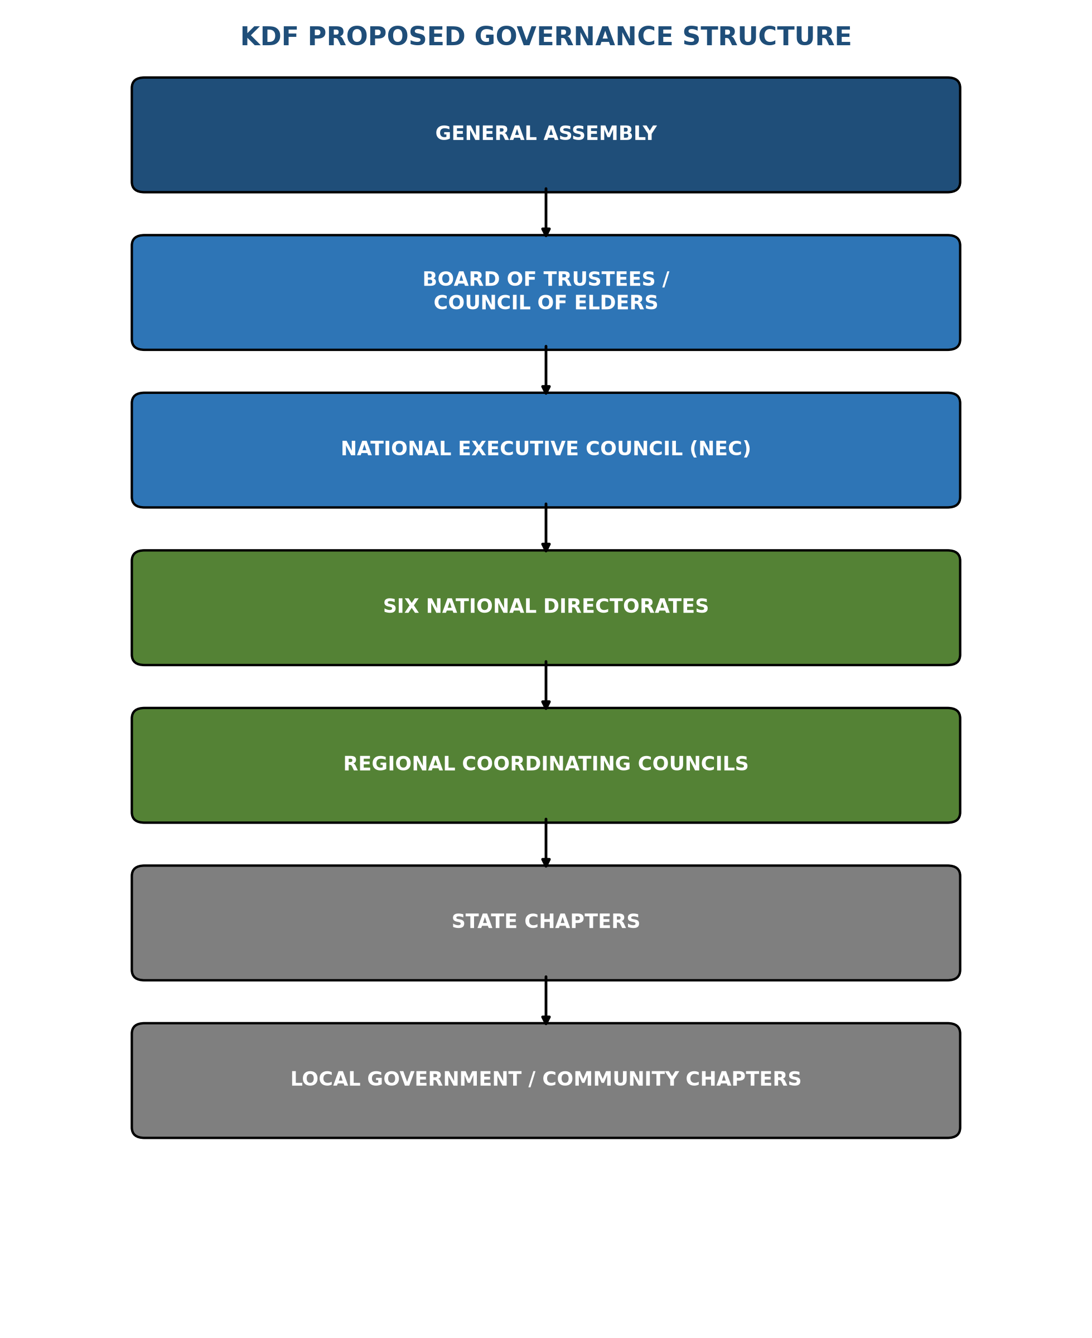

7. The General Assembly
The General Assembly shall be the supreme representative organ of KDF.
It shall comprise representatives from:
- State chapters
- Community chapters
- Traditional institutions
- Women
- Youth
- Professionals
- Business community
- Academia
- Other recognised stakeholder groups

Functions
The General Assembly shall:
- Approve the broad direction of KDF.
- Receive annual reports.
- Receive audited financial statements.
- Approve major constitutional amendments.
- Elect or confirm national leadership as provided by the constitution.
- Review the performance of the organisation.
- Approve major long-term development policies.
The General Assembly should ordinarily meet once every year.

8. Board of Trustees / Council of Elders
A small body of approximately 7-11 eminent persons should serve as the institutional custodians of KDF.

Functions
- Protect the founding objectives of KDF.
- Provide institutional guidance.
- Protect the non-partisan character of the Forum.
- Mediate major internal disputes.
- Provide continuity between successive administrations.
- Advise on major strategic decisions.
- Provide oversight on major assets and long-term commitments.
The Board should not interfere unnecessarily in day-to-day administration.

9. National Executive Council
The National Executive Council shall be the principal executive organ.

Proposed Officers
# | Office
1 | President
2 | Deputy President
3 | Secretary-General
4 | Deputy Secretary-General
5 | Treasurer
6 | Financial Secretary
7 | Legal Adviser
8 | Publicity/Communications Secretary
9 | Organising Secretary
10 | Six Directorate Directors

The President shall coordinate the activities of the NEC and serve as the principal representative of KDF.

10. Six National Directorates
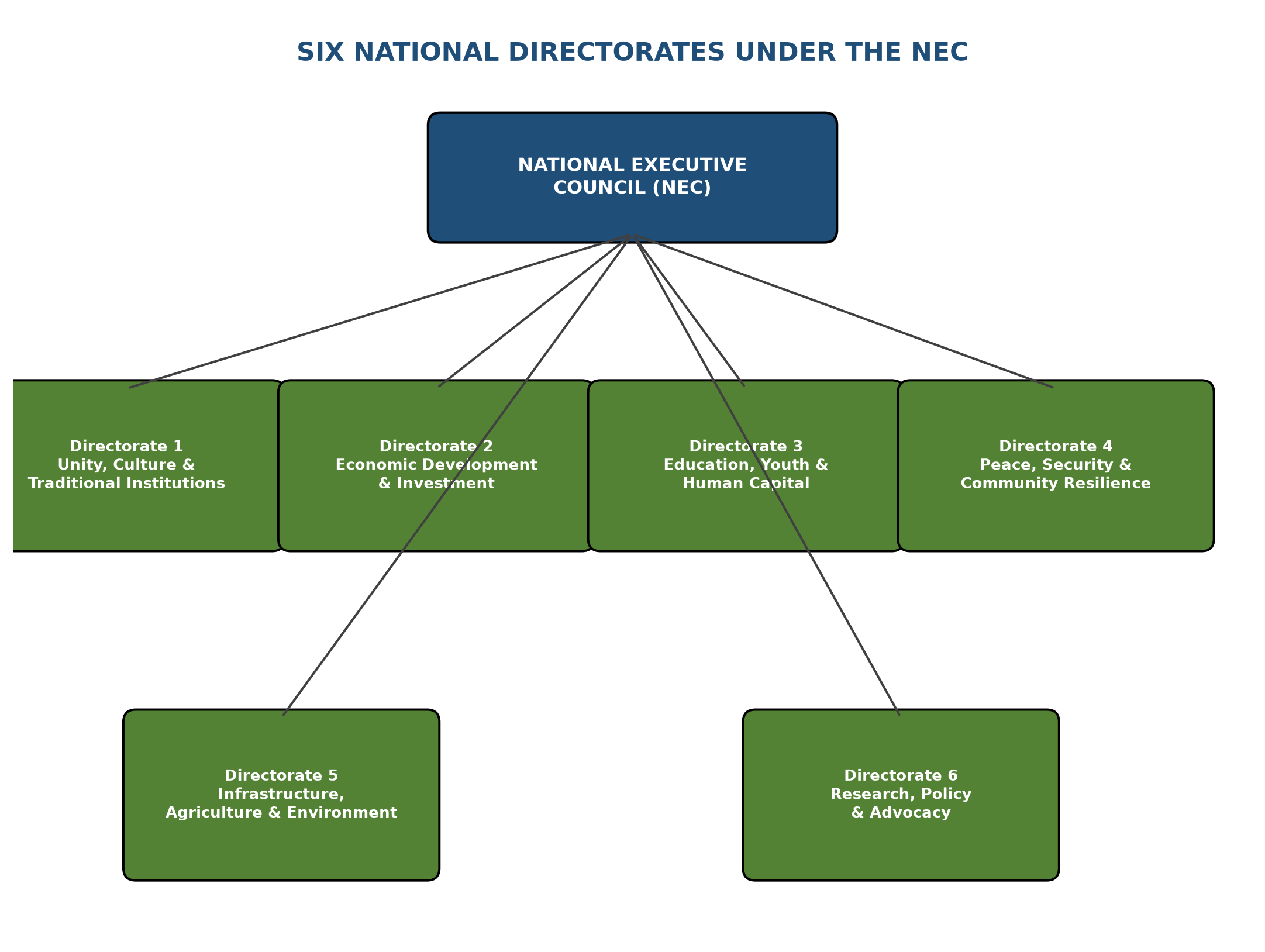
Directorate | Responsibilities | Flagship Project
1. Unity, Culture & Traditional Institutions | Kwararafa history; cultural heritage; traditional institutions; cultural festivals; community reconciliation; oral history; cultural documentation; heritage preservation. | Kwararafa Cultural and Historical Archive
2. Economic Development & Investment | Investment mobilisation; agriculture; agro-processing; entrepreneurship; SMEs; cooperative development; business networking; diaspora investment; public-private partnerships. | Kwararafa Investment and Economic Summit
3. Education, Youth & Human Capital | Scholarships; vocational training; youth empowerment; leadership development; professional mentorship; women empowerment; entrepreneurship; professional database. | Kwararafa Human Capital Development Programme
4. Peace, Security & Community Resilience | Conflict prevention; early-warning mechanisms; community dialogue; peacebuilding; disaster preparedness; community resilience; research on security challenges; liaison with appropriate government institutions. (Focus: peacebuilding/resilience, not partisan or operational security activities.) | Kwararafa Peace and Community Resilience Initiative
5. Infrastructure, Agriculture & Environment | Community infrastructure; water; healthcare; education facilities; rural development; agriculture; environmental protection; housing; digital connectivity. | Kwararafa Community Development Programme
6. Research, Policy & Advocacy | Research; policy analysis; development planning; demographic studies; historical research; economic research; infrastructure assessment; documentation of community needs. | Kwararafa Research and Development Institute (KRDI) - to publish the "Annual Kwararafa Development Report"

11. Regional Structure
To avoid excessive centralisation, KDF shall establish Regional Coordinating Councils.
The regions may broadly correspond to Nigeria's six geopolitical zones, subject to the final constitution and the actual distribution of participating Kwararafa communities.

Each Regional Council Should Have:
- Regional Coordinator
- Secretary
- Treasurer
- Youth Coordinator
- Women Coordinator
- Development Coordinator
The Regional Council shall coordinate activities between the National Secretariat and State Chapters.

12. State Chapter
Each state chapter should remain deliberately lean.

Proposed Structure
- State Coordinator/Chairman
- Secretary
- Treasurer
- Women Coordinator
- Youth Coordinator
- Development/Projects Officer
- Organising Officer

The State Chapter Shall:
- Mobilise members.
- Identify development priorities.
- Coordinate community chapters.
- Maintain membership records.
- Implement national programmes.
- Submit quarterly reports to the Regional Council.

13. Community Chapter
At grassroots level, KDF should operate through a simple structure: a Community Coordinator supported by a small Community Committee.
The Community Chapter shall identify:
- Education needs
- Healthcare needs
- Infrastructure requirements
- Agricultural opportunities
- Youth opportunities
- Women development needs
- Community conflicts
- Local investment opportunities
This information should feed directly into the KDF development planning system.

14. Presidential Advisory Council
The President may establish a Presidential Advisory Council of approximately 10-15 distinguished persons.
Membership may include:
- Senior academics
- Business leaders
- Professionals
- Traditional leaders
- Security and peacebuilding experts
- Lawyers
- Economists
- Engineers
- Medical professionals
- Women leaders
- Youth representatives
- Diaspora representatives
The Council shall provide strategic advice but shall not replace the constitutional organs of KDF.

15. Kwararafa Development Fund
A dedicated Kwararafa Development Fund (KDF Fund) should be established. Its purpose shall be to finance approved development initiatives.
Possible Sources | Financial Safeguards
Membership contributions | Separate development and administrative accounts
Donations | Dual authorisation for withdrawals
Philanthropy | Proper financial records
Corporate partnerships | Annual independent audit
Diaspora contributions | Annual financial report to members
Development agencies | Clear procurement procedures
Endowments / Investment income / Fundraising programmes | No individual officer shall have unilateral control over KDF funds

16. Membership
Category | Description
A. Individual Members | Ordinary members who subscribe to the objectives of KDF.
B. Professional Members | Qualified professionals who contribute specialised knowledge.
C. Institutional Members | Recognised organisations, associations and community development bodies.
D. Youth Members | Young people participating in KDF programmes.
E. Honorary Members | Distinguished persons who have made significant contributions to KDF objectives.
F. Diaspora Members | Kwararafa persons living outside Nigeria who wish to contribute to development.

17. The KDF Professional Register
One of the first practical projects should be the creation of a "Kwararafa Professional and Skills Register". It should voluntarily capture areas of expertise such as:
Medicine | Engineering | Law | ICT | Aviation | Agriculture | Education
Finance | Construction | Security studies | Entrepreneurship | Science | Public administration

The register will enable KDF to know what human resources it already possesses before seeking external assistance.

18. First-Year Priorities
The first year should not attempt to solve everything. KDF should concentrate on five deliverables:
# | Priority | Deliverable
1 | Unity | Create a functioning national network linking participating communities.
2 | Human Capital | Establish scholarships, mentorship and skills-development programmes.
3 | Economic Empowerment | Create the Kwararafa Investment and Economic Network.
4 | Cultural Preservation | Begin systematic documentation of Kwararafa history and cultural heritage.
5 | Development Projects | Select a small number of highly visible, achievable community projects.

19. First 100 Days
The following should constitute the immediate take-off programme.
Phase | Key Actions
Days 1-30 | Constitute the inaugural Steering Committee; Define membership and participating communities; Prepare the draft constitution; Establish the interim secretariat; Identify founding members; Establish communication channels; Begin the professional database.
Days 31-60 | Establish state/regional contact points; Convene consultations with traditional and community stakeholders; Finalise the constitutional framework; Establish thematic directorates; Develop the first-year strategic plan; Begin registration processes where appropriate.
Days 61-100 | Hold the inaugural KDF conference; Adopt the constitution; Confirm/elect substantive leadership according to the adopted rules; Launch the KDF Professional Register; Launch the Kwararafa Development Fund; Approve the first five development projects; Publish the KDF 100-Day Communique and Development Agenda.

20. Three-Year Strategic Target
By the end of three years, KDF should aim to have achieved the following across six pillars:
Pillar | Targets
A. Organisation | Functional national secretariat; Recognised state/community structures; Transparent membership register.
B. Human Capital | Scholarship programme; Professional network; Youth skills programme.
C. Economy | Investment summit; Business network; Agricultural initiatives; Development fund.
D. Culture | Historical archive; Cultural documentation; Annual cultural forum.
E. Development | Completed community projects; Infrastructure priority database; Partnerships with government and development organisations.
F. Research | Kwararafa Development Report; Research institute/network; Evidence-based development proposals.

21. Accountability Framework
Every level of KDF should submit periodic reports:
Level | Reporting Frequency
Community | Monthly/quarterly activity report
State | Quarterly report
Regional | Quarterly consolidated report
National | Annual performance report

The President should present an "Annual State of Kwararafa Development Address" covering:
- Achievements
- Challenges
- Finances
- Projects
- Membership
- Human capital
- Partnerships
- Next-year priorities

22. Inaugural Implementation Committee
Pending the formal establishment of all constitutional organs, the President may establish an Inaugural Steering Committee of approximately 15-21 persons.

Suggested Portfolios
# | Portfolio
1 | Chairman/President
2 | Deputy Chairman
3 | Secretary
4 | Legal/Constitution
5 | Finance
6 | Membership
7 | Traditional Institutions
8 | Culture/History
9 | Education
10 | Youth
11 | Women
12 | Economic Development
13 | Agriculture
14 | Infrastructure
15 | Peacebuilding
16 | Research
17 | Communications
18 | Diaspora
19 | Technology/Data
20 | Project Development
21 | Partnerships/Fundraising

Its mandate should be temporary and should terminate when the substantive constitutional organs are inaugurated.

23. The KDF Development Model
The Forum should adopt a simple philosophy:
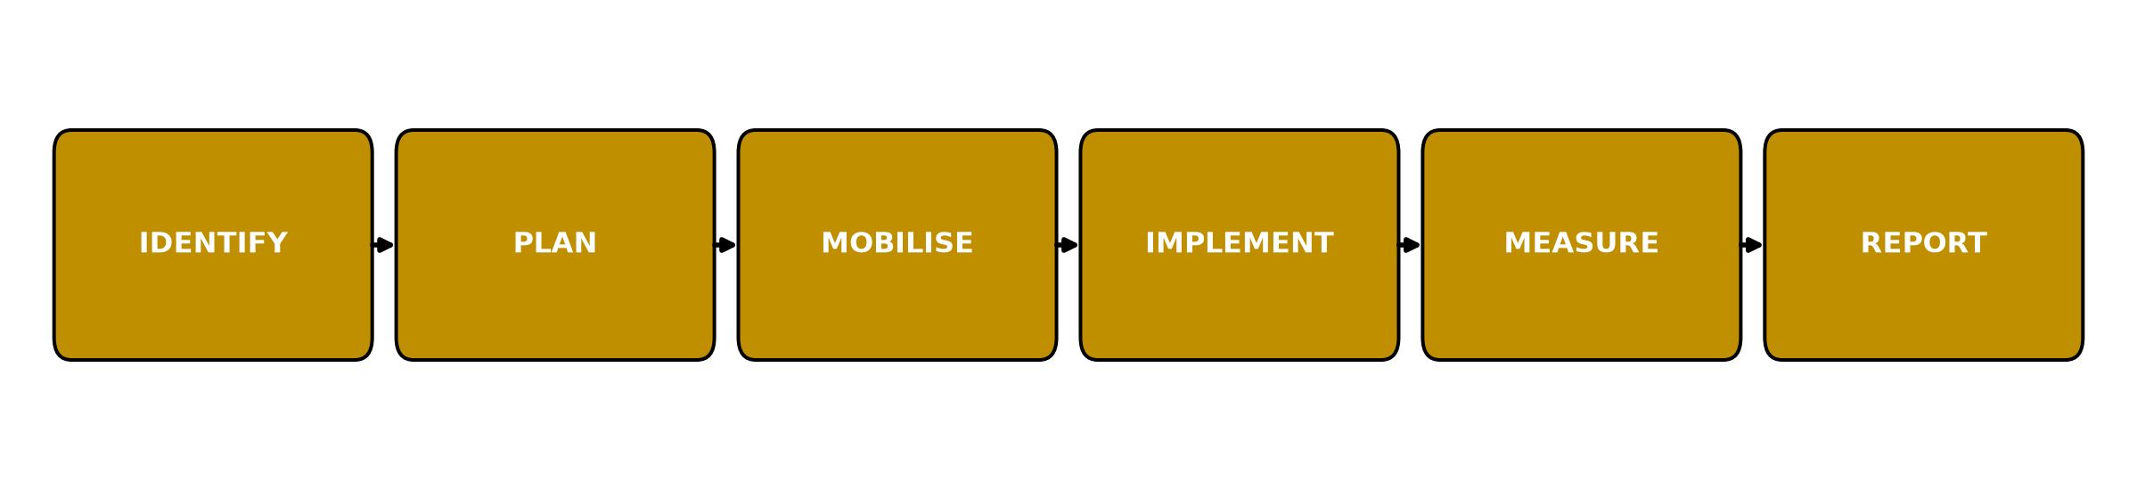
Every proposed KDF project should pass through these six stages. This will prevent the Forum from becoming primarily a platform for meetings and resolutions.

24. Proposed Inaugural Theme
"One People, Shared Heritage, Common Future: Mobilising Kwararafa Human and Economic Capital for Sustainable Development."

25. Presidential Declaration of Purpose
At the inaugural meeting, the President may declare:
"Kwararafa Development Forum is established not merely to remember our past, but to organise our present and build our common future. Our objective is to transform our shared heritage into shared opportunity; our human capital into development; our diversity into strength; and our communities into partners in peace and progress. KDF shall belong to all, serve all and be accountable to all."

26. Immediate Decisions Required from the Inaugural Meeting
The inaugural meeting should approve only the essential matters:
- Adoption of the name - Kwararafa Development Forum (KDF).
- Adoption of the vision and mission.
- Approval of the interim governance structure.
- Appointment of the Inaugural Steering Committee.
- Approval of the constitutional drafting committee.
- Approval of membership framework.
- Approval of the six Directorates.
- Approval of the first 100-day programme.
- Approval of the process for registration.
- Approval of the first KDF National Development Conference.

Conclusion
The proposed structure deliberately keeps KDF lean at the top and strong at the grassroots.
The President provides strategic leadership; the Board provides institutional continuity; the NEC provides executive direction; the six Directorates provide professional capacity; and the State and Community Chapters provide grassroots implementation.
The ultimate objective should be to build an institution that survives individual personalities and administrations and becomes a permanent platform for unity, cultural preservation, human-capital development and economic progress.

