TALKING POINTS — 20-SLIDE EXPANDED PRESENTATION
Synced Slide-by-Slide Script for AVM Monday Riku Morgan (Rtd) — North-Central Security Summit 2026
Companion to: north_central_security_20slides.html (interactive deck) and NORTH_CENTRAL_SECURITY_20SLIDE_FAILSAFE.pptx (static fail-safe). Expanded from the original 10-slide / 5-minute cut per Chairman's directive, 14 September 2026 (presentation rescheduled to the following morning).

SLIDE 1 — Security as the Foundation of 20-Year Development (2-Minute Introduction)
Distinguished military leaders, policymakers, governors, traditional rulers and stakeholders,
As we contemplate a 20-year infrastructural and social development plan for the North Central Region, we must begin with one fundamental reality: development cannot endure where insecurity is allowed to thrive. Roads, schools, hospitals, agricultural investments and industrial corridors cannot deliver their full value if communities remain vulnerable to banditry, kidnapping, communal violence and farmer–herder conflicts.
Our strategic end state must therefore be a secure, peaceful and economically productive North Central, where security is not merely reactive, but preventive, community-based and firmly integrated into the development process.
A particularly important opportunity is the principle of local-government financial autonomy affirmed by the Supreme Court. If properly implemented, financially autonomous local governments can become the frontline of grassroots security and development. With resources directly available at the local level, Local Government Councils can invest in community policing support, early-warning mechanisms, rural roads, lighting, water infrastructure, youth employment, agricultural development, emergency response and peacebuilding — while remaining within the constitutional responsibilities of the appropriate security agencies.
This changes the security equation.
Instead of waiting for crises to reach state capitals, we can build a system in which 774 local-government-level institutions nationally, and the North Central LGAs in particular, become active partners in identifying threats, preventing conflicts and accelerating development.
Our 20-year vision should therefore connect security, local governance and infrastructure into one development architecture.
The end state is a North Central where farmers can cultivate without fear, pastoral communities can pursue lawful livelihoods, children can attend school safely, investors can operate confidently, infrastructure is protected, and communities themselves become stakeholders in preserving peace.
In essence, our proposition is simple: give communities the resources, institutions and partnerships to secure peace — and peace will give development the space to flourish.
Pacing: ~2 min (fixed — delivered as provided)

SLIDE 2 — Table 1: Chronology of Kidnapping & Banditry
Plain-language note on this table: every figure below is a confirmed or clearly-labelled figure from a named source (see References). Where a number is unverified — for example, the 600 abduction claim from video evidence in Niger State — it is explicitly marked "unverified" and kept separate from the confirmed police figure of 60–80. Never present the unverified figure as fact at the podium; always say "confirmed" or "unverified" alongside the number.
Period | Location | Incident | Killed | Abducted | Source
May 2026 | Plateau State | Coordinated attacks, multiple communities | 62 | — | HumAngle Media (2026); Premium Times (2026)
June 2026 | Plateau State | Continued attacks, multiple LGAs | 43 | — | Berom Youth Moulders Association (2026)
1–11 July 2026 | Plateau State | Early-July escalation | 16 | — | HumAngle Media (2026)
22 August 2026 | Niger State (Borgu LGA, Kpenya/Dekara) | Mosque raid | 30 (confirmed) | 60–80 (confirmed); 600 (UNVERIFIED, video) | Reuters (2026a); Reuters (2026b); Daily Trust (2026)
August 2026 (ongoing) | Niger State → Benin Republic | Mass displacement following Borgu raid | — | ~2,000 fled as refugees | Revo Culture (2026); IOM (2026)
Jul 2025 – Jun 2026 (12-month) | National aggregate | Full-year kidnapping economy | 1,142 | 7,825 | SBM Intelligence (2026); Vanguard (2026)

SAY: "This is not a scattered set of incidents — it is a twelve-month, nationally-documented pattern, and North-Central Nigeria sits at the centre of it."
Pacing: ~45 sec

SLIDE 3 — Table 2: The Economy of Kidnapping
Plain-language note on this table: "average ransom per victim" is a calculated figure (total ransom ÷ total victims, both from SBM Intelligence 2026) — it is a national average, not a confirmed per-case amount, and individual ransoms vary widely by region and target. The USD conversion uses an approximate exchange rate of ₦1,500 to $1 for illustration; it is independently consistent with Reuters' own reporting of "over $5 million" raised.
Metric | Figure | Note
Total ransom paid (12 months) | ₦7.78 billion | SBM Intelligence (2026)
Total victims (12 months) | 7,825 | SBM Intelligence (2026)
Average ransom per victim | ≈ ₦994,500 (~₦1 million) | Calculated: ₦7.78bn ÷ 7,825
USD equivalent of total ransom | ≈ US$5.2 million | Calculated at ≈₦1,500/US$1; consistent with Reuters (2026c)
Year-on-year growth in ransom economy | 66% | SBM Intelligence (2026)
Reinvestment cycle | Ransom → Weapons → Transport → Recruitment → Next Attack | Pattern derived from SBM Intelligence (2026) analysis

SAY: "Every naira paid is not the end of the story — it is the seed capital for the next attack. This is a self-funding business model, and we must break the funding cycle, not just chase the perpetrators."
Pacing: ~45 sec

SLIDE 4 — Graphical Representation: Severity Map (Table 1)
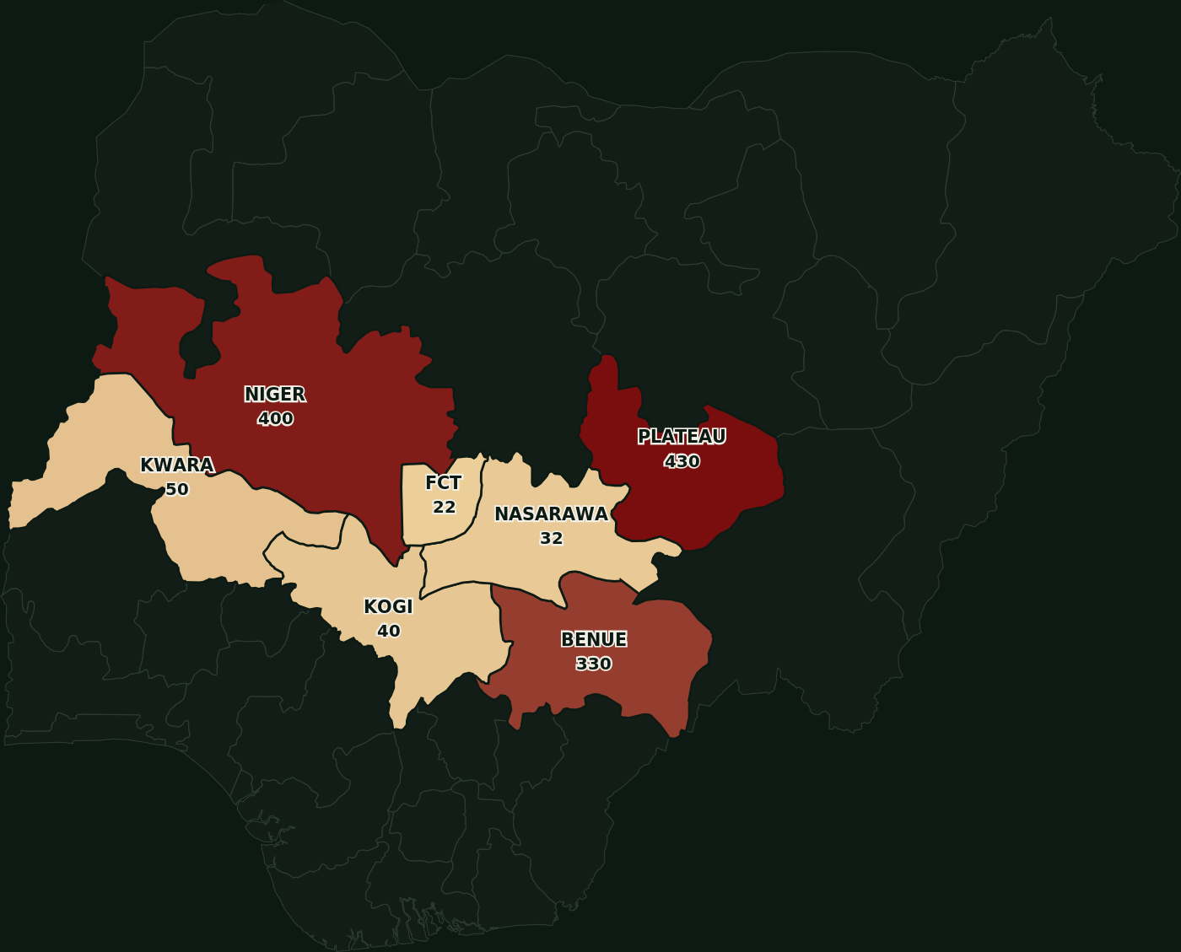
Visual on screen: a colour-graded map of Nigeria. The seven North-Central units (Plateau, Niger, Benue, Kwara, Kogi, Nasarawa, FCT) are shaded on a gradient from pale gold to deep red, scaled to each state's share of the 1,304 recorded regional incidents from Table 1. All other states are shown muted, for geographic context only.
SAY: Look at the map, not the spreadsheet — Plateau and Niger carry the deepest red. That is where this crisis is heaviest right now.
Pacing: ~40 sec
SLIDE 5 — Graphical Representation: Economic Exposure Map (Table 2)
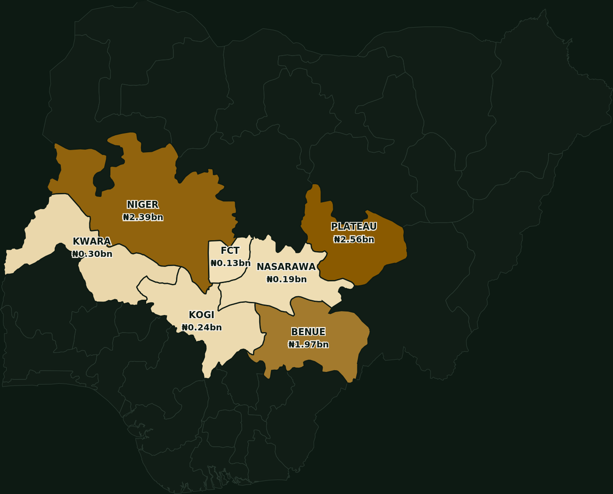
Visual on screen: a second colour-graded map of Nigeria, same seven North-Central units, shaded from pale gold to deep amber by modeled ransom exposure. IMPORTANT — plain-language note: the national ransom total (₦7.78bn, SBM Intelligence 2026) is not broken down per state in the source data. The figures on this map are calculated by distributing that national total proportionally to each state's share of recorded incidents from Table 1. This is an illustrative modeled estimate, not an independently reported per-state figure — say this explicitly at the podium.
SAY: Same pattern, different lens — where the violence is worst, the ransom economy is deepest too. They move together.
Pacing: ~40 sec

SLIDE 6 — The North-Central Security Question
Benue, Kogi, Kwara, Nasarawa, Niger, Plateau, and the Federal Capital Territory form the bridge between the north and south of this country. They contain our major agricultural belts, our forests, our highways, our energy infrastructure. And increasingly, they contain terrorism and infiltration, banditry, kidnapping for ransom, farmer-herder conflict, communal violence, arms trafficking, illegal mining, rural criminality, and the steady recruitment of our youth into criminal networks.
The Armed Conflict Location and Event Data Project (ACLED) has recorded hundreds of security incidents and substantial fatalities across Benue, Plateau and Niger between January 2024 and December 2025. Niger State and parts of Kwara face terrorist activity and the cross-border movement of armed groups. The evidence is not ambiguous. The enemy does not respect state boundaries. Why, then, should our response?
Pacing: ~35 sec

SLIDE 7 — 121 Killed in 10 Weeks — Plateau State
In Plateau State alone — one state — 121 people were confirmed killed across just ten weeks: 62 in May, 43 in June, and 16 in the first eleven days of July 2026. This is not historical data. This is the pace of violence right now, in a single state, in this region.
Pacing: ~30 sec

SLIDE 8 — A Single Operation, Hundreds of Lives — Niger State
In August 2026, a single mosque raid in Borgu LGA, Niger State, saw police confirm 60 to 80 people abducted, with video evidence suggesting — unverified — up to 600. Thirty people were confirmed killed. Roughly 2,000 residents fled across the border into Benin Republic, choosing to leave their own country rather than remain. One operation. Hundreds of lives disrupted or lost.
Pacing: ~30 sec

SLIDE 9 — Every State Carries a Share
This is not confined to one flashpoint. Across all seven North-Central units — Niger, Plateau, Benue, Kwara, Kogi, Nasarawa, and the FCT — every single state carries a share of this crisis. No state is untouched. This is a regional emergency, and it requires a regional response.
Pacing: ~30 sec

SLIDE 10 — The Ransom Economy Self-Funds
Understand the mechanism: abduct, hold for negotiation, collect ransom, reinvest in weapons and recruitment, repeat — stronger the next time. Every naira paid in ransom funds the next attack. It's a business model, not random criminality, and we must treat it as one.
Pacing: ~30 sec

SLIDE 11 — This Is a Development Emergency
I want to be direct: this is not merely a law-and-order problem. It is lost harvests, interrupted schooling, and a generation growing up distrustful of the state. Say it plainly: we are losing a generation, not just a security statistic.
Pacing: ~30 sec

SLIDE 12 — New Security Architecture: One Threat Picture
No single agency can do everything. But together, our agencies can know almost everything that matters. This requires five disciplines operating as one continuous cycle: we must SEE, by collecting information; we must SHARE, by moving it fast to those who need it; we must DECIDE, by establishing clear responsibility and command; we must ACT, by responding proportionately and rapidly; and we must LEARN, by analysing what happened and preventing its repetition.
The Armed Forces, the Police, the DSS, the NSCDC, the NDLEA and Customs, State Security Councils, Local Government structures, Traditional Institutions, and Community organisations each hold a piece of the picture. None of them, alone, holds the whole picture. Fusing these pieces into one threat picture is the single most practical reform available to us — and it costs far less than another battalion.
Pacing: ~40 sec

SLIDE 13 — Regional Security Intelligence & Fusion Centre
A fusion centre exists to answer five questions continuously: where is the threat, who is responsible, what is their capability, what are they likely to do next, and what resource can respond fastest. It maintains a living operational picture of attack locations, kidnapping incidents, suspicious movements, criminal corridors, conflict flashpoints, illegal mining and arms trafficking routes.
This is not a new invention. The United Kingdom's Joint Terrorism Analysis Centre and the United States' National Counterterrorism Center were both built on the same premise — that fragmented agencies, however capable individually, lose to threats that move faster than their information does. India's Multi-Agency Centre, built after the 2008 Mumbai attacks exposed exactly this kind of fragmentation, shows what happens when a state finally decides fusion is not optional. North-Central Nigeria needs its own version, built for our terrain and our institutions, but built on the same principle.
Pacing: ~40 sec

SLIDE 14 — Community Early Warning & Early Response Network
Farmers, hunters, teachers, traditional rulers, transporters, religious leaders, health workers, and market women see things no satellite and no patrol will ever see. What we need is a structured Community Early Warning and Early Response Network. Let me be precise about what this is not: it is not a vigilante system, and it is not a parallel intelligence service. It is a disciplined, legally governed community information network, accountable to the same rules of law that govern every other part of our security architecture.
Kenya's Nyumba Kumi community policing initiative and the Philippines' Barangay Peacekeeping Action Teams both demonstrate the same lesson from very different contexts: formal, well-governed community structures out-perform informal vigilantism on every measure that matters — accuracy, accountability, and sustainability.
Pacing: ~40 sec

SLIDE 15 — Traditional Rulers in the Security Architecture
Traditional rulers know who lives in, and who enters, their domain. They are often aware of families in conflict and land or resource disputes long before those disputes turn violent. They are frequently the first to notice radicalisation among youth. Yet today they are consulted mostly after violence occurs, when their value would be greatest before it.
The structured interface I propose links the Traditional Council directly with Police, DSS, a Military Liaison officer, Local Government, and Community Representatives — a standing table, not an emergency meeting.
Pacing: ~35 sec

SLIDE 16 — Security Corridors, Not Administrative Boundaries
A criminal group does not stop at a state border. Neither should our response. Kwara–Niger–Kainji, Niger–Kaduna–FCT, Benue–Nasarawa, Benue–Taraba, Plateau–Bauchi, and Kogi–Nasarawa–Benue are not abstractions on a map; they are the actual corridors along which threats move today. North-Central governors agreed in 2025 to pursue joint security operations across these very corridors. The next step is not another agreement. It is institutionalisation — giving that political agreement a permanent operational home.
Pacing: ~35 sec

SLIDE 17 — Rapid Response: The 30–60 Minute Window
Thirty to sixty minutes can determine whether an incident becomes a failed attack or a mass-casualty event. This window demands police rapid response units, military quick reaction forces, mobile security teams, medical evacuation capability, aviation support where appropriate, communications support, and community liaison officers — all pre-positioned, not reactive.
Israel's civil defence response architecture, built around exactly this kind of pre-positioning rather than after-the-fact mobilisation, has shown for decades how much a well-rehearsed short window can achieve when the alternative is a slow, sequential chain of phone calls.
Pacing: ~35 sec

SLIDE 18 — Financially Autonomous Local Governments — The Solution
Here is the fix: push real financial power, with real accountability, down to the Local Government level. This is the same Supreme Court-affirmed principle I opened with — the frontline of grassroots security and development. Push power and money down to the LG — that's where the threat actually lives, and where prevention is cheapest and fastest.
Pacing: ~35 sec

SLIDE 19 — The Formula
Financial Autonomy, plus Accountability, plus Local Intelligence, plus Responsive Governance, plus Professional Coordination, equals stronger grassroots security. Autonomy without audits just decentralises corruption — say this caveat out loud.
Pacing: ~35 sec

SLIDE 20 — 5-Year Metrics & Evaluation Roadmap (20-Year Plan)
Plain-language note on this table: these are proposed evaluation milestones for the 20-year development plan, phased in 5-year blocks, to be tracked and independently audited at each stage — they are planning targets, not yet-achieved results.
Phase | Years | Key Evaluation Targets
I — Foundation | 1–5 | Regional Fusion Centre operational across all 7 states/FCT; LG security allocations disbursed & independently audited; kidnapping incidents down 30% from baseline; Community Early-Warning Network live in 50% of high-risk LGAs; average response time under 90 minutes
II — Consolidation | 6–10 | Kidnapping incidents down 60% from baseline; 100% of LGAs integrated into the fusion centre threat picture; all 6 security corridors institutionalised; displaced-family return rate above 70%; LG financial-autonomy audit compliance above 90%
III — Maturity | 11–15 | Kidnapping incidents down 85% from baseline; rapid-response window consistently under 45 minutes region-wide; rising arrests and prosecutions of criminal networks, not just displacement; community trust index above 75%; full agricultural corridor reactivation, farming without armed escort
IV — Sustained Peace & Development Dividend | 16–20 | Kidnapping-for-ransom reduced to under 5% of baseline — no longer a viable industry; North-Central becomes a source of security best practice for other regions; full economic corridor integration — roads, schools and hospitals fully protected and operational; self-sustaining LG security-financing model, replicable nationally

SAY: "A twenty-year plan without five-year checkpoints is just a hope. These are the checkpoints, and we should be judged against them publicly, at every stage."
Pacing: ~50 sec

SLIDE 21 — The North-Central Security Compact: Seven Commitments
I ask this summit to adopt seven commitments. One Threat Picture: we share intelligence. One Early-Warning System: we listen to communities. One Rapid-Response Philosophy: we respond before massacres, not after them. One Professional Standard: discipline, law, and dignity govern every action we take. One Regional Approach: no one exploits state boundaries for cover. One Development Agenda: we secure and rebuild together, not sequentially. And One Measure of Success: the safety and dignity of the citizen — not the volume of activity we can report.
Pacing: ~40 sec

SLIDE 22 — Closing — The Regional Security Shield
"If every local government across the North-Central states is empowered, accountable and connected — we begin to build a regional security shield."
He simply wants to arrive alive. That is the standard by which we must judge ourselves. And it is not beyond the capacity of Nigeria. Thank you.
— Air Vice Marshal Monday Riku Morgan (Rtd)
Pacing: ~30 sec

REFERENCES (Harvard Style)
This reference list also appears in full on the final slide of the interactive deck (Slide 21 — References), per standing instruction.
ACLED – Armed Conflict Location & Event Data Project (2026) Nigeria conflict and fatality data, North-Central zone, March–September 2026. Available at: https://acleddata.com (Accessed: 14 September 2026).
Berom Youth Moulders Association (2026) Incident data on Plateau State attacks, May–July 2026, reviewed and published by HumAngle Media (2026), op. cit.
Daily Trust (2026) 30 killed in attacks on four Niger mosques. Available at: https://dailytrust.com/30-killed-in-attacks-on-four-niger-mosques (Accessed: 14 September 2026).
Government of India, Ministry of Home Affairs (2026) Multi-Agency Centre (MAC), established following the 26 November 2008 Mumbai attacks.
Government of Israel, Home Front Command (2026) Civil defence rapid-response and pre-positioning doctrine. Available at: https://www.idf.il/en/mini-sites/home-front-command (Accessed: 14 September 2026).
Government of Kenya, National Police Service (2026) Nyumba Kumi Community Policing Initiative.
Government of the Philippines, Department of the Interior and Local Government (2026) Barangay Peacekeeping Action Teams (BPAT).
Government of the United Kingdom, Security Service MI5 (2026) Joint Terrorism Analysis Centre (JTAC). Available at: https://www.mi5.gov.uk/joint-terrorism-analysis-centre (Accessed: 14 September 2026).
HumAngle Media (2026) Nigeria Conflict Tracker – monthly national security metrics, March–June 2026. Available at: https://humanglemedia.com (Accessed: 14 September 2026).
HumAngle Media (2026) Residents recall a weekend of bloodshed across Benue and Plateau communities. Available at: https://humanglemedia.com/residents-recall-a-weekend-of-bloodshed-across-benue-and-plateau-communities (Accessed: 14 September 2026).
International Organization for Migration (2026) Displacement Tracking Matrix (DTM), Nigeria, Round 18. Geneva: IOM.
National Counterterrorism Center (2026) About NCTC. Available at: https://www.dni.gov/nctc (Accessed: 14 September 2026).
North-Central Nigeria Governors' Forum (2025) Joint Security Operations Agreement across shared corridors.
Premium Times (2026) Nine family members, baby killed in Plateau attack. Available at: https://www.premiumtimesng.com/news/headlines/894898-nine-family-members-baby-killed-in-plateau-attack.html (Accessed: 14 September 2026).
Reuters (2026a) Gunmen abduct over 60 worshippers, Nigeria mosque, police say. 22 August. Available at: https://www.reuters.com/world/africa/gunmen-abduct-over-60-worshippers-nigeria-mosque-police-say-2026-08-22/ (Accessed: 14 September 2026).
Reuters (2026b) Video appears to show 600 people abducted in Nigeria mosque attack, residents say. 24 August. Available at: https://www.reuters.com/world/africa/video-appears-show-600-people-abducted-nigeria-mosque-attack-residents-say-2026-08-24/ (Accessed: 14 September 2026).
Reuters (2026c) Nigerian gunmen raise over $5 million in mass kidnappings, study finds. 26 August. Available at: https://www.reuters.com/world/africa/nigerian-gunmen-raise-over-5-million-mass-kidnappings-study-finds-2026-08-26/ (Accessed: 14 September 2026).
Revo Culture (2026) Regional synthesis of Niger State Borgu attacks and cross-border displacement. Available at: https://revoculture.org/articles/religion/103 (Accessed: 14 September 2026).
SBM Intelligence (2026) The Economics of Nigeria's Kidnap Industry (2026 Edition). Lagos: SBM Intelligence.
Vanguard (2026) 7,825 abducted, 1,142 killed in one year – SBM. Available at: https://www.vanguardngr.com/2026/08/7825-abducted-1142-killed-in-one-year-sbm/ (Accessed: 14 September 2026).

