Assignment 1 , 159.735, 2020 S2

Family Name: JIANG , Given Name: TAO ,

Student ID:20004769

**Ass1 Parallel Random Number Generation**

The experiment uses multiple processors to calculate the value of Pi in parallel to verify Amdahl's Law.

Amdahl's Law In an ideal environment, as the number of processors increases, the operating speed will increase. When the number of processors is not limited, the operating efficiency has nothing to do with the number of processors. It is related to the ratio of the calculation time required for the Serial section and Parallelizable sections. The maximum speedup limit will be 1/f.

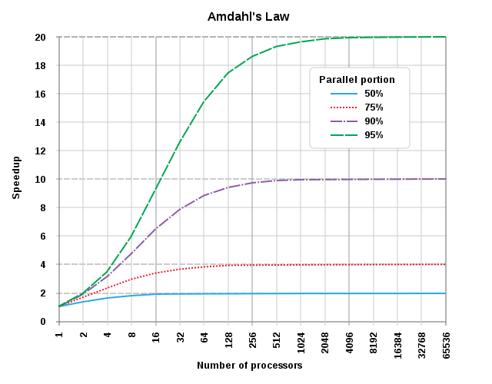

* **User’s Guide**

I use macOS as a development platform. And it only supports 4 processors maximum.

macOS env：

```  
mmpic++ ass_1.cpp - out  
mpirun -n 4 out  
```

At the same time, I deployed the program to Mighty for testing. Get the final experimental results.

Mighty env：

Login mighty as user 20004769

/home/s20004769/ass1/

```ssh  
mpic++ ass_1.cpp pi  
qsub pi.pbs  
  
```

* **Experiment results**

The experiment uses a single factor multi-group controlled experiment. The amount of calculation N remains unchanged (N = 300000000). Use different numbers of processors for comparison. The experiment records the running time of the Master processor and slave processors at the same time. Among them, the Master processor is not only responsible for allocating tasks; it is also responsible for part of the parallel computing. Due to many slave processors data, I processed the experimental data and took the average of the slave processors and slave processors that took the longest time as records. Furthermore, calculate the time used for communication. The results are as follows:

|  |  |  |  |  |  |  |
| --- | --- | --- | --- | --- | --- | --- |
| Total proc | Master self work | Serial | Master total | slave max | slave avg | parallel portion |
| 1 | 25.2021 | 6.82E-05 | 25.2022 | 25.202 | 25.2021 | 0.0003% |
| 2 | 12.6183 | 9.13E-05 | 12.6184 | 12.586 | 12.60215 | 0.0007% |
| 4 | 6.30917 | 0.006062 | 6.31523 | 6.3153 | 6.310945 | 0.0960% |
| 8 | 3.15617 | 0.010004 | 3.16437 | 3.1643 | 3.157776 | 0.3161% |
| 16 | 1.57974 | 0.0042453 | 1.58399 | 1.5807 | 1.58074 | 0.2680% |
| 32 | 0.789581 | 0.240099 | 1.02968 | 0.8013 | 0.792757 | 23.3178% |

Table 1: multi-processors results

Chart 1: Multiple processors time cost

* **Conclusion**

It can be seen from the above experiments that as the number of processors increases, the computational efficiency is improving. However, it is not that there is no linear relationship. It can be seen from the experimental results of the two groups of 16 processors and 32 processors that even if the number of processors doubles, the computational efficiency is not much improved. When the number of processors is not limited, the operating efficiency has nothing to do with the number of processors. It is related to the ratio of the calculation time required for the Serial section and Parallelizable sections. The result complies with Amdahl's Law.