Assignment 4 , 159.735, 2020 S2

Family Name: JIANG , Given Name: TAO ,

Student ID:20004769

**Assignment4 :** **Modelling Gravitational Lensing on a GPU**

The experiment use GPU to accelerate the calculation of gravitational lensing phenomenon between celestial bodies.

The experiment uses CUDA for parallel computing. I pass the *d_lensim, npixx, npixy, lens_scale, d_xlens, d_ylens, d_eps, nlenses* parameter to the GPU. After parallel calculation, *d_lensim* is obtained and copied from GPU to CPU.

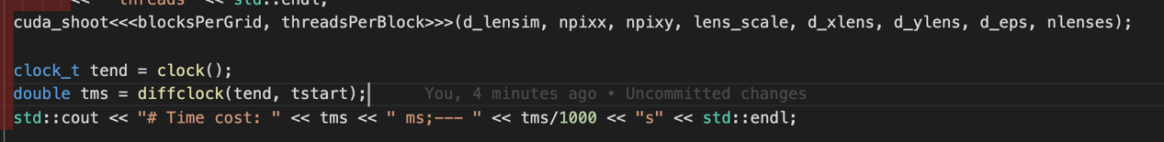

* **User’s Guide**

I use Ubuntu as a development platform.

Ubuntu env：

```shell  
make   
./lens_cuda 100   
ds9 lens_gpu.fit &  
```

There is a screenshot of the Modelling Gravitational Lensing with 100 lenses by CUDA.

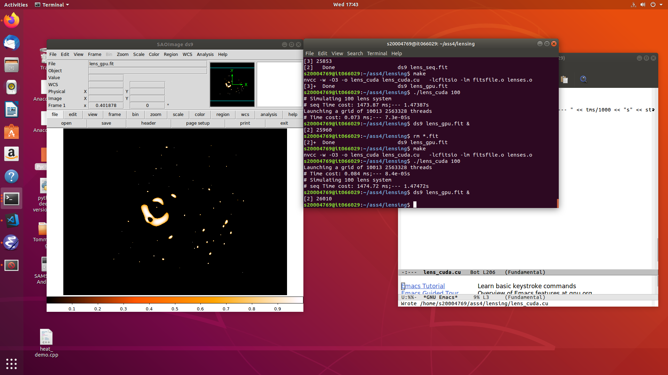

* **Experiment results**

The experiment compares the computing power of CUDA's parallel and sequential through different numbers of lenses. There are a total of 2,563,328 threads used on the GPU for the experiment, And I setup each block has 256 threads. The experiment records both sequential, parallel running time and speed-up, the time unit is ms.

The results are as follows:

|  |  |  |  |
| --- | --- | --- | --- |
| **nlenses** | **Seq Time** | **cuda Time** | **seepdup** |
| 10 | 177.921 | 0.07 | 2541.7286 |
| 40 | 626.167 | 0.073 | 8577.6301 |
| 50 | 756.878 | 0.072 | 10512.194 |
| 80 | 1475.05 | 0.065 | 22693.077 |
| 100 | 1452.27 | 0.073 | 19894.11 |
| 150 | 2317.29 | 0.061 | 37988.361 |
| 200 | 2918.42 | 0.073 | 39978.356 |
| 250 | 3700.34 | 0.072 | 51393.611 |
| 300 | 4400.07 | 0.072 | 61112.083 |
| 350 | 4943.4 | 0.072 | 68658.333 |
| 400 | 5641.99 | 0.072 | 78360.972 |
| 450 | 6315.74 | 0.076 | 83101.842 |
| 500 | 7044.67 | 0.075 | 93928.933 |
| 550 | 8075.2 | 0.073 | 110619.18 |
| 600 | 9736.85 | 0.073 | 133381.51 |
| 650 | 10461.3 | 0.071 | 147342.25 |
| 700 | 10001.6 | 0.071 | 140867.61 |
| 750 | 11738.5 | 0.089 | 131893.26 |
| 800 | 11394.2 | 0.06 | 189903.33 |
| 850 | 12485.7 | 0.074 | 168725.68 |
| 900 | 12921.6 | 0.076 | 170021.05 |
| 950 | 13797 | 0.073 | 189000 |
| 1000 | 14261.3 | 0.072 | 198073.61 |
| 2000 | 28333.6 | 0.071 | 399064.79 |
| 3000 | 42169.7 | 0.075 | 562262.67 |

Table 1: The test result of sequential and parallel running time

Chart 1: Modelling Gravitational Lensing on a GPU running time

Chart 2: CUDA parallel sppedup

* **Conclusion**

It can be seen from the above chart1 that the sequential program execution time speed tends to increase as the lenses increase. However, the GPU parallel computing speed is very fast and stable. The reason is there are many threads on the GPU, and the number of parallel tasks does not exceed this value, so each thread is executed quickly.

The Chart2 is the GPU speed-up when calculating different lenses. More threads can speed up even more. The results of this experiment conform to Gustafson's Law.