WEEK 6 LAB 5: MYSTERY BOX CHALLENGE PART #1
(12/17/2025)

1.0 INTRODUCTION
In this lab you will determine the ‘value’ of two unknown components. Each Mystery box contains one component, and it could be a resistor, capacitor, or resistor.
Q 1.1 :
Lab Group Number: 35
Lab Group Leader: Zachary Kramer
Lab Group Member Names: Tong Su, Carter Flynn Swanson, Zachary Kramer
Date: 11/7/2026 .
Full Name of Lab: Week 6 Lab 5 - Part 1: Mystery Box Challenge .

2.0 BACKGROUND
In the “week 4 Lab 3 – Measuring Impedance” you used your oscilloscope and signal generator to determine the impedance of a known component by determining the current phasor and applying Ohm’s law. This lab is a logical extension where the component type and value are unknown. You will use a similar technique to that employed in lab 3 to determine the impedance, and from that find the component type and value.
As the experimental technique and many of the observations are similar to lab 3, I recommend you have a copy of your lab report available to you as you execute this lab.
In general, the values of components of a linear network which produce a specific impedance at a specific frequency are not unique. However, for a single component they are theoretically unique, and you can utilize a single frequency. In practice you should ensure that the frequency you utilize produces a meaningful measurement and utilize multiple frequencies to verify your result.

3.0 PROCEDURE

3.1. ANALYTICAL PREDICTIONS.
A schematic of the experimental setup is shown in Figure 1.0. We can determine the expected values of the measurements based on the analytical techniques we have developed in this class. This is similar to the analysis you executed for Lab 3. However, in this case we are only trying to find the single unknown variable (C, L, or R) rather than the current. Thus, we only must know the V1 and V2 phasors. For this analysis assume the phase of the source is 0 deg, and the amplitude of the source is 1V (e.g. 2Vp-p).

Q3.1.1 Assume the magic box has a resistor of unknow value inside. Determine the following Phasors as a function of the unknown resistor value R. Show all your work.
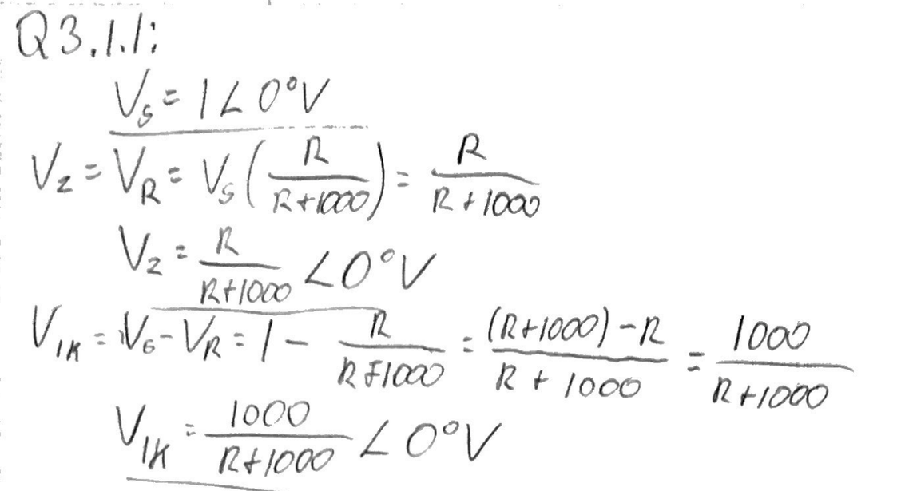

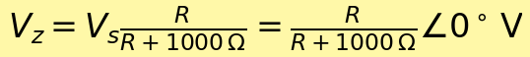


Q3.1.2 Assume the magic box has a capacitor of unknow value inside. Determine the following Phasors as a function of the unknown capacitor value C and frequency (w). Remember | V | = [V V*]^1/2 if V is a phasor and V* is the complex conjugate. The complex algebra gets a little messy, but if you go slow and are patient you can grind it out. The magnitude is a complicated expression, while the phase simplifies to a fair simple expression. Show all your work.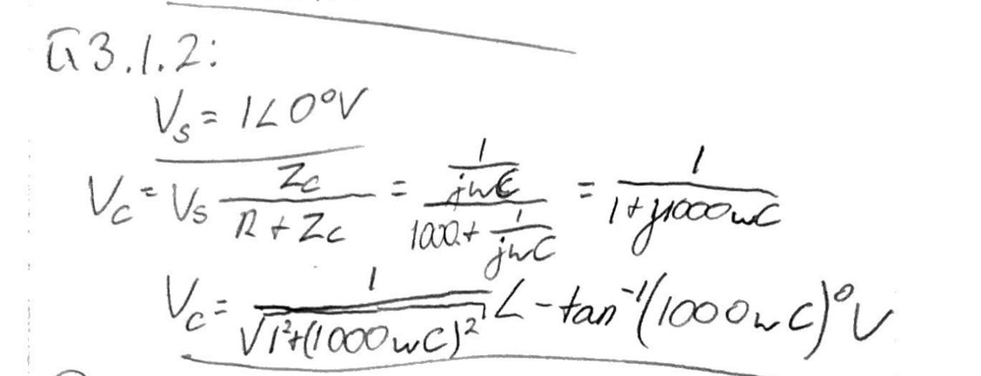
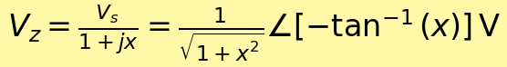
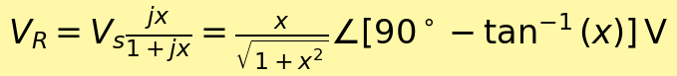
Q3.1.3 Assume the magic box has an inductor of unknow value inside. Determine the following Phasors as a function of the unknown Inductor value L and frequency (w). Show all your work.
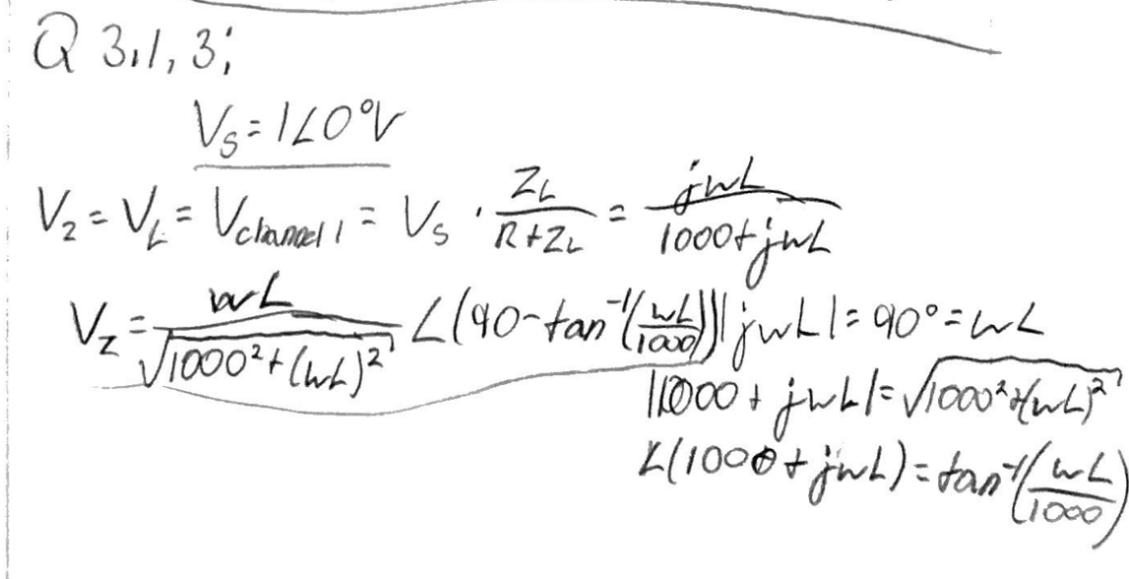
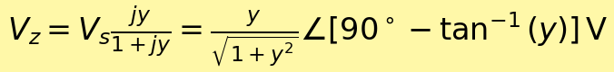
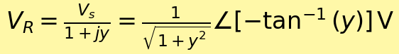

3.2. EXPERIMENTAL SETUP.
Set up your signal generator and oscilloscope the same way as for “Week 4 Lab 3 Measuring Impedance”. You will replace the capacitor/inductor from lab 4 with one of your mystery boxes. Use a 2Vp-p signal for this lab (e.g. Amplitude is 1V).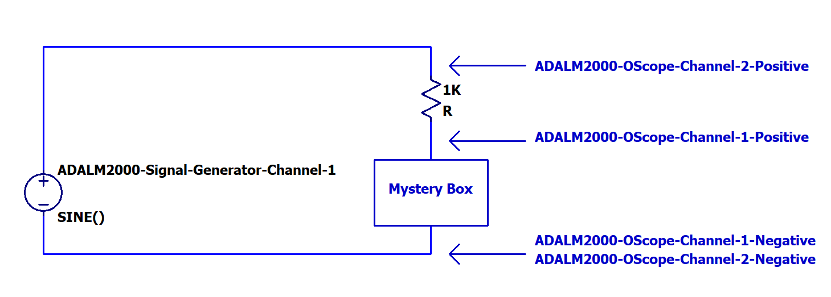
Figure 1: Experimental Schematic
To connect the mystery box into the circuit, utilize the IC Clamps that are part of your kit as shown in the following figure. Be careful with the leads on the Mystery Box as they are easy to break.
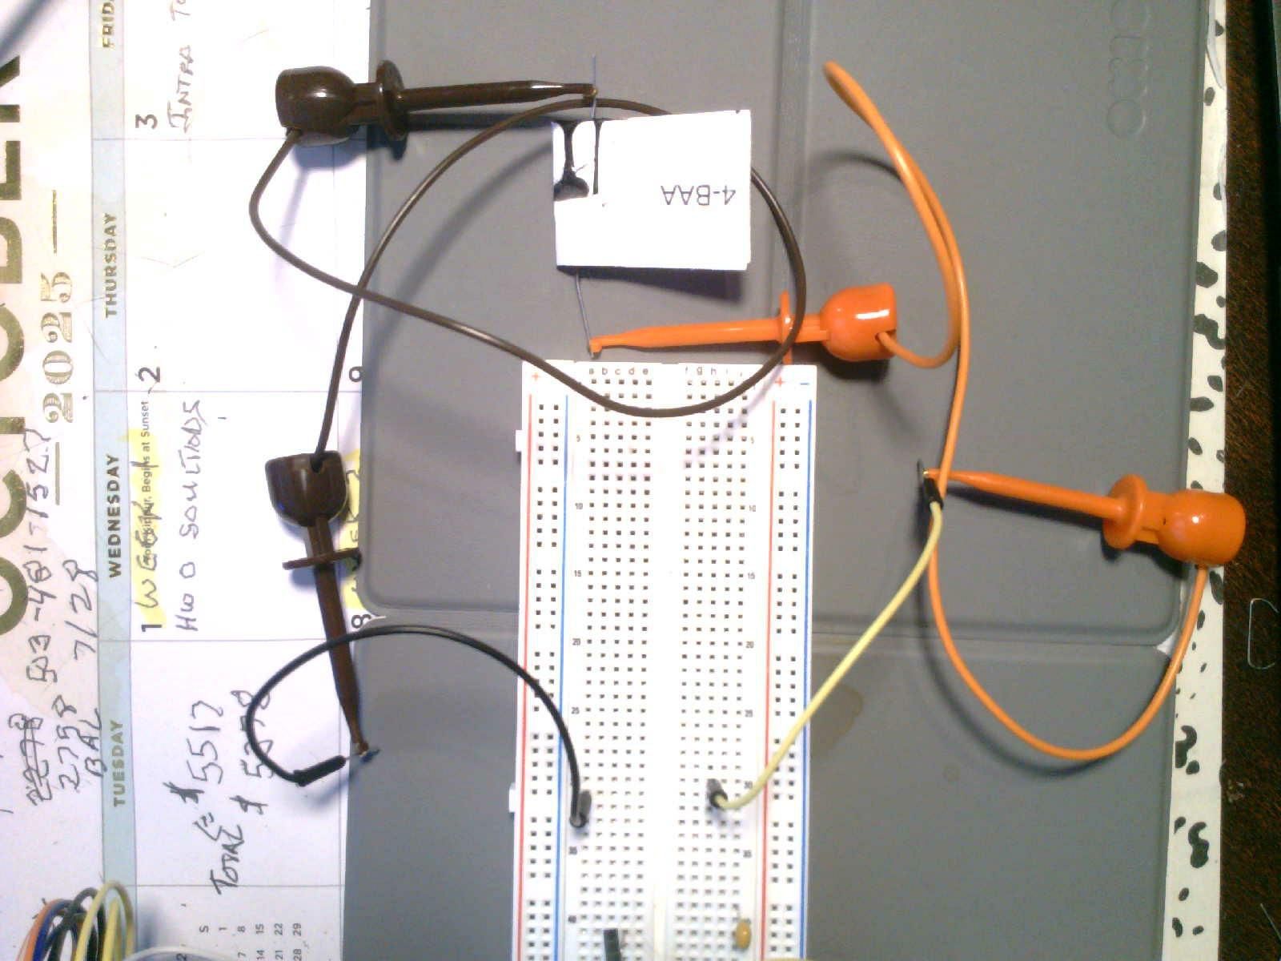
Figure 2: Mystery Box Connections
Q3.2.1 Include a photograph and a TinkerCAD Breadboard layout of your experimental setup.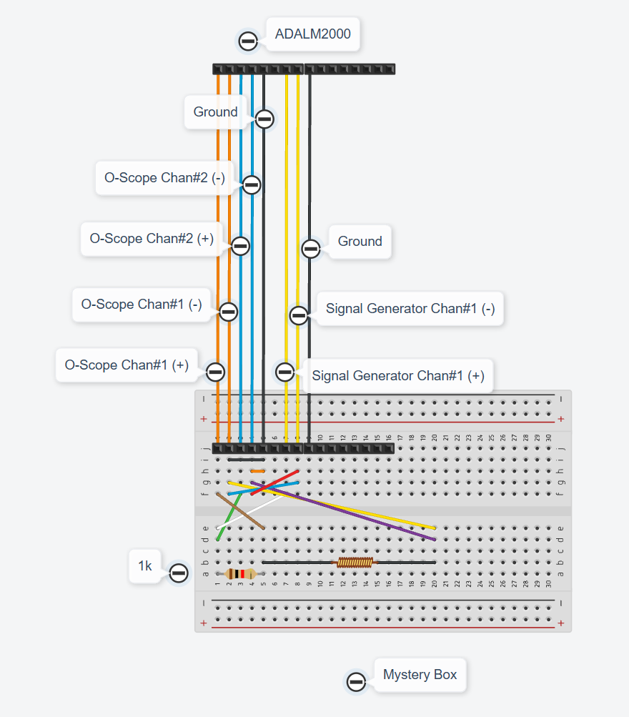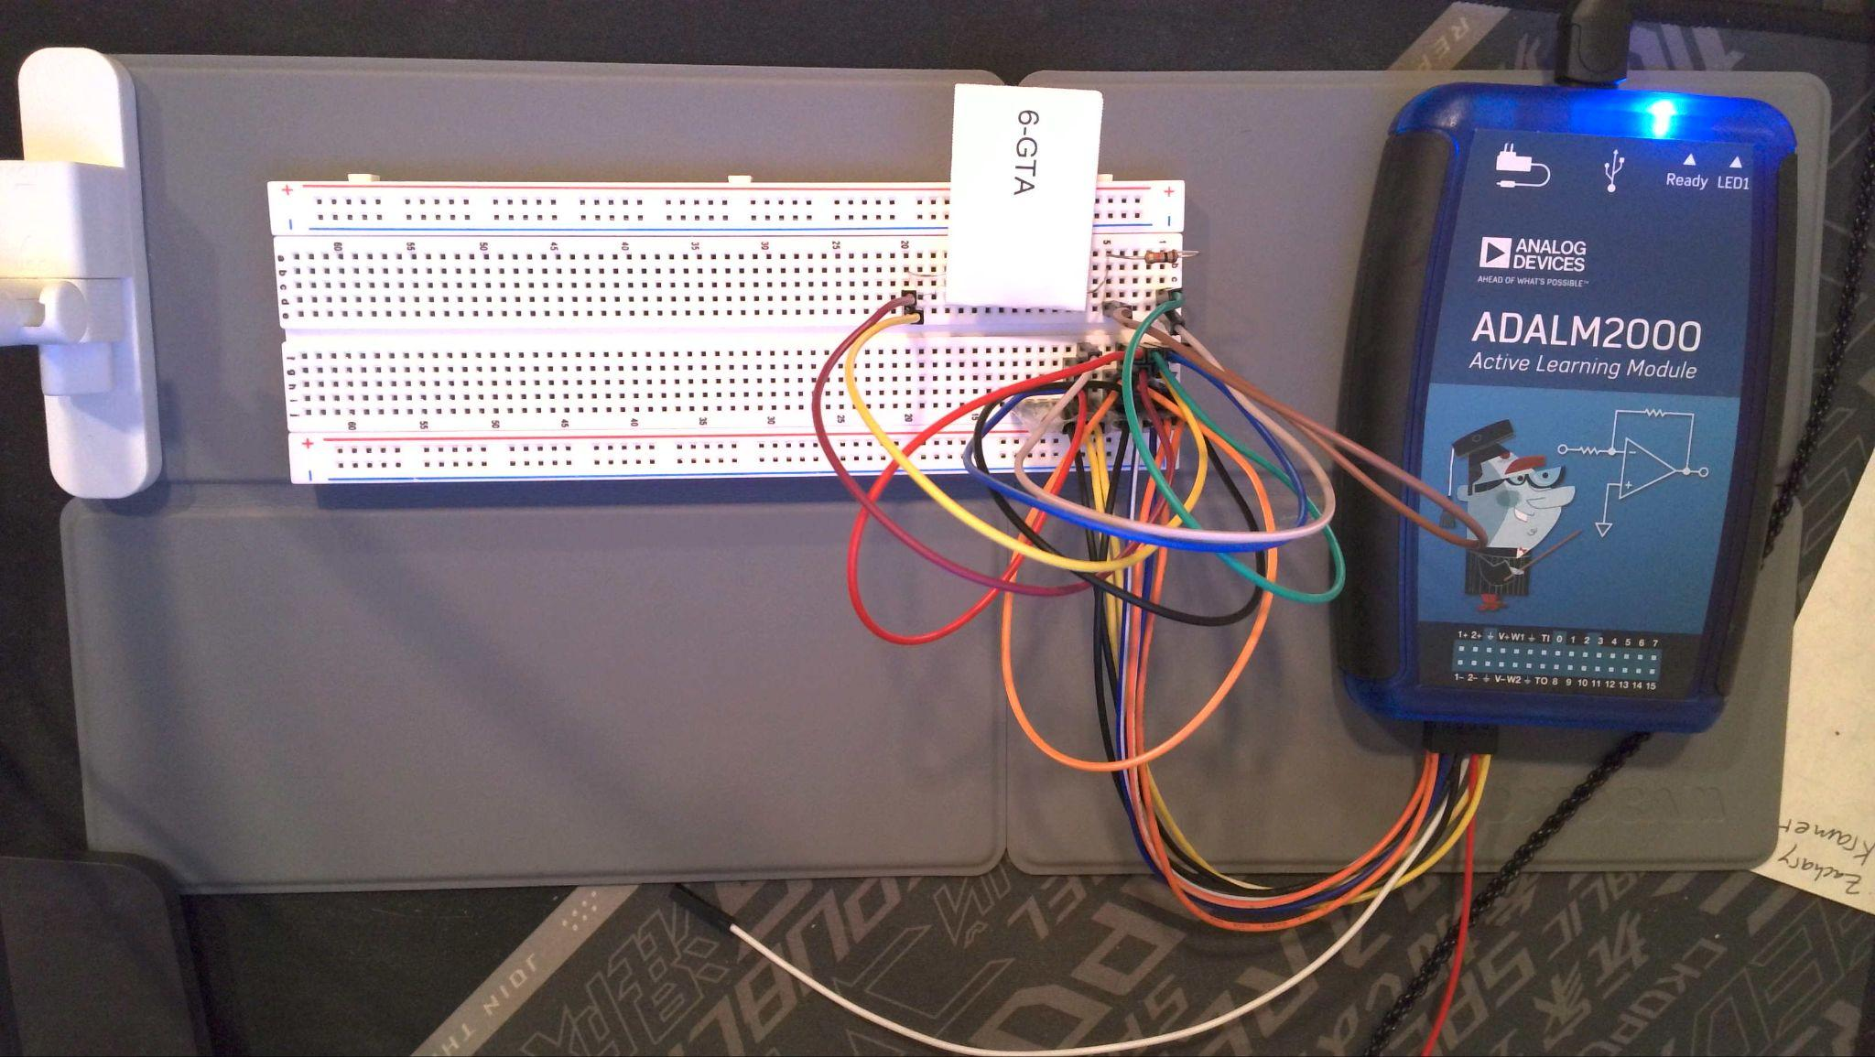
Experimental setup shown above with the 1 kΩ series resistor and Box 6-GTA.

3.3. MYSTERY BOX #1.
Mystery Box #1: Vary the frequency (limit yourself to 10Hz to 300kHz) until you get waveforms similar to what you generated in Lab 3. Make sure you can measure the amplitude difference and phase difference (if there is one) accurately with the cursors.
Q3.3.1 Mystery Box #1: Based on a visual inspection of the O-scope Trace is the Mystery Box a resistor, capacitor, or inductor? Why? (This is a very important question. You will have grave difficulty with the rest of this lab if you can’t answer it. Contact me with questions)
CH1, the voltage across the mystery box, lags CH2, the input. The resistor voltage CH2 − CH1 leads the input. This is the expected behavior of a series RC circuit with the output across the capacitor. A resistor would have essentially zero relative phase; an inductor voltage would lead the input.
NOTE: If you determine that your Magic Box has no phase shift, then you may neglect some of the portions of some questions that involve computations of the phase. Please explicitly identify that you didn’t do something because your phase measurement was zero.

Q3.3.2 Mystery Box #1: Provide two O-Scope Screen Captures. They should include the frequency and amplitude of Channel #1, Channel #2, and Channel #2 – Channel #1 in the measurement window. For the first plot use the cursors to measure the time delay between V_{s} = Channel #2 V and V_{Z} = Channel #1 V from which you will determine the relative phase (If there is a phase difference). For the second plot use the cursors to measure the time delay between V_{s} and V_{r} = Channel #2 V – Channel #1 V (e.g. the math trace).
Note: If the absolute value of your measured phase between Vs and Vr is greater than 50 degrees, adjust the frequency of your signal until you are less than 50 degrees. The ATAN function becomes very steep as you approach 90 degrees which makes for a very sensitive measurement as the phase approaches 90 degrees. This step will keep you out of trouble when you double the frequency later in the lab.
Capture 1: CH2 input (purple), CH1 box voltage (orange), M1 = CH2 − CH1 (green). Box voltage lags the input.
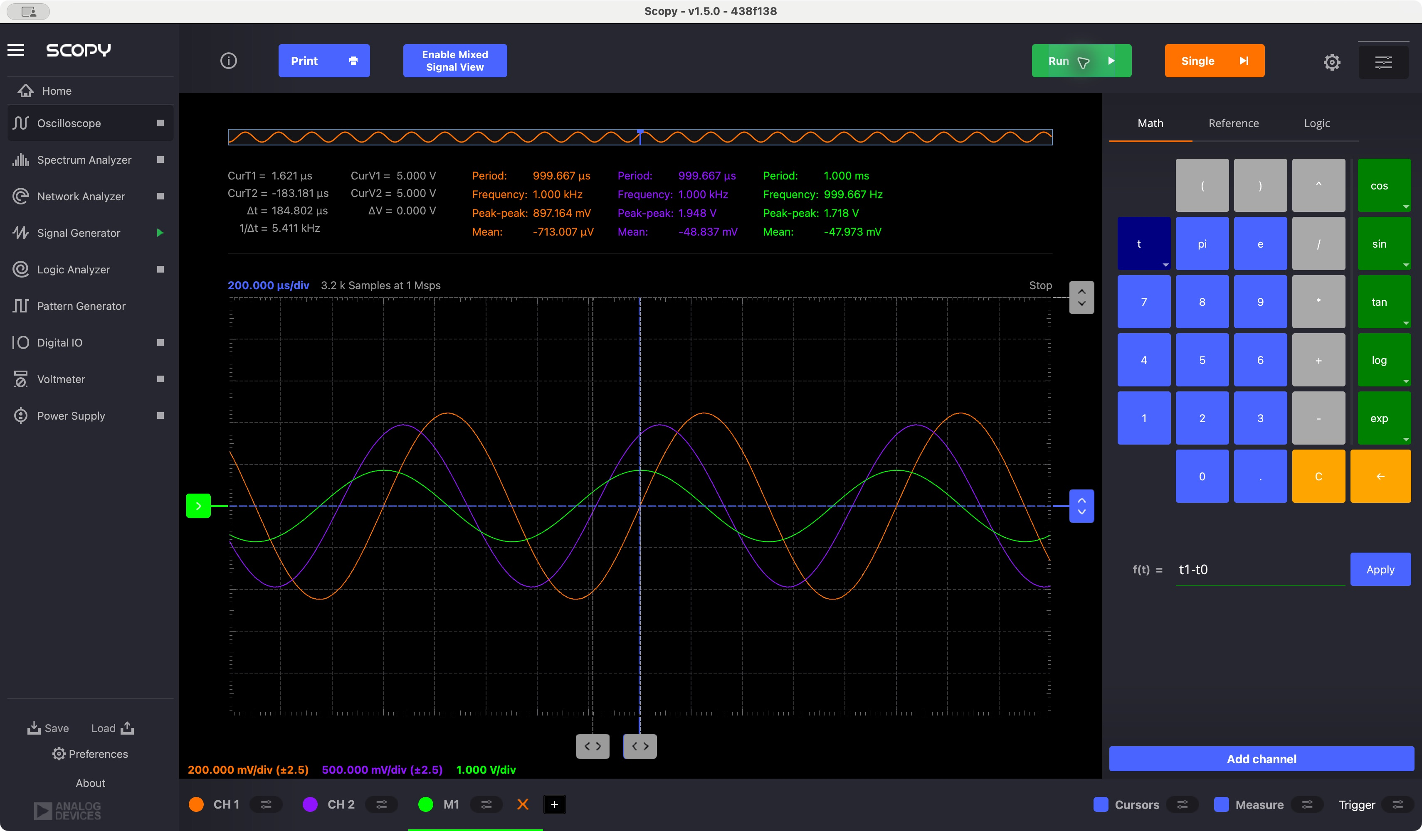
Capture 2: resistor voltage leads the input. The displayed Δt = T1 − T2 = 84.296 μs gives +30.36°, satisfying the required magnitude below 50°. The displayed reciprocal cursor difference is not the signal frequency.
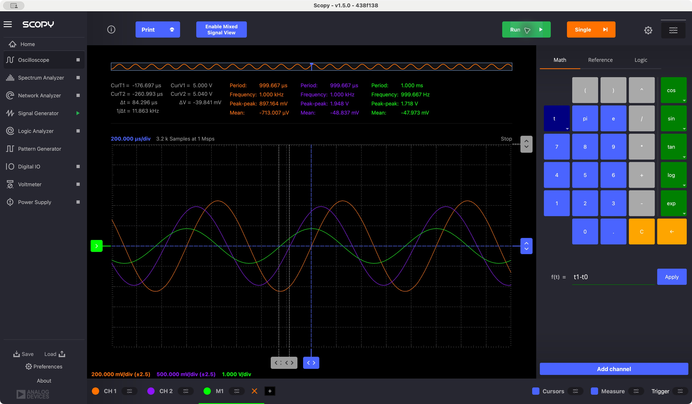
Q3.3.3 Mystery Box #1: From these measurements determine the three voltages phasors and write them here:
The retained scope measurements are CH2 = 1.948 Vpp, CH1 = 0.897164 Vpp, and M1 = 1.718 Vpp. Divide Vpp by two for peak phasors.
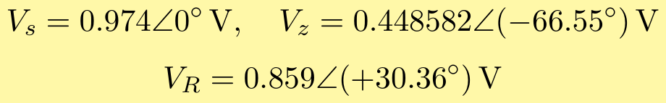
The input period is 999.667 μs. The box crossing follows the input by 184.802 μs; the resistor crossing precedes it by 84.296 μs. These original cursor placements are approximate. Their phase separation is 96.91°, rather than the ideal 90°, so they contain a measurable inconsistency.
Q3.3.4 Use your analytical results from section 3.1 and your experimental results to determine the contents of Mystery Box #1. You will need to plug your measured results into the magnitude equation or the phase equation and solve for C, L, or R (One of them is a lot easier mathematically). Once you find C, L, or R back substitute your result into the whichever of the magnitude or phase equations you didn’t use and verify the result against your measurement. For example, if you have a capacitor and you used the phase equation to determine C, then plug C back into magnitude equation and verify that matches your measured result. Show your work.
For R = 1000 Ω and the unknown capacitor connected in series, the capacitor impedance is 1/(jωC). Applying the voltage divider gives:
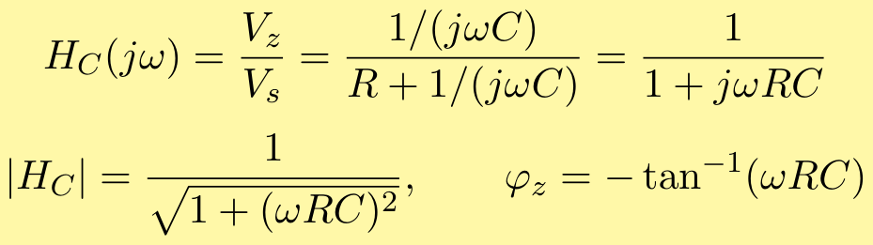
Using the measured magnitude ratio at approximately 1000 Hz and solving for the unknown capacitance:
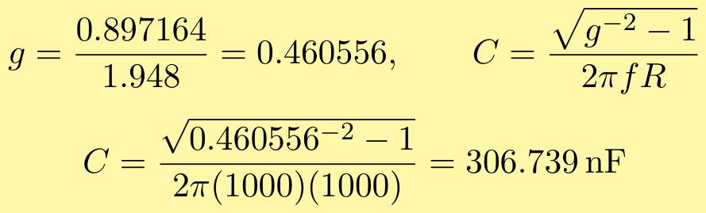
Result: C ≈ 306.7 nF; component type: capacitor; Box ID: 1-ZFR.
Independently substitute this capacitance into the phase relation:
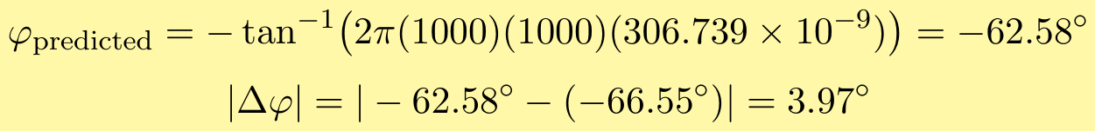
The phase discrepancy is 3.97°. The result supports capacitive behavior, but the magnitude and manually measured phase do not match exactly. Cursor placement and component/instrument nonidealities may contribute; their individual contributions were not measured.
The true capacitor value is unknown, so these comparisons are not percent errors against a manufacturer value. The resistor is used at its confirmed nominal value of 1 kΩ.

Q3.3.5 [Extra Credit] To determine the value of the component in the mystery box it is not necessary to use the V2-V1 phasor equations. However, if you determined these equations as extra credit you should experimentally verify, they are correct. Plug in your component value into the magnitude and phase equations for V2-V1 and verify they match your experimental result. Show all your work.
The same series current flows through R and C. With x = ωRC, the resistor voltage-divider expression and the predicted phasor are:
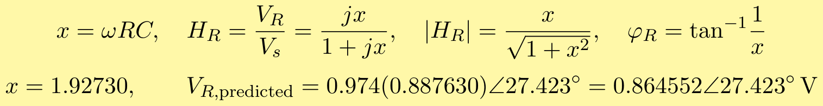
Measured: 0.859 ∠ +30.36° V. Predicted: 0.864552 ∠ +27.423° V. The measured magnitude is 0.64% below prediction; the phase is 2.94° above prediction.
Q3.3.6 Construct the circuit in LTSPICE utilizing the component type and value you found. Run a simulation and verify your experimental results. Be explicit! Don’t just include a SPICE plot and think you are done. You must measure the amplitude and phase and explicitly compare them to your experimentally measurements (Note: Remember Spice uses an ideal voltage source whereas you found in the ‘Measuring Source Impedance’ lab that the ADALM2000 has an internal impedance which effect the voltage output. For amplitude look at the ratio of V1/V2.)
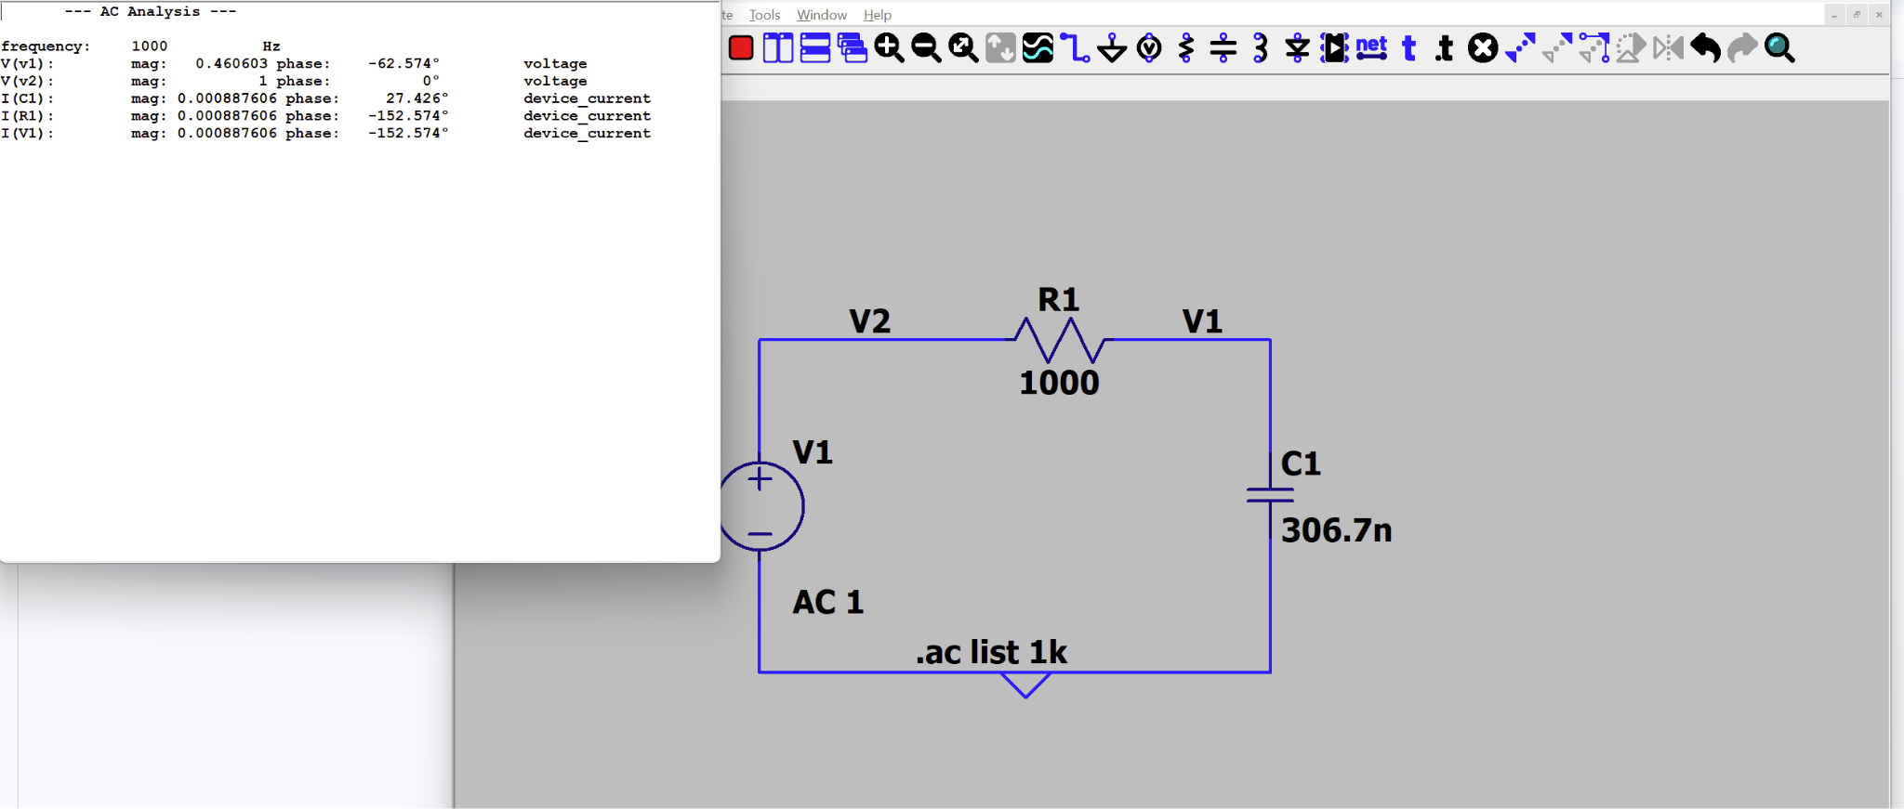
For the voltage ratios of the experimental and simulated ideal circuits we get $0.8972 V/1.948 V = 0.4606$ (experimental) and $0.4606 V/1.00 V = 0.4606$ (ideal). The simulated and experimental ratios almost perfectly match—and do perfectly match when rounded to the fourth decimal place. This proves the calculated 306.7 nF is accurate. For the phase angles, we found that the experimental angle was -66.55 degrees and the simulated ideal angle was -62.58 degrees, being only 3.97 degrees apart. This error could’ve either come from the tolerance variation of the resistor or very small misplacings in the cursors, but otherwise the angles are super close.

Very early in this lab it was observed that for a linear circuit with a single component it was unique and a measurement at a single frequency was adequate. It is now time to verify this assumption. To do this we will make measurements at two additional frequencies.
Q3.3.7 Half the frequency you used previously and make the same measurements of magnitude and phase as the new frequency. Include an O-Scope trace that supports your result.
Generator: sine, 500 Hz, 2 Vpp, zero offset. Scope: 200 μs/div, 3200 samples at 1 MS/s. CH2 input = 1.980 Vpp; CH1 box = 1.409 Vpp; M1 resistor = 1.366 Vpp. Input period = 2.000 ms.
The −43.675° phase is fitted from the exported CH1 and CH2 samples. The following original Scopy export supports the amplitude readings. Its time cursors were retained from a previous capture and are not valid for this phase.
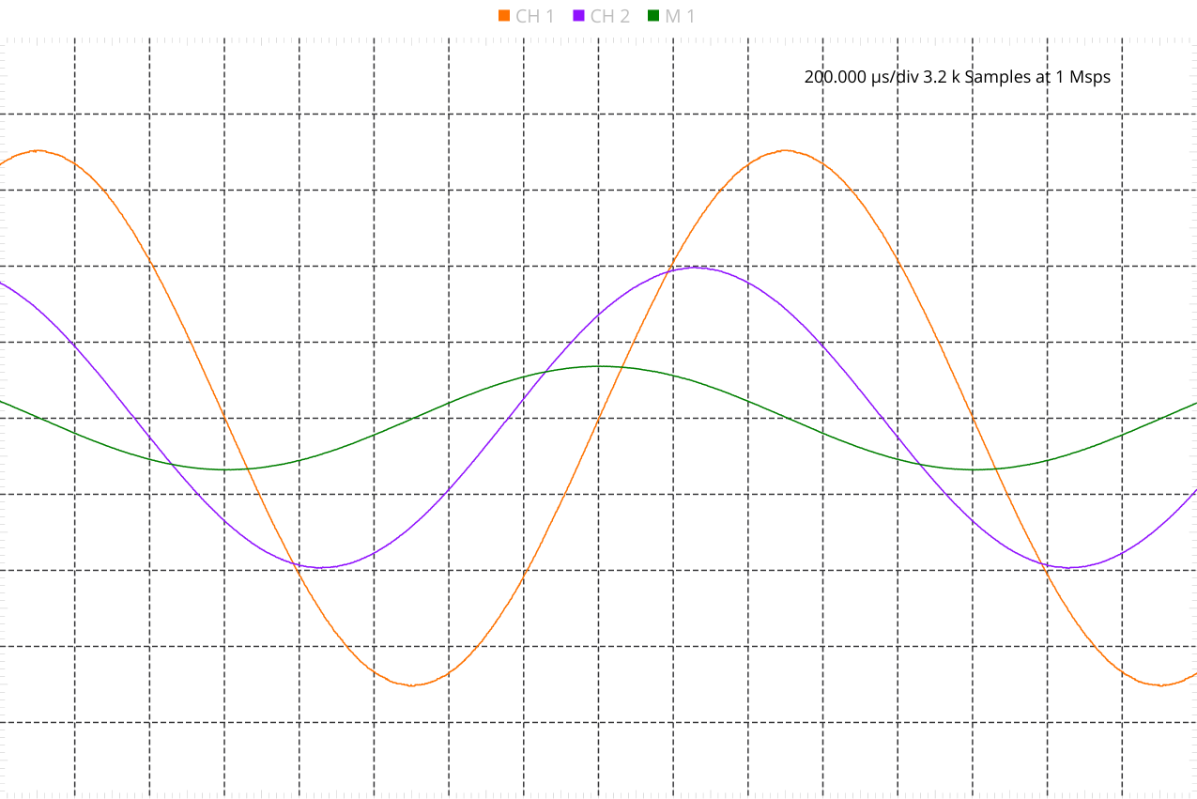
Q3.3.7 500 Hz manual cursor measurement
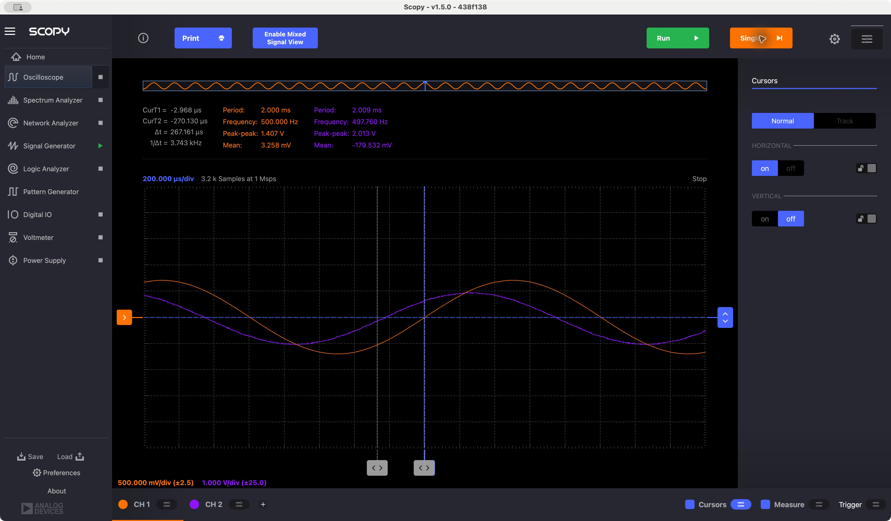
The cursor placement is approximate: the input cursor is slightly left of the rising zero crossing. This increases the indicated delay and phase magnitude. The displayed delay is used without correction; the 0.001 microsecond difference from subtracting rounded cursor positions is display rounding.
Calculation from this capture (peak phasors; input is the phase reference):
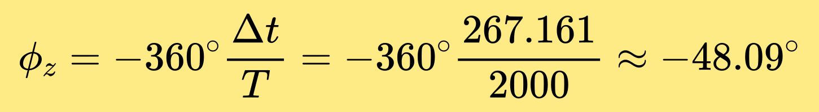
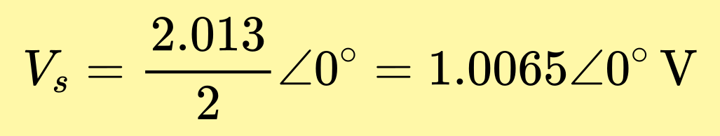
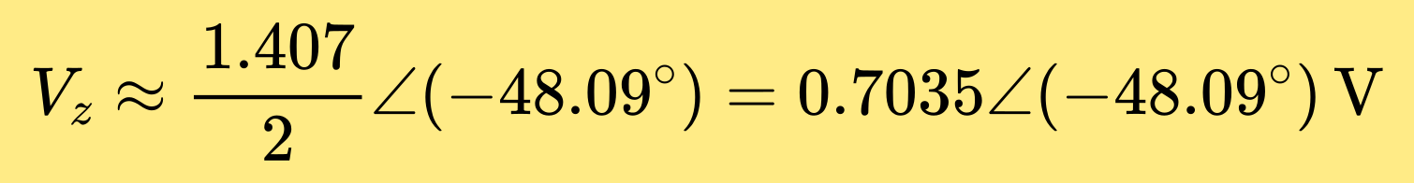
This repeat capture supplements the original CSV dataset above. The original fitted values used in the following component-value calculation are retained.

Q3.3.8 Use your measured results and analytical equations to determine the type and value of the component in Mystery Box #1. You may use the magnitude or phase, and you DON’T have to back substitute your result to verify your equations (You have already done that). Show all your work.
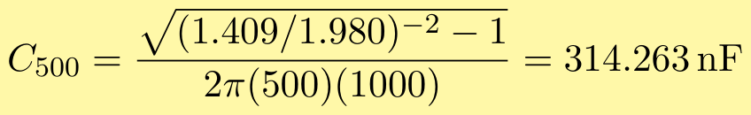
C ≈ 314.3 nF; capacitor; Box ID: 1-ZFR.

Q3.3.9 Double the frequency you used previously and make the same measurements of magnitude and phase as the new frequency. Include an O-Scope trace that supports your result.
The frequency is doubled relative to the original 1 kHz baseline: f = 2 kHz. Generator: sine, 2 Vpp, zero offset. CH2 input = 1.937 Vpp; CH1 box = 0.493364 Vpp; M1 resistor = 1.872 Vpp. Input period = 500.000 μs.
The −74.885° phase is fitted from the exported CH1 and CH2 samples. The original Scopy export below has cursors hidden; it supports the measured amplitudes and frequency.
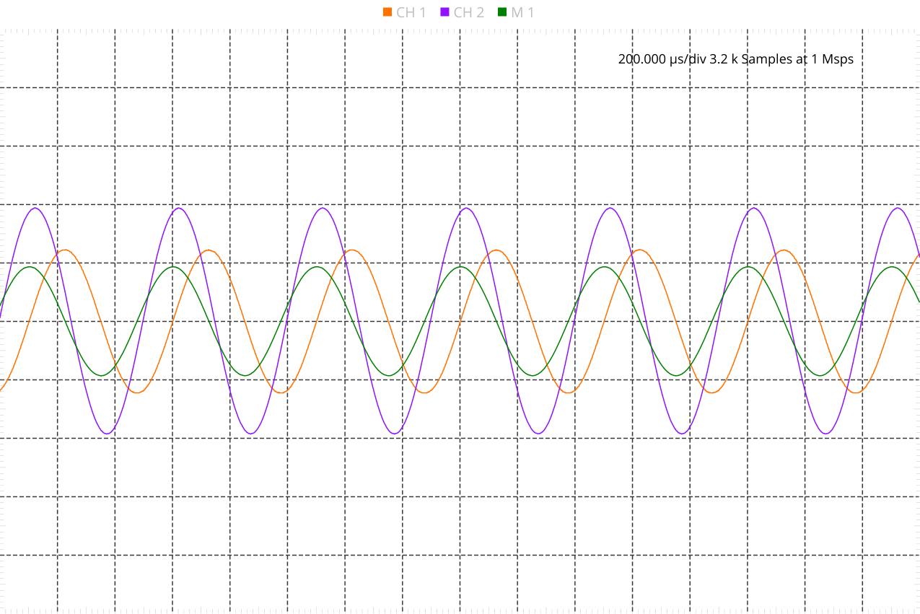
Q3.3.9 2 kHz manual cursor measurement
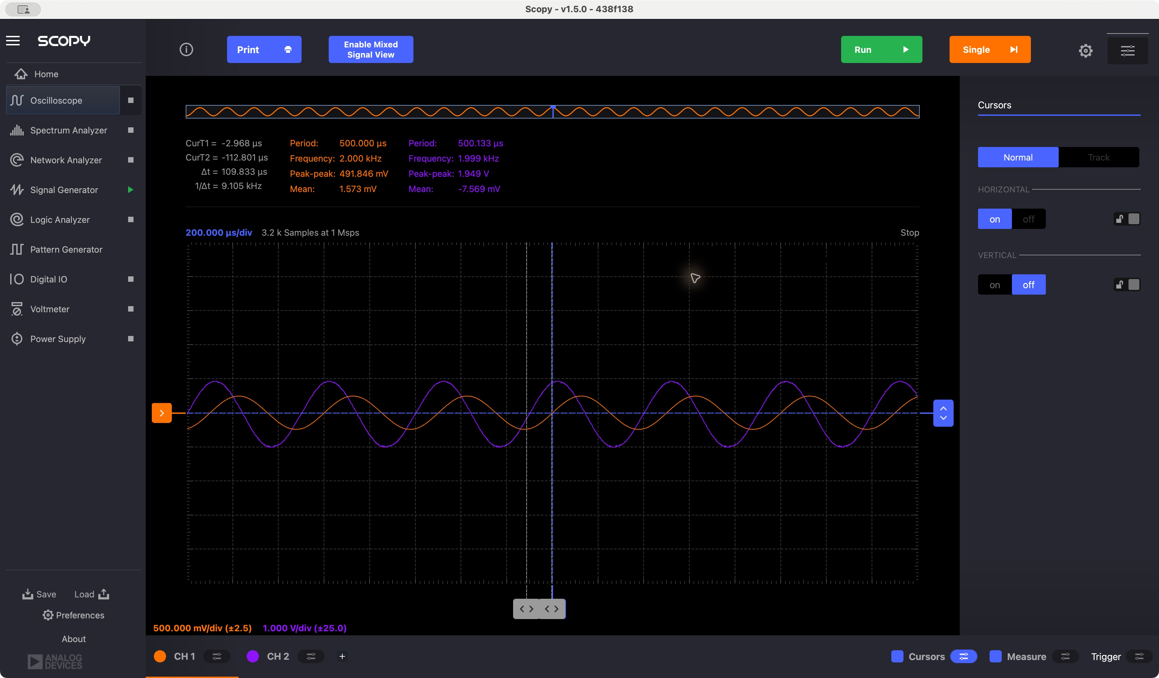
Time cursors are placed approximately at the corresponding rising zero crossings. The orange box voltage lags the purple input. The period used is 500.000 microseconds (2 kHz).
Calculation from this capture (peak phasors; input is the phase reference):
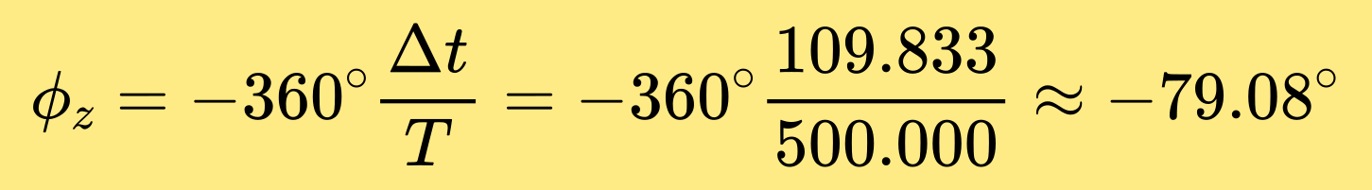
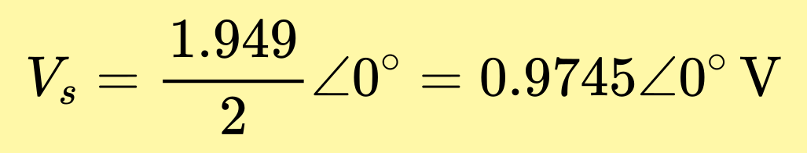
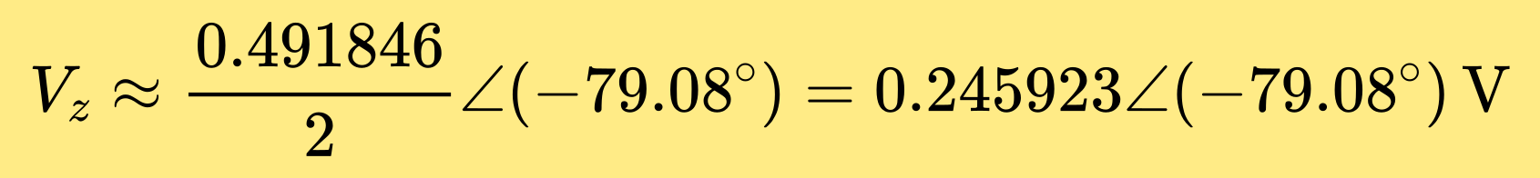
This repeat capture supplements the original CSV dataset above. The original fitted values used in the following component-value calculation are retained.

Q3.3.10 Use your measured results and analytical equations to determine the type and value of the component in Mystery Box #1. You may use the magnitude or phase, and you DON’T have to back substitute your result to verify your equations (You have already done that). Show all your work.
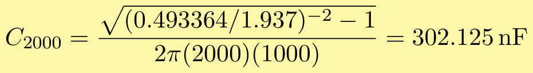
C ≈ 302.1 nF; capacitor; Box ID: 1-ZFR.
Q3.3.11 Do your results support the assumption that conducting the experiment at a single frequency is valid?
The three magnitude-based estimates are 314.263 nF, 306.739 nF, and 302.125 nF. Their small variation supports the single-capacitor model over the measured frequency range.
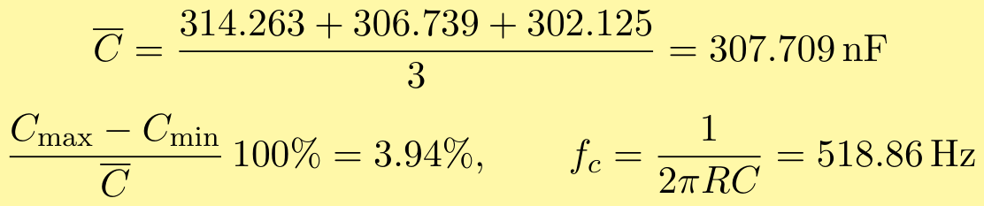
The results support single-frequency identification approximately when the component type and series resistance are known. Measurements at additional frequencies test that assumption. This is not proof that every unknown network can be uniquely identified from one frequency.
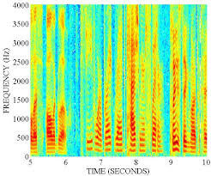
Let’s think about this circuit in another way. Assume Vs is the input to the circuit and V₁ is the output of the circuit. The input can now be a multiple frequency signal rather than a pure sinusoid. This is more realistic of most signals. For example, the voice band is generally considered to be 300 to 3400 Hz (this is the old telephone network definition, you will see some variation in this depending on your source). To the right you can see a Spectrogram of 10 seconds of speech. The vertical axis is frequency, and the color represents the power at that frequency. It is clear that any given time, there are many frequencies simultaneously present. The horizontal axis is time, and you can see that the frequency distribution changes as the speaker uses different sounds.
Figure 6: Example Spectrogram of 10sec of Speech

Q3.3.12 Populate the following table with your magnitude results. Assume that V1 is the output of the circuit and V2 is the input to the circuit. Study the table and speculate on what the effect of the Magic Box on the output if V2 were a multiple frequency signal (the speech example is just one possibility). Provide a discussion of your speculation/observations below the table. (Note: This question and discussion are a preview of the material we will cover in week 7 and 8.)
Frequency (Hz) | Source Amplitude (V2) | Magic Box Amplitude (V1) | Ratio V1/V2
500 | 0.990000 | 0.704500 | 0.711616
1000 | 0.974000 | 0.448582 | 0.460556
2000 | 0.968500 | 0.246682 | 0.254705
The amplitudes below are peak values (one half of the scope Vpp readings).
The capacitor output is a low-pass response: gain decreases as frequency increases. A multiple-frequency input therefore loses more of its high-frequency content than its low-frequency content. For speech this would reduce high-frequency detail and alter the waveform. The estimated cutoff is about 519 Hz; the transition is gradual, not an abrupt frequency boundary.
Conclusion: Box 1-ZFR contains a capacitor, approximately 0.307 μF using the 1 kΩ series resistor.

3.4 MYSTERY BOX #2.
You will now repeat the procedure for Mystery Box #2.
Mystery Box #2: Vary the frequency (limit yourself to 10Hz to 300kHz) until you get waveforms like what you generated in “Week 4 Lab 3 Measuring Impedance”. Make sure you can measure the amplitude difference and phase difference (if there is one) accurately with the cursors.
Q3.4.1 Mystery Box #2: Based on a visual inspection of the O-scope Trace is the Mystery Box a resistor, capacitor, or inductor? Why?
The box voltage (CH1) leads the input (CH2), which indicates inductive behavior for the tested series circuit. The measured lead was +6.54° at 5 kHz, +18.33° at 10 kHz, and +13.09° at 20 kHz.
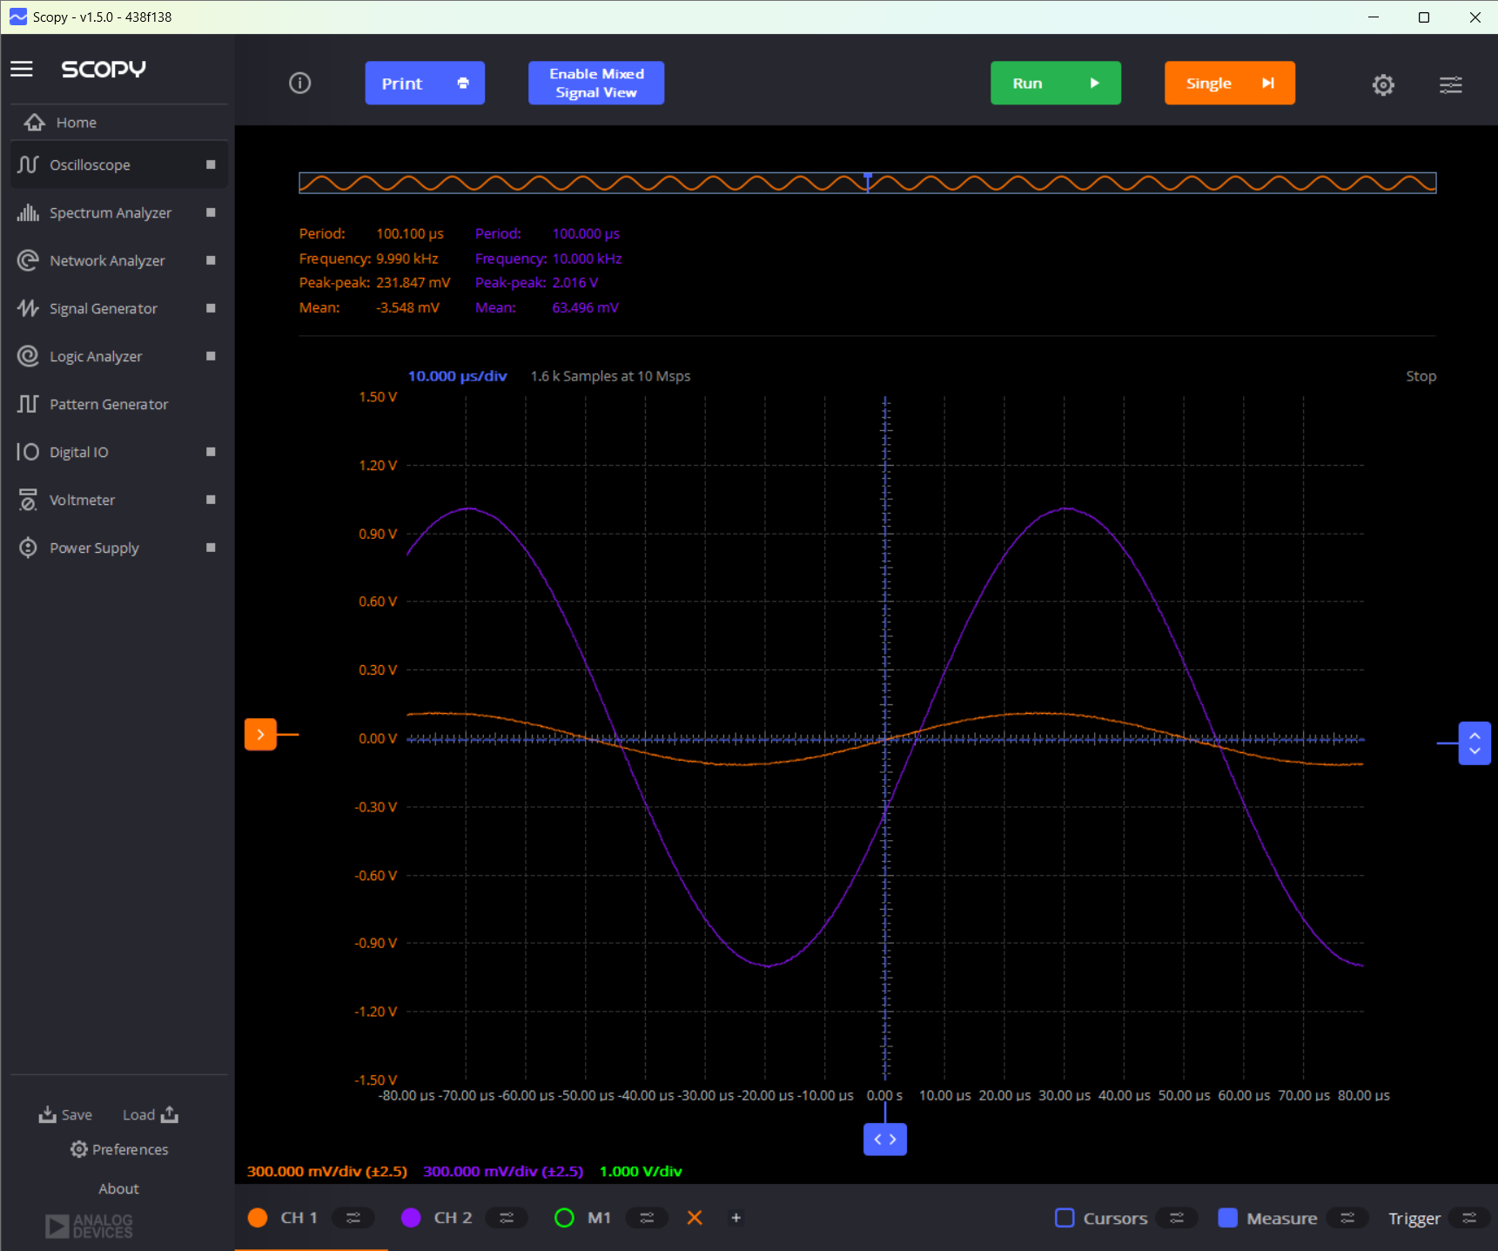

Q3.4.2 Mystery Box #2: Provide two O-Scope Screen Captures. They should include the frequency and amplitude of Channel #1, Channel #2, and Channel #2 – Channel #1 in the measurement window. For the first plot use the cursors to measure the time delay between V_{s} = Channel #2 V and V_{Z} = Channel #1 V from which you will determine the relative phase. For the second plot use the cursors to measure the time delay between V_{s} and V_{r} = Channel #2 V – Channel #1 V (e.g. the math trace).
Note: If the absolute value of your measured phase between Vs and Vr is greater than 50 degrees, adjust the frequency of your signal until you are less than 50 degrees. The ATAN function becomes very steep as you approach 90 degrees which makes for a very sensitive measurement as the phase approaches 90 degrees. This step will keep you out of trouble when you double the frequency later in the lab.
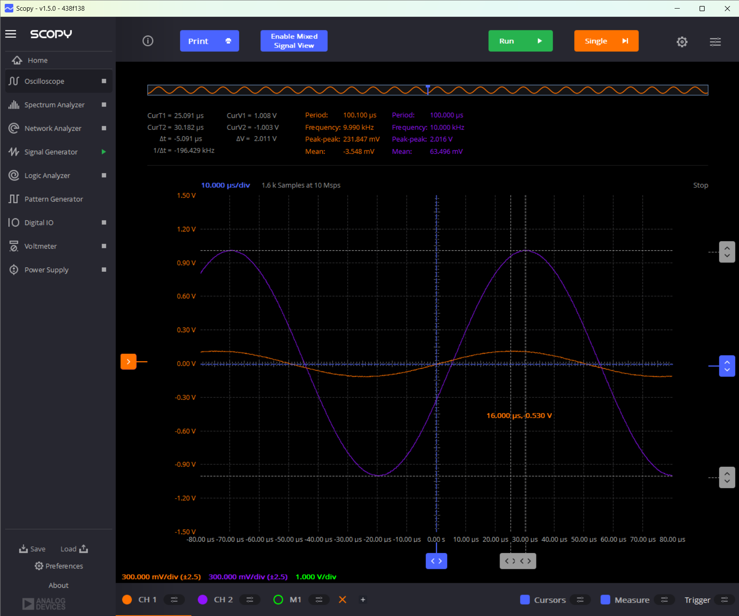

10 kHz, first capture. CH1 = 0.231847 Vpp at 9.990 kHz and CH2 = 2.016 Vpp at 10.000 kHz. M1 is shown in the second capture.

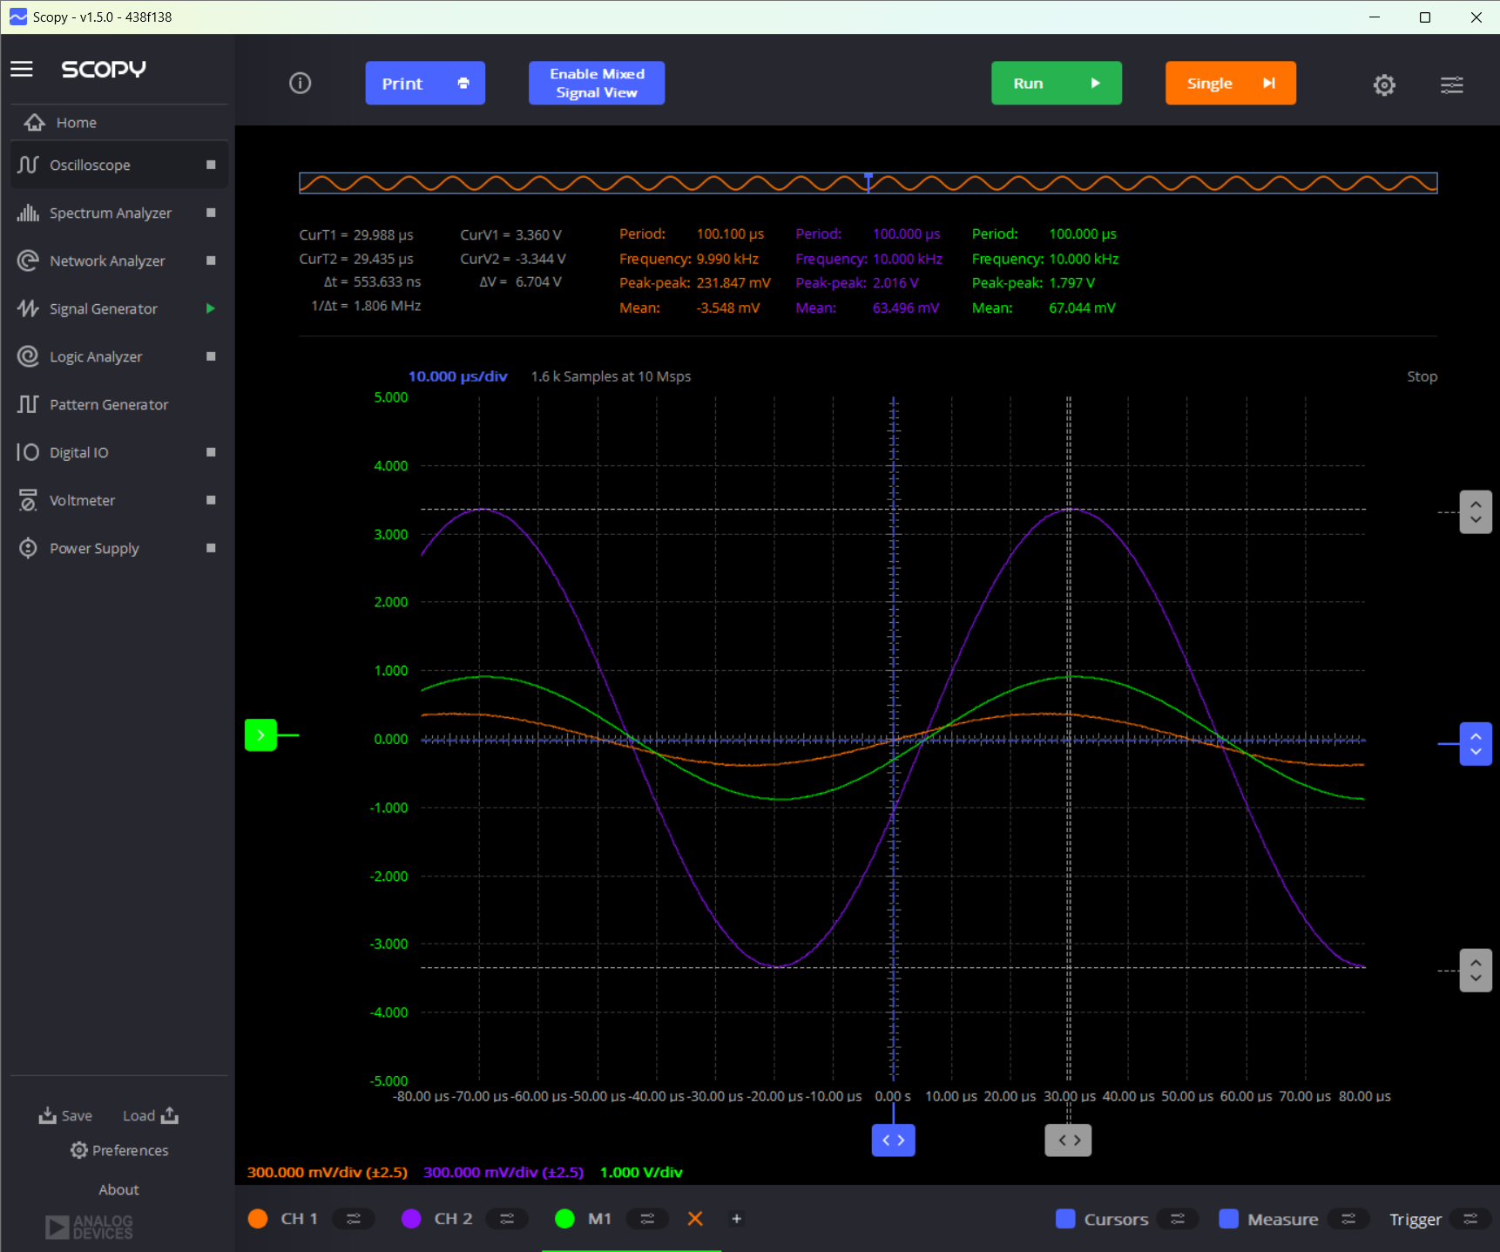

10 kHz, second capture. M1 = CH2 − CH1 = 1.797 Vpp at 10.000 kHz.

Q3.4.3 Mystery Box #2: From these measurements determine the three voltages phasors and write them here:
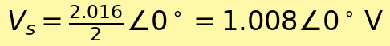
The M1 trace gives 0.8985 V peak and a cursor phase magnitude of 1.99°. The phasor subtraction indicates a lag.
Q3.4.4 Use your analytical results from section 3.1 and your experimental results to determine the contents of Mystery Box #2. You will need to plug your measured results into the magnitude equation or the phase equation and solve for C, L, or R (One of them is a lot easier mathematically). Once you find C, L, or R back substitute your result into the whichever of the magnitude or phase equations you didn’t use and verify the result against your measurement. For example, if you have a capacitor and you used the phase equation to determine C, then plug C back into magnitude equation and verify that matches your measured result. Show your work.
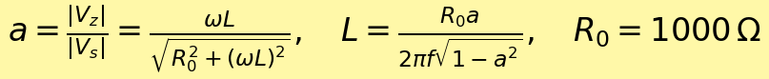
Box ID 6-GTA. The waveform indicates inductive behavior. The 10 kHz amplitude-only fit is 1.84 mH.
The measured box phase was +18.33°, a 65.07° difference. The phase measurement does not validate the ideal-inductor fit.
Q3.4.5 [Extra Credit] To determine the value of the component in the mystery box it is not necessary to use the V2-V1 phasor equations. However, if you determined these equations as extra credit you should experimentally verify, they are correct. Plug in your derived component value in the magnitude and phase equations from section 3.1 and verify they match your experimental result. Show all your work.
The M1 trace measured 0.8985 V peak, about 10.3% below the prediction. The cursor gave a phase magnitude of 1.99°, compared with 6.60° predicted. The CH1/CH2 phasor subtraction gives a lag of 2.32°, about 4.28° less than the predicted lag.
Q3.4.6 Construct the circuit in LTSPICE utilizing the component type and value you found. Run a simulation and verify your experimental results. Be explicit! Don’t just include a SPICE plot and think you are done. You must measure the amplitude and phase and explicitly compare them to your experimentally measurements (Note: Remember Spice uses an ideal voltage source whereas you found in the ‘Measuring Source Impedance’ lab that the ADALM2000 has an internal impedance which effect the voltage output. For amplitude look at the ratio of V1/V2.
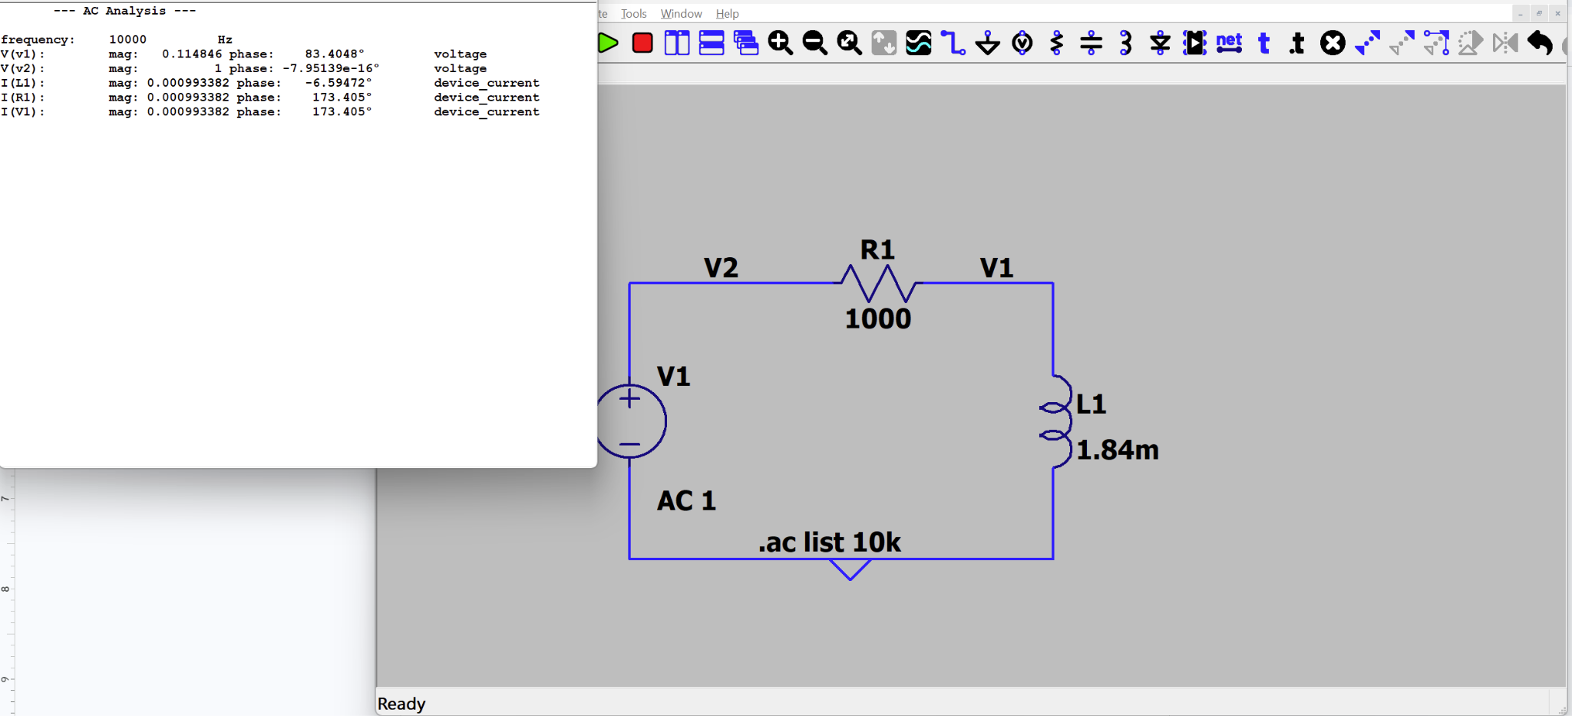
At 10 kHz, LTspice gave a box-to-input gain of 0.1148, compared with 0.1150 from Scopy, an absolute difference of 0.0002. We used the measured gain to estimate L, so the gain comparison checks the fitted result. The simulated and measured box phases were +83.40° and +18.33°, a difference of 65.07°. The measured phase does not validate the ideal 1.84 mH model.

Very early in this lab it was observed that for a linear circuit with a single component it was unique and a measurement at a single frequency was adequate. It is now time to verify this assumption. To do this we will make measurements at two additional frequencies.
Q3.4.7 Half the frequency you used previously and make the same measurements of magnitude and phase as the new frequency. Include an O-Scope trace that supports your result.
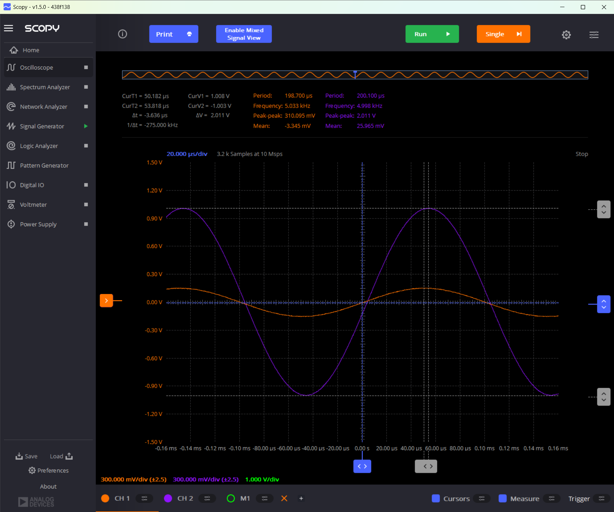

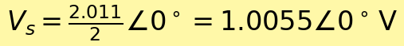

Q3.4.8 Use your measured results and analytical equations to determine the type and value of the component in Mystery Box #1. You may use the magnitude or phase, and you DON’T have to back substitute your result to verify your equations (You have already done that). Show all your work.
Box ID 6-GTA. Inductive behavior. The 5 kHz amplitude-only fit is 4.97 mH.

Q3.4.9 Double the frequency you used previously and make the same measurements of magnitude and phase as the new frequency. Include an O-Scope trace that supports your result.
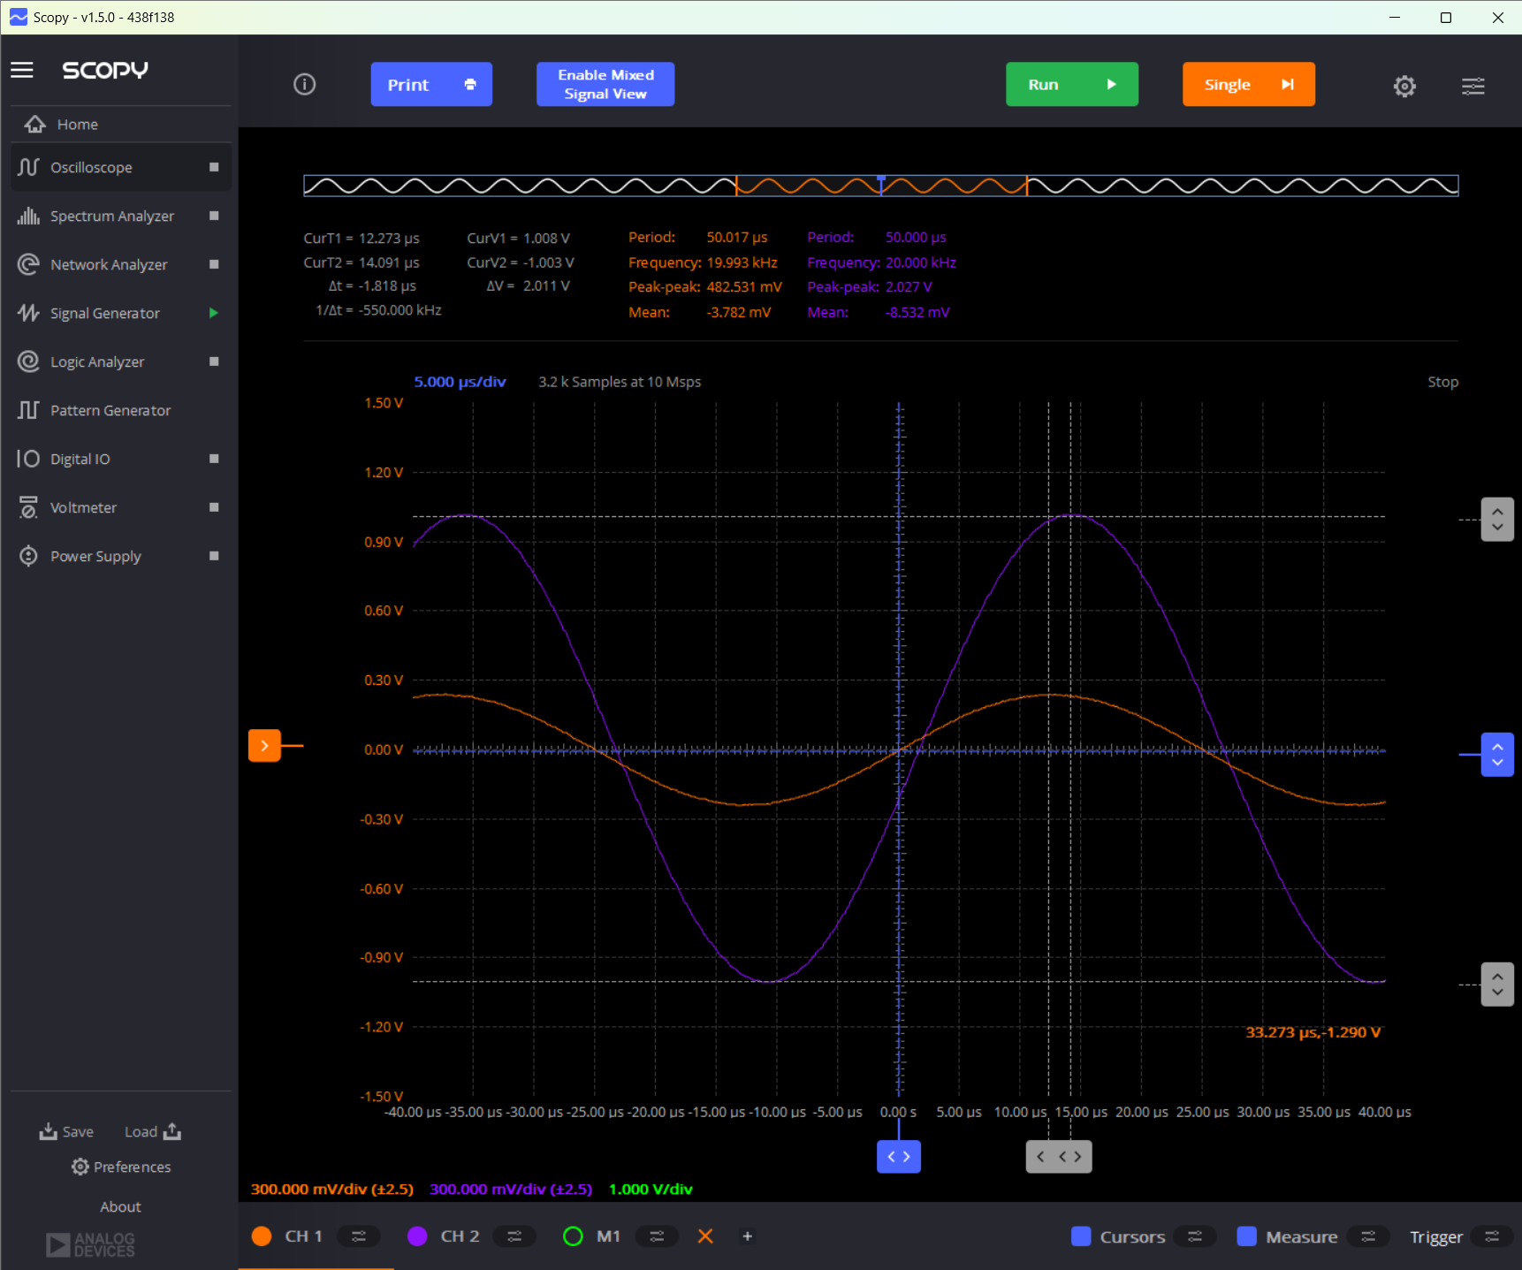

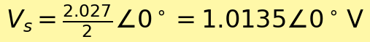
Q3.4.10 Use your measured results and analytical equations to determine the type and value of the component in Mystery Box #1. You may use the magnitude or phase, and you DON’T have to back substitute your result to verify your equations (You have already done that). Show all your work.
Box ID 6-GTA. Inductive behavior. The 20 kHz amplitude-only fit is 1.95 mH.
Q3.4.11 Do your results support the assumption that conducting the experiment at a single frequency is valid?
Our measurements do not support a reliable single-frequency inductance estimate for Box 6-GTA. The ideal RL fits were 4.97 mH at 5 kHz, 1.84 mH at 10 kHz, and 1.95 mH at 20 kHz. The 5 kHz estimate is over twice the other two, and the 10 kHz fit misses the measured phase by 65.07°.

Let’s think about this circuit in another way. Assume Vs is the input to the circuit and V₁ is the output of the circuit. The input can now be a multiple frequency signal rather than a pure sinusoid. This is more realistic of most signals. For example, the voice band is generally considered to be 300 to 3400 Hz (this is the old telephone network definition, you will see some variation in this depending on your source). To the right you can see a Spectrogram of 10 seconds of speech. The vertical axis is frequency, and the color represents the power at that frequency. It is clear that any given time, there are many frequencies simultaneously present. The horizontal axis is time, and you can see that the frequency distribution changes as the speaker uses different sounds.
Figure 6: Example Spectrogram of 10sec of Speech

Q3.4.12 Populate the following table with your magnitude results. Assume that V1 is the output of the circuit and V2 is the input to the circuit. Study the table and speculate on what the effect of the Magic Box on the output if V2 were a multiple frequency signal (the speech example is just one possibility). Provide a discussion of your speculation/observations below the table. (Note: This question and discussion are a preview of the material we will cover in week 7 and 8.)
The box-to-input gain falls from 0.1542 at 5 kHz to 0.1150 at 10 kHz, then rises to 0.2381 at 20 kHz. All three components would be attenuated, with the 10 kHz component reduced the most and the 20 kHz component reduced the least.
A signal containing those frequencies would therefore change shape as the relative amplitudes change. Our measurements cover 5–20 kHz, above the speech band described in the prompt.

Frequency (Hz) | Source Amplitude (V2) | Magic Box Amplitude (V1) | Ratio V1/V2
5,000 | 1.0055 | 0.15505 | 0.1542
10,000 | 1.0080 | 0.11592 | 0.1150
20,000 | 1.0135 | 0.24127 | 0.2381

