Week 6 Lab 5: Mystery Box Challenge Part #1
(12/17/2025)

1.0 Introduction
In this lab you will determine the ‘value’ of two unknown components. Each Mystery box contains one component, and it could be a resistor, capacitor, or resistor.
Q 1.1 :
Lab Group Number: 35
Lab Group Leader:
Lab Group Member Names: Tong Su, Carter Flynn Swanson, Zachary Kramer
Progress version: Q3.3.1–Q3.3.4 updated with measurements and screenshots. Other unanswered sections remain pending.
Date: .
Full Name of Lab: .

2.0 Background
In the “week 4 Lab 3 – Measuring Impedance” you used your oscilloscope and signal generator to determine the impedance of a known component by determining the current phasor and applying Ohm’s law. This lab is a logical extension where the component type and value are unknown. You will use a similar technique to that employed in lab 3 to determine the impedance, and from that find the component type and value.
As the experimental technique and many of the observations are similar to lab 3, I recommend you have a copy of your lab report available to you as you execute this lab.
In general, the values of components of a linear network which produce a specific impedance at a specific frequency are not unique. However, for a single component they are theoretically unique, and you can utilize a single frequency. In practice you should ensure that the frequency you utilize produces a meaningful measurement and utilize multiple frequencies to verify your result.

3.0 Procedure

3.1. Analytical Predictions.
A schematic of the experimental setup is shown in Figure 1.0. We can determine the expected values of the measurements based on the analytical techniques we have developed in this class. This is similar to the analysis you executed for Lab 3. However, in this case we are only trying to find the single unknown variable (C, L, or R) rather than the current. Thus, we only must know the V1 and V2 phasors. For this analysis assume the phase of the source is 0 deg, and the amplitude of the source is 1V (e.g. 2Vp-p).

Q3.1.1 Assume the magic box has a resistor of unknow value inside. Determine the following Phasors as a function of the unknown resistor value R. Show all your work.

V_{s} = V Channel 2 = / .
V_{z} = V_{R} = V Channel 1 = / .
V_{1K} = V Channel 2 – V Channel 1 = / .

Q3.1.2 Assume the magic box has a capacitor of unknow value inside. Determine the following Phasors as a function of the unknown capacitor value C and frequency (w). Remember | V | = [V V*]^1/2 if V is a phasor and V* is the complex conjugate. The complex algebra gets a little messy, but if you go slow and are patient you can grind it out. The magnitude is a complicated expression, while the phase simplifies to a fair simple expression. Show all your work.

V_{s} = V Channel 2 = / .
V_{z} = V_{c} = V Channel 1 = / .
[Extra Credit] V_{R} = V Channel 2 – V Channel 1 = / .
Q3.1.3 Assume the magic box has an inductor of unknow value inside. Determine the following Phasors as a function of the unknown Inductor value L and frequency (w). Show all your work.

V_{s} = V Channel 2 = / .
V_{z} = V_{c} = V Channel 1 = / .
[Extra Credit] V_{R} = V Channel 2 – V Channel 1 = / .

3.2. Experimental Setup.
Set up your signal generator and oscilloscope the same way as for “Week 4 Lab 3 Measuring Impedance”. You will replace the capacitor/inductor from lab 4 with one of your mystery boxes. Use a 2Vp-p signal for this lab (e.g. Amplitude is 1V).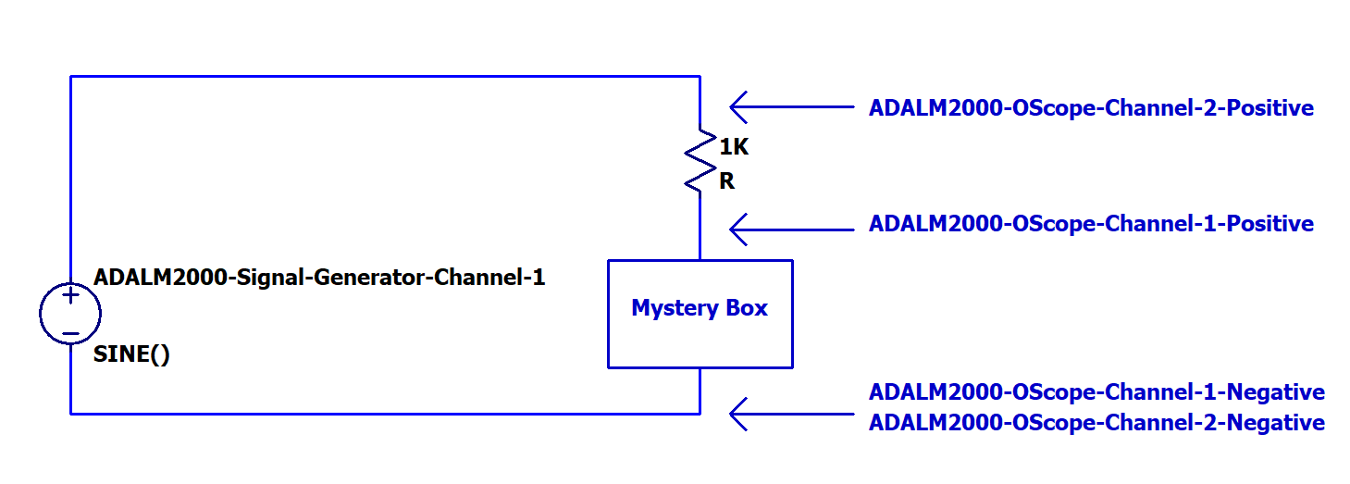
Figure 1: Experimental Schematic
To connect the mystery box into the circuit, utilize the IC Clamps that are part of your kit as shown in the following figure. Be careful with the leads on the Mystery Box as they are easy to break.
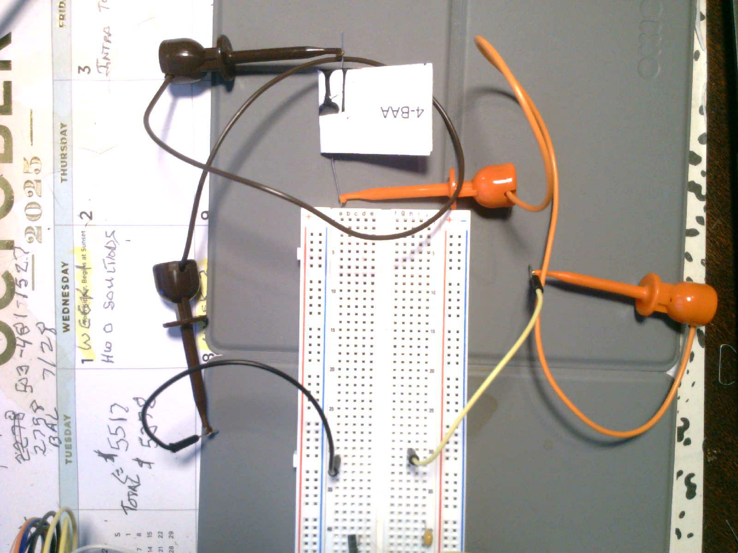
Figure 2: Mystery Box Connections
Q3.2.1 Include a photograph and a TinkerCAD Breadboard layout of your experimental setup.

3.3. Mystery Box #1.
Mystery Box #1: Vary the frequency (limit yourself to 10Hz to 300kHz) until you get waveforms similar to what you generated in Lab 3. Make sure you can measure the amplitude difference and phase difference (if there is one) accurately with the cursors.
Q3.3.1 Mystery Box #1: Based on a visual inspection of the O-scope Trace is the Mystery Box a resistor, capacitor, or inductor? Why? (This is a very important question. You will have grave difficulty with the rest of this lab if you can’t answer it. Contact me with questions)
Box 1-ZFR is identified as a capacitor. The box voltage (CH1) lags the input voltage (CH2) by approximately 66.55°, while the resistor voltage (M1 = CH2 − CH1) leads the input. This behavior is consistent with a capacitor in the given series circuit. A resistor would have no phase shift, whereas the voltage across an inductor would lead the input.
NOTE: If you determine that your Magic Box has no phase shift, then you may neglect some of the portions of some questions that involve computations of the phase. Please explicitly identify that you didn’t do something because your phase measurement was zero.

Q3.3.2 Mystery Box #1: Provide two O-Scope Screen Captures. They should include the frequency and amplitude of Channel #1, Channel #2, and Channel #2 – Channel #1 in the measurement window. For the first plot use the cursors to measure the time delay between V_{s} = Channel #2 V and V_{Z} = Channel #1 V from which you will determine the relative phase (If there is a phase difference). For the second plot use the cursors to measure the time delay between V_{s} and V_{r} = Channel #2 V – Channel #1 V (e.g. the math trace).
Note: If the absolute value of your measured phase between Vs and Vr is greater than 50 degrees, adjust the frequency of your signal until you are less than 50 degrees. The ATAN function becomes very steep as you approach 90 degrees which makes for a very sensitive measurement as the phase approaches 90 degrees. This step will keep you out of trouble when you double the frequency later in the lab.
Q3.3.2 Screenshot 1 Input and mystery box voltage
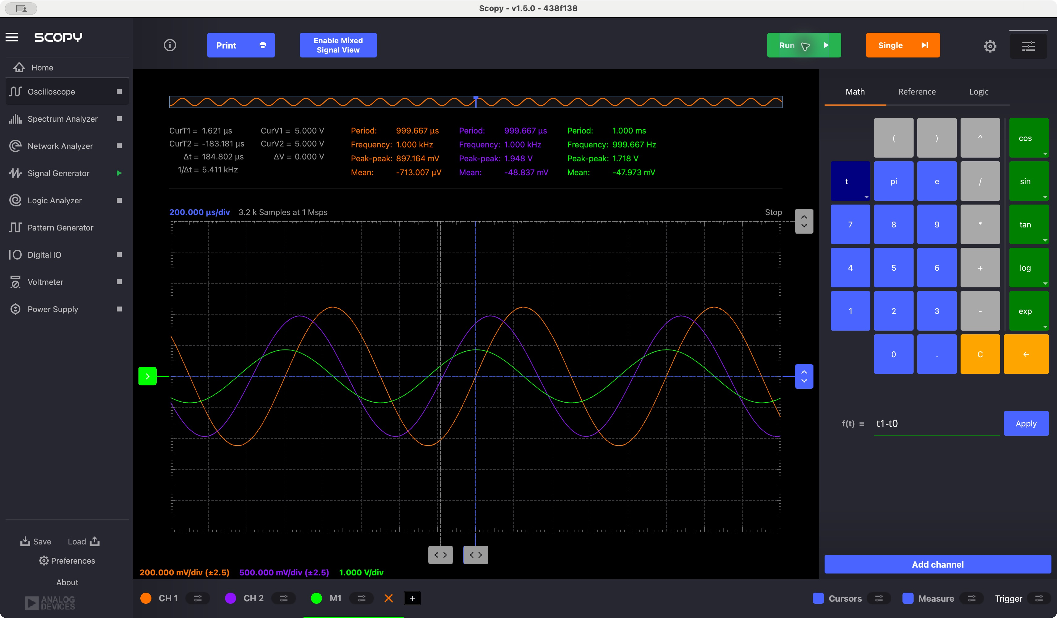
Box 1-ZFR at approximately 1.000 kHz. CH2 = input (purple), CH1 = box voltage (orange), and M1 = CH2 − CH1 (green). Vpp: CH2 1.948 V; CH1 0.897164 V; M1 1.718 V. The input period is 999.667 µs. The box rising zero crossing follows the input by 184.802 µs, giving φz = −66.55°.
Q3.3.2 Screenshot 2 Input and resistor voltage
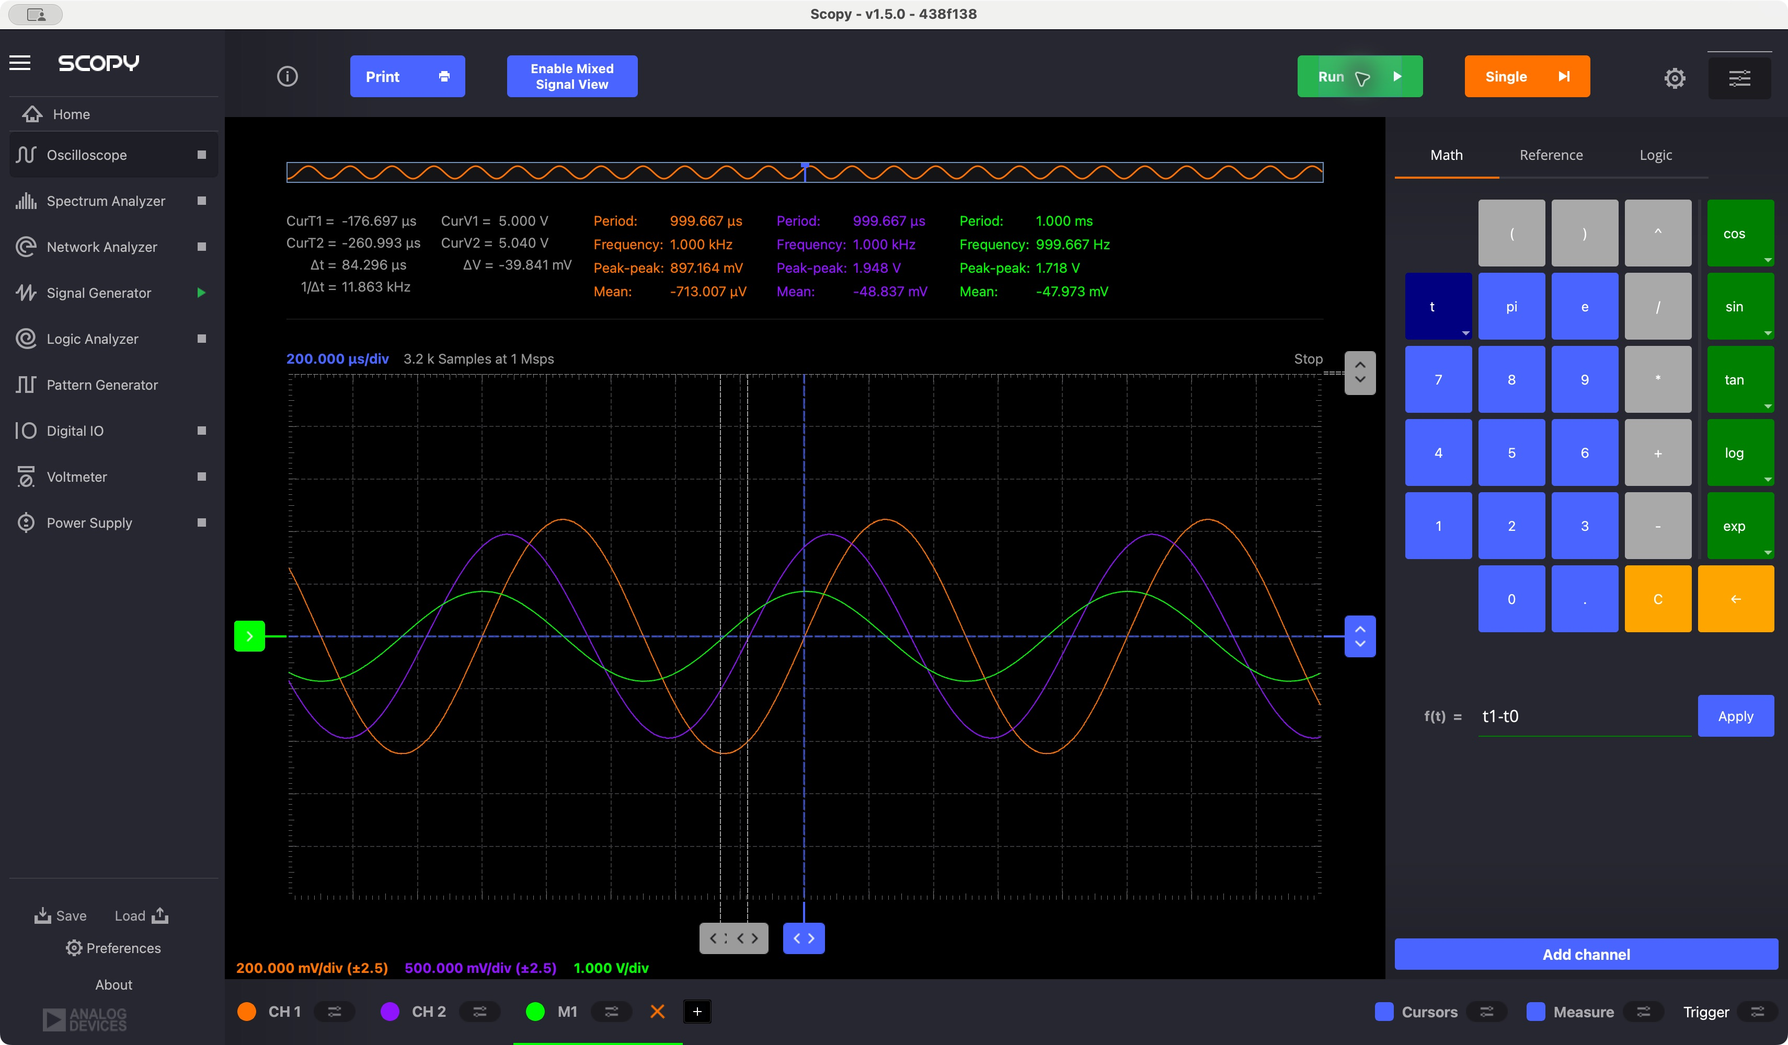
The resistor voltage M1 rises through zero before the input CH2. T1 = −176.697 µs (input), T2 = −260.993 µs (resistor); displayed Δt = T1 − T2 = 84.296 µs. Therefore φr = +30.36°, satisfying |φr| < 50°. Cursor locations are approximate manual measurements. The displayed 1/Δt is not the signal frequency.

Q3.3.3 Mystery Box #1: From these measurements determine the three voltages phasors and write them here:
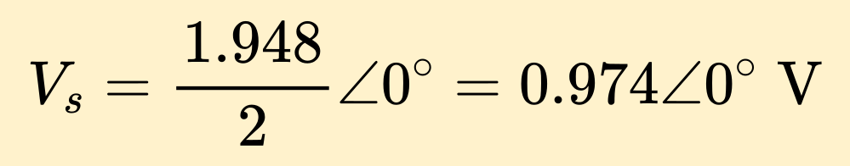
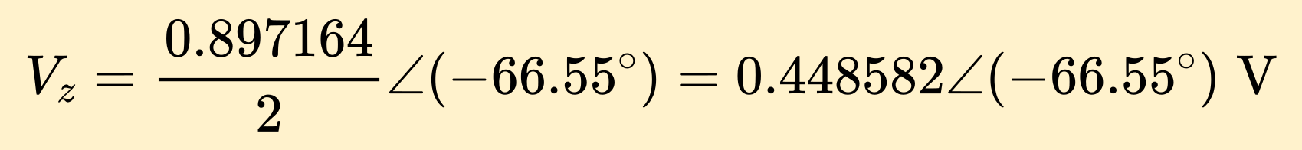
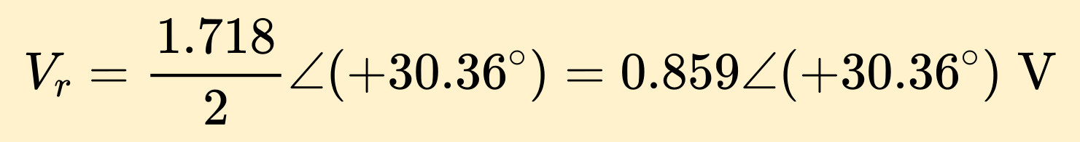
Peak-amplitude phasors are used, with the input as the zero-phase reference. The resistor voltage leads the input, giving a positive angle. The phase calculations are:
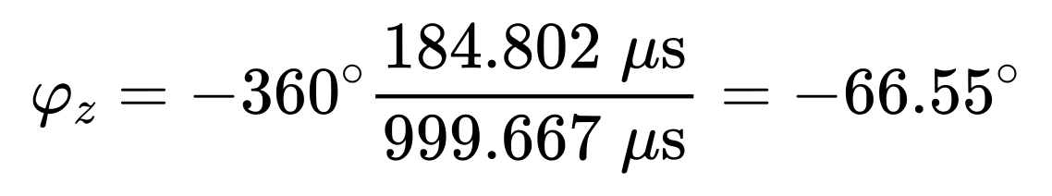
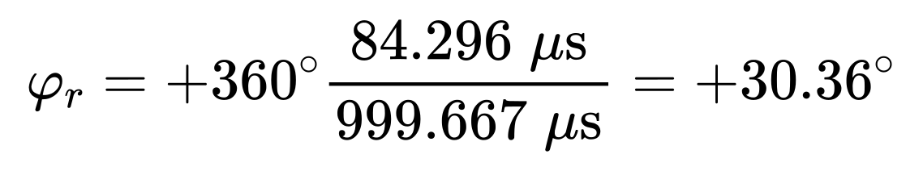
Q3.3.4 Use your analytical results from section 3.1 and your experimental results to determine the contents of Mystery Box #1. You will need to plug your measured results into the magnitude equation or the phase equation and solve for C, L, or R (One of them is a lot easier mathematically). Once you find C, L, or R back substitute your result into the whichever of the magnitude or phase equations you didn’t use and verify the result against your measurement. For example, if you have a capacitor and you used the phase equation to determine C, then plug C back into magnitude equation and verify that matches your measured result. Show your work.
The external series resistor is 1 kΩ ±5%, identified by brown–black–red–gold bands. We use its nominal resistance R = 1000 Ω; no multimeter resistance measurement is available.
For a series RC circuit with the output measured across the capacitor:
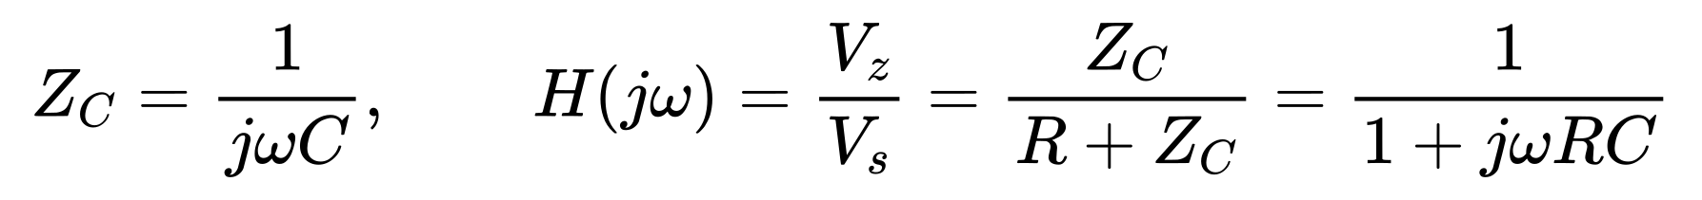
The magnitude and phase relations are:
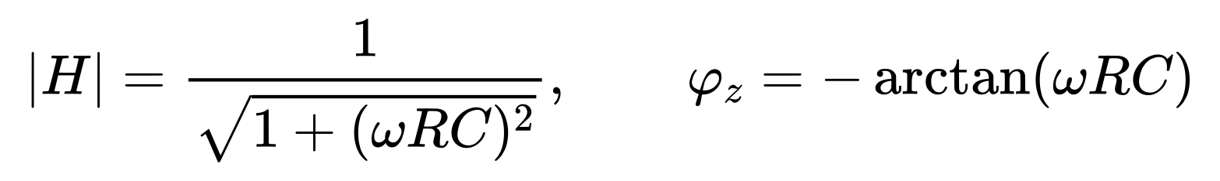
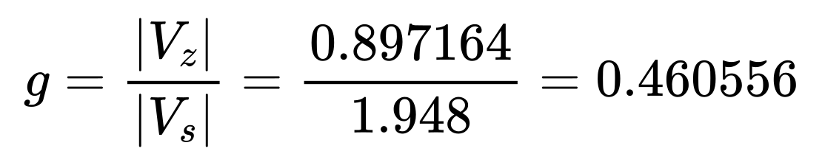
Solve the magnitude equation for C, using f ≈ 1000 Hz and the nominal R = 1000 Ω:
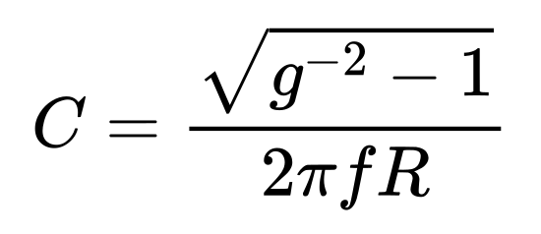
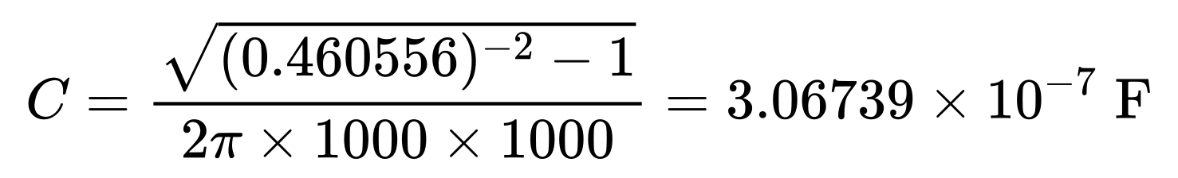
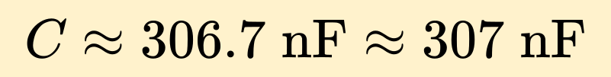
Independent verification by back-substitution into the phase equation:
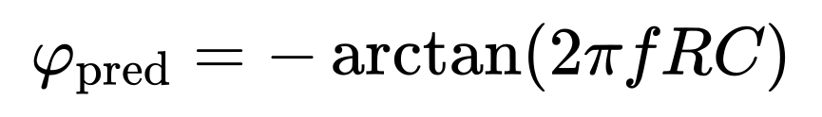
The comparison supports capacitive behavior but does not show exact agreement. The two measured output angles differ by 96.91°, compared with 90° for an ideal RC circuit, indicating measurement inconsistency. Manual cursor placement and nonideal behavior may contribute; their individual effects were not measured.
The actual capacitance is unknown, so no percent error relative to a true or nominal capacitor value is claimed. The estimate uses the nominal external resistance. Its ±5% tolerance alone corresponds to about 292.1–322.9 nF for the same measured gain; this is not a total uncertainty interval.
Result: capacitor, approximately 307 nF, inferred from the measured magnitude ratio at 1 kHz. Additional-frequency measurements remain to be completed.
Final identification: capacitor, C ≈ 307 nF using R = 1 kΩ nominal. BOX ID: 1-ZFR.

Q3.3.5 [Extra Credit] To determine the value of the component in the mystery box it is not necessary to use the V2-V1 phasor equations. However, if you determined these equations as extra credit you should experimentally verify, they are correct. Plug in your component value into the magnitude and phase equations for V2-V1 and verify they match your experimental result. Show all your work.

Q3.3.6 Construct the circuit in LTSPICE utilizing the component type and value you found. Run a simulation and verify your experimental results. Be explicit! Don’t just include a SPICE plot and think you are done. You must measure the amplitude and phase and explicitly compare them to your experimentally measurements (Note: Remember Spice uses an ideal voltage source whereas you found in the ‘Measuring Source Impedance’ lab that the ADALM2000 has an internal impedance which effect the voltage output. For amplitude look at the ration of V1/V2.)

Very early in this lab it was observed that for a linear circuit with a single component it was unique and a measurement at a single frequency was adequate. It is now time to verify this assumption. To do this we will make measurements at two additional frequencies.
Q3.3.7 Half the frequency you used previously and make the same measurements of magnitude and phase as the new frequency. Include an O-Scope trace that supports your result.

V_{s} = V Channel 2 = / .
V_{z} = V_{Z} = V Channel 1 = / .

Q3.3.8 Use your measured results and analytical equations to determine the type and value of the component in Mystery Box #1. You may use the magnitude or phase, and you DON’T have to back substitute your result to verify your equations (You have already done that). Show all your work.

R/L/C = __________________________ BOX ID: __________________________

Q3.3.9 Double the frequency you used previously and make the same measurements of magnitude and phase as the new frequency. Include an O-Scope trace that supports your result.

V_{s} = V Channel 2 = / .
V_{z} = V_{Z} = V Channel 1 = / .

Q3.3.10 Use your measured results and analytical equations to determine the type and value of the component in Mystery Box #1. You may use the magnitude or phase, and you DON’T have to back substitute your result to verify your equations (You have already done that). Show all your work.

Q3.3.11 Do your results support the assumption that conducting the experiment at a single frequency is valid?

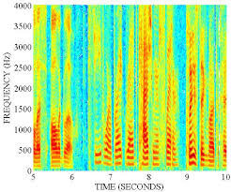
Let’s think about this circuit in another way. Assume Vs is the input to the circuit and V₁ is the output of the circuit. The input can now be a multiple frequency signal rather than a pure sinusoid. This is more realistic of most signals. For example, the voice band is generally considered to be 300 to 3400 Hz (this is the old telephone network definition, you will see some variation in this depending on your source). To the right you can see a Spectrogram of 10 seconds of speech. The vertical axis is frequency, and the color represents the power at that frequency. It is clear that any given time, there are many frequencies simultaneously present. The horizontal axis is time, and you can see that the frequency distribution changes as the speaker uses different sounds.
Figure 6: Example Spectrogram of 10sec of Speech

Q3.3.12 Populate the following table with your magnitude results. Assume that V1 is the output of the circuit and V2 is the input to the circuit. Study the table and speculate on what the effect of the Magic Box on the output if V2 were a multiple frequency signal (the speech example is just one possibility). Provide a discussion of your speculation/observations below the table. (Note: This question and discussion are a preview of the material we will cover in week 7 and 8.)
Frequency (Hz) | Source Amplitude (V2) | Magic Box Amplitude (V1) | Ratio V1/V2

3.4 Mystery Box #2.
You will now repeat the procedure for Mystery Box #2.
Mystery Box #2: Vary the frequency (limit yourself to 10Hz to 300kHz) until you get waveforms like what you generated in “Week 4 Lab 3 Measuring Impedance”. Make sure you can measure the amplitude difference and phase difference (if there is one) accurately with the cursors.
Q3.4.1 Mystery Box #2: Based on a visual inspection of the O-scope Trace is the Mystery Box a resistor, capacitor, or inductor? Why?

Q3.4.2 Mystery Box #2: Provide two O-Scope Screen Captures. They should include the frequency and amplitude of Channel #1, Channel #2, and Channel #2 – Channel #1 in the measurement window. For the first plot use the cursors to measure the time delay between V_{s} = Channel #2 V and V_{Z} = Channel #1 V from which you will determine the relative phase. For the second plot use the cursors to measure the time delay between V_{s} and V_{r} = Channel #2 V – Channel #1 V (e.g. the math trace).
Note: If the absolute value of your measured phase between Vs and Vr is greater than 50 degrees, adjust the frequency of your signal until you are less than 50 degrees. The ATAN function becomes very steep as you approach 90 degrees which makes for a very sensitive measurement as the phase approaches 90 degrees. This step will keep you out of trouble when you double the frequency later in the lab.

Q3.4.3 Mystery Box #2: From these measurements determine the three voltages phasors and write them here:
V_{s} = V Channel 2 = / .
V_{z} = V_{Z} = V Channel 1 = / .
[Extra Credit] V_{R} = V Channel 2 – V Channel 1 = / .

Q3.4.4 Use your analytical results from section 3.1 and your experimental results to determine the contents of Mystery Box #2. You will need to plug your measured results into the magnitude equation or the phase equation and solve for C, L, or R (One of them is a lot easier mathematically). Once you find C, L, or R back substitute your result into the whichever of the magnitude or phase equations you didn’t use and verify the result against your measurement. For example, if you have a capacitor and you used the phase equation to determine C, then plug C back into magnitude equation and verify that matches your measured result. Show your work.

R/L/C = __________________________ BOX ID: __________________________

Q3.4.5 [Extra Credit] To determine the value of the component in the mystery box it is not necessary to use the V2-V1 phasor equations. However, if you determined these equations as extra credit you should experimentally verify, they are correct. Plug in your derived component value in the magnitude and phase equations from section 3.1 and verify they match your experimental result. Show all your work.

Q3.4.6 Construct the circuit in LTSPICE utilizing the component type and value you found. Run a simulation and verify your experimental results. Be explicit! Don’t just include a SPICE plot and think you are done. You must measure the amplitude and phase and explicitly compare them to your experimentally measurements (Note: Remember Spice uses an ideal voltage source whereas you found in the ‘Measuring Source Impedance’ lab that the ADALM2000 has an internal impedance which effect the voltage output. For amplitude look at the ration of V1/V2.

Very early in this lab it was observed that for a linear circuit with a single component it was unique and a measurement at a single frequency was adequate. It is now time to verify this assumption. To do this we will make measurements at two additional frequencies.
Q3.4.7 Half the frequency you used previously and make the same measurements of magnitude and phase as the new frequency. Include an O-Scope trace that supports your result.

V_{s} = V Channel 2 = / .
V_{z} = V_{Z} = V Channel 1 = / .

Q3.4.8 Use your measured results and analytical equations to determine the type and value of the component in Mystery Box #1. You may use the magnitude or phase, and you DON’T have to back substitute your result to verify your equations (You have already done that). Show all your work.

R/L/C = __________________________ BOX ID: __________________________

Q3.4.9 Double the frequency you used previously and make the same measurements of magnitude and phase as the new frequency. Include an O-Scope trace that supports your result.

V_{s} = V Channel 2 = / .
V_{z} = V_{Z} = V Channel 1 = / .

Q3.4.10 Use your measured results and analytical equations to determine the type and value of the component in Mystery Box #1. You may use the magnitude or phase, and you DON’T have to back substitute your result to verify your equations (You have already done that). Show all your work.

Q3.4.11 Do your results support the assumption that conducting the experiment at a single frequency is valid?

Let’s think about this circuit in another way. Assume Vs is the input to the circuit and V₁ is the output of the circuit. The input can now be a multiple frequency signal rather than a pure sinusoid. This is more realistic of most signals. For example, the voice band is generally considered to be 300 to 3400 Hz (this is the old telephone network definition, you will see some variation in this depending on your source). To the right you can see a Spectrogram of 10 seconds of speech. The vertical axis is frequency, and the color represents the power at that frequency. It is clear that any given time, there are many frequencies simultaneously present. The horizontal axis is time, and you can see that the frequency distribution changes as the speaker uses different sounds.
Figure 6: Example Spectrogram of 10sec of Speech

Q3.4.12 Populate the following table with your magnitude results. Assume that V1 is the output of the circuit and V2 is the input to the circuit. Study the table and speculate on what the effect of the Magic Box on the output if V2 were a multiple frequency signal (the speech example is just one possibility). Provide a discussion of your speculation/observations below the table. (Note: This question and discussion are a preview of the material we will cover in week 7 and 8.)
Frequency (Hz) | Source Amplitude (V2) | Magic Box Amplitude (V1) | Ratio V1/V2

