



**REPORT ON STUDENT INDUSTRIAL WORK EXPERINCE SCHEME (SIWES)**

**UNDERTAKEN AT**

**MZIENET SYSTEMS,**

**OSIELE ABEOKUTA, OGUN STATE.**

**BY**

**IDOWU LATEEF ANUOLUWAPO**

**MATRIC NO: 20183033**

**IN PARTIAL FULFILMENT FOR THE AWARD OF THE DEGREE OF BACHELOR OF SCIENCE (B.Sc) in MATHEMATICS**

**SUBMITTED TO**

**THE DEPARTMENT OF MATHEMATICS**

**COLLEGE OF PHYSICAL SCIENCES**

**FEDERAL UNIVERSITY OF AGRICULTURE, ABEOKUTA.**

**FEBRUARY 2022 – AUGUST 2022**

**CERTIFICATION**

This is to certify that this Students’ Industrial Work Experience was carried out by **IDOWU LATEEF ANUOLUWAPO,** with matriculation number **20183033** of the Department of Mathematics at **Mzienet Systems, Opp. OVL Block Industry, Osiele Abeokuta, Ogun State.**

**____________________________ ___________________________**

**Idowu Lateef Anuoluwapo Professor M.O Omeike**

*Student Supervising Lecturer*

_______________________________

**Dr. E. Adeleke**

*Head of Department*

**DEDICATION**

This SIWES REPORT is dedicated to the ALMIGHTY GOD and to my loving parents Mr. and Mrs. Idowu. May God continue to bless you abundantly (Amen).

**ACKNOWLEDGMENT**

My profound gratitude goes to Almighty God for the grace to be alive and the opportunity to undergo the SIWES. I’m also grateful to my dearest parent and my siblings for their indefatigable support towards my education. I’m grateful to the Federal Government for giving student like me who are willing to learn, the opportunity to gain practical experiences in the just concluded SIWES. I so much appreciate my supervisor at **MZIENET SYSTEMS, Mr Francis Ajayi** who did all his best to put me through the learning and tasks during the duration of my Industrial Training. I am also indebted to the members and staff of **Mzienet Systems** especially **Mr. Samson Oderinwale, Mr. Mark Uxier, and Miss. Ponmile Simisola** for their contribution towards making my training worthwhile.

**ABSTRACT**

The Industrial Training Fund (ITF) established the Students Industrial Work Experience Scheme (SIWES) to develop the skills of younger generations to contribute to the development of the technology industry and society in general. This executive summary summarizes the events, meetings, and experiences I had during my six-month internship. Students did obtain practical work on the job training, according to the data. The SIWES program teaches students how to use and manage information technology (IT) equipment and progress in a safe and effective manner. However, the study found that if students are exposed to research resources and accommodations, supported by complete, structured and suitable supervision by their supervisors and furthermore if equipment and machinery monitoring is well-structured, there would inevitably be an increase in performance rates.

**TABLE OF CONTENTS**

**CERTIFICATION i**

**DEDICATION ii**

**ACKNOWLEDGMENT iii**

**ABSTRACT iv**

**CHAPTER ONE**

1.0 Introduction 1

1.1 Historical Background of Siwes 1-2

1.2 Aims and Objectives of Siwes 2-3

1.3 Importance and Benefits of Siwes 3

**CHAPTER TWO**

2.1 Historical Background of Norak Technologies Limited 4

2.2 Departments in Norak Technologies Limited 4

2.3 Mission, Vision and Objectives of Norak Technologies Limited 4-5

2.4 Services and Operations of Norak Technologies Limited 5

2.5 Organogram of Norak Technologies Limited 6

**CHAPTER THREE**

3.0 Introduction to Web Development 7

3.1 WEEK ONE – WEEK FIVE (February 28, 2022 – April 1, 2022)

HTML - Hyper Text Markup Language 8 - 9

3.1.1 Introduction to HTML

3.1.2 Functions and Importance of HTML

3.2 WEEK SIX – WEEK ELEVEN (April 4, 2022 – May 13, 2022)

CSS - Cascading Style Sheet 10 - 13

3.2.1 Introduction to CSS

3.2.2 Functions And Importance of CSS

3.3 WEEK TWELVE – WEEK TWENTY FOUR (May 16, 2022 – August 12, 2022)

JS – JavaScript 14 - 16

3.3.1 Introduction to JS

3.3.2 Functions and Importance of JS

**CHAPTER FOUR**

4.0 Knowledge and Skill Acquired 17

4.1 Knowledge Acquired

4.2 Skill Sets

**CHAPTER FIVE**

5.1 Conclusion 18  
5.2 Recommendation 18-19

5.3 Problems Encountered 19-20

5.4 References 21

**CHAPTER ONE**

**INTRODUCTION**

According to Achiaga (1995), practical knowledge is learning without which mastery of an area of knowledge may be too difficult to achieve. Practical knowledge involves developing skills through the use of tools or equipment to perform tasks that are related to a field of study. Such skills enable one to harness the available resources to meet needs of society. It was to this background that SIWES otherwise known as Student Industrial Training Experience Scheme was introduced in Nigerian tertiary institutions.

SIWES is a skill development program designed to prepare students of universities, polytechnics, monotechnics and colleges of education for transition from the college environment to work (Akerejola 2008). Oyedele (1990) states that work experience is an educational program in which students participates in work activities while attending school. This work experience gives students the opportunity to be part of an actual situation outside classroom. SIWES is a cooperative industrial internship program that involves institutions of higher learning, industries, the federal government of Nigeria, Industrial Training Fund (ITF), Nigerian Universities Commission (NUC), and NBTE/NCE in Nigeria.

**1.1 HISTORICAL BACKGROUND OF SIWES**

Before the establishment of the scheme, there was growing concern among our industrialists that graduates of our institutions of higher learning lacked adequate practical background studies preparatory for employment in industries. Thus, the employers were of the opinion that the theoretical education going on in higher institution was not responsive to the need of the employers of labour. It is against this background that the rationale for initiating and designing the scheme by the fund training its formative years 1973/1974 was introduced to acquaint student with the skills of handling employers’ equipment and machinery. The ITF solely funded the scheme during its formulative years. But as the financial involvement became unbearable to the fund, it withdrew from the scheme in 1978. The Federal Government in November 1984 reverted the management and implementation of the SIWES programme to ITF and it was effectively taken over by the Industrial Training Fund in July 1985 with the funding being solely borne by the Federal Government.

**1.2 AIMS AND OBJECTIVE OF SIWES**

**Aims:**

SIWES was established with the aim of making education relevant and to bridge the yawning gap between the theory and practice of engineering, technology, and science-related disciplines in tertiary institutions in Nigeria.

**Objectives**

The specific objectives of SIWES were summarized by the federal government in its gazette of April, 1978 as follows:-

* To provide an avenue for students in institutions of higher learning to acquire industrial skills and experiences in their courses of study.
* To provide students with an opportunity to apply their knowledge in real work and actual practice.
* To make the transition from school to the world of work easier and to enhance students contacts for later job placement.
* To expose and prepare students of universities, polytechnics, colleges of technology, colleges of agriculture and colleges of education to industrial work situation they are likely to meet after graduation.

**1.3 IMPORTANCE AND BENEFIT OF SIWES**

The major benefits accruing to students who participate conscientiously in industrial training are the skills and competencies they acquire. These relevant production skills remain a part of the recipients of industrial training as life-long assets which cannot be taken away from them.

Other benefits of the industrial training scheme to students who participate include:

* Exposure of students to the environment in which they will eventually work, thereby enabling them to see how their future professions are organized in practice.
* Opportunity for students to blend theoretical knowledge acquired in the classroom with practical hand-on application of knowledge required to perform work in the industry.
* Preparing students to contribute to the productivity of their employers and national development immediately after graduation.

**CHAPTER TWO**

**MZIENET SYSTEMS**

**2.1 HISTORICAL BACKGROUND**

**Mzienet Systems** is an Information Technology organization that started operation in the year 2010 at No.3, Orieta street, Oru-Ijebu Ogun State, founded by **Francis Ajayi.** The company was formerly known as **ELITE SYSTEMS** before it was officially renamed and rebranded to **MZIENET SYSTEMS** in the year2019. Mzienet Systems has its head office at Lane C, B22 Opposite OVL Block Industry, Federal College of Education, Abeokuta Campus where it started as a business center that offer services like :

* Research works
* Sales of laptops, desktop computers and accessories
* Computer training
* Plastic ID card design and production
* Computer engineering and many more….

The company has competencies in Information Technology (IT) and related fields. The organization provides state-of-the-art products, technologies relevance in the Nigerian context and plans to create a niche for herself in Information Technology industry in Nigeria and Globally.

**2.2 DEPARTMENTS**

* Administrative and Finance
* Operations/ Human resource
* Client support
* Academy and training
* Project management
* Maintenance

**2.3 MISSION, VISION AND CORE VALUES OF MZIENET SYSTEMS**

**VISION STATEMENT**

To be the best Information Communication Technology firm and life transforming partner

**MISSION**

Helping to create platforms to make you work smart, easy and better with Technology

**CORE VALUES**

**Excellence:** Consistently provide quality service and exceeding expectations

**Innovation:** Continuously evolving

**Integrity:** We will always stand for what is just and right

**Client centeredness:** Our focus is on creating the best experience to meet our client needs and imaginations

**2.4 SERVICES & OPERATIONS**

Currently; Mzienet Systems specializes in the following areas:

* Software Development
* Website Development and Design
* Product design and management
* Mobile application development
* Networking and security
* Co-works spaces
* Outsourcing
* ICT consultation
* ICT training through its academy which gives opportunity to learn in-demand IT skills like:
* Front and backend development
* Graphics Design
* 2D & 3D animations
* Product design (UI/UX)
* Data Analytics
* Desktop Publishing
* Networking

**2.5 ORGANOGRAM OF MZIENET SYSTEMS**

**CHAPTER THREE**

**3.0 INTRODUCTION TO WEB DEVELOPMENT**

Web development is the process of building and maintaining websites. It involves creating the design, layout, and features of a website, and making sure it functions properly and is easily accessible to users.

In simpler terms, think of it like building a house. Just like a house needs a foundation, walls, roof, windows, doors, and furniture to be considered a complete structure, a website needs a domain name, web hosting, HTML pages, CSS styles, JavaScript functionality, and content (text, images, videos, etc.) to be considered a complete website.

The web developer's job is to put all these pieces together, just like a contractor puts together the pieces of a house to build it. And just like how a house needs regular maintenance and upgrades, a website also needs to be regularly updated and maintained to keep it functioning properly and to add new features.

**Categories of Web Development**

1. **Front-end Development:** This involves the development of the client-side of a website, including the design, layout, and user interface. Front-end developers use HTML, CSS, and JavaScript to create the look and feel of a website.
2. **Back-end Development:** This involves the development of the server-side of a website, including the database, server-side scripts, and APIs (Application Programming Interfaces). Back-end developers use programming languages like PHP, Ruby, Python, and more to create the functionality of a website.
3. **Full-stack Development**: This involves both front-end and back-end development, where a full-stack developer has expertise in both areas and can build a complete website from scratch.

**WEEK ONE - WEEK FIVE (February 28, 2022 – April 1, 2022)**

**3.1 HTML – Hyper Text Markup Language**

**3.1.1 Introduction To HTML**

HTML stands for Hypertext Markup Language. It's the standard markup language used to create web pages. Think of HTML like the blueprint for a building. Just like a blueprint shows the layout and design of a building, HTML shows the structure and content of a web page.

HTML uses a series of tags, such as <head>, <body>, <h1>, <p>, <a>, etc., to define the structure and content of a web page. For example, the <h1> tag is used to create a main heading, while the <p> tag is used to create a paragraph of text.

When a web browser (such as Google Chrome, Mozilla Firefox, etc.) loads a web page, it reads the HTML code and uses it to display the page's content and structure to the user.

In simpler terms, HTML is like a recipe that tells the web browser what ingredients (content) to use, and how to arrange them (structure) to create a web page.

Here is a typical example of an HTML document:

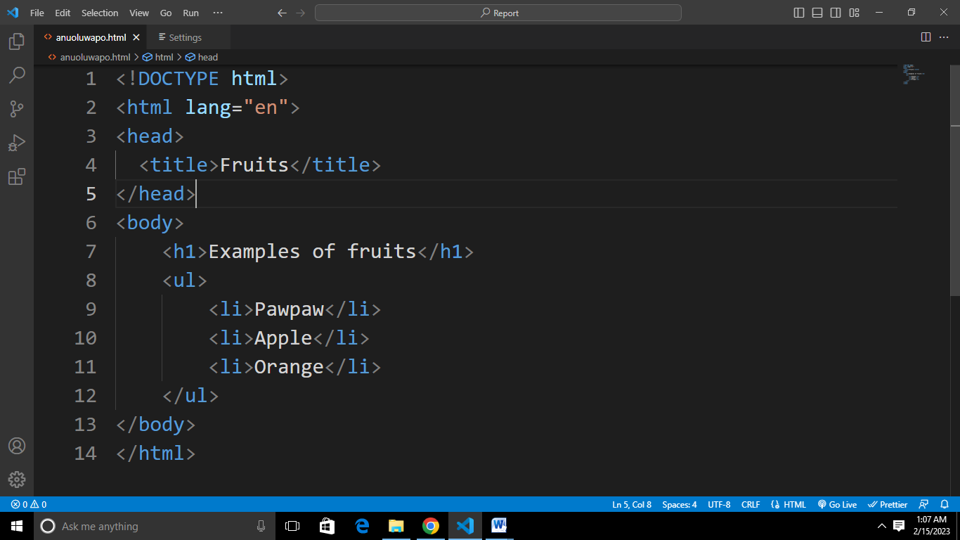

This example shows a simple HTML document with a main heading, a paragraph of text, an unordered list, and a hyperlink.

The <!DOCTYPE html> declaration at the top of the document specifies that this is an HTML5 document.

The <html> tag is the root element of the document and contains all the other elements.

The <head> element contains information about the document, such as the title of the page, which is displayed in the browser's title bar.

The <body> element contains the content of the page, such as headings, paragraphs, lists, and links.

This is just a simple example, and HTML documents can be much more complex and include a variety of other elements to create more advanced layouts and functionality.

**3.1.2 Functions and Importance of HTML**

HTML is used to structure and display content on the World Wide Web. The essence of HTML is to provide a standardized way of structuring and displaying content on the web. HTML provides a set of tags and attributes that can be used to define the structure, text, images, links, and other types of content that make up a web page. By using HTML, web developers can create consistent and easily accessible documents that can be viewed by anyone with a web browser.

HTML allows for the creation of complex and interactive web pages, with the addition of technologies like CSS and JavaScript, which provide styling and dynamic behavior to HTML content.

In summary, the essence of HTML is to provide a way to structure and display content on the web, in a consistent and accessible manner, and to provide a foundation for further enhancements through styling and dynamic behavior.

**WEEK SIX - WEEK ELEVEN (April 4, 2022 – May 13, 2022)**

**3.2 CSS – Cascading Style Sheet**

**3.2.1 Introduction to CSS**

CSS stands for Cascading Style Sheets. It is a stylesheet language used to describe the look and formatting of a web page written in HTML. Think of CSS like the paint and decorations for a building. Just like paint and decorations give a building its color, style, and personality, CSS gives a web page its visual appearance, layout, and design.

CSS is used to style and format HTML elements, such as headings, paragraphs, links, and images, to create a cohesive and attractive web page. CSS provides a wide range of styling options, including colors, fonts, sizes, spacing, and more, allowing for the creation of unique and visually appealing web pages.

CSS can be written directly into an HTML document, or it can be stored in a separate file and linked to from the HTML document.

In simpler terms, CSS is like the magic that makes your web page look beautiful and professional, by giving it the right colors, fonts, and overall design.

There are several ways to use CSS in a web page:

1. **Inline CSS:** Inline CSS is written directly into the HTML element using the style attribute. For example:

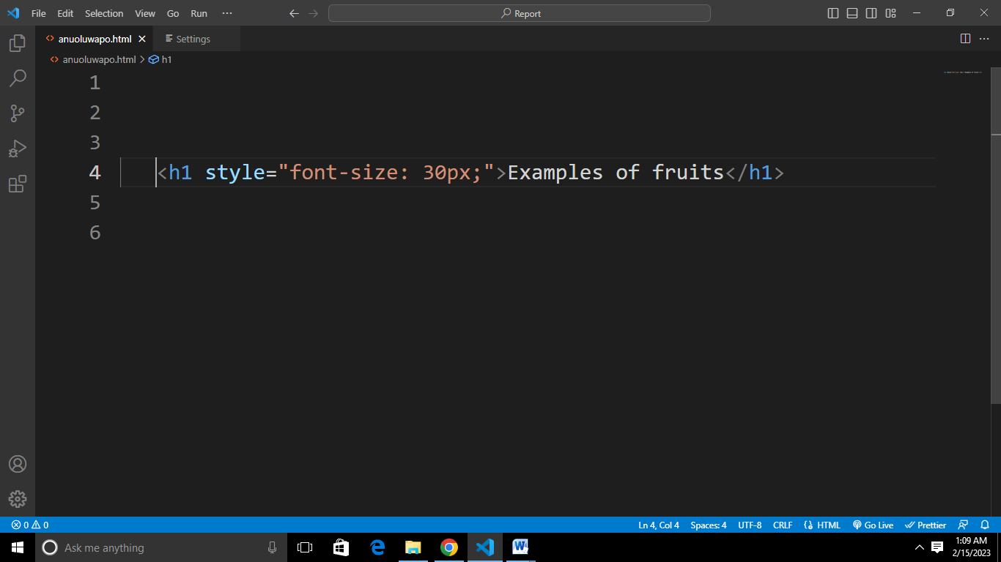

1. **Internal CSS:** Internal CSS is written in the <head> section of the HTML document, within a <style> tag. For example:

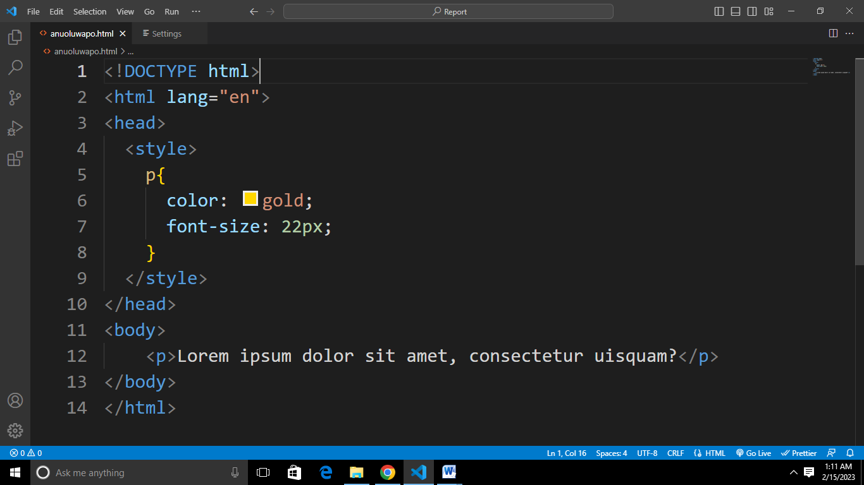

1. **External CSS:** External CSS is written in a separate .css file and linked to from the HTML document using a <link> tag in the <head> section. For example:

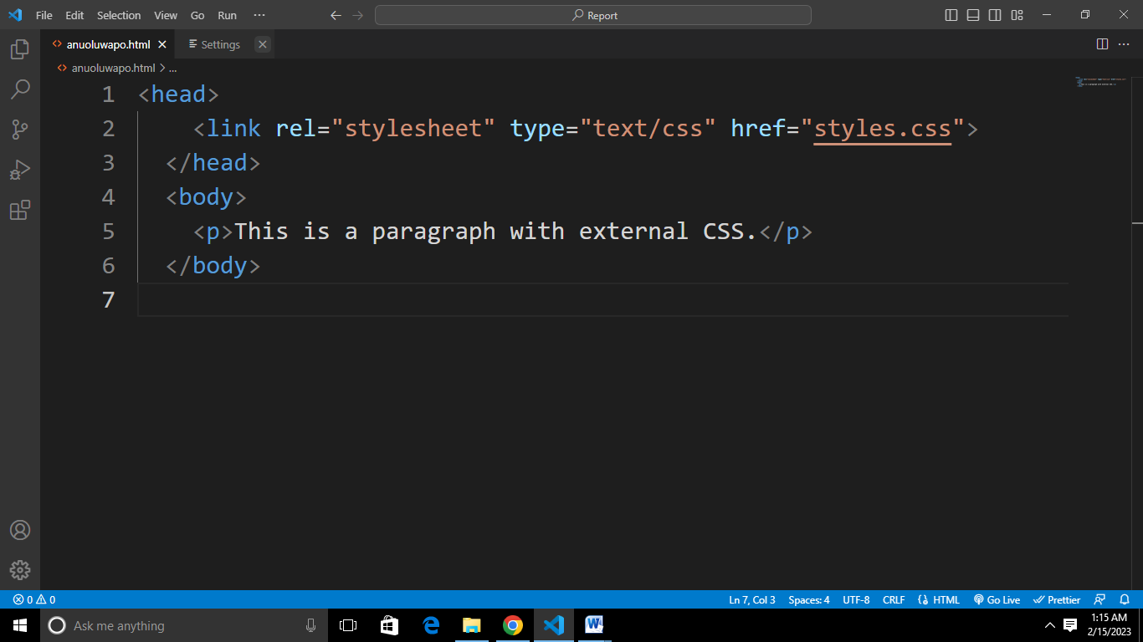

In the external CSS example, the styles.css file would contain the CSS rules, such as:

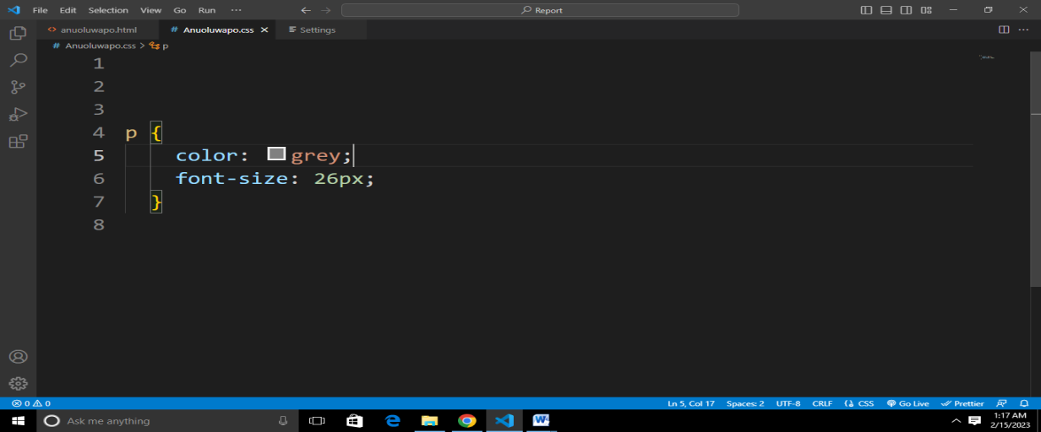

**3.2.2 Functions and Importance of CSS**

CSS is an essential tool for web development, and it provides a powerful and flexible way to control the look and formatting of web pages. Whether you are creating a simple personal website or a complex web application, CSS is a key technology that you should have in your toolkit.

CSS plays a crucial role in web development and has several functions and benefits, including:

1. **Separation of Contents:** CSS separates the presentation of a website from its content, making it easier for developers to manage and maintain the website. This allows for changes in the visual design to be made without affecting the underlying HTML code.
2. **Customizable Look and Feel:** CSS provides a wide range of styling options, such as font and color, background and border, position and layout, and more. These options allow you to create a unique look and feel for your web pages, and to create consistent and professional designs.
3. **Cross-Browser Compatibility:** CSS is supported by all modern web browsers, which means that your styles will be applied consistently across different browsers and platforms. This makes it easier to create web pages that look good on all devices, from desktop computers to mobile phones.
4. **Improved Performance**: By separating the presentation of a web page from its content, CSS enables the browser to cache styles and apply them to multiple pages, which can improve the performance of your website
5. **Enhances Accessibility:** CSS provides a way to control the presentation of a web page, which can be used to make web content more accessible to people with disabilities. For example, CSS can be used to change the font size, color, and contrast of a web page, to make it easier to read for people with low vision

**WEEK TWELVE ---- WEEK TWENTY-FOUR**

**3.3 JS – JavaScript**

**3.3.1 Introduction To JavaScript**

JavaScript is an essential component of modern web development, and it provides a powerful and flexible way to add dynamic behavior and interactivity to web pages.

JavaScript is a dynamic computer programming language. It is lightweight and most commonly used as a part of the web pages, whose implementation allows a client-side script to interact with a user and to make dynamic pages. It is an interpreted programming language with object-oriented capabilities.

There are two main ways to include JavaScript in a web page:

1. **Internal Script:** You can include JavaScript code directly within a web page by using the <script> tag. The script tag is placed within the HTML document, and the JavaScript code is written between the opening and closing script tags. For example:

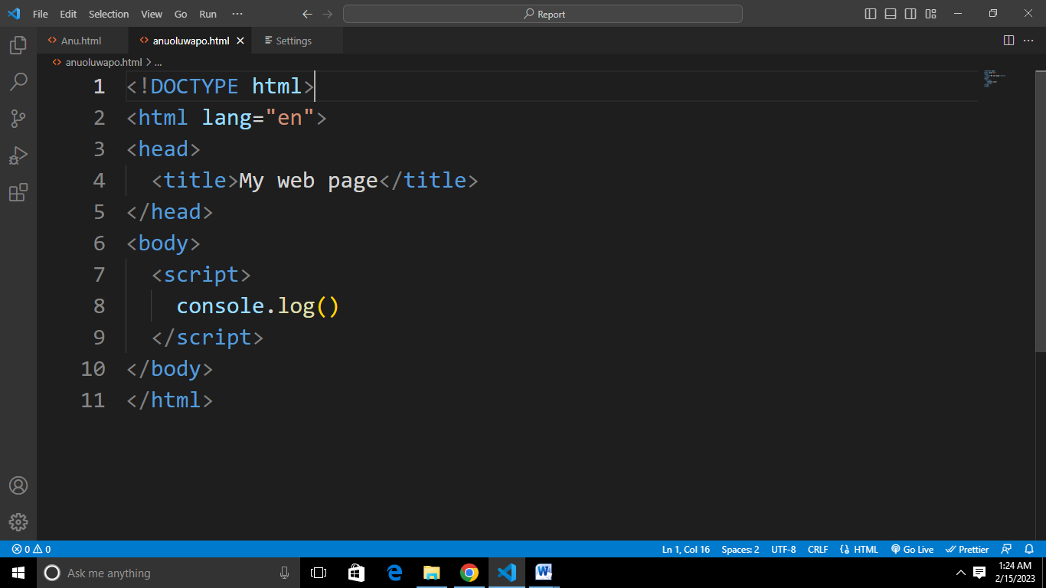

1. **External Script:** You can also include JavaScript code in a web page by linking to an external JavaScript file. This is done using the src attribute of the script tag, and the file must have a .js file extension. For example:

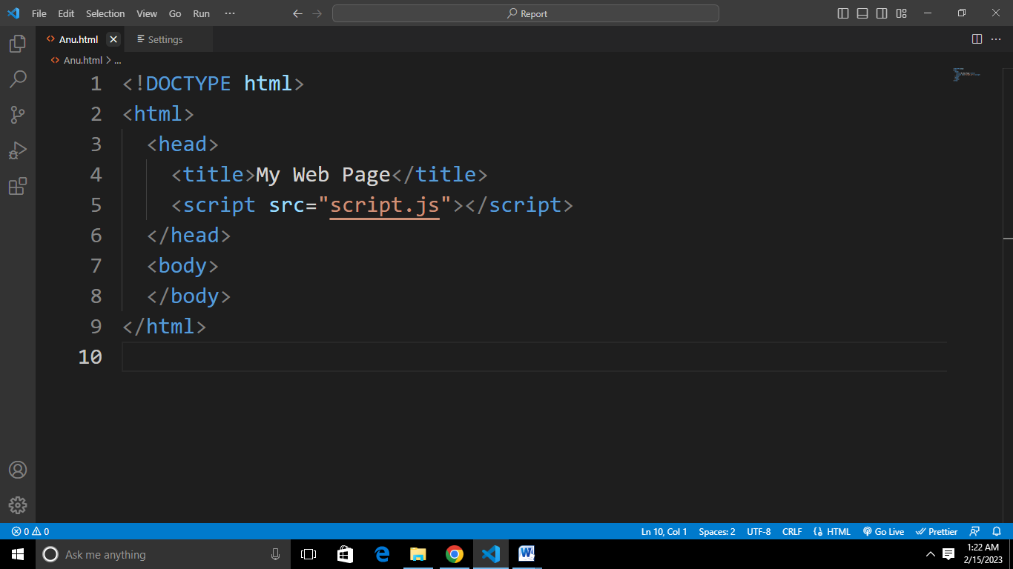

**3.3.2 Functions and Importance of JavaScript**

JavaScript is a powerful and versatile language that is used in a wide range of web development tasks, from form validation and user interaction to complex data visualization and real-time communication. Whether you are creating a simple personal website or a complex web application, JavaScript is an essential tool that you should have in your web development toolkit.

Some of the key **functions** of JavaScript include:

1. **Form Validation:** JavaScript is often used to validate user input in forms, by checking that data is entered correctly and completely, and by providing real-time feedback to the user. This helps to ensure that the data entered into forms is accurate and usable, and it improves the user experience by reducing the need for error correction and repetition.
2. **Data Manipulation:** JavaScript provides a powerful set of data handling and manipulation features, including arrays, objects, and regular expressions. With JavaScript, you can create complex data structures and algorithms, and you can perform advanced data manipulation and analysis.
3. **User Interactivity:** JavaScript is used to create dynamic and interactive user interfaces, by responding to user actions such as mouse clicks, form submissions, and key presses. With JavaScript, you can make web pages feel more like native applications, and you can create custom interactions and animations that enhance the user experience.
4. **Client-Side Processing:** JavaScript is often used for client-side processing, which means that it runs on the user's web browser, rather than on a remote server. This allows for fast and efficient processing, and it reduces the amount of data that needs to be sent between the browser and the server.

Some of the **importance** of JS includes:

1. **Improved user experience:** By providing dynamic and interactive elements, JavaScript can improve the overall user experience and make web pages more engaging.
2. **Dynamic Interactivity:** JavaScript is essential for creating dynamic and interactive web pages that respond to user actions and events. With JavaScript, you can make web pages feel more like native applications, and you can create custom interactions and animations that enhance the user experience.
3. **Cross**-**platform compatibility:** JavaScript is supported by all major browsers, which means that code written in JavaScript can run on any device with a web browser.

**CHAPTER FOUR**

**4.0 Knowledge and Skills Acquired**

During my SIWES, I gained a good understanding of web development concepts and skills. Here are some key areas I covered:

1. HTML: I learnt how to create structured and semantically meaningful web pages using HTML (Hypertext Markup Language).
2. CSS: I learnt how to style and layout web pages using CSS (Cascading Style Sheets).
3. JavaScript: I learnt the basics of programming in JavaScript, a client-side scripting language that adds interactivity and dynamic behavior to web pages.
4. Responsive design: I learnt about responsive design, which allows web pages to adapt to different screen sizes and devices.

**CHAPTER FIVE**

**5.1 Conclusion**

In conclusion, web development is a vast and dynamic field that continues to evolve and grow, as new technologies and tools become available. It involves the creation and maintenance of websites and web applications, and requires a combination of technical skills and creative abilities.

HTML provides the structure and content of web pages, while CSS is used to style and visually enhance the content. JavaScript is a programming language that allows for dynamic and interactive user interfaces, and it is widely used in web development to create rich and engaging user experiences.

Overall, the knowledge and skills I have acquired in web development will be invaluable in my career, as the demand for web developers continues to grow, and as the internet continues to play an increasingly important role in our lives. Whether I am interested in building websites, creating web applications, or working in a related field, web development is an essential and rewarding area to study and explore.

**5.2 Recommendation**

Here are my recommendations as regards the SIWES program itself:

1. **Timely feedback and evaluation:** Recommend that students receive timely feedback and evaluation on their work, to help them understand their strengths and weaknesses and make necessary improvements.
2. **Placement at relevant companies:** Recommend that students be placed at companies that are relevant to their field of study, to ensure that they gain practical experience that is aligned with their career goals.
3. **Collaborative learning opportunities:** Recommend that students be given opportunities to collaborate with other students and professionals in the field, to encourage teamwork, build relationships, and deepen their understanding of web development concepts and practices.

Here are my recommendations to MZIENET SYSTEMS:

1. **Real-world projects and assignments:** Recommend that students be given real-world projects and assignments that are aligned with their career goals, to help them gain practical experience and build their portfolios.
2. **Career development resources:** Recommend that the organization provide students with career development resources, such as resume building, interview preparation, and job search strategies, to help them succeed in the job market.
3. **Experienced and knowledgeable mentors:** Recommend that the organization provide students with experienced and knowledgeable mentors who can provide guidance and support throughout the SIWES program.

**5.3 Problems Encountered**

As with any complex field, web development can come with a number of **challenges and problems** that need to be addressed. Some of the most common issues faced by web developers include:

1. Cross-browser Compatibility: Ensuring that a website or web application works correctly and consistently across multiple web browsers can be a major challenge. Different browsers may render web content differently, and developers need to take this into account when building websites.
2. **Responsive Design:** With an increasing number of users accessing the internet from a variety of devices, including smartphones and tablets, it is essential that websites are designed to be responsive, and adapt to different screen sizes and resolutions.
3. **Security:** Security is a major concern for web developers, and it is essential that appropriate measures are taken to protect sensitive information and prevent unauthorized access. This includes implementing secure authentication and authorization mechanisms, and regularly updating the website or web application to address any known security vulnerabilities.
4. **Performance:** The speed and performance of a website or web application can have a major impact on the user experience, and developers need to be mindful of optimizing their code and using efficient algorithms to ensure that pages load quickly and effectively.
5. **Accessibility:** Ensuring that a website is accessible to all users, including those with disabilities, is a legal requirement in many countries, and it is also an ethical consideration for developers. This requires taking steps to make the website accessible, such as using descriptive alt text for images and providing alternative text for videos.

**5.4 References**

* [www.w3schools.com](http://www.w3schools.com)
* HTML & CSS: The Complete Reference, Fifth Edition (Complete Reference Series) by Thomas A. Powell
* <https://www.tutorialspoint.com/javascript/javascript_tutorial.pdf>
* Ochiaga C.C, (1995).Theory and practice of career development.
* Oyedele, J.P. (1990) Co-operative work experience programme for youths in business education. Business Education Journals 2: 30-53.