**A TECHNICAL REPORT ON**

**STUDENT INDUSTRIAL WORK EXPERIENCE SCHEME (SIWES)**

**UNDERTAKEN**

**AT**

**(ICTREC FUNAAB)**

**INFORMATION COMMUNICATION TECHNOLOGY RESOURCE CENTER**

**FEDERAL UNIVERSITY OF AGRICULTURE ABEOKUTA**

**BY**

**ADEBISI ADEWUNMI FAITH**

**MATRIC NO: 20182972**

**SUBMITTED TO THE DEPARTMENT OF MATHEMATICS,**

**COLLEGE OF PHYSICAL SCIENCES**

**FEDERAL UNIVERSITY OF AGRICULTURE, ABEOKUTA**

**JANUARY 2023**

**CERTIFICATION**

This is to certify that this report is a detailed account of Student Industrial Work Experience Scheme (SIWES), undertaken by **ADEBISI ADEWUNMI FAITH** at the **Information Communication Resource Center Federal University of Agriculture (ICTREC FUNAAB)** for a period of six (6) months and has been prepared in accordance to the regulations guiding the preparation of report to the Department of Mathematics, Federal University of Agriculture, Abeokuta (FUNAAB).

**_____________________________ _______________________**

**ADEBISI ADEWUNMI FAITH PROF. J.A. OGUNTUASE**

**(Student) (Supervising Lecturer)**

**____________________**

**DR. E.O ADELEKE**

**(Head of Department)**

**DEDICATION**

I dedicate this report to Almighty God, my beloved parents Mr. and Mrs. Adebisi, the lecturers and other staff members of the department of Mathematics, Federal University of Agriculture, Abeokuta. (FUNAAB).

**ACKNOWLEDGEMENT**

My utmost gratitude goes to almighty God the most gracious, the most merciful, for his mercies and provision upon my life. My profound gratitude also goes to my school, FUNAAB, my College, COLPHYS, my Department, Mathematics and my Supervisors Prof. J.A Oguntuase for giving me the opportunity for this great experience. I also want to express my profound gratitude to the entire staff of Information Communication Technology (ICTREC FUNAAB) . I sincerely appreciate the Industrial Training Fund (ITF) and all other supervising agencies that ensure the continuity of the Industrial training for students. Indeed, they have made a tremendous impact in my life.

**TABLE OF CONTENTS**

Certification i

Dedication ii

Acknowledgement iii

**CHAPTER ONE:**

1. Introduction 1
   1. Historical Background of SIWES 1 - 2
   2. Aims and Objectives of SIWES 2
   3. Importance and Benefits of SIWES 3

**CHAPTER TWO: HISTORICAL BACKGROUND OF ICTREC FUNAAB**

2.0 History of (ICTREC) FUNAAB

2.1 Aims and Objectives of Information Communication Technology Resource Center (ICTREC) FUNAAB

2.2 Activities of Information Communication Technology Resource Center (ICTREC) FUNAAB

2.3 Organogram of Information Communication Technology Resource Center (ICTREC) FUNAAB

**CHAPTER THREE: ACTIVITIES AT (ICTREC) FUNAAB**

1. Summary of Activities Undertaken at Information Communication Technology Resource Center (ICTREC FUNAAB)

3.1 Introduction to HTML

3.2

3.3

**CHAPTER FOUR: KNOWKEDGE AND SKILLS ACQUIRED**

1. Knowledge and Skill acquired at Information Communication Technology Resource Center (ICTREC) FUNAAB

**CHAPTER FIVE**

1. Summary of Attachment Activities
   1. Challenges Encountered
   2. Recommendations
   3. Conclusion

**CHAPTER ONE**

**1.0 INTRODUCTION**

The Students Industrial Work Experience Scheme (SIWES) is the accepted skills training programme, which forms part of the approved minimum academic standards in the various degree programmes for all the Nigerian universities. It is an effort to bridge the gap existing between theory and practice of engineering and technology, medical science, physical science, biological science, agriculture, management and other professional educational programs in the Nigerian tertiary institutions. It is aimed at exposing students to machines and equipment, professional work methods and ways of safe-guarding the work area s and workers in industries and other organization.

The scheme is a tripartite program, involving the students, the universities and the industry (employers of labour). It is funded by the Federal government of Nigeria and jointly coordinated by the industrial Training Fund (ITF) and the National Universities commission (NUC).

The duration of the program can be different, for the universities it's (twenty four weeks) six month, and a year for college and polytechnics in which the concerned student must be available all through this period to acquire the best knowledge he/she can get. During the period of industrial training (IT), students are exposed to machines, equipment’s and professional method of work, industrial safety in working environments as well as developing their work ethics etc.

The Student Industrial Work Experience Scheme (SIWES) therefore is aimed at giving the students the opportunity to relate and translate their theoretical knowledge to the real world of work.

**1.1 HISTORICAL BACKGROUND OF SIWES**

In the earlier stage of science and technology education in Nigeria, students were graduating from their respective institution without any technical knowledge or working experience. It was in this view that students undergoing science and technology related courses were mandated to undergo SIWES. The Student Industrial Work Experience Scheme (SIWES) was established by the Industrial Training Found (ITF) 1973 to enable students of tertiary institutions have basic technical knowledge of industrial works base on their courses of study before the completion of their program in their respective institutions. The scheme was designed to expose the students to industrial environment and enable them develop occupational competencies so that they can readily contribute their quota to national economic and technological development after graduation. The major background behind the embankment of students in SIWES was to expose them to the industrial environment and enable them develop occupational competencies so that they can readily contribute their quota to national economic and technological development after graduation.

The scheme commenced in 1974 with eleven (11) institutions, by 1978 when the number of institution had grown from eleven (11) to thirty-two (32), the ITF was force to reduce the number of approved programme to Engineering and Technology disciplines in Universities, Polytechnics and Colleges of Technology.

The Industrial Training Fund (ITF) withdrew and the federal government took over the funding of the scheme through the National University Commission (NUC) and the National Board for Technical Education. These two commissions managed the scheme for 5 years (1979-1984). Consequently, the Federal government handed over the administration of the scheme to the ITF in December 1984.

**1.2 AIMS AND OBJECTIVES OF SIWES**

Specifically, the objectives of the students industrial work experience scheme (SIWES) are to:

1. Prepare students for the work situation they are likely to meet after graduation
2. Expose students to work methods and techniques in handling equipment and machinery that may not be available in the universities.
3. Provide an avenue for students in the Nigerian Universities to acquire industrial skills and experience in their course of study
4. Enlist and strengthen employers’ involvement in the entire educational process of preparing university graduates for employment in industry.
5. Provide students with an opportunity to apply their theoretical knowledge in real work situation, thereby bridging the gap between university work and actual practices
6. Expose students to work methods and techniques in handling equipment and machinery that may not be available in the universities.

**1.3 IMPORTANCE AND BENEFITS OF SIWES**

i. It provides students with an opportunity to apply their theoretical knowledge in real life situations.

ii. It strengthens links between the employers, universities and industrial training fund (ITF).

iii. It exposes students to more practical work methods and techniques.

iv. It also prepares the students for the labour market after graduation.

v. Enhancing students’ contacts with potential employers while on training.

**CHAPTER TWO**

**2.0 HISTORICAL BACKGROUND OF ICTREC FUNAAB**

Information and Communication Technology Resource Centre (ICTREC) is fast becoming the pivot in which mist activities on University Campuses revolve and it is on it academic, administrative and other elements in the higher education processes ride.  This is because Computer and allied Communication Technologies are becoming “must have tools” for delivering good and result oriented higher education. It is for this reason that every campus in the universe is not now complete without a dynamic computer infrastructure and services at the Centre for teaching, learning, research and extension.  Like many other Universities, the wobbly development of ICT on FUNAAB campus arises from the fact that it evolved not as a dynamically planned activity.  Hence, the haphazard way the technology was introduced had imposed some strictures and limitations that have posed as bottlenecks and impediments to the orderly growth of ICT on FUNAAB campus.  This is not to recognize the enormous remedial measures that have become necessary in order to turn the tide on ICT use on Campus .ICT in FUNAAB had a very humble beginning and its development had not been free from the challenges which many such units in Nigerian Universities faced at their inception even with the existence of a Computer Science Department. The Information and Communication Technology Resource Centre (ICTREC) developed from the lowly beginning of what was initially named Computer Centre under the current management.  It inherited most of the infrastructure and services of the said Computer Centre as well as some of the headaches of the old structure.  The Centre now operates with the following units:

* + Open Users and Commercials Unit
  + Management Information System Unit
  + Training and Help Desk Unit
  + Network / Internet Administration Unit
  + Hardware Maintenance and Multimedia Unit
  + Web Unit
  + Project Development Unit

**2.1 AIMS AND OBJECTIVES INFORMATION COMMUNICATION TECHNOLOGY RESOURCE CENTER (ICTREC) FUNAAB**

The aims and Objectives of the Information and Communication Technology Resource Centre (ICTREC) is to advance FUNAAB Evolution into a leading world class University by deploying , managing and supporting optimal utilization of ICT solutions and services in enhancing administrative procedures/processes, supporting learning and improving delivery of the FUNAAB's teaching, research and extension mandate.

**Objectives**

* Dissemination of good practices in Information and Communication Technology (ICT) innovation to scale up successful computing activities.
* Discharge appropriate staffs and students development through ICT training in other to ensure progress at institutional level.
* Support research and development in learning objects with respect to ICT.
* Promotion and relating interactions between ICT vendors and the institution.
* Developing ICT solutions and facilitating use of open soft solutions that can enhance the delivery of the core mandates of the university.
* Providing multimedia coverage for learning, teaching, research and other general uses .
* Delivering enhanced career-oriented training with a strong international flavour and contents through international certification training for staff, students and the public
* Offering ICT training capacities beyond the campus that will extend the catchment-area and relevance of the university mandate to school drop-outs at every so the they can be brought into training schemes for meaningful employment and discouraged from all sorts of crimes, particularly cybercrimes.

**2.2 ACTIVITIES AT INFORMATION COMMUNICATION TECHNOLOGY RESOURCE CENTER (ICTREC) FUNAAB**

**Major activities**

* Design, implement, monitoring and maintenance of University network.
* Management Information Systems for both staffs and students.
* Administration of electronic assessments for students
* Software Development and support solution for third party solutions
* Professional training and ICT supports for staff and students
* Hardware maintenance and configurations
* Email and internet services
* Multimedia services and electronic training

**2.3 ORGANOGRAM OF INFORMATION COMMUNICATION TECHNOLOGY RESOURCE CENTER (ICTREC) FUNAAB**

**Information Communication Technology Resource Center is divided into seven (7) units**

1. Network Administration and Internet Service or Network/Internet Administration Unit
2. Management Information Systems Unit.
3. Project Development Unit
4. Training and Help Desk Unit
5. Open users and commercial units
6. Hardware maintenance and Multimedia
7. Web Unit

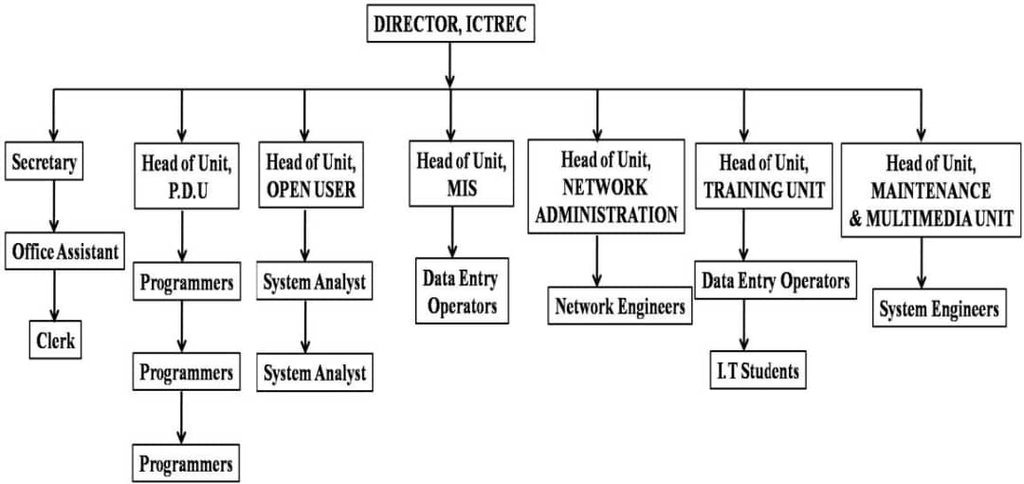

**CHAPTER THREE**

**3.0 SUMMARY OF ACTIVITIES IN ICTREC FUNAAB**

After my assumption of duty Undertaken at Information Communication Technology Resource Center (ICTREC FUNAAB). I was introduced to every member of the departments and I was briefed on the activities of the department. These are the activities actively undertaken by me at the training and help desk unit during my SIWES at Information Communication Technology Resource Center (ICTREC FUNAAB)

**3.1 ONLINE DATA ANALYSIS WITH R TRAINING**

After my first week of assumption of duty at the training and help desk unit, a data internet access account was created for me to be able to have access to internet usage which enable me to increase my understanding and application of statistical analysis with R programming in the following Data Analysis Project.

**3.2 PROJECT 1**

**WISCONSIN HOSPITAL HEALTHCARE COST AND UTILIATION ANALYSIS REPORT**

**BUSINESS SCENERIO**

The US Agency for Healthcare wants to analyze the Healthcare costs and Utilization of patients in the age group 0-17 years in Wisconsin hospital.

**PROJECT EXPECTATION**

The Healthcare agency wants to achieve the following goals.

1. Find the age category of people who frequent the hospital and has the maximum expenditure.
2. Find the diagnosis related group with maximum hospitalization and expenditure.

**ANALYSIS**

1. To record the patient’s statistics, the agency wants to find the age category who frequent the hospital and has the maximum expenditure. Using graphical analysis a bar plot is used to display frequency in each age category and their maximum expenditure.

**R CODE**

1. library(readr)
2. Hospital_cost <- data.frame(read_csv("HospitalCosts.csv"))
3. View(Hospital_cost);str(Hospital_cost)
4. attach(Hospital_cost)
5. library(ggplot2)
6. # Frequency in each age category and their maximum expenditure
7. Graph.01 <- ggplot(data = Hospital_cost, aes(x =factor(AGE), y = TOTCHG, fill = AGE)) + geom_col() + labs(x = "PATIENT AGE GROUP", y = "EXPENDITURE", title = "The Age Category who frequent the Hospital and thier Expenditure", caption = "The infants have the maximum number of visit and expenditure going above 600,000.")
8. Graph.01

**OUTPUT SCREENSHOT**

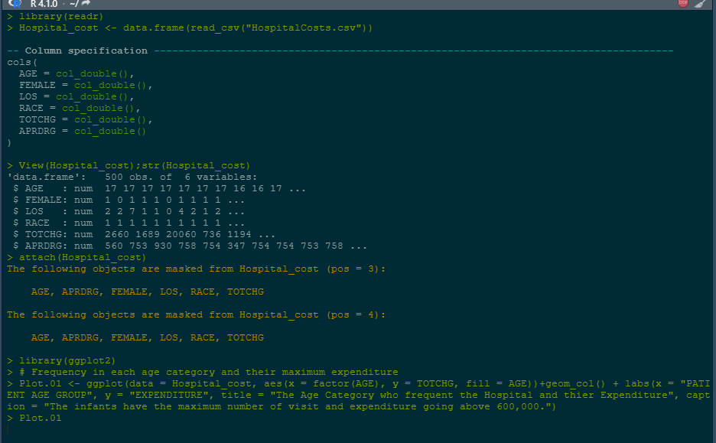

**Graph.01**

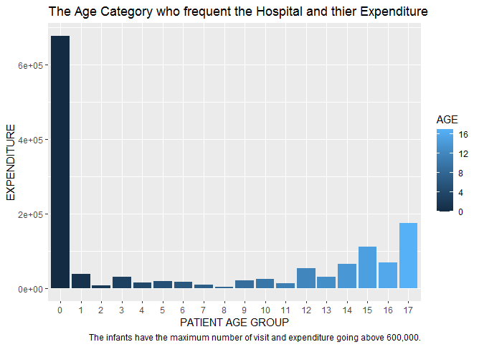

**INTERPRETATION OF RESULT**

From Graph.01 that is displayed above, we can see that the infant have the maximum number of hospital visit and maximum expenditure spending over 600,000.

**ANALYSIS**

1. To find the diagnosis related group with maximum hospitalization and expenditure, using maximum function to summarize the data.

**R** CODE

1. #maximum number of hospitalization
2. max_LOS <- max(LOS)
3. #maximum number of expenditure
4. max_TOTCHG <- max(TOTCHG)
5. # group with maximum number of hospitalization and expenditure
6. max_LOS_and_TOTCHG <- Hospital_cost[TOTCHG == max_TOTCHG & LOS == max_LOS,]
7. max_LOS_and_TOTCHG

**OUTPUT SCREENSHOT**

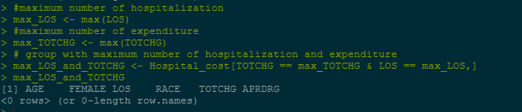

**INTERPRETATION OF RESULT**

From the analysis it known that the maximum number of hospital stay is 41 and the maximum expenditure is recorded as 48388.For any diagnosis related group to have the maximum hospitalization and expenditure it must have both maximum number of hospitalization and expenditure, however there was no diagnosis related group which could satisfy these two condition.

* 1. **PROJECT 2**

**ANALYSIS OF STOPING DISTANCE OF CARS AT A GIVEN SPEED**

The cars dataset gives Speed and Stopping Distances of Cars. This dataset is a data frame with 50 rows and 2 variables. The rows refer to cars and the variables refer to speed (the numeric Speed in mph) and dist (the numeric stopping distance in ft.).

**PROJECT EXPECTATION**

The Automobile agency wants to achieve the following goals.

1. Determine if there is an association between the distance travelled by the car and the speed covered.
2. Determine the relationship between the distance travelled by the car and the speed covered.

**ANALYSIS**

**R CODE**

1. data(cars)
2. summary(cars)
3. plot(cars, col='blue', pch=20, cex=2, main="Relationship between Speed and Stopping Distance for 50 Cars",xlab="Speed in mph", ylab="Stopping Distance in feet")
4. set.seed(122)
5. speed.c = scale(cars$speed, center=TRUE, scale=FALSE)
6. mod1 = lm(formula = dist ~ speed.c, data = cars)
7. summary(mod1)
8. ##
9. ## Call:
10. ## lm(formula = dist ~ speed.c, data = cars)
11. ##
12. ## Residuals:
13. ## Min 1Q Median 3Q Max
14. ## -29.069 -9.525 -2.272 9.215 43.201
15. ##
16. ## Coefficients:
17. ## Estimate Std. Error t value Pr(>|t|)
18. ## (Intercept) 42.9800 2.1750 19.761 < 2e-16 ***
19. ## speed.c 3.9324 0.4155 9.464 1.49e-12 ***
20. ## ---
21. ## Signif. codes: 0 '***' 0.001 '**' 0.01 '*' 0.05 '.' 0.1 ' ' 1
22. ##
23. ## Residual standard error: 15.38 on 48 degrees of freedom
24. ## Multiple R-squared: 0.6511, Adjusted R-squared: 0.6438
25. ## F-statistic: 89.57 on 1 and 48 DF, p-value: 1.49e-12

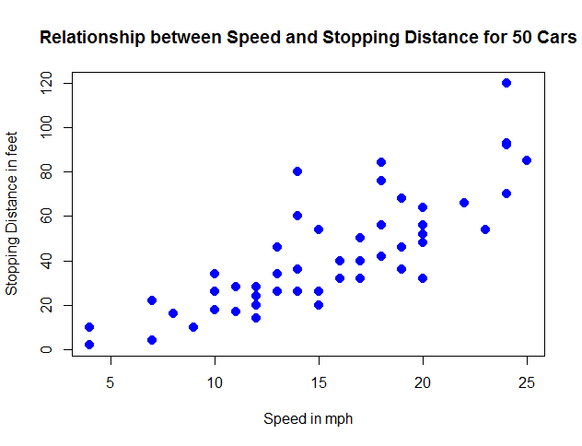

**INTERPRETATION OF RESULT**

* Residuals are essentially the difference between the actual observed response values (distance to stop dist in our case) and the response values that the model predicted
* We can see that the distribution of the residuals do not appear to be strongly symmetrical. That means that the model predicts certain points that fall far away from the actual observed points. We could take this further consider plotting the residuals to see whether this normally distributed. We can deduce that from the analysis it takes an average car in our dataset **42.98** feet to come to a stop. The second row in the Coefficients is the slope, the effect speed has in distance required for a car to stop. The slope term in our model is saying that for every 1 mph increase in the speed of a car, the required distance to stop goes up by **3.9324088** feet.
* We can say that the required distance for a car to stop can vary by **0.4155128** feet.
* The t-statistic values are relatively far away from zero and are large relative to the standard error, which could indicate a relationship exists. In general, t-values are also used to compute p-values.
* The p-values are very close to zero. a small p-value for the intercept and the slope indicates that we can conclude that there exist a linear relationship between the speed and stopping distance covered by the cars.

**3.4 HTML Introduction 1**

## What is HTML?

* HTML stands for Hyper Text Markup Language
* HTML is the standard markup language for creating Web pages
* HTML describes the structure of a Web page
* HTML consists of a series of elements
* HTML elements tell the browser how to display the content
* HTML elements label pieces of content such as "this is a heading", "this is a paragraph", "this is a link", etc.

## A Simple HTML Document

<!DOCTYPE html>  
<html>  
<head>  
<title>Page Title</title>  
</head>  
<body>  
  
<h1>My First Heading</h1>  
<p>My first paragraph.</p>  
  
</body>  
</html>

## Web Browsers

The purpose of a web browser (Chrome, Edge, Firefox, Safari) is to read HTML documents and display them correctly. A browser does not display the HTML tags, but uses them to determine how to display the document:

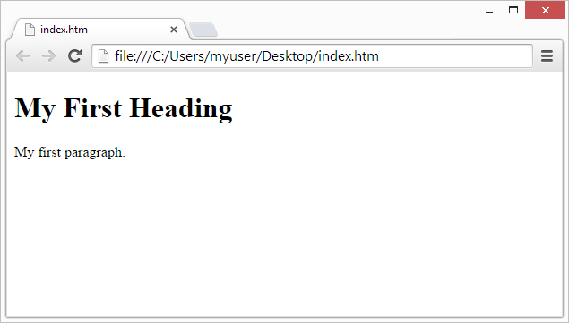

## Learn HTML Using Notepad or TextEdit

Web pages can be created and modified by using professional HTML editors.However, for learning HTML we recommend a simple text editor like Notepad (PC) or TextEdit (Mac).

We believe that using a simple text editor is a good way to learn HTML.Follow the steps below to create your first web page with Notepad or TextEdit.

## Step 1: Open Notepad (PC)

**Windows 8 or later:**

Open the **Start Screen** (the window symbol at the bottom left on your screen). Type **Notepad**.

**Windows 7 or earlier:**

Open **Start** >**Programs >** **Accessories >** **Notepad**

## Step 1: Open TextEdit (Mac)

Open **Finder > Applications > TextEdit**

Also change some preferences to get the application to save files correctly. In **Preferences > Format >**choose**"Plain Text"**

Then under "Open and Save", check the box that says "Display HTML files as HTML code instead of formatted text".

**Then open a new document to place the code.**

## Step 2: Write Some HTML

Write or copy the following HTML code into Notepad:

<!DOCTYPE html>  
<html>  
<body>  
  
<h1>My First Heading</h1>  
  
<p>My first paragraph.</p>  
  
</body>  
</html>

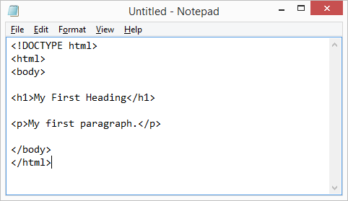

## Step 3: Save the HTML Page

Save the file on your computer. Select **File > Save as** in the Notepad menu.

Name the file **"index.htm"** and set the encoding to **UTF-8** (which is the preferred encoding for HTML files).

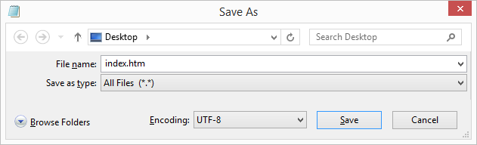

## Step 4: View the HTML Page in Your Browser

Open the saved HTML file in your favorite browser (double click on the file, or right-click - and choose "Open with").

The result will look much like this:



## HTML Documents

All HTML documents must start with a document type declaration: <!DOCTYPE html>.

The HTML document itself begins with <html> and ends with </html>.

The visible part of the HTML document is between <body> and </body>.

<!DOCTYPE html>  
<html>  
<body>  
  
<h1>My First Heading</h1>  
<p>My first paragraph.</p>  
  
</body>  
</html>

## The <!DOCTYPE> Declaration

The <!DOCTYPE> declaration represents the document type, and helps browsers to display web pages correctly.

It must only appear once, at the top of the page (before any HTML tags).

The <!DOCTYPE> declaration is not case sensitive.

The <!DOCTYPE> declaration for HTML5 is:

<**!DOCTYPE html**>

## How to View HTML Source

Have you ever seen a Web page and wondered "Hey! How did they do that?"

### View HTML Source Code:

Right-click in an HTML page and select "View Page Source" (in Chrome) or "View Source" (in Edge), or similar in other browsers. This will open a window containing the HTML source code of the page.

### Inspect an HTML Element:

Right-cli ck on an element (or a blank area), and choose "Inspect" or "Inspect Element" to see what elements are made up of (you will see both the HTML and the CSS). You can also edit the HTML or CSS on-the-fly in the Elements or Styles panel that opens

## HTML Attributes

* All HTML elements can have **attributes**
* Attributes provide **additional information** about elements
* Attributes are always specified in **the start tag**
* Attributes usually come in name/value pairs like: **name="value"**

## The href Attribute

The <a> tag defines a hyperlink. The href attribute specifies the URL of the page the link goes to:

<a href="https://portal.unaab.edu.ng">Visit Funnab portal</a>

## The src Attribute

The <img> tag is used to embed an image in an HTML page. The src attribute specifies the path to the image to be displayed:

<img src="img_girl.jpg">

There are two ways to specify the URL in the src attribute:

**1. Absolute URL** - Links to an external image that is hosted on another website. Example: src="https://www.w3schools.com/images/img_girl.jpg".

**Notes:** External images might be under copyright. If you do not get permission to use it, you may be in violation of copyright laws. In addition, you cannot control external images; it can suddenly be removed or changed.

**2. Relative URL** - Links to an image that is hosted within the website. Here, the URL does not include the domain name. If the URL begins without a slash, it will be relative to the current page. Example: src="img_girl.jpg". If the URL begins with a slash, it will be relative to the domain. Example: src="/images/img_girl.jpg".

**Tip:** It is almost always best to use relative URLs. They will not break if you change domain

## HTML Headings

HTML headings are defined with the <h1> to <h6> tags.

<h1> defines the most important heading. <h6> defines the least important heading.

<h1>Heading 1</h1>  
<h2>Heading 2</h2>  
<h3>Heading 3</h3>  
<h4>Heading 4</h4>  
<h5>Heading 5</h5>  
<h6>Heading 6</h6>

## Headings Are Important

Search engines use the headings to index the structure and content of your web pages.

Users often skim a page by its headings. It is important to use headings to show the document structure.

<h1> headings should be used for main headings, followed by <h2> headings, then the less important <h3>, and so on.

## Bigger Headings

Each HTML heading has a default size. However, you can specify the size for any heading with the style attribute, using the CSS font-size property:

<h1 style="font-size:60px;">Heading 1</h1>

## HTML Paragraphs

The HTML <p> element defines a paragraph.

A paragraph always starts on a new line, and browsers automatically add some white space (a margin) before and after a paragraph.

## HTML Display

You cannot be sure how HTML will be displayed.

Large or small screens, and resized windows will create different results.

With HTML, you cannot change the display by adding extra spaces or extra lines in your HTML code.

The browser will automatically remove any extra spaces and lines when the page is displayed

## HTML Horizontal Rules

The <hr> tag defines a thematic break in an HTML page, and is most often displayed as a horizontal rule.

The <hr> element is used to separate content (or define a change) in an HTML page

## HTML Line Breaks

The HTML <br> element defines a line break.

Use <br> if you want a line break (a new line) without starting a new paragraph

## HTML Images Syntax

The HTML <img> tag is used to embed an image in a web page.

Images are not technically inserted into a web page; images are linked to web pages. The <img> tag creates a holding space for the referenced image.

The <img> tag is empty, it contains attributes only, and does not have a closing tag.

The <img> tag has two required attributes:

* src - Specifies the path to the image
* alt - Specifies an alternate text for the image

## Image Maps

The HTML <map> tag defines an image map. An image map is an image with clickable areas. The areas are defined with one or more <area> tags.

Try to click on the computer, phone, or the cup of coffee in the image below:

<img src="workplace.jpg" alt="Workplace" usemap="#workmap">  
  
<map name="workmap">  
  <area shape="rect" coords="34,44,270,350" alt="Computer" href="computer.htm">  
  <area shape="rect" coords="290,172,333,250" alt="Phone" href="phone.htm">  
  <area shape="circle" coords="337,300,44" alt="Coffee" href="coffee.htm">  
</map>

## The Areas

Then, add the clickable areas.

A clickable area is defined using an <area> element.

### Shape

You must define the shape of the clickable area, and you can choose one of these values:

* rect - defines a rectangular region
* circle - defines a circular region
* poly - defines a polygonal region
* default - defines the entire region

You must also define some coordinates to be able to place the clickable area onto the image.

### Shape="rect"

The coordinates for shape="rect" come in pairs, one for the x-axis and one for the y-axis.

So, the coordinates 34,44 is located 34 pixels from the left margin and 44 pixels from the top

## Background Image on a HTML element

To add a background image on an HTML element, use the HTML style attribute and the CSS background-image property

## Background Cover

If you want the background image to cover the entire element, you can set the background-size property to cover.

Also, to make sure the entire element is always covered, set the background-attachment property to fixed:

This way, the background image will cover the entire element, with no stretching (the image will keep its original proportions)

## How To Add a Favicon in HTML

You can use any image you like as your favicon. You can also create your own favicon on sites like [https://www.favicon.cc](https://www.favicon.cc/).

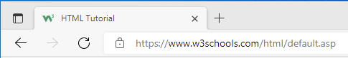

To add a favicon to your website, either save your favicon image to the root directory of your webserver, or create a folder in the root directory called images, and save your favicon image in this folder. A common name for a favicon image is "favicon.ico".

Next, add a <link> element to your "index.html" file, after the <title> element, like this:

<!DOCTYPE html>  
<html>  
<head>  
  <title>My Page Title</title>  
  <link rel="icon" type="image/x-icon" href="/images/favicon.ico">  
</head>  
<body>  
  
<h1>This is a Heading</h1>  
<p>This is a paragraph.</p>  
  
</body>  
</html>

**CHAPTER FOUR**

**4.0 KNOWLEDGE AND SKILL ACQUIRED**

After undertaken the twenty four weeks Student Industrial Work Experience Scheme (SIWES), and actively taking part in the activities of the Information Communication Resource Center (ICTREC FUNAAB) for the effective running of the day to day activities of Federal University of Agriculture, the knowledge and skills acquired during this course (industrial training) include knowledge on:

* Data Analysis with R programming language.
* Fundamentals of Data Analysis for Research using R
* The process of creating graphical visualization of data in R using ggplot2 package.
* The use of Microsoft excel and R in the preparation of various statistical analysis for the weekly and monthly work report.
* Simple linear regression model with R.
* HTML – HyperText Markup Language

**CHAPTER FIVE**

**5.0 PROBLEMS ENCOUNTERED, CONCLUSION AND RECOMMENDATION**

**5.1 PROBLEMS ENCOUNTERED**

The following are the challenges I encountered in the course of the six months Student Industrial Work Experience Scheme (SIWES):

* I was unable to secure a reputable organization that relates with my course of study on time.
* Restriction of Interns from some facilities which makes some of the task given difficult to carry out.
* High cost of transportation.

**5.2 CONCLUSION**

My six months Student Industrial Work Experience Scheme was a great success and as well a great time of acquisition of knowledge and skills. To me, it was not just another academic requirement, I viewed it as a job that I have to contribute to the organization’s success and most importantly my success.

I undoubtedly was able to get a proper and more defined orientation as to what learning outside the school environment entails as it really aided me and facilitated my views and perspectives towards a more practical approach of my field (statistics) rather than just the theoretical approach.

**5.3 RECOMMENDATION**

Although this Scheme did achieve quite a lot of its stated objectives and benefits, but nevertheless, I will recommend the following suggestions which might improve the qualitative context of the Scheme:

* The scheme should make a shortlist of various organizations for the respective course of study of students in tertiary institutions.
* Students should be granted more time to undergo the training in order to have a better and long term approach/experience of the practical knowledge of ones field of study.
* Prompt payment of student industrial training allowance to help student overcome the financial challenges that may arise during the period of training.

**5.4 REFERENCES**

* [www.w3schools.com](http://www.w3schools.com)
* HTML & CSS: The Complete Reference, Fifth Edition (Complete Reference Series) by Thomas A. Powell
* <https://www.tutorialspoint.com/javascript/javascript_tutorial.pdf>
* Ochiaga C.C, (1995).Theory and practice of career development.
* Oyedele, J.P. (1990) Co-operative work experience programme for youths in business education. Business Education Journals 2: 30-53.