**HTML Introduction**

## What is HTML?

* HTML stands for Hyper Text Markup Language
* HTML is the standard markup language for creating Web pages
* HTML describes the structure of a Web page
* HTML consists of a series of elements
* HTML elements tell the browser how to display the content
* HTML elements label pieces of content such as "this is a heading", "this is a paragraph", "this is a link", etc.

## A Simple HTML Document

<!DOCTYPE html>  
<html>  
<head>  
<title>Page Title</title>  
</head>  
<body>  
  
<h1>My First Heading</h1>  
<p>My first paragraph.</p>  
  
</body>  
</html>

## Web Browsers

The purpose of a web browser (Chrome, Edge, Firefox, Safari) is to read HTML documents and display them correctly. A browser does not display the HTML tags, but uses them to determine how to display the document:

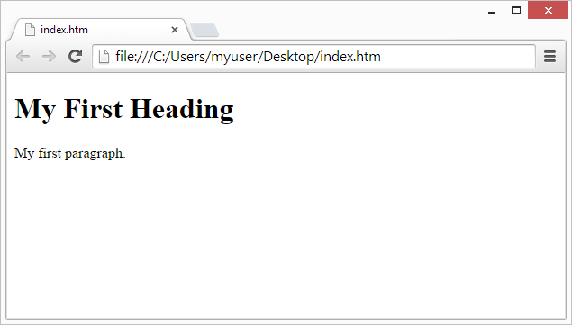

## Learn HTML Using Notepad or TextEdit

Web pages can be created and modified by using professional HTML editors.However, for learning HTML we recommend a simple text editor like Notepad (PC) or TextEdit (Mac).

We believe that using a simple text editor is a good way to learn HTML.Follow the steps below to create your first web page with Notepad or TextEdit.

## Step 1: Open Notepad (PC)

**Windows 8 or later:**

Open the **Start Screen** (the window symbol at the bottom left on your screen). Type **Notepad**.

**Windows 7 or earlier:**

Open **Start** >**Programs >** **Accessories >** **Notepad**

## Step 1: Open TextEdit (Mac)

Open **Finder > Applications > TextEdit**

Also change some preferences to get the application to save files correctly. In **Preferences > Format >**choose**"Plain Text"**

Then under "Open and Save", check the box that says "Display HTML files as HTML code instead of formatted text".

**Then open a new document to place the code.**

## Step 2: Write Some HTML

Write or copy the following HTML code into Notepad:

<!DOCTYPE html>  
<html>  
<body>  
  
<h1>My First Heading</h1>  
  
<p>My first paragraph.</p>  
  
</body>  
</html>

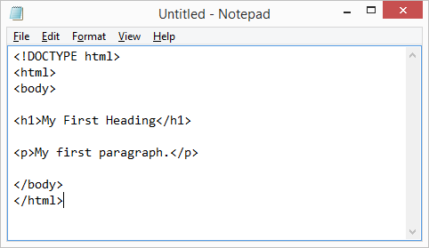

## Step 3: Save the HTML Page

Save the file on your computer. Select **File > Save as** in the Notepad menu.

Name the file **"index.htm"** and set the encoding to **UTF-8** (which is the preferred encoding for HTML files).

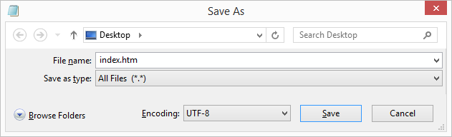

## Step 4: View the HTML Page in Your Browser

Open the saved HTML file in your favorite browser (double click on the file, or right-click - and choose "Open with").

The result will look much like this:



## HTML Documents

All HTML documents must start with a document type declaration: <!DOCTYPE html>.

The HTML document itself begins with <html> and ends with </html>.

The visible part of the HTML document is between <body> and </body>.

<!DOCTYPE html>  
<html>  
<body>  
  
<h1>My First Heading</h1>  
<p>My first paragraph.</p>  
  
</body>  
</html>

## The <!DOCTYPE> Declaration

The <!DOCTYPE> declaration represents the document type, and helps browsers to display web pages correctly.

It must only appear once, at the top of the page (before any HTML tags).

The <!DOCTYPE> declaration is not case sensitive.

The <!DOCTYPE> declaration for HTML5 is:

**<!DOCTYPE html>**

## How to View HTML Source

Have you ever seen a Web page and wondered "Hey! How did they do that?"

### View HTML Source Code:

Right-click in an HTML page and select "View Page Source" (in Chrome) or "View Source" (in Edge), or similar in other browsers. This will open a window containing the HTML source code of the page.

### Inspect an HTML Element:

Right-click on an element (or a blank area), and choose "Inspect" or "Inspect Element" to see what elements are made up of (you will see both the HTML and the CSS). You can also edit the HTML or CSS on-the-fly in the Elements or Styles panel that opens

## HTML Attributes

* All HTML elements can have **attributes**
* Attributes provide **additional information** about elements
* Attributes are always specified in **the start tag**
* Attributes usually come in name/value pairs like: **name="value"**

## The href Attribute

The <a> tag defines a hyperlink. The href attribute specifies the URL of the page the link goes to:

<a href="https://portal.unaab.edu.ng">Visit Funnab portal</a>

## The src Attribute

The <img> tag is used to embed an image in an HTML page. The src attribute specifies the path to the image to be displayed:

<img src="img_girl.jpg">

There are two ways to specify the URL in the src attribute:

**1. Absolute URL** - Links to an external image that is hosted on another website. Example: src="https://www.w3schools.com/images/img_girl.jpg".

**Notes:** External images might be under copyright. If you do not get permission to use it, you may be in violation of copyright laws. In addition, you cannot control external images; it can suddenly be removed or changed.

**2. Relative URL** - Links to an image that is hosted within the website. Here, the URL does not include the domain name. If the URL begins without a slash, it will be relative to the current page. Example: src="img_girl.jpg". If the URL begins with a slash, it will be relative to the domain. Example: src="/images/img_girl.jpg".

**Tip:** It is almost always best to use relative URLs. They will not break if you change domain

## HTML Headings

HTML headings are defined with the <h1> to <h6> tags.

<h1> defines the most important heading. <h6> defines the least important heading.

<h1>Heading 1</h1>  
<h2>Heading 2</h2>  
<h3>Heading 3</h3>  
<h4>Heading 4</h4>  
<h5>Heading 5</h5>  
<h6>Heading 6</h6>

## Headings Are Important

Search engines use the headings to index the structure and content of your web pages.

Users often skim a page by its headings. It is important to use headings to show the document structure.

<h1> headings should be used for main headings, followed by <h2> headings, then the less important <h3>, and so on.

## Bigger Headings

Each HTML heading has a default size. However, you can specify the size for any heading with the style attribute, using the CSS font-size property:

<h1 style="font-size:60px;">Heading 1</h1>

## HTML Paragraphs

The HTML <p> element defines a paragraph.

A paragraph always starts on a new line, and browsers automatically add some white space (a margin) before and after a paragraph.

## HTML Display

You cannot be sure how HTML will be displayed.

Large or small screens, and resized windows will create different results.

With HTML, you cannot change the display by adding extra spaces or extra lines in your HTML code.

The browser will automatically remove any extra spaces and lines when the page is displayed

## HTML Horizontal Rules

The <hr> tag defines a thematic break in an HTML page, and is most often displayed as a horizontal rule.

The <hr> element is used to separate content (or define a change) in an HTML page

## HTML Line Breaks

The HTML <br> element defines a line break.

Use <br> if you want a line break (a new line) without starting a new paragraph

## HTML Images Syntax

The HTML <img> tag is used to embed an image in a web page.

Images are not technically inserted into a web page; images are linked to web pages. The <img> tag creates a holding space for the referenced image.

The <img> tag is empty, it contains attributes only, and does not have a closing tag.

The <img> tag has two required attributes:

* src - Specifies the path to the image
* alt - Specifies an alternate text for the image

## Image Maps

The HTML <map> tag defines an image map. An image map is an image with clickable areas. The areas are defined with one or more <area> tags.

Try to click on the computer, phone, or the cup of coffee in the image below:

<img src="workplace.jpg" alt="Workplace" usemap="#workmap">  
  
<map name="workmap">  
  <area shape="rect" coords="34,44,270,350" alt="Computer" href="computer.htm">  
  <area shape="rect" coords="290,172,333,250" alt="Phone" href="phone.htm">  
  <area shape="circle" coords="337,300,44" alt="Coffee" href="coffee.htm">  
</map>



## The Areas

Then, add the clickable areas.

A clickable area is defined using an <area> element.

### Shape

You must define the shape of the clickable area, and you can choose one of these values:

* rect - defines a rectangular region
* circle - defines a circular region
* poly - defines a polygonal region
* default - defines the entire region

You must also define some coordinates to be able to place the clickable area onto the image.

### Shape="rect"

The coordinates for shape="rect" come in pairs, one for the x-axis and one for the y-axis.

So, the coordinates 34,44 is located 34 pixels from the left margin and 44 pixels from the top

## Background Image on a HTML element

To add a background image on an HTML element, use the HTML style attribute and the CSS background-image property

## Background Cover

If you want the background image to cover the entire element, you can set the background-size property to cover.

Also, to make sure the entire element is always covered, set the background-attachment property to fixed:

This way, the background image will cover the entire element, with no stretching (the image will keep its original proportions)

## How To Add a Favicon in HTML

You can use any image you like as your favicon. You can also create your own favicon on sites like [https://www.favicon.cc](https://www.favicon.cc/).

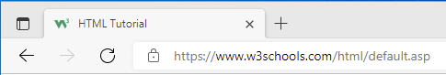

To add a favicon to your website, either save your favicon image to the root directory of your webserver, or create a folder in the root directory called images, and save your favicon image in this folder. A common name for a favicon image is "favicon.ico".

Next, add a <link> element to your "index.html" file, after the <title> element, like this:

<!DOCTYPE html>  
<html>  
<head>  
  <title>My Page Title</title>  
  <link rel="icon" type="image/x-icon" href="/images/favicon.ico">  
</head>  
<body>  
  
<h1>This is a Heading</h1>  
<p>This is a paragraph.</p>  
  
</body>  
</html>