



**REPORT ON STUDENT INDUSTRIAL WORK EXPERINCE SCHEME (SIWES)**

**UNDERTAKEN AT**

**MZIENET SYSTEMS,**

**OSIELE ABEOKUTA, OGUN STATE.**

**BY**

**JOSEPH EBENEZER DANIEL**

**MATRIC NO: 20183036**

**IN PARTIAL FULFILMENT FOR THE AWARD OF THE DEGREE OF BACHELOR OF SCIENCE (B.Sc) in MATHEMATICS**

**SUBMITTED TO**

**THE DEPARTMENT OF MATHEMATICS**

**COLLEGE OF PHYSICAL SCIENCES**

**FEDERAL UNIVERSITY OF AGRICULTURE, ABEOKUTA.**

**FEBRUARY 2022 – AUGUST 2022**

**CERTIFICATION**

This is to certify that this Students’ Industrial Work Experience was carried out by **JOSEPH EBENIZER DANIEL,** with matriculation number **20183036** of the Department of Mathematics at **Mzienet Systems, Opp. OVL Block Industry, Osiele Abeokuta, Ogun State.**

**____________________________ ___________________________**

**Joseph Ebenezer Daniel Professor M.O Omeike**

*Student Supervising Lecturer*

_______________________________

**Dr. E. Adeleke**

*Head of Department*

**DEDICATION**

This SIWES REPORT is dedicated to the ALMIGHTY GOD and to my loving parents Mr. and Mrs. Ebenezer. May God continue to bless you abundantly (Amen).

**ACKNOWLEDGMENT**

My profound gratitude goes to God for the grace to be alive and the opportunity to undergo the SIWES. I’m also grateful to my dearest parent and my siblings for their indefatigable support towards my education. I’m grateful to the Federal Government for giving student like me who are willing to learn, the opportunity to gain practical experiences in the just concluded SIWES. I so much appreciate my supervisor at **MZIENET SYSTEMS, Mr Francis Ajayi** who did all his best to put me through the learning and tasks during the duration of my Industrial Training. I am also indebted to the members and staff of **Mzienet Systems** especially **Mr. Samson Oderinwale, Mr. Mark Uxier, and Miss. Ponmile Simisola** for their contribution towards making my training worthwhile.

**ABSTRACT**

The Industrial Training Fund (ITF) established the Students Industrial Work Experience Scheme (SIWES) to develop the skills of younger generations to contribute to the development of the technology industry and society in general. This executive summary summarizes the events, meetings, and experiences I had during my six-month internship. Students did obtain practical work on the job training, according to the data. The SIWES program teaches students how to use and manage information technology (IT) equipment and progress in a safe and effective manner. However, the study found that if students are exposed to research resources and accommodations, supported by complete, structured and suitable supervision by their supervisors and furthermore if equipment and machinery monitoring is well-structured, there would inevitably be an increase in performance rates.

**TABLE OF CONTENTS**

**CERTIFICATION i**

**DEDICATION ii**

**ACKNOWLEDGMENT iii**

**ABSTRACT iv**

**CHAPTER ONE**

1.0 Introduction 1

1.1 Historical Background of Siwes 1-2

1.2 Aims and Objectives of Siwes 2-3

1.3 Importance and Benefits of Siwes 3

**CHAPTER TWO**

2.1 Historical Background of Norak Technologies Limited 4

2.2 Departments in Norak Technologies Limited 4

2.3 Mission, Vision and Objectives of Norak Technologies Limited 4-5

2.4 Services and Operations of Norak Technologies Limited 5

2.5 Organogram of Norak Technologies Limited 6

**CHAPTER THREE**

3.0 Introduction to Web Development 7

3.1 WEEK ONE – WEEK FIVE (February 28, 2022 – April 1, 2022)

HTML - Hyper Text Markup Language 8 - 11

3.1.1 Introduction to HTML

3.1.2 Functions and Importance of HTML

3.2 WEEK SIX – WEEK ELEVEN (April 4, 2022 – May 13, 2022)

CSS - Cascading Style Sheet 12 - 14

3.2.1 Introduction to CSS

3.2.2 Functions And Importance of CSS

3.3 WEEK TWELVE – WEEK TWENTY FOUR (May 16, 2022 – August 12, 2022)

JS – JavaScript 15 - 17

3.3.1 Introduction to JS

3.3.2 Functions and Importance of JS

**CHAPTER FOUR**

4.0 Knowledge and Skill Acquired 18

4.1 Knowledge Acquired

4.2 Skill Sets

**CHAPTER FIVE**

5.1 Conclusion 19  
5.2 Recommendation 19 - 20

5.3 Problems Encountered 20 - 21

5.4 References 22

**CHAPTER ONE**

**INTRODUCTION**

According to Achiaga (1995), practical knowledge is learning without which mastery of an area of knowledge may be too difficult to achieve. Practical knowledge involves developing skills through the use of tools or equipment to perform tasks that are related to a field of study. Such skills enable one to harness the available resources to meet needs of society. It was to this background that SIWES otherwise known as Student Industrial Training Experience Scheme was introduced in Nigerian tertiary institutions.

SIWES is a skill development program designed to prepare students of universities, polytechnics, monotechnics and colleges of education for transition from the college environment to work (Akerejola 2008). Oyedele (1990) states that work experience is an educational program in which students participates in work activities while attending school. This work experience gives students the opportunity to be part of an actual situation outside classroom. SIWES is a cooperative industrial internship program that involves institutions of higher learning, industries, the federal government of Nigeria, Industrial Training Fund (ITF), Nigerian Universities Commission (NUC), and NBTE/NCE in Nigeria.

**1.1 HISTORICAL BACKGROUND OF SIWES**

Before the establishment of the scheme, there was growing concern among our industrialists that graduates of our institutions of higher learning lacked adequate practical background studies preparatory for employment in industries. Thus, the employers were of the opinion that the theoretical education going on in higher institution was not responsive to the need of the employers of labour. It is against this background that the rationale for initiating and designing the scheme by the fund training its formative years 1973/1974 was introduced to acquaint student with the skills of handling employers’ equipment and machinery. The ITF solely funded the scheme during its formulative years. But as the financial involvement became unbearable to the fund, it withdrew from the scheme in 1978. The Federal Government in November 1984 reverted the management and implementation of the SIWES programme to ITF and it was effectively taken over by the Industrial Training Fund in July 1985 with the funding being solely borne by the Federal Government.

**1.2 AIMS AND OBJECTIVE OF SIWES**

**Aims:**

SIWES was established with the aim of making education relevant and to bridge the yawning gap between the theory and practice of engineering, technology, and science-related disciplines in tertiary institutions in Nigeria.

**Objectives**

The specific objectives of SIWES were summarized by the federal government in its gazette of April, 1978 as follows:-

* To provide an avenue for students in institutions of higher learning to acquire industrial skills and experiences in their courses of study.
* To provide students with an opportunity to apply their knowledge in real work and actual practice.
* To make the transition from school to the world of work easier and to enhance students contacts for later job placement.
* To expose and prepare students of universities, polytechnics, colleges of technology, colleges of agriculture and colleges of education to industrial work situation they are likely to meet after graduation.

**1.3 IMPORTANCE AND BENEFIT OF SIWES**

The major benefits accruing to students who participate conscientiously in industrial training are the skills and competencies they acquire. These relevant production skills remain a part of the recipients of industrial training as life-long assets which cannot be taken away from them.

Other benefits of the industrial training scheme to students who participate include:

* Exposure of students to the environment in which they will eventually work, thereby enabling them to see how their future professions are organized in practice.
* Opportunity for students to blend theoretical knowledge acquired in the classroom with practical hand-on application of knowledge required to perform work in the industry.
* Preparing students to contribute to the productivity of their employers and national development immediately after graduation.

**CHAPTER TWO**

**MZIENET SYSTEMS**

**2.1 HISTORICAL BACKGROUND**

**Mzienet Systems** is an Information Technology organization that started operation in the year2010 at No.3, Orieta street, Oru-Ijebu Ogun State, founded by **Francis Ajayi.** The company was formerly known as **ELITE SYSTEMS** before it was officially renamed and rebranded to **MZIENET SYSTEMS** in the year2019. Mzienet Systems has its head office at Lane C, B22 Opposite OVL Block Industry, Federal College of Education, Abeokuta Campus where it started as a business center that offer services like :

* Research works
* Sales of laptops, desktop computers and accessories
* Computer training
* Plastic ID card design and production
* Computer engineering and many more….

The company has competencies in Information Technology (IT) and related fields. The organization provides state-of-the-art products, technologies relevance in the Nigerian context and plans to create a niche for herself in Information Technology industry in Nigeria and Globally.

**2.2 DEPARTMENTS**

* Administrative and Finance
* Operations/ Human resource
* Client support
* Academy and training
* Project management
* Maintenance

**2.3 MISSION, VISION AND CORE VALUES OF MZIENET SYSTEMS**

**VISION STATEMENT**

To be the best Information Communication Technology firm and life transforming partner

**MISSION**

Helping to create platforms to make you work smart, easy and better with Technology

**CORE VALUES**

**Excellence:** Consistently provide quality service and exceeding expectations

**Innovation:** Continuously evolving

**Integrity:** We will always stand for what is just and right

**Client centeredness:** Our focus is on creating the best experience to meet our client needs and imaginations

**2.4 SERVICES & OPERATIONS**

Currently; Mzienet Systems specializes in the following areas:

* Software Development
* Website Development and Design
* Product design and management
* Mobile application development
* Networking and security
* Co-works spaces
* Outsourcing
* ICT consultation
* ICT training through its academy which gives opportunity to learn in-demand IT skills like:
* Front and backend development
* Graphics Design
* 2D & 3D animations
* Product design (UI/UX)
* Data Analytics
* Desktop Publishing
* Networking

**2.5 ORGANOGRAM OF MZIENET SYSTEMS**

**CHAPTER THREE**

**3.0 INTRODUCTION TO WEB DEVELOPMENT**

Web development is a dynamic and constantly evolving field that involves the creation and maintenance of websites and web applications using a variety of technologies and programming languages.

Web development refers to the process of creating, designing, and maintaining websites. It encompasses a range of activities, including web design, web content development, client-side scripting, and server-side scripting

The goal of web development is to create websites and web applications that are fast, user-friendly, and accessible to a wide audience. Web developers work closely with web designers, project managers, and stakeholders to ensure that the final product meets the needs and expectations of the end-users.

**Categories of Web Development**

Earlier, we mentioned that web development work could be client-side scripting, and server-side scripting, or the full stack. What exactly do these terms mean?

The **client-side scripting** (front end) involves the creation of the user interface of a website, including its layout, visual design, and interaction design. Front-end developers use languages such as HTML, CSS, and JavaScript to build the front-end of a website.

Front end is the stuff you see on the website in your browser, including the presentation of content and user interface elements like the navigation bar.

The **server-side scripting (**back end) involves the creation of the server-side components of a website, including its database and application logic. Back-end developers use programming languages such as PHP, Ruby, Python, and Java to build the back-end of a website. The back end stores and serves program data to ensure that the front end has what it needs. This process can become very complicated when a website has millions of users.

**Full-stack** developers are comfortable working with both the **front** and **back** ends.

**WEEK ONE - WEEK FIVE (February 28, 2022 – April 1, 2022)**

**3.1 HTML – Hyper Text Markup Language**

**3.1.1 Introduction to HTML**

HTML stands for Hypertext Markup Language and it is the standard markup language used to create web pages. HTML is used to structure the content of a web page, including text, images, and other multimedia elements, and to define how that content is displayed in a web browser.

HTML consists of a series of tags that are used to define the different elements on a web page, such as headings, paragraphs, lists, images, and links. The tags are surrounded by angle brackets, and they tell the web browser how to interpret and display the content. For example, the <h1> tag is used to define a first-level heading, while the <p> tag is used to define a paragraph of text.

HTML also provides a way to add attributes to elements, which can be used to provide additional information or modify the behavior of an element. For example, the src attribute is used to specify the source of an image, and the href attribute is used to specify the target of a link.

In addition to defining the structure and content of a web page, HTML can also be used to add interactivity and dynamic behavior using technologies such as JavaScript and CSS. For example, HTML5, the latest version of HTML, introduced new elements and attributes that can be used to create interactive and multimedia-rich web pages.

HTML is a fundamental technology for web development, and it is essential for anyone who wants to create or maintain websites and web applications. A good understanding of HTML can help you create more effective and accessible websites that meet the needs and expectations of your users.

Here is a basic structure of an HTML document:

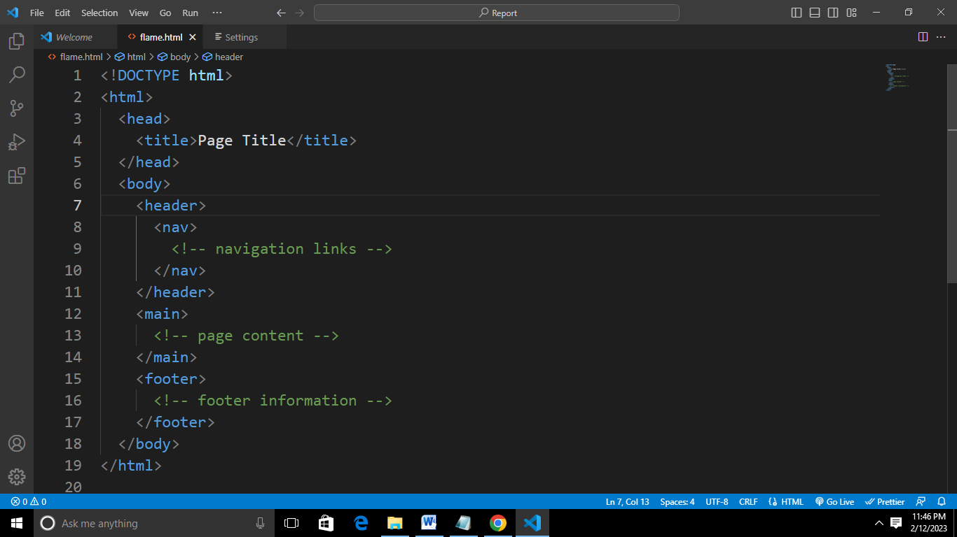

In the example above,

1. <!DOCTYPE html>: This is the document type declaration and it indicates that the document is an HTML5 document.
2. <html>: This tag is the root element of the HTML document and it contains all the other elements.
3. <head>: This tag contains information about the document, such as the title of the page, which is displayed in the browser tab, and meta information, such as the character encoding.
4. <title>: This tag is used to define the title of the page.
5. <body>: This tag contains the main content of the page, including the header, main content, and footer.
6. <header>: This tag contains information that appears at the top of the page, such as a logo and navigation links.
7. <nav>: This tag is used to define a section of navigation links.
8. <main>: This tag is used to define the main content of the page.
9. <footer>: This tag contains information that appears at the bottom of the page, such as copyright information.

**3.1.2 Functions and Importance of HTML**

HTML is the standard markup language for documents designed to be displayed in a web browser. It is heavily used for creating pages that are displayed on the World Wide Web. Every page that we witness, on the World Wide Web, is written using a version of HTML code.

Here are some of the key **functions** of HTML:

1. **Structuring Content:** HTML provides a set of elements and tags for structuring the content of a web page. These elements and tags include headings, paragraphs, lists, links, images, and many others, which allow you to create a hierarchical and well-structured document.
2. **Creating Hyperlinks:** HTML provides the <a> tag, which allows you to create hyperlinks that connect web pages to each other, and to other resources, such as images, videos, and documents. Hyperlinks are an essential part of the web, and they enable users to navigate between pages and explore the content of a website.
3. **Adding Media:** HTML provides tags such as <img> and <video> that allow you to embed images and videos in your web pages. This allows you to create rich and engaging content, and to communicate information in a visual and interactive way. HTML also provides the <audio> tag for adding audio content, which enables you to create podcasts and other audio-based content for your users

Here are some **importance** of HTML:

a. **Standard for Web Development:** HTML is the standard markup language used for creating web pages, and it is supported by all web browsers. This means that HTML is an essential tool for web developers, and it provides a common language and structure for creating web content that can be accessed by millions of users around the world.

b. **Essential for Web Accessibility:** HTML provides a way to structure content in a way that is accessible to people with disabilities, such as those who are blind or have low vision. HTML provides elements and attributes for adding descriptive text, alternative text for images, and other information that can be used by assistive technologies, such as screen readers, to make web content more accessible.

c. **Enables Interactivity and Dynamic Content:** HTML provides a way to create static web pages, but it also enables you to create dynamic and interactive web pages. HTML can be used in conjunction with other technologies, such as JavaScript and CSS, to create complex and engaging web applications that respond to user actions and provide rich, interactive experiences.

**WEEK SIX - WEEK ELEVEN (April 4, 2022 – May 13, 2022)**

**3.2 CSS – Cascading Style Sheet**

**3.2.1 Introduction To CSS**

* CSS is a language we use to style a web page.
* CSS stands for Cascading Style Sheets.
* CSS describes how HTML elements are to be displayed on screen, paper, or in other media.
* CSS saves a lot of work. It can control the layout of multiple web pages all at once.

There are several ways to use CSS in a web page:

1. **External Style Sheet:** An external style sheet is a separate CSS file that is linked to one or more HTML pages. To use an external style sheet, you need to create a .css file and link to it from each HTML page that you want to style. The link to the style sheet is added to the head of the HTML document, using the <link> tag.

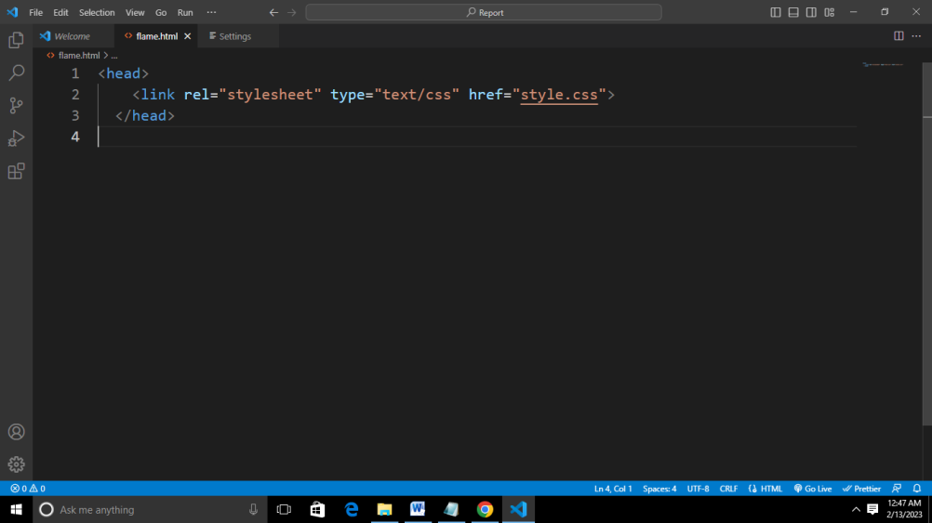

1. **Internal Style Sheet:** An internal style sheet is a block of CSS that is added to the head of an HTML document, using the <style> tag. An internal style sheet is useful when you only need to apply styles to a single HTML page.

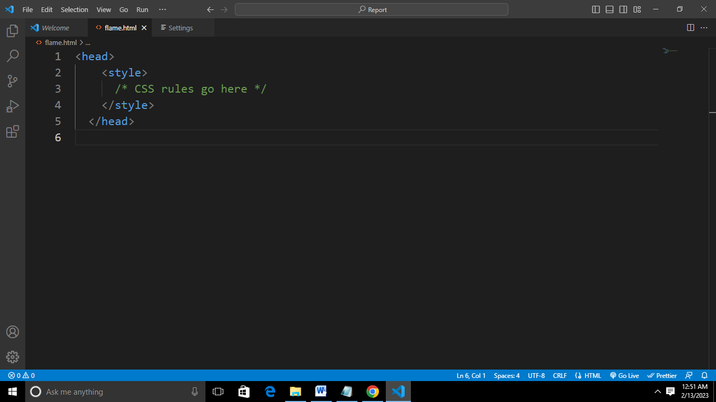

1. **Inline Styles:** Inline styles are styles that are applied directly to an HTML element, using the style attribute. Inline styles are useful when you need to apply styles to a single element on a web page, but they are not recommended for general use, as they can make it harder to maintain and update the styles on a web page.

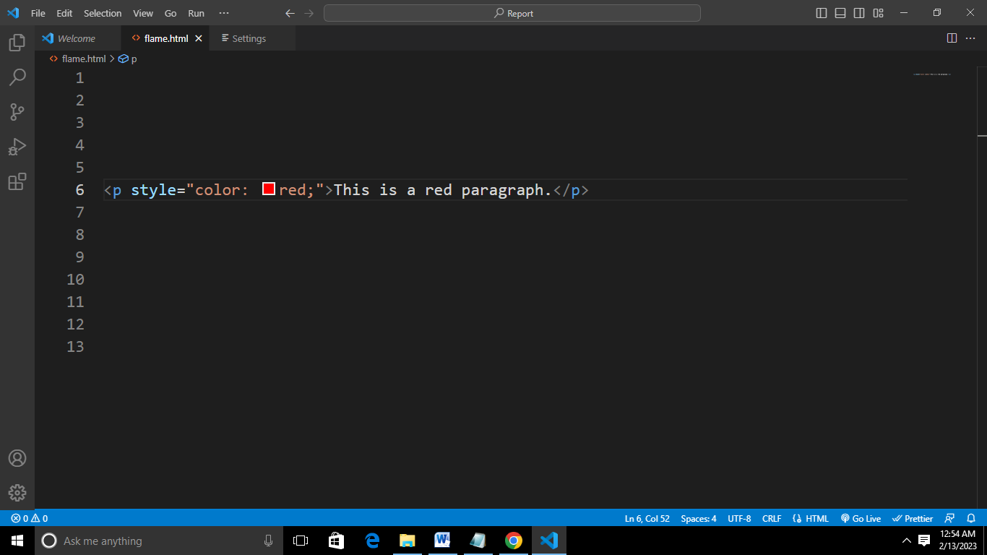

**3.2.2 Functions and Importance of CSS**

CSS is an essential tool for web development, and it provides a powerful and flexible way to control the look and formatting of web pages. Whether you are creating a simple personal website or a complex web application, CSS is a key technology that you should have in your toolkit.

CSS plays a crucial role in web development and has several functions and benefits, including:

1. **Separates Contents and Presentation:** CSS allows you to separate the content of a web page, which is defined using HTML, from its presentation, which is defined using CSS. This separation of concerns makes it easier to maintain and update the appearance of a web page, without affecting the content.
2. **Customizable Look and Feel:** CSS provides a wide range of styling options, such as font and color, background and border, position and layout, and more. These options allow you to create a unique look and feel for your web pages, and to create consistent and professional designs.
3. **Cross-Browser Compatibility:** CSS is supported by all modern web browsers, which means that your styles will be applied consistently across different browsers and platforms. This makes it easier to create web pages that look good on all devices, from desktop computers to mobile phones.
4. **Improved Performance:** By separating the presentation of a web page from its content, CSS enables the browser to cache styles and apply them to multiple pages, which can improve the performance of your website
5. **Enhances Accessibility:** CSS provides a way to control the presentation of a web page, which can be used to make web content more accessible to people with disabilities. For example, CSS can be used to change the font size, color, and contrast of a web page, to make it easier to read for people with low vision

**WEEK TWELVE - WEEK TWENTY-FOUR (May 16, 2022 – August 8, 2022)**

**3.3 JS – JavaScript**

**3.3.1 Introduction to JavaScript**

JavaScript is an essential component of modern web development, and it provides a powerful and flexible way to add dynamic behavior and interactivity to web pages.

JavaScript is a dynamic computer programming language. It is lightweight and most commonly used as a part of the web pages, whose implementation allows a client-side script to interact with a user and to make dynamic pages. It is an interpreted programming language with object-oriented capabilities.

There are two main ways to include JavaScript in a web page:

1. **Internal Script:** You can include JavaScript code directly within a web page by using the <script> tag. The script tag is placed within the HTML document, and the JavaScript code is written between the opening and closing script tags. For example:

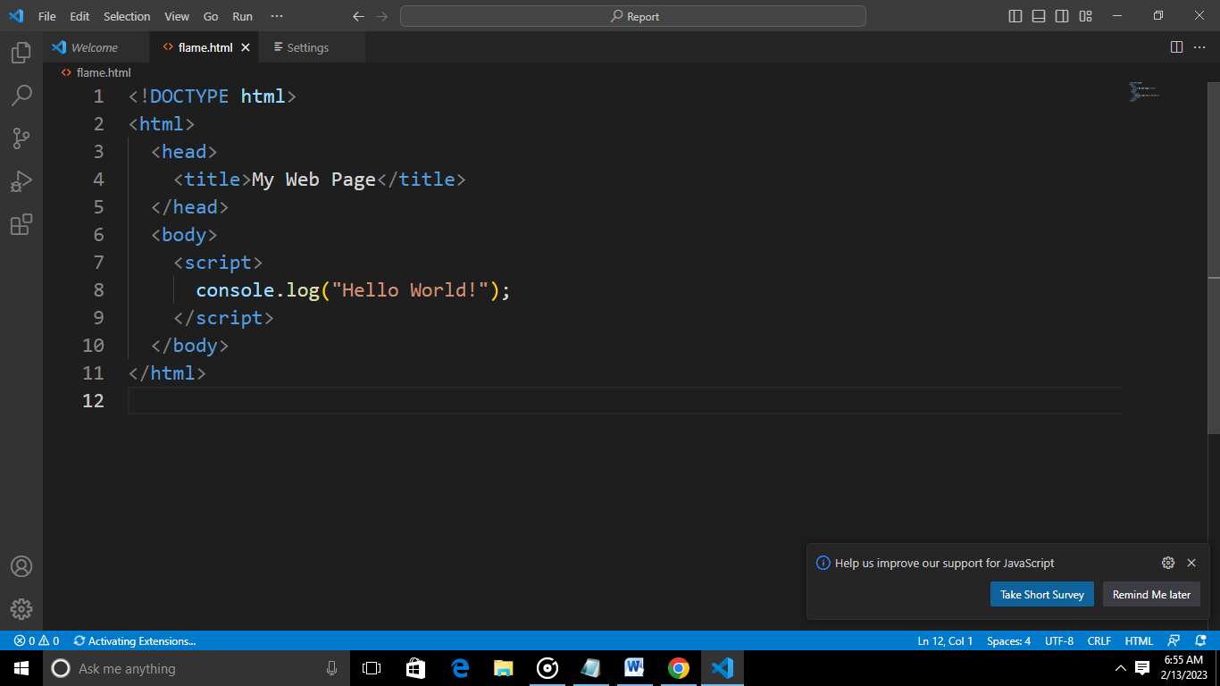

1. **External Script:** You can also include JavaScript code in a web page by linking to an external JavaScript file. This is done using the src attribute of the script tag, and the file must have a .js file extension. For example:

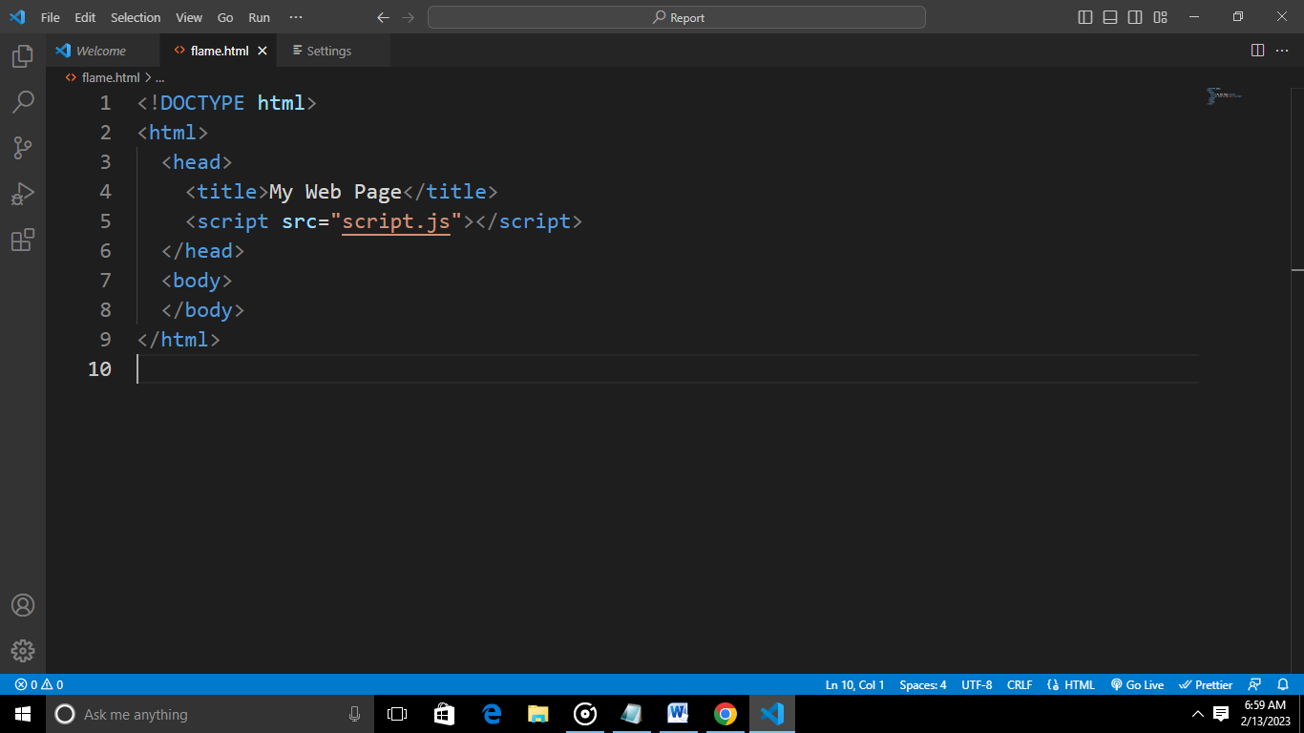

**3.3.2 Functions and Importance of JavaScript**

JavaScript is a powerful and versatile language that is used in a wide range of web development tasks, from form validation and user interaction to complex data visualization and real-time communication. Whether you are creating a simple personal website or a complex web application, JavaScript is an essential tool that you should have in your web development toolkit.

Some of the key **functions** of JavaScript include:

1. **Form Validation:** JavaScript is often used to validate user input in forms, by checking that data is entered correctly and completely, and by providing real-time feedback to the user. This helps to ensure that the data entered into forms is accurate and usable, and it improves the user experience by reducing the need for error correction and repetition.
2. **Data Manipulation:** JavaScript provides a powerful set of data handling and manipulation features, including arrays, objects, and regular expressions. With JavaScript, you can create complex data structures and algorithms, and you can perform advanced data manipulation and analysis.
3. **Dynamic Content:** JavaScript is used to dynamically update the content of a web page, without requiring a full page reload. This can be used to create dynamic navigation menus, to display real-time data updates, or to create other types of dynamic and responsive content.
4. **Asynchronous Processing:** JavaScript provides support for asynchronous processing, which means that it can perform multiple tasks at the same time, without blocking or slowing down the execution of other tasks. This makes JavaScript well-suited for use in web applications that need to perform time-consuming or complex operations, such as loading large data sets or performing real-time communication.

Some of the **importance** of JS includes:

1. **Improved user experience:** By providing dynamic and interactive elements, JavaScript can improve the overall user experience and make web pages more engaging.
2. **Dynamic Interactivity:** JavaScript is essential for creating dynamic and interactive web pages that respond to user actions and events. With JavaScript, you can make web pages feel more like native applications, and you can create custom interactions and animations that enhance the user experience.
3. **Cross-platform compatibility:** JavaScript is supported by all major browsers, which means that code written in JavaScript can run on any device with a web browser.

**CHAPTER FOUR**

**4.0 Knowledge and Skills Acquired**

During my SIWES, I gained a good understanding of web development concepts and skills. Here are some key areas I covered:

1. HTML: I learnt how to create structured and semantically meaningful web pages using HTML (Hypertext Markup Language).
2. CSS: I learnt how to style and layout web pages using CSS (Cascading Style Sheets).
3. JavaScript: I learnt the basics of programming in JavaScript, a client-side scripting language that adds interactivity and dynamic behavior to web pages.
4. Responsive design: I learnt about responsive design, which allows web pages to adapt to different screen sizes and devices.

**CHAPTER FIVE**

**5.1 Conclusion**

In conclusion, web development is a vast and dynamic field that continues to evolve and grow, as new technologies and tools become available. It involves the creation and maintenance of websites and web applications, and requires a combination of technical skills and creative abilities.

HTML provides the structure and content of web pages, while CSS is used to style and visually enhance the content. JavaScript is a programming language that allows for dynamic and interactive user interfaces, and it is widely used in web development to create rich and engaging user experiences.

Overall, the knowledge and skills I have acquired in web development will be invaluable in my career, as the demand for web developers continues to grow, and as the internet continues to play an increasingly important role in our lives. Whether I am interested in building websites, creating web applications, or working in a related field, web development is an essential and rewarding area to study and explore.

**5.2 Recommendation**

Here are my recommendations as regards the SIWES program itself:

1. **Adequate supervision and mentorship:** Recommend that students receive adequate supervision and mentorship from experienced professionals in the field, to ensure that they are receiving the support and guidance they need to succeed.
2. **Access to resources and equipment:** Recommend that students have access to the resources and equipment they need to effectively carry out their work, such as computers, software, and other tools.
3. **Collaborative learning opportunities:** Recommend that students be given opportunities to collaborate with other students and professionals in the field, to encourage teamwork, build relationships, and deepen their understanding of web development concepts and practices.

Here are my recommendations to MZIENET SYSTEMS:

1. **Experienced and knowledgeable mentors:** Recommend that the organization provide students with experienced and knowledgeable mentors who can provide guidance and support throughout the SIWES program.
2. **Real-world projects and assignments:** Recommend that students be given real-world projects and assignments that are aligned with their career goals, to help them gain practical experience and build their portfolios.
3. **Collaborative learning opportunities:** Recommend that the organization create opportunities for students to collaborate with each other and with professionals in the field, to encourage teamwork, build relationships, and deepen their understanding of web development concepts and practices.
4. **Career development resources:** Recommend that the organization provide students with career development resources, such as resume building, interview preparation, and job search strategies, to help them succeed in the job market.

**5.3 Problems Encountered**

As with any complex field, web development can come with a number of **challenges and problems** that need to be addressed. Some of the most common issues faced by web developers include:

1. **Cross-browser Compatibility:** Ensuring that a website or web application works correctly and consistently across multiple web browsers can be a major challenge. Different browsers may render web content differently, and developers need to take this into account when building websites.
2. **Responsive Design:** With an increasing number of users accessing the internet from a variety of devices, including smartphones and tablets, it is essential that websites are designed to be responsive, and adapt to different screen sizes and resolutions.
3. **Security:** Security is a major concern for web developers, and it is essential that appropriate measures are taken to protect sensitive information and prevent unauthorized access. This includes implementing secure authentication and authorization mechanisms, and regularly updating the website or web application to address any known security vulnerabilities.
4. **Performance:** The speed and performance of a website or web application can have a major impact on the user experience, and developers need to be mindful of optimizing their code and using efficient algorithms to ensure that pages load quickly and effectively.
5. **Accessibility:** Ensuring that a website is accessible to all users, including those with disabilities, is a legal requirement in many countries, and it is also an ethical consideration for developers. This requires taking steps to make the website accessible, such as using descriptive alt text for images and providing alternative text for videos.

**5.4 References**

* [www.w3schools.com](http://www.w3schools.com)
* HTML & CSS: The Complete Reference, Fifth Edition (Complete Reference Series) by Thomas A. Powell
* https://www.tutorialspoint.com/javascript/javascript_tutorial.pdf
* Ochiaga C.C, (1995).Theory and practice of career development.
* Oyedele, J.P. (1990) Co-operative work experience programme for youths in business education. Business Education Journals 2: 30-53.