



**REPORT ON STUDENT INDUSTRIAL WORK EXPERINCE SCHEME (SIWES)**

**UNDERTAKEN AT**

**MZIENET SYSTEMS,**

**OSIELE ABEOKUTA, OGUN STATE.**

**BY**

**ALADEJIMI ADEBIMPE TOBILOBA**

**MATRIC NO: 20183000**

**IN PARTIAL FULFILMENT FOR THE AWARD OF THE DEGREE OF BACHELOR OF SCIENCE (B.Sc) in MATHEMATICS**

**SUBMITTED TO**

**THE DEPARTMENT OF MATHEMATICS**

**COLLEGE OF PHYSICAL SCIENCES**

**FEDERAL UNIVERSITY OF AGRICULTURE, ABEOKUTA.**

**FEBRUARY 2022 – AUGUST 2022**

**CERTIFICATION**

This is to certify that this Students’ Industrial Work Experience was carried out by **ALADEJIMI ADEBIMPE TOBILOBA,** with matriculation number **20183000** of the Department of Mathematics at **Mzienet Systems, Opp. OVL Block Industry, Osiele Abeokuta, Ogun State.**

**____________________________ ___________________________**

**ALADEJIMI ADEBIMPE Professor M.O Omeike**

*Student Supervising Lecturer*

_______________________________

**Dr. E. ADELEKE**

*Head of Department*

**DEDICATION**

This SIWES REPORT is dedicated to the ALMIGHTY GOD and to my loving parents Mr. and Mrs. Aladejimi . May God continue to bless you abundantly (Amen).

**ACKNOWLEDGMENT**

My profound gratitude goes to Almighty Allah for the grace to be alive and the opportunity to undergo the SIWES. I’m also grateful to my dearest parent and my siblings for their indefatigable support towards my education. I’m grateful to the Federal Government for giving student like me who are willing to learn, the opportunity to gain practical experiences in the just concluded SIWES. I so much appreciate my supervisor at **MZIENET SYSTEMS, Mr. Francis Ajayi** who did all his best to put me through the learning and tasks during the duration of my Industrial Training. I am also indebted to the members and staff of **Mzienet Systems** especially **Mr. Samson Oderinwale, Mr. Mark Uxier, and Miss. Ponmile Simisola** for their contribution towards making my training worthwhile.

**ABSTRACT**

The Industrial Training Fund (ITF) established the Students Industrial Work Experience Scheme (SIWES) to develop the skills of younger generations to contribute to the development of the technology industry and society in general. This executive summary summarizes the events, meetings, and experiences I had during my six-month internship. Students did obtain practical work on the job training, according to the data. The SIWES program teaches students how to use and manage information technology (IT) equipment and progress in a safe and effective manner. However, the study found that if students are exposed to research resources and accommodations, supported by complete, structured and suitable supervision by their supervisors and furthermore if equipment and machinery monitoring is well-structured, there would inevitably be an increase in performance rates.

**TABLE OF CONTENTS**

**CERTIFICATION i**

**DEDICATION ii**

**ACKNOWLEDGMENT iii**

**ABSTRACT iv**

**CHAPTER ONE**

1.0 Introduction 1

1.1 Historical Background of Siwes 1-2

1.2 Aims and Objectives of Siwes 2-3

1.3 Importance and Benefits of Siwes 3

**CHAPTER TWO**

2.1 Historical Background of Norak Technologies Limited 4

2.2 Departments in Norak Technologies Limited 4

2.3 Mission, Vision and Objectives of Norak Technologies Limited 4-5

2.4 Services and Operations of Norak Technologies Limited 5

2.5 Organogram of Norak Technologies Limited 6

**CHAPTER THREE**

3.0 Introduction to Web Development 7

3.1 WEEK ONE – WEEK FIVE (February 28, 2022 – April 1, 2022)

HTML - Hyper Text Markup Language 8 - 9

3.1.1 Introduction to HTML

3.1.2 Functions and Importance of HTML

3.2 WEEK SIX – WEEK ELEVEN (April 4, 2022 – May 13, 2022)

CSS - Cascading Style Sheet 10 - 11

3.2.1 Introduction to CSS

3.2.2 Functions And Importance of CSS

3.3 WEEK TWELVE – WEEK TWENTY FOUR (May 16, 2022 – August 12, 2022)

JS – JavaScript 12 - 13

3.3.1 Introduction to JS

3.3.2 Functions and Importance of JS

**CHAPTER FOUR**

4.0 Knowledge and Skill Acquired 14

4.1 Knowledge Acquired

4.2 Skill Sets

**CHAPTER FIVE**

5.1 Conclusion 15  
5.2 Recommendation 15 - 17

5.3 Problems Encountered 17

5.4 References 18

**CHAPTER ONE**

**INTRODUCTION**

According to Achiaga (1995), practical knowledge is learning without which mastery of an area of knowledge may be too difficult to achieve. Practical knowledge involves developing skills through the use of tools or equipment to perform tasks that are related to a field of study. Such skills enable one to harness the available resources to meet needs of society. It was to this background that SIWES otherwise known as Student Industrial Training Experience Scheme was introduced in Nigerian tertiary institutions.

SIWES is a skill development program designed to prepare students of universities, polytechnics, monotechnics and colleges of education for transition from the college environment to work (Akerejola 2008). Oyedele (1990) states that work experience is an educational program in which students participates in work activities while attending school. This work experience gives students the opportunity to be part of an actual situation outside classroom. SIWES is a cooperative industrial internship program that involves institutions of higher learning, industries, the federal government of Nigeria, Industrial Training Fund (ITF), Nigerian Universities Commission (NUC), and NBTE/NCE in Nigeria.

**1.1 HISTORICAL BACKGROUND OF SIWES**

Before the establishment of the scheme, there was growing concern among our industrialists that graduates of our institutions of higher learning lacked adequate practical background studies preparatory for employment in industries. Thus, the employers were of the opinion that the theoretical education going on in higher institution was not responsive to the need of the employers of labour. It is against this background that the rationale for initiating and designing the scheme by the fund training its formative years 1973/1974 was introduced to acquaint student with the skills of handling employers’ equipment and machinery. The ITF solely funded the scheme during its formulative years. But as the financial involvement became unbearable to the fund, it withdrew from the scheme in 1978. The Federal Government in November 1984 reverted the management and implementation of the SIWES programme to ITF and it was effectively taken over by the Industrial Training Fund in July 1985 with the funding being solely borne by the Federal Government.

**1.2 AIMS AND OBJECTIVE OF SIWES**

**Aims:**

SIWES was established with the aim of making education relevant and to bridge the yawning gap between the theory and practice of engineering, technology, and science-related disciplines in tertiary institutions in Nigeria.

**Objectives**

The specific objectives of SIWES were summarized by the federal government in its gazette of April, 1978 as follows:-

* To provide an avenue for students in institutions of higher learning to acquire industrial skills and experiences in their courses of study.
* To provide students with an opportunity to apply their knowledge in real work and actual practice.
* To make the transition from school to the world of work easier and to enhance students contacts for later job placement.
* To expose and prepare students of universities, polytechnics, colleges of technology, colleges of agriculture and colleges of education to industrial work situation they are likely to meet after graduation.

**1.3 IMPORTANCE AND BENEFIT OF SIWES**

The major benefits accruing to students who participate conscientiously in industrial training are the skills and competencies they acquire. These relevant production skills remain a part of the recipients of industrial training as life-long assets which cannot be taken away from them.

Other benefits of the industrial training scheme to students who participate include:

* Exposure of students to the environment in which they will eventually work, thereby enabling them to see how their future professions are organized in practice.
* Opportunity for students to blend theoretical knowledge acquired in the classroom with practical hand-on application of knowledge required to perform work in the industry.
* Preparing students to contribute to the productivity of their employers and national development immediately after graduation.

**CHAPTER TWO**

**MZIENET SYSTEMS**

**2.1 HISTORICAL BACKGROUND**

**Mzienet Systems** is an Information Technology organization that started operation in the year2010 at No.3, Orieta street, Oru-Ijebu Ogun State, founded by **Francis Ajayi.** The company was formerly known as **ELITE SYSTEMS** before it was officially renamed and rebranded to **MZIENET SYSTEMS** in the year2019. Mzienet Systems has its head office at Lane C, B22 Opposite OVL Block Industry, Federal College of Education, Abeokuta Campus where it started as a business center that offer services like :

* Research works
* Sales of laptops, desktop computers and accessories
* Computer training
* Plastic ID card design and production
* Computer engineering and many more….

The company has competencies in Information Technology (IT) and related fields. The organization provides state-of-the-art products, technologies relevance in the Nigerian context and plans to create a niche for herself in Information Technology industry in Nigeria and Globally.

**2.2 DEPARTMENTS**

* Administrative and Finance
* Operations/ Human resource
* Client support
* Academy and training
* Project management
* Maintenance

**2.3 MISSION, VISION AND CORE VALUES OF MZIENET SYSTEMS**

**VISION STATEMENT**

To be the best Information Communication Technology firm and life transforming partner

**MISSION**

Helping to create platforms to make you work smart, easy and better with Technology

**CORE VALUES**

**Excellence:** Consistently provide quality service and exceeding expectations

**Innovation:** Continuously evolving

**Integrity:** We will always stand for what is just and right

**Client centeredness:** Our focus is on creating the best experience to meet our client needs and imaginations

**2.4 SERVICES & OPERATIONS**

Currently; Mzienet Systems specializes in the following areas:

* Software Development
* Website Development and Design
* Product design and management
* Mobile application development
* Networking and security
* Co-works spaces
* Outsourcing
* ICT consultation
* ICT training through its academy which gives opportunity to learn in-demand IT skills like:
* Front and backend development
* Graphics Design
* 2D & 3D animations
* Product design (UI/UX)
* Data Analytics
* Desktop Publishing
* Networking

**2.5 ORGANOGRAM OF MZIENET SYSTEMS**

**CHAPTER THREE**

**3.0 INTRODUCTION TO WEB DEVELOPMENT**

Web development refers to the process of creating, building, and maintaining websites and web applications. It involves a variety of skills and disciplines, including web design, coding, scripting, and content creation.

Web developers use programming languages such as HTML, CSS, and JavaScript to build websites that are functional, user-friendly, and visually appealing. They also use web development frameworks and content management systems to streamline the development process and ensure the website meets industry standards and best practices.

**Categories of Web Development**

Web development can be divided into two main categories: front-end development and back-end development. **Front-end** development refers to the part of web development that deals with the user interface and user experience of a website, while **back-end** development focuses on the server-side of the website, including the database and server-side scripting.

Web development is a constantly evolving field, and developers must stay up-to-date with the latest technologies and trends in order to create websites that are fast, secure, and accessible to users across all devices and platforms.

**WEEK ONE - WEEK FIVE (February 28, 2022 – April 1, 2022)**

**3.1 HTML – Hyper Text Markup Language**

**3.1.1 Introduction to HTML**

HTML (Hypertext Markup Language) is a markup language used to create web pages and web applications. It provides a set of tags and attributes that web developers use to structure and format the content of a web page.

HTML is an important component of web development, as it provides the structure and content of a web page. It is often used in conjunction with other web technologies, such as CSS and JavaScript, to create rich and interactive web experiences.

HTML uses a system of tags and attributes to define the structure and content of a web page. For example, the <h1> tag is used to define a header, the <p> tag is used to define a paragraph, and the <img> tag is used to embed an image. Attributes are used to specify additional information about an element, such as the source of an image or the URL of a link.

Here is an example of a simple HTML page:

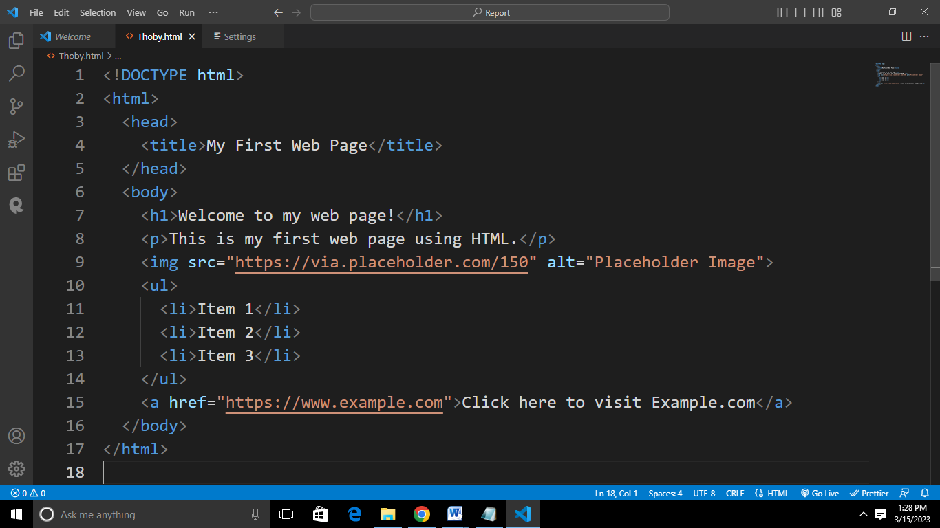

This HTML code creates a simple web page that includes a heading, paragraph, image, list, and hyperlink. The doctype declaration specifies that the document type is HTML, the <head> tag contains metadata about the document, and the <body> tag contains the visible content of the page. Other tags used in the code include <h1> for the main heading, <p> for the paragraph, <img> for the image, <ul> and <li> for the list, and <a> for the hyperlink.

**3.1.2 Importance of HTML**

Certainly! HTML (Hypertext Markup Language) is the standard markup language used for creating web pages. HTML is the backbone of the web and plays a crucial role in creating and structuring the content of web pages. Here are some reasons why HTML is important:

1. **Integration:** HTML can be integrated with other programming languages, such as CSS (Cascading Style Sheets) and JavaScript, to create dynamic and interactive web pages.
2. **SEO:** HTML plays a significant role in search engine optimization (SEO). Search engines like Google use HTML to understand the content of web pages and rank them accordingly in search results.
3. **Content:** HTML is used to define the content of a web page, including text, images, and other multimedia elements. The content of a web page can be easily edited and updated using HTML, making it a flexible and versatile way to create and manage web content.
4. **Accessibility:** HTML provides a way to create web pages that are accessible to a wide range of users, including those with disabilities. This is achieved through the use of semantic elements, proper labeling of content, and the ability to add alternative text for images.

**WEEK SIX - WEEK ELEVEN (April 4, 2022 – May 13, 2022)**

**3.2 CSS – Cascading Style Sheet**

**3.2.1 Introduction To CSS**

CSS is a powerful tool that helps web developers to create visually appealing and user-friendly web pages. CSS means Cascading Style Sheet

CSS allows developers to separate the content and structure of a web page from its visual appearance. With CSS, designers can create rules and styles that can be applied to various HTML elements on a web page, such as fonts, colors, layout, and other design elements.

CSS works by creating a set of rules that define how specific HTML elements should be displayed on the web page. These rules can be applied to individual elements, groups of elements, or the entire page. The rules can also be organized into different classes, allowing developers to apply the same styles to multiple elements.

Here is an example of CSS usage:

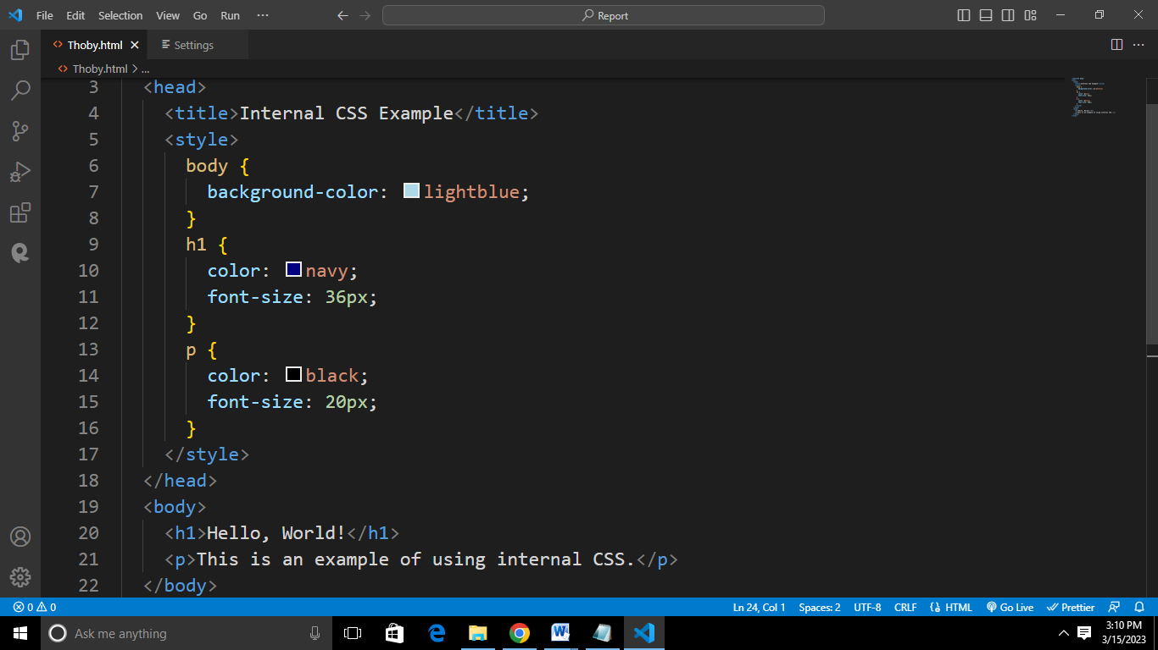

In this example, we have defined the styles for the body, h1, and p elements within the <style> tags in the <head> section of the HTML document. These styles will be applied to any body, h1, and p elements within the HTML document.

**3.2.2 Functions and Importance of CSS**

Certainly! CSS (Cascading Style Sheets) is a styling language used for describing the visual presentation of web pages, including layout, typography, colors, and more.

CSS handles the look and feel part of a web page. Using CSS, you can control the color of the text, the style of fonts, the spacing between paragraphs, how columns are sized and laid out, etc.

Here are some reasons why CSS is important:

1. **Branding:** CSS can be used to create a consistent visual brand identity for websites, helping to establish a recognizable and memorable brand for businesses and organizations.
2. **Styling Flexibility:** CSS provides a wide range of styling options, including layout, typography, colors, and animations. This flexibility allows developers to create visually appealing and engaging web pages that capture users' attention.
3. **Better Performance:** By reducing the size of HTML files and centralizing the styling information in a single CSS file, websites can load faster and use less bandwidth.
4. **Optimization:** CSS can be used to optimize the performance of web pages, by reducing file sizes, minimizing the number of HTTP requests, and improving page load times. This is crucial for creating fast-loading web pages that provide a good user experience.
5. **Responsive Design:** CSS makes it possible to create responsive designs that automatically adjust the layout of a website to the size of the device or screen being used, which is crucial for a good user experience on different devices.

**WEEK TWELVE - WEEK TWENTY-FOUR (May 16, 2022 – August 8, 2022)**

**3.3 JS – JavaScript**

**3.3.1 Introduction To JavaScript**

JavaScript is a powerful and versatile programming language that can be used to create a wide range of applications and features on the web and beyond.

JavaScript is a versatile language that can be used for a wide variety of applications, including creating dynamic web pages, building web and mobile applications, developing server-side applications, creating games, and much more.

JavaScript is a language that is executed by a web browser's JavaScript engine. It is typically embedded within HTML and CSS to provide dynamic behavior and interactive features.

To use JavaScript in a web page, you need to add the JavaScript code to an HTML file, either within a <script> tag in the head or body of the document, or by linking to an external JavaScript file using the src attribute.

Here's a simple example of JavaScript implementation:

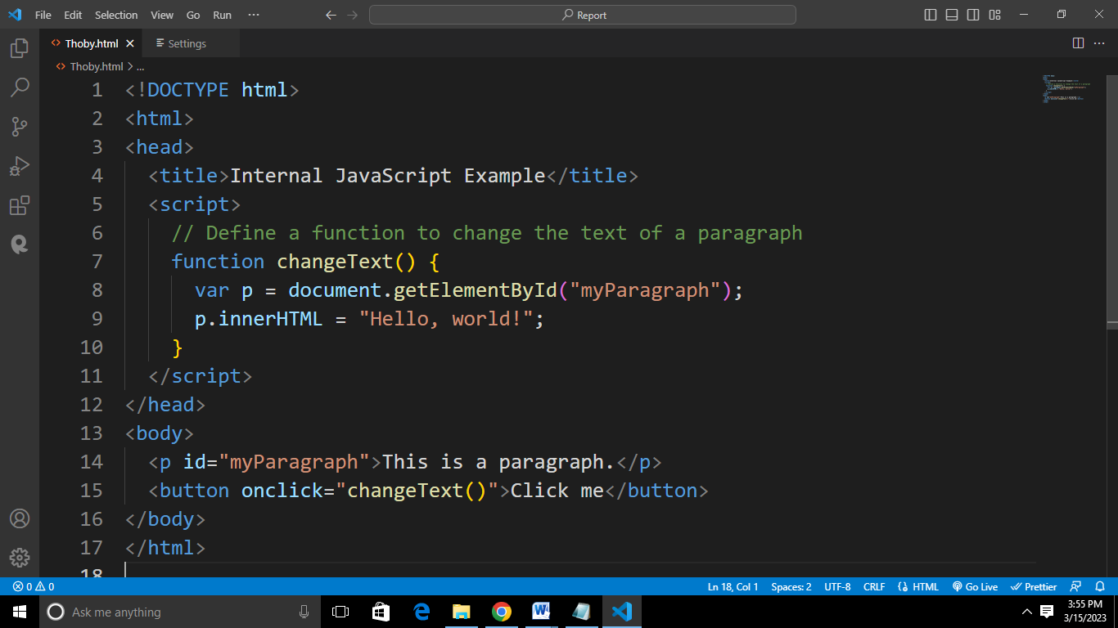

In this example, we have an HTML document that includes an internal JavaScript block in the <head> section. This block defines a function called changeText() that retrieves an HTML element with the ID "myParagraph" and changes its content to "Hello, world!".

In the body of the document, we have a paragraph element with the ID "myParagraph" and a button that calls the changeText() function when clicked. When the user clicks the button, the text of the paragraph element is changed to "Hello, world!".

**3.3.2 Functions and Importance of JavaScript**

JavaScript can make the website more interactive and user-friendliness of JavaScript helps easy navigation of the website and helps designers to guide the visitors with additional information or guide them through walkthroughs. Visual effects can also be achieved with JavaScript. JavaScript can be used effectively to create special effects like rollover for images.

Some of the key functions and importance of JavaScript include:

1. **Animations:** JavaScript can be used to create animations on a web page by changing the position, size, or style of HTML elements over time. Animations can add visual interest to a page and can be used to provide feedback to users.
2. **Event handling:** JavaScript can be used to handle user events like mouse clicks, key presses, and form submissions. By attaching event listeners to HTML elements, JavaScript can respond to these events and perform actions such as updating the page content, validating user input, or submitting data to a server.
3. **Web components:** JavaScript can be used to create custom web components, which are reusable, modular pieces of code that can be used to build complex web applications. Web components are becoming increasingly popular as a way to simplify web development and create more maintainable code.
4. **Error handling:** JavaScript can be used to handle errors that occur during the execution of a web page. By using try-catch blocks and other error-handling techniques, you can gracefully handle errors and prevent them from crashing the page.
5. **Complex web applications:** JavaScript can be used to build complex web applications, such as e-commerce platforms, social media sites, and content management systems.
6. **Cross-platform compatibility:** JavaScript is supported by all major browsers, which means that code written in JavaScript can run on any device with a web browser.

**CHAPTER FOUR**

**4.0 Knowledge and Skills Acquired**

During my SIWES, I gained a good understanding of web development concepts and skills. Here are some key areas I covered:

1. HTML: I learnt how to create structured and semantically meaningful web pages using HTML (Hypertext Markup Language).
2. CSS: I learnt how to style and layout web pages using CSS (Cascading Style Sheets).
3. JavaScript: I learnt the basics of programming in JavaScript, a client-side scripting language that adds interactivity and dynamic behavior to web pages.
4. Responsive design: I learnt about responsive design, which allows web pages to adapt to different screen sizes and devices.
5. Web development frameworks and libraries: I learnt about popular web development framework(React), that can be used to streamline web development and make it easier to build complex web applications.

**CHAPTER FIVE**

**5.1 Conclusion**

In conclusion, I had the opportunity to learn the fundamentals of web development, including HTML, CSS, and JavaScript. This knowledge has provided me with the foundation necessary to create web pages and web applications.

My experience in web development has given me the opportunity to gain practical skills such as coding, testing, debugging, and troubleshooting. These skills are essential for a career in web development and can be applied in various projects.

More so, SIWES program has exposed me to industry practices in web development, such as version control, agile development methodologies, and collaboration tools. These practices are crucial for working in a team and ensuring that web development projects are completed efficiently and effectively.

**5.2 Recommendation**

Here are my recommendations as regards the SIWES program itself:

1. **Placement at relevant companies:** Recommend that students be placed at companies that are relevant to their field of study, to ensure that they gain practical experience that is aligned with their career goals.
2. **Adequate supervision and mentorship:** Recommend that students receive adequate supervision and mentorship from experienced professionals in the field, to ensure that they are receiving the support and guidance they need to succeed.
3. **Opportunities for skill development:** Recommend that students be given opportunities to develop their skills and gain hands-on experience, through real-world projects and other activities.
4. **Access to resources and equipment:** Recommend that students have access to the resources and equipment they need to effectively carry out their work, such as computers, software, and other tools.
5. **Collaborative learning opportunities:** Recommend that students be given opportunities to collaborate with other students and professionals in the field, to encourage teamwork, build relationships, and deepen their understanding of web development concepts and practices.
6. **Regular training and workshops:** Recommend that students receive regular training and workshops to help them stay current with the latest technologies, tools, and trends in web development.

Here are my recommendations to MZIENET SYSTEMS:

1. **Up-to-date technology and equipment:** Recommend that the organization invest in up-to-date technology and equipment to ensure that students have access to the resources they need to effectively carry out their work.
2. **Experienced and knowledgeable mentors:** Recommend that the organization provide students with experienced and knowledgeable mentors who can provide guidance and support throughout the SIWES program.
3. **Real-world projects and assignments:** Recommend that students be given real-world projects and assignments that are aligned with their career goals, to help them gain practical experience and build their portfolios.
4. **Timely feedback and evaluation:** Recommend that students receive timely feedback and evaluation on their work, to help them understand their strengths and weaknesses and make necessary improvements.
5. **Collaborative learning opportunities:** Recommend that the organization create opportunities for students to collaborate with each other and with professionals in the field, to encourage teamwork, build relationships, and deepen their understanding of web development concepts and practices.
6. **Regular training and workshops:** Recommend that the organization provide regular training and workshops to help students stay current with the latest technologies, tools, and trends in web development.

**5.3 Problems Encountered**

As with any complex field, web development can come with a number of **challenges and problems** that need to be addressed. Some of the most common issues faced by web developers include:

1. **Responsive Design:** With an increasing number of users accessing the internet from a variety of devices, including smartphones and tablets, it is essential that websites are designed to be responsive, and adapt to different screen sizes and resolutions.
2. **Security:** Security is a major concern for web developers, and it is essential that appropriate measures are taken to protect sensitive information and prevent unauthorized access. This includes implementing secure authentication and authorization mechanisms, and regularly updating the website or web application to address any known security vulnerabilities.
3. **Accessibility:** Ensuring that a website is accessible to all users, including those with disabilities, is a legal requirement in many countries, and it is also an ethical consideration for developers. This requires taking steps to make the website accessible, such as using descriptive alt text for images and providing alternative text for videos.

**5.4 References**

* [www.w3schools.com](http://www.w3schools.com)
* HTML & CSS: The Complete Reference, Fifth Edition (Complete Reference Series) by Thomas A. Powell
* https://www.tutorialspoint.com/javascript/javascript_tutorial.pdf
* Ochiaga C.C, (1995).Theory and practice of career development.
* Oyedele, J.P. (1990) Co-operative work experience programme for youths in business education. Business Education Journals 2: 30-53.