



**REPORT ON STUDENT INDUSTRIAL WORK EXPERINCE SCHEME (SIWES)**

**UNDERTAKEN AT**

**MZIENET SYSTEMS,**

**OSIELE ABEOKUTA, OGUN STATE.**

**BY**

**OLALERE BABATUNDE**

**MATRIC NO: 20183060**

**IN PARTIAL FULFILMENT FOR THE AWARD OF THE DEGREE OF BACHELOR OF SCIENCE (B.Sc) in MATHEMATICS**

**SUBMITTED TO**

**THE DEPARTMENT OF MATHEMATICS**

**COLLEGE OF PHYSICAL SCIENCES**

**FEDERAL UNIVERSITY OF AGRICULTURE, ABEOKUTA.**

**FEBRUARY 2022 – AUGUST 2022**

**CERTIFICATION**

This is to certify that this Students’ Industrial Work Experience was carried out by **OLALERE BABATUNDE,** with matriculation number **20183060** of the Department of Mathematics at **Mzienet Systems, Opp. OVL Block Industry, Osiele Abeokuta, Ogun State.**

**____________________________ ___________________________**

**Olalere Babatunde Professor M.O Omeike**

*Student Supervising Lecturer*

_______________________________

**Dr. E. ADELEKE**

*Head of Department*

**DEDICATION**

This SIWES REPORT is dedicated to the ALMIGHTY GOD and to my loving parents Mr. and Mrs. Olalere . May God continue to bless you abundantly (Amen).

**ACKNOWLEDGMENT**

My profound gratitude goes to Almighty Allah for the grace to be alive and the opportunity to undergo the SIWES. I’m also grateful to my dearest parent and my siblings for their indefatigable support towards my education. I’m grateful to the Federal Government for giving student like me who are willing to learn, the opportunity to gain practical experiences in the just concluded SIWES. I so much appreciate my supervisor at **MZIENET SYSTEMS, Mr. Francis Ajayi** who did all his best to put me through the learning and tasks during the duration of my Industrial Training. I am also indebted to the members and staff of **Mzienet Systems** especially **Mr. Samson Oderinwale, Mr. Mark Uxier, and Miss. Ponmile Simisola** for their contribution towards making my training worthwhile.

**ABSTRACT**

The Industrial Training Fund (ITF) established the Students Industrial Work Experience Scheme (SIWES) to develop the skills of younger generations to contribute to the development of the technology industry and society in general. This executive summary summarizes the events, meetings, and experiences I had during my six-month internship. Students did obtain practical work on the job training, according to the data. The SIWES program teaches students how to use and manage information technology (IT) equipment and progress in a safe and effective manner. However, the study found that if students are exposed to research resources and accommodations, supported by complete, structured and suitable supervision by their supervisors and furthermore if equipment and machinery monitoring is well-structured, there would inevitably be an increase in performance rates.

**TABLE OF CONTENTS**

**CERTIFICATION i**

**DEDICATION ii**

**ACKNOWLEDGMENT iii**

**ABSTRACT iv**

**CHAPTER ONE**

1.0 Introduction 1

1.1 Historical Background of Siwes 1-2

1.2 Aims and Objectives of Siwes 2-3

1.3 Importance and Benefits of Siwes 3

**CHAPTER TWO**

2.1 Historical Background of Norak Technologies Limited 4

2.2 Departments in Norak Technologies Limited 4

2.3 Mission, Vision and Objectives of Norak Technologies Limited 4-5

2.4 Services and Operations of Norak Technologies Limited 5

2.5 Organogram of Norak Technologies Limited 6

**CHAPTER THREE**

3.0 Introduction to Web Development 7

3.1 WEEK ONE – WEEK FIVE (February 28, 2022 – April 1, 2022)

HTML - Hyper Text Markup Language 8 - 9

3.1.1 Introduction to HTML

3.1.2 Functions and Importance of HTML

3.2 WEEK SIX – WEEK ELEVEN (April 4, 2022 – May 13, 2022)

CSS - Cascading Style Sheet 10 - 11

3.2.1 Introduction to CSS

3.2.2 Functions And Importance of CSS

3.3 WEEK TWELVE – WEEK TWENTY FOUR (May 16, 2022 – August 12, 2022)

JS – JavaScript 12 - 13

3.3.1 Introduction to JS

3.3.2 Functions and Importance of JS

**CHAPTER FOUR**

4.0 Knowledge and Skill Acquired 14

4.1 Knowledge Acquired

4.2 Skill Sets

**CHAPTER FIVE**

5.1 Conclusion 15  
5.2 Recommendation 15 - 17

5.3 Problems Encountered 17

5.4 References 18

**CHAPTER ONE**

**INTRODUCTION**

According to Achiaga (1995), practical knowledge is learning without which mastery of an area of knowledge may be too difficult to achieve. Practical knowledge involves developing skills through the use of tools or equipment to perform tasks that are related to a field of study. Such skills enable one to harness the available resources to meet needs of society. It was to this background that SIWES otherwise known as Student Industrial Training Experience Scheme was introduced in Nigerian tertiary institutions.

SIWES is a skill development program designed to prepare students of universities, polytechnics, monotechnics and colleges of education for transition from the college environment to work (Akerejola 2008). Oyedele (1990) states that work experience is an educational program in which students participates in work activities while attending school. This work experience gives students the opportunity to be part of an actual situation outside classroom. SIWES is a cooperative industrial internship program that involves institutions of higher learning, industries, the federal government of Nigeria, Industrial Training Fund (ITF), Nigerian Universities Commission (NUC), and NBTE/NCE in Nigeria.

**1.1 HISTORICAL BACKGROUND OF SIWES**

Before the establishment of the scheme, there was growing concern among our industrialists that graduates of our institutions of higher learning lacked adequate practical background studies preparatory for employment in industries. Thus, the employers were of the opinion that the theoretical education going on in higher institution was not responsive to the need of the employers of labour. It is against this background that the rationale for initiating and designing the scheme by the fund training its formative years 1973/1974 was introduced to acquaint student with the skills of handling employers’ equipment and machinery. The ITF solely funded the scheme during its formulative years. But as the financial involvement became unbearable to the fund, it withdrew from the scheme in 1978. The Federal Government in November 1984 reverted the management and implementation of the SIWES programme to ITF and it was effectively taken over by the Industrial Training Fund in July 1985 with the funding being solely borne by the Federal Government.

**1.2 AIMS AND OBJECTIVE OF SIWES**

**Aims:**

SIWES was established with the aim of making education relevant and to bridge the yawning gap between the theory and practice of engineering, technology, and science-related disciplines in tertiary institutions in Nigeria.

**Objectives**

The specific objectives of SIWES were summarized by the federal government in its gazette of April, 1978 as follows:-

* To provide an avenue for students in institutions of higher learning to acquire industrial skills and experiences in their courses of study.
* To provide students with an opportunity to apply their knowledge in real work and actual practice.
* To make the transition from school to the world of work easier and to enhance students contacts for later job placement.
* To expose and prepare students of universities, polytechnics, colleges of technology, colleges of agriculture and colleges of education to industrial work situation they are likely to meet after graduation.

**1.3 IMPORTANCE AND BENEFIT OF SIWES**

The major benefits accruing to students who participate conscientiously in industrial training are the skills and competencies they acquire. These relevant production skills remain a part of the recipients of industrial training as life-long assets which cannot be taken away from them.

Other benefits of the industrial training scheme to students who participate include:

* Exposure of students to the environment in which they will eventually work, thereby enabling them to see how their future professions are organized in practice.
* Opportunity for students to blend theoretical knowledge acquired in the classroom with practical hand-on application of knowledge required to perform work in the industry.
* Preparing students to contribute to the productivity of their employers and national development immediately after graduation.

**CHAPTER TWO**

**MZIENET SYSTEMS**

**2.1 HISTORICAL BACKGROUND**

**Mzienet Systems** is an Information Technology organization that started operation in the year2010 at No.3, Orieta street, Oru-Ijebu Ogun State, founded by **Francis Ajayi.** The company was formerly known as **ELITE SYSTEMS** before it was officially renamed and rebranded to **MZIENET SYSTEMS** in the year 2019. Mzienet Systems has its head office at Lane C, B22 Opposite OVL Block Industry, Federal College of Education, Abeokuta Campus where it started as a business center that offer services like:

* Research works
* Sales of laptops, desktop computers and accessories
* Computer training
* Plastic ID card design and production
* Computer engineering and many more….

The company has competencies in Information Technology (IT) and related fields. The organization provides state-of-the-art products, technologies relevance in the Nigerian context and plans to create a niche for herself in Information Technology industry in Nigeria and Globally.

**2.2 DEPARTMENTS**

* Administrative and Finance
* Operations/ Human resource
* Client support
* Academy and training
* Project management
* Maintenance

**2.3 MISSION, VISION AND CORE VALUES OF MZIENET SYSTEMS**

**VISION STATEMENT**

To be the best Information Communication Technology firm and life transforming partner

**MISSION**

Helping to create platforms to make you work smart, easy and better with Technology

**CORE VALUES**

**Excellence:** Consistently provide quality service and exceeding expectations

**Innovation:** Continuously evolving

**Integrity:** We will always stand for what is just and right

**Client centeredness:** Our focus is on creating the best experience to meet our client needs and imaginations

**2.4 SERVICES & OPERATIONS**

Currently; Mzienet Systems specializes in the following areas:

* Software Development
* Website Development and Design
* Product design and management
* Mobile application development
* Networking and security
* Co-works spaces
* Outsourcing
* ICT consultation
* ICT training through its academy which gives opportunity to learn in-demand IT skills like:
* Front and backend development
* Graphics Design
* 2D & 3D animations
* Product design (UI/UX)
* Data Analytics
* Desktop Publishing
* Networking

**2.5 ORGANOGRAM OF MZIENET SYSTEMS**

**CHAPTER THREE**

**3.0 INTRODUCTION TO WEB DEVELOPMENT**

Web development refers to the process of creating, designing, and maintaining websites. It encompasses a range of activities, including web design, web content development, client-side scripting, and server-side scripting

Web development could be a good profession for you if you like solving logical problems, building useful things, and experimenting with new technologies. Web developers are in high demand, generally have a good work/life balance, and command comfortable salaries.

**Categories of Web Development**

Earlier, we mentioned that web development work could be client-side scripting, and server-side scripting, or the full stack. What exactly do these terms mean?

The **client-side scripting** (front end) involves the creation of the user interface of a website, including its layout, visual design, and interaction design. Front-end developers use languages such as HTML, CSS, and JavaScript to build the front-end of a website.

Front end is the stuff you see on the website in your browser, including the presentation of content and user interface elements like the navigation bar.

The **server-side scripting (**back end) involves the creation of the server-side components of a website, including its database and application logic. Back-end developers use programming languages such as PHP, Ruby, Python, and Java to build the back-end of a website.. The back end stores and serves program data to ensure that the front end has what it needs. This process can become very complicated when a website has millions of users.

**Full-stack** developers are comfortable working with both the **front** and **back** ends.

**WEEK ONE - WEEK FIVE (February 28, 2022 – April 1, 2022)**

**3.1 HTML – Hyper Text Markup Language**

**3.1.1 Introduction To HTML**

HTML stands for Hypertext Markup Language and it is the standard markup language used to create web pages. HTML is used to structure the content of a web page, including text, images, and other multimedia elements, and to define how that content is displayed in a web browser.

HTML is the combination of Hypertext and Markup language. Hypertext defines the link between web pages. A markup language is used to define the text document within the tag which defines the structure of web pages. This language is used to annotate (make notes for the computer) text so that a machine can understand it and manipulate text accordingly. Most markup languages (e.g. HTML) are human-readable. The language uses tags to define what manipulation has to be done on the text.

HTML uses a system of tags and attributes to define the structure and content of a web page. For example, the <h1> tag is used to define a header, the <p> tag is used to define a paragraph, and the <img> tag is used to embed an image. Attributes are used to specify additional information about an element, such as the source of an image or the URL of a link.

Here is an example of a simple HTML page:

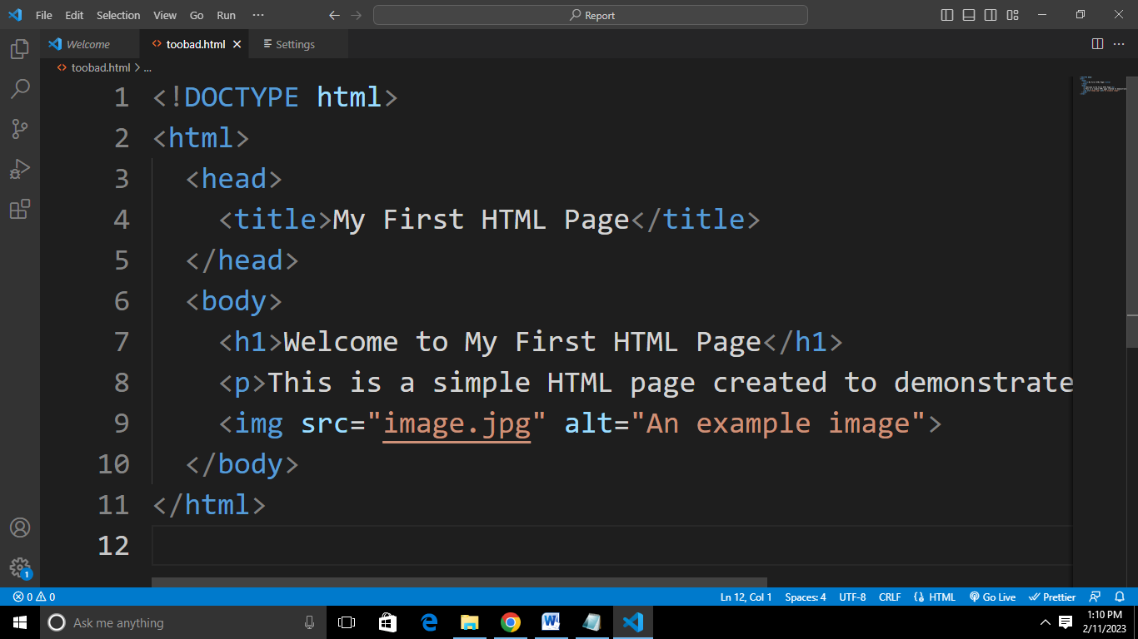

In the example above,

<!DOCTYPE html> declaration specifies that this is an HTML5 document,

<html> tag encloses the entire document,

<head> tag contains information about the document such as its title,

<body> tag contains the main content of the page,

<h1> tag defines a header,

<p> tag defines a paragraph,

<img> tag embeds an image with the source "image.jpg" and alternative text "An example image".

**3.1.2 Functions and Importance of HTML**

HTML is very important for creating webpages. **It makes the webpages on internet viewable**. So it can be said that it is because of HTML that web pages are interesting to look at, but the importance of HTML is often taken for granted.

HTML serves several important functions and plays a crucial role in the development of websites. Here are some of the key functions and benefits of HTML:

1. **Structure:** HTML provides a way to structure the content of a web page into different elements, such as headers, paragraphs, lists, and tables. This structure helps to make the content of a web page more organized and easier to understand.
2. **Semantics:** HTML provides a set of semantic elements, such as <header>, <nav>, and <article>, that give meaning to the structure and content of a web page. This makes it easier for search engines to understand the content of a page and improves accessibility for users with disabilities.
3. **Content:** HTML is used to define the content of a web page, including text, images, and other multimedia elements. The content of a web page can be easily edited and updated using HTML, making it a flexible and versatile way to create and manage web content.
4. **Interactivity:** HTML provides a way to add interactivity to a web page through the use of links, forms, and other elements. This makes it possible to create dynamic and engaging websites that can respond to user input and interactions.
5. **Accessibility:** HTML provides a way to create web pages that are accessible to a wide range of users, including those with disabilities. This is achieved through the use of semantic elements, proper labeling of content, and the ability to add alternative text for images.

**WEEK SIX - WEEK ELEVEN (April 4, 2022 – May 13, 2022)**

**3.2 CSS – Cascading Style Sheet**

**3.2.1 Introduction To CSS**

CSS (Cascading Style Sheets) is a style sheet language used for describing the presentation of a document written in HTML or XML. It provides a way to control the look and feel of a web page, separate from its content. With CSS, you can set properties such as the font, color, size, spacing, layout, and more for HTML elements.

In short, CSS is a design language that makes a website look more appealing than just plain or uninspiring pieces of text. Whereas HTML largely determines textual content, CSS determines visual structure, layout, and aesthetics.

CSS is used to style and layout web pages — for example, to alter the font, color, size, and spacing of your content, split it into multiple columns, or add animations and other decorative features.

To use CSS, you need to create a separate CSS file or add the CSS code to the head of the HTML file. In the CSS code, you specify the styles using selectors and declarations. A selector determines which HTML elements the styles should be applied to, and a declaration is a set of properties and values that define the style.

Here is an example of how CSS can be used to change the color and font-size of an HTML element:

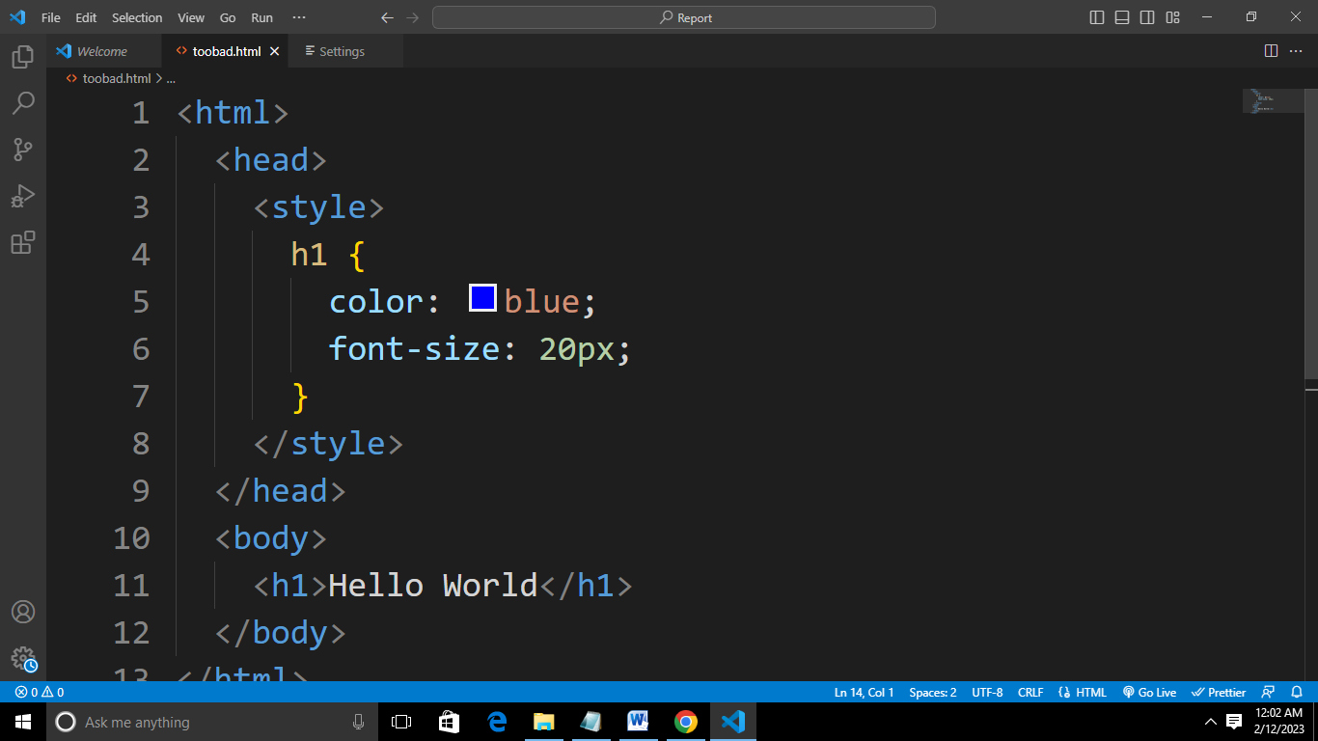

In this example,

the selector h1 matches all <h1> elements in the HTML document,

the declarations color: blue and font-size: 20px specify the font color and size for the selected elements.

**3.2.2 Functions and Importance of CSS**

CSS is the language for describing the presentation of Web pages, including colors, layout, and fonts. It allows one to adapt the presentation to different types of devices, such as large screens, small screens, or printers. CSS is independent of HTML and can be used with any XML-based markup language.

CSS handles the look and feel part of a web page. Using CSS, you can control the color of the text, the style of fonts, the spacing between paragraphs, how columns are sized and laid out, etc. CSS saves time − You can write CSS once and then reuse the same sheet in multiple HTML pages.

CSS plays a crucial role in web development and has several functions and benefits, including:

1. **Separation of Contents:** CSS separates the presentation of a website from its content, making it easier for developers to manage and maintain the website. This allows for changes in the visual design to be made without affecting the underlying HTML code.
2. **Consistency and Reusability:** CSS makes it possible to apply the same styles to multiple elements and pages, ensuring consistent design throughout a website. This helps to improve the overall user experience and makes maintenance easier.
3. **Better Performance:** By reducing the size of HTML files and centralizing the styling information in a single CSS file, websites can load faster and use less bandwidth.
4. **Improved Accessibility:** CSS provides a way to control the presentation of a website, including the font size and color, which can be adjusted to improve accessibility for users with visual or motor impairments.
5. **Responsive Design:** CSS makes it possible to create responsive designs that automatically adjust the layout of a website to the size of the device or screen being used, which is crucial for a good user experience on different devices.

**WEEK TWELVE - WEEK TWENTY-FOUR (May 16, 2022 – August 8, 2022)**

**3.3 JS – JavaScript**

**3.3.1 Introduction to JavaScript**

JavaScript is a high-level, interpreted programming language that is commonly used to add interactivity and other dynamic features to web pages. It is often used in conjunction with HTML and CSS to build web applications and user interfaces.

JavaScript can be used to manipulate the content and layout of a web page in real-time, respond to user input, create animations, and perform many other types of tasks. It can also be used to make HTTP requests to a server and retrieve or update data dynamically, making it an essential part of modern web development.

JavaScript is a dynamic computer programming language. It is lightweight and most commonly used as a part of the web pages, whose implementation allows a client-side script to interact with a user and to make dynamic pages. It is an interpreted programming language with object-oriented capabilities.

To use JavaScript in a web page, you need to add the JavaScript code to an HTML file, either within a <script> tag in the head or body of the document, or by linking to an external JavaScript file using the src attribute.

Here's a simple example that displays an alert message using JavaScript:

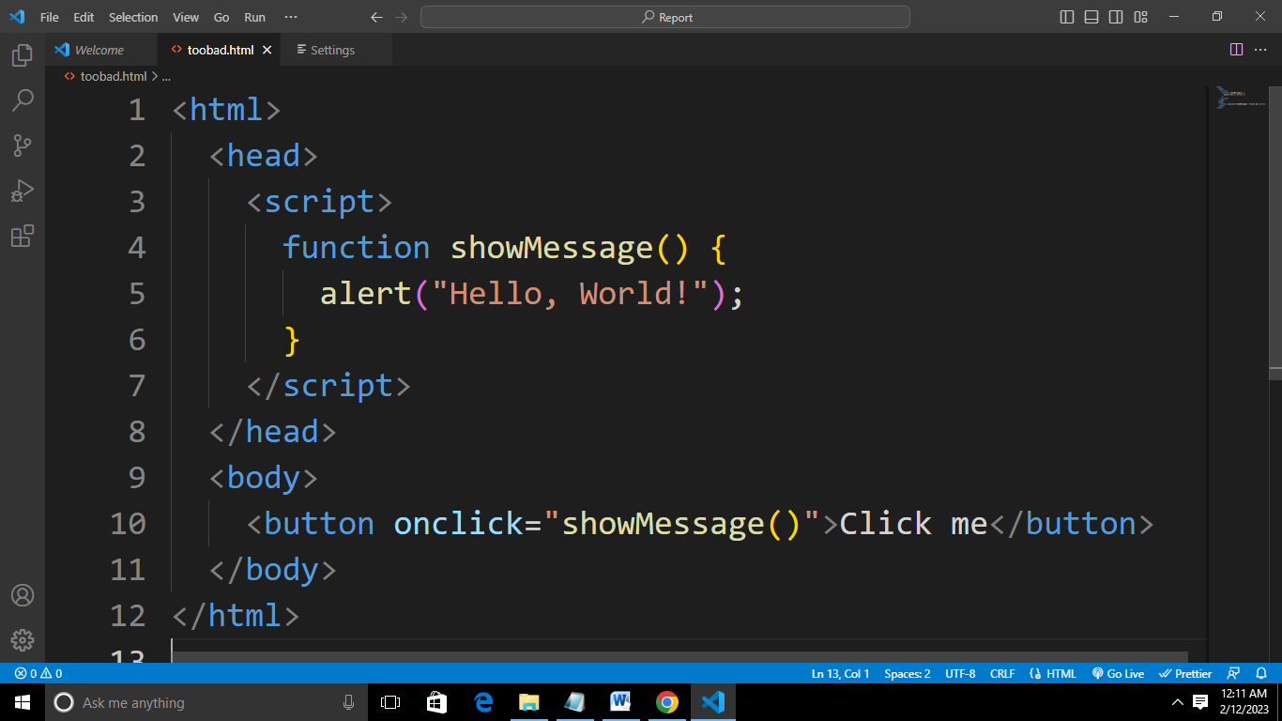

In this example, the showMessage function is defined using JavaScript. The onclick attribute of the button element is used to specify that the showMessage function should be called when the button is clicked. When the button is clicked, the alert function is called, which displays a pop-up window with the message "Hello, World!".

**3.3.2 Functions and Importance of JavaScript**

JavaScript is a high-level programming language that is used to make dynamic, interactive web pages. It is a client-side language, which means that the code is executed on the user's device rather than on a server.

JavaScript can make the website more interactive and user-friendliness of JavaScript helps easy navigation of the website and helps designers to guide the visitors with additional information or guide them through walkthroughs. Visual effects can also be achieved with JavaScript. JavaScript can be used effectively to create special effects like rollover for images.

Some of the key functions and importance of JavaScript include:

1. **Dynamic interactivity:** JavaScript allows you to add dynamic and interactive elements to web pages, such as pop-up windows, animations, and form validation.
2. **DOM manipulation:** JavaScript can manipulate the Document Object Model (DOM), which is the structure of a web page. This allows developers to update the content and style of a page without requiring a page refresh.
3. **Improved user experience:** By providing dynamic and interactive elements, JavaScript can improve the overall user experience and make web pages more engaging.
4. **Complex web applications:** JavaScript can be used to build complex web applications, such as e-commerce platforms, social media sites, and content management systems.
5. **Cross-platform compatibility:** JavaScript is supported by all major browsers, which means that code written in JavaScript can run on any device with a web browser.

**CHAPTER FOUR**

**4.0 Knowledge and Skills Acquired**

During my SIWES, I gained a good understanding of web development concepts and skills. Here are some key areas I covered:

1. HTML: I learnt how to create structured and semantically meaningful web pages using HTML (Hypertext Markup Language).
2. CSS: I learnt how to style and layout web pages using CSS (Cascading Style Sheets).
3. JavaScript: I learnt the basics of programming in JavaScript, a client-side scripting language that adds interactivity and dynamic behavior to web pages.
4. Responsive design: I learnt about responsive design, which allows web pages to adapt to different screen sizes and devices.
5. Web development frameworks and libraries: I learnt about popular web development framework(React), that can be used to streamline web development and make it easier to build complex web applications.
6. Web development tools: I learnt about various tools and technologies used in web development, such as version control systems (e.g., Git), text editors (e.g., Visual Studio Code), and development environments (e.g., WAMP, XAMPP).
7. Web development best practices: I learnt about best practices in web development, such as writing clean and maintainable code, using proper indentation and commenting, and testing and debugging your code.

**CHAPTER FIVE**

**5.1 Conclusion**

In conclusion, my experience during the SIWES in web development has provided me with a solid foundation in the fundamental concepts and skills needed to create dynamic and interactive web pages. By learning HTML, CSS, and JavaScript, I have gained the ability to create structured and semantically meaningful web pages that are visually appealing and responsive to different devices.

These skills and knowledge will be valuable assets as I continue my education and/or pursue a career in web development. My experience during the SIWES has equipped me with the ability to build complex web applications, and has provided me with the foundation to continue learning and growing as a web developer.

**5.2 Recommendation**

Here are my recommendations as regards the SIWES program itself:

1. **Placement at relevant companies:** Recommend that students be placed at companies that are relevant to their field of study, to ensure that they gain practical experience that is aligned with their career goals.
2. **Adequate supervision and mentorship:** Recommend that students receive adequate supervision and mentorship from experienced professionals in the field, to ensure that they are receiving the support and guidance they need to succeed.
3. **Opportunities for skill development:** Recommend that students be given opportunities to develop their skills and gain hands-on experience, through real-world projects and other activities.
4. **Access to resources and equipment:** Recommend that students have access to the resources and equipment they need to effectively carry out their work, such as computers, software, and other tools.
5. **Collaborative learning opportunities:** Recommend that students be given opportunities to collaborate with other students and professionals in the field, to encourage teamwork, build relationships, and deepen their understanding of web development concepts and practices.
6. **Regular training and workshops:** Recommend that students receive regular training and workshops to help them stay current with the latest technologies, tools, and trends in web development.

Here are my recommendations to MZIENET SYSTEMS:

1. **Up-to-date technology and equipment:** Recommend that the organization invest in up-to-date technology and equipment to ensure that students have access to the resources they need to effectively carry out their work.
2. **Experienced and knowledgeable mentors:** Recommend that the organization provide students with experienced and knowledgeable mentors who can provide guidance and support throughout the SIWES program.
3. **Real-world projects and assignments:** Recommend that students be given real-world projects and assignments that are aligned with their career goals, to help them gain practical experience and build their portfolios.
4. **Timely feedback and evaluation:** Recommend that students receive timely feedback and evaluation on their work, to help them understand their strengths and weaknesses and make necessary improvements.
5. **Collaborative learning opportunities:** Recommend that the organization create opportunities for students to collaborate with each other and with professionals in the field, to encourage teamwork, build relationships, and deepen their understanding of web development concepts and practices.
6. **Regular training and workshops:** Recommend that the organization provide regular training and workshops to help students stay current with the latest technologies, tools, and trends in web development.

**5.3 Problems Encountered**

As with any complex field, web development can come with a number of **challenges and problems** that need to be addressed. Some of the most common issues faced by web developers include:

1. **Responsive Design:** With an increasing number of users accessing the internet from a variety of devices, including smartphones and tablets, it is essential that websites are designed to be responsive, and adapt to different screen sizes and resolutions.
2. **Security**: Security is a major concern for web developers, and it is essential that appropriate measures are taken to protect sensitive information and prevent unauthorized access. This includes implementing secure authentication and authorization mechanisms, and regularly updating the website or web application to address any known security vulnerabilities.
3. **Accessibility:** Ensuring that a website is accessible to all users, including those with disabilities, is a legal requirement in many countries, and it is also an ethical consideration for developers. This requires taking steps to make the website accessible, such as using descriptive alt text for images and providing alternative text for videos.

**5.4 References**

* [www.w3schools.com](http://www.w3schools.com)
* HTML & CSS: The Complete Reference, Fifth Edition (Complete Reference Series) by Thomas A. Powell
* https://www.tutorialspoint.com/javascript/javascript_tutorial.pdf
* Ochiaga C.C, (1995).Theory and practice of career development.
* Oyedele, J.P. (1990) Co-operative work experience programme for youths in business education. Business Education Journals 2: 30-53.