Session 1
lsk_live_c712b73a2a73d1698551c52e07956033277fb808ec2b99346e89da09ca20fef6
APP ID: app_2e8c856895320f4852d7
URL: /ai-builders-july-6/tj-mcclure

Prompt Engineering --
- Goal: [The one thing you want produced, in a sentence.]
- Context: [Everything the AI needs to know. Background, audience, source material, the why. Over-share.]
- Rules: [How it should do the work and what good looks like. Success criteria, format, length, do's and donTs.]

Long Prompt Engineering --
- Goal: [The one thing you want produced, in a sentence.]

- Context: [Background, motivation, audience, why this matters.]

- Inputs:
<source>
[Paste long source material here: notes, transcripts, prior drafts, data.]
</source>

- Examples:
<example>
[One worked example of a good output. Add a second if behavior is fuzzy.]
</example>

- Role (optional): You are a [type of expert] who [specific lens]. [Add only on complex work.]

- Process: Think step by step. [Or list specific steps: "First do X. Then Y. Then Z."]

- Format: [Output structure: length, sections, tone, anything specific you want.]

- Self-check: Before you finish, verify [the specific thing that, if wrong, makes the output useless].

AI Builder Process
Plan : scope the work, then goal, context, rules
Build : create → review → feedback
Learn : measure, log, skillify
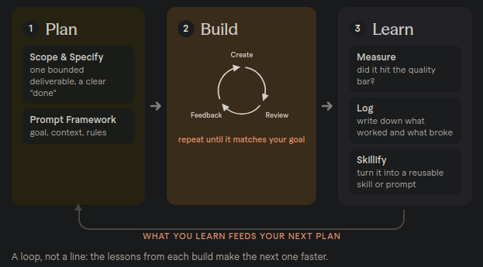

AI Brand Summary

OpenAI (ChatGPT & Codex)
ChatGPT is the popular web chat assistant for Q&A, writing, and brainstorming. Codex is the desktop app that can operate your computer directly to get real work done.

Google (Gemini)
Gemini is Google's Workspace-native chat app — great for Gmail/Docs/Drive context, but chat-only with no app control. The Gemini CLI adds agentic, terminal-based capability.

Anthropic (Claude)
Claude is known for strong writing, reasoning, and coding, with a full range of surfaces — Claude Chat, Cowork, and Claude Code — from casual use to deep engineering control.

Microsoft (Copilot)
Copilot is Microsoft's AI layer across Word, Excel, Outlook, and Teams (OpenAI-powered), best for teams already living in Microsoft 365 and Windows.

