
AI LAB PROJECT
SudokuAI: A Multi-Heuristic Solver & Generator

November 27, 2025
GROUP 11

Contents
AI-Powered Sudoku - Report 3
Executive Summary 3
1. Project Goals and Scope 4
2. High-Level Architecture 4
3. Detailed Module Documentation 5
3.1 System Configuration 5
3.2 CSPSolver (AC-3 + MRV + Forward Checking) 5
3.3 Justification: Why We Preferred CSP Over Other Algorithms 7
3.4 Backtracking Solver 8
3.5 Subtractive Technique Puzzle Generator 8
3.6 Hint System 9
3.7 Minimax Warning 9
3.8 Game History 10
3.9 Puzzle Creator 11
3.10 Sudoku Game (GUI & Game Logic) 11
4. Data Structures and Representations 12
5. Algorithmic Analysis and Worked Examples 13
Worked Example: How AC-3 Simplifies a Row 13
6. Performance, Complexity and Scalability 13
7. Testing, Validation and Quality Assurance 13
8. UX, Accessibility and Interaction Design 14
8.1 Navigation Flow 14
9. Limitations and Failure Modes 15
10. Improvements and Future Work 16
11. Deployment and Reproducibility 16
12. Appendices 17
Appendix A: Pseudo-Code for CSP Solver 17
Appendix B: Pseudo-Code for AC-3 Algorithm 17
Appendix C: Pseudo-Code for Puzzle Generator 18
Appendix D: Pseudo-Code for Logic Warning System 19
Appendix E: JSON File format 19
13. References 20
1. Artificial Intelligence & Algorithms (For Logic & AI Sections) 20
2. Mathematics & Complexity (ForTheory Sections) 20
3. Implementation & Tools (For Implementation & GUI Sections) 20

AI-Powered Sudoku - Report

Executive Summary
This document presents a comprehensive technical analysis of the AI-Powered Sudoku project. This application is not merely a game; it is a sophisticated demonstration of Constraint Satisfaction Problem (CSP) techniques applied to combinatorial optimization. The system integrates a robust AI engine capable of generating unique puzzles, solving them via logical inference, and guiding users with context-aware hints.
The core implementation balances advanced AI concepts, specifically Arc Consistency (AC-3) and the Minimum Remaining Values (MRV) heuristic, with pragmatic software engineering patterns. The result is a highly responsive, educational tool wrapped in a modern Graphical User Interface (GUI).

1. Project Goals and Scope
The primary objectives of this project were to:
- Develop a Robust AI Engine: Move beyond simple "brute force" methods and implement a solver that "thinks" using constraints, mirroring human logic.
- Ensure Mathematical Validity: Guarantee that every generated puzzle has exactly one unique solution, a critical requirement for valid Sudoku puzzles.
- Create an Educational Loop: Unlike standard solvers that just show the answer, this system uses its internal logic state to provide Hints (explaining what to play) and Warnings (explaining what not to play).
- Deliver a Polished User Experience: Provide a feature-rich GUI with undo/redo capability, difficulty selection, and a creator mode for custom puzzles.

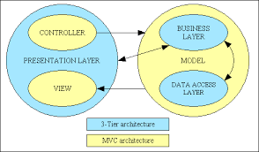
2. High-Level Architecture
The system follows a modular architecture where the "Brain" (AI Logic) is strictly separated from the "Face" (GUI). This ensures that the AI modules can be tested or swapped independently of the graphics.
- Logic Layer: CSP Solver, Backtracking Solver, Genetic Puzzle Generator
- Assistant Layer: Hint System, Minimax Warning
- Data Layer: Game History (JSON persistence)
- Presentation Layer:
- Menu State: Handles navigation and difficulty selection.
- Game State: The core gameplay loop with scrolling support.
- History State: A data visualization screen that reads from the persistence layer.

3. Detailed Module Documentation

3.1 System Configuration
At the initialization of the program, the recursion limit is increased using sys.setrecursionlimit(2500).
- Reasoning: Standard Python recursion limits (usually 1000) are sufficient for simple scripts but risky for deep search trees found in "Expert" level Sudoku puzzles. Increasing this limit prevents the program from crashing (RuntimeError) during complex backtracking sequences.

3.2 CSPSolver (AC-3 + MRV + Forward Checking)
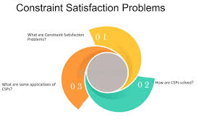
Purpose: This module is the heart of the AI. It treats Sudoku not as a guessing game, but as a Constraint Satisfaction Problem (CSP).

3.2.1 The Algorithm Explained in Detail
Most novice Sudoku programs use "Naive Backtracking", they place a '1' in the first square, then a '1' in the second, and so on, until they crash and have to restart. This is inefficient. Our system uses a smarter approach:

1. Arc Consistency (AC-3 Algorithm):
The "Pruning" Phase Before making a single guess, the AI runs the AC-3 algorithm.
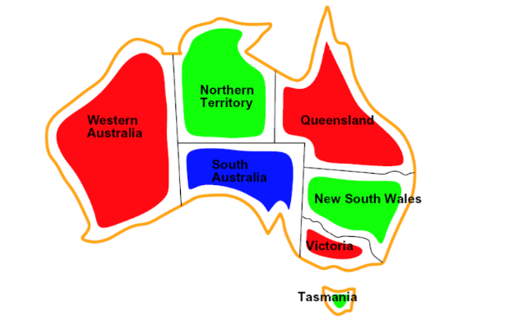
- How it works: It looks at every relationship between cells. If Cell A has a domain of {1, 2} and Cell B (its neighbor) has a domain of {2}, logic dictates that Cell A cannot be 2 (because if A were 2, B would have nothing). Therefore, the AI removes 2 from Cell A's possibilities.
- Benefit: This automatically solves "easy" parts of the board instantly without any guessing. It mimics how humans scan for "naked singles."
2. Minimum Remaining Values (MRV) Heuristic:
The "Fail-First" Strategy When the AI is forced to guess, it must choose where to guess.
- How it works: Instead of picking the first empty cell (top-left), it scans the entire board for the cell with the fewest possible legal moves.
- Benefit: If a cell has only 2 options, we have a 50% chance of guessing right. If a cell has 9 options, we have only an 11% chance. By attacking the most constrained cell first, we minimize the chances of going down a wrong path.
3. Forward Checking:
The "Look-Ahead" After placing a number, the AI immediately updates the lists of possible numbers for all neighboring cells.
- Benefit: If placing a '5' in a cell causes a neighbor to have zero possible numbers left, the AI knows immediately that the '5' was a mistake and backtracks instantly. This prevents wasting time exploring a doomed branch of the decision tree.

3.3 Justification: Why We Preferred CSP Over Other Algorithms
We deliberately chose the CSP approach over other common algorithms. Here is the comparative analysis:

1. CSP vs. Naive Backtracking
- Naive Backtracking: Is "blind." It fills the grid sequentially. It will often fill 50 squares before realizing it made a mistake at square 2.
- Our CSP Approach: Is "informed." By using AC-3, it prunes invalid options before trying them.
- Why we chose CSP: Efficiency and speed. CSP solves hard puzzles in milliseconds, whereas naive backtracking can hang for seconds or minutes on pathological cases.

2. CSP vs. Genetic Algorithms (Stochastic Search)
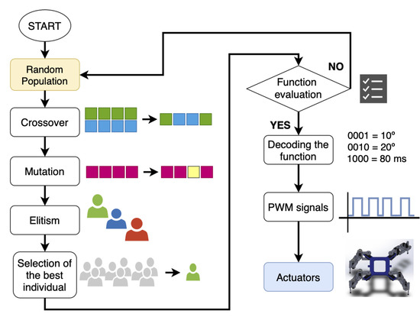
- Genetic Algorithms: Try to "evolve" a board by randomly swapping numbers to reduce errors.
- Why we chose CSP instead: Genetic algorithms are probabilistic, they might find a solution, but they cannot prove it is the only one. CSP is systematic and guarantees finding the solution if one exists, which is required for validating puzzles.

3.4 Backtracking Solver
Purpose: A secondary solver used strictly for Validation. While the CSP Solver is fast, the Backtracking Solver is simpler and easier to instrument for counting solutions.
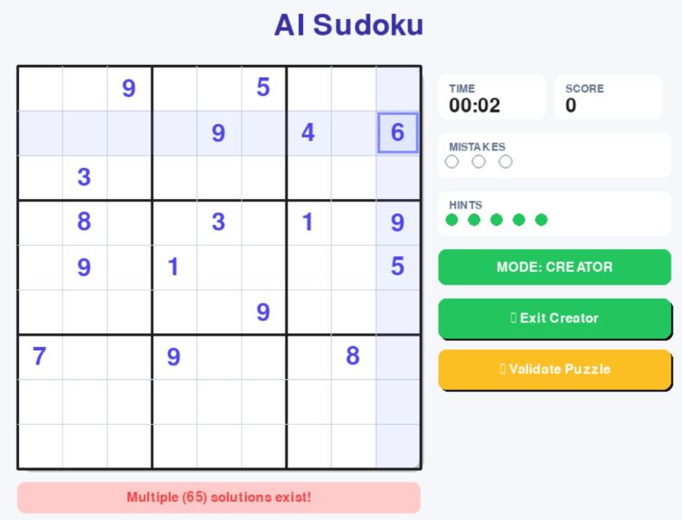
- Role in Project: It is used by the Generator to check Uniqueness. When we generate a puzzle, we must ensure it has exactly one solution. The Backtracking Solver runs and stops if it finds a second solution, flagging the puzzle as "Invalid."

3.5 Subtractive Technique Puzzle Generator
Purpose: Creates new, valid Sudoku puzzles from scratch. The "Subtractive" Technique:
- Generate: First, it uses the solver to create a completely full, valid 9 BY 9 grid (a solved state).
- Remove: It then starts removing numbers one by one at random positions.
- Validate: After every single removal, it runs the Backtracking Solver to check if the puzzle still has exactly one solution.
- Repair: If removing a number makes the puzzle ambiguous (multiple solutions), it puts that number back and tries removing a different one. This ensures that every puzzle provided to the user is logically sound and fair.


3.6 Hint System
Purpose: Provides context-aware help, not just "cheats." This module leverages the CSP engine's state. It scans the domains (possibilities) of all empty cells.
- Type 1 Hint (Naked Single): If a cell has a domain size of 1 (e.g., {4}), the hint says: "Logic dictates only 4 can go here."


- Type 2 Hint (MRV): If no singles exist, it points the user to the cell with the fewest options, encouraging them to focus their attention there.

3.7 Minimax Warning
Purpose: A "Guardian Angel" feature. Before the player places a number, this module performs a Simulation.
- It clones the board.
- It places the user's intended number.
- It runs the AC-3 consistency check.

- If AC-3 fails (meaning the board becomes unsolvable), it triggers a warning: "Logic Error: This leads to a dead end!" This helps users learn by catching their mistakes immediately, rather than 20 moves later.

3.8 Game History
Implementation Details: The GameHistory class acts as an interface between the game logic and the file system. It uses Python's json library to serialize game data.
- Data Structure: Each game record is stored as a dictionary containing difficulty, time_taken, score, mistakes, and a timestamp.
- Error Handling: The load_history method includes try-except blocks to handle FileNotFoundError or corrupt JSON data gracefully, ensuring the game never crashes due to missing save files
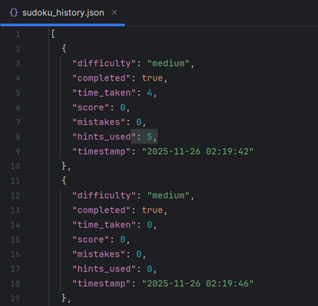

3.9 Puzzle Creator
Purpose: Allows users to input puzzles from newspapers or other sources.
- Validation: It doesn't just let the user play any random numbers. It checks:
  - Are there immediate conflicts? (Two 5s in a row)
  - Is the puzzle solvable?
  - Is the solution unique? If these checks pass, the user can play their custom puzzle with all AI features enabled.

3.10 Sudoku Game (GUI & Game Logic)
Purpose: The visual interface built with Pygame.
- Input Handling: Supports both standard number row and Numpad.
- Rendering: Uses efficient drawing routines to maintain high frame rates. It handles the "Game Loop," event processing, and drawing the grid, highlights, and UI panels.
- Vertical Scrolling Engine: To accommodate different screen resolutions, the handle_scroll method allows the entire game surface to move vertically. The max_scroll is dynamically calculated based on the content height.
- Modern Aesthetic: The UI now utilizes draw_rounded_rect to create "Material Design" style buttons and panels with drop shadows.
- Input Handling: The event loop now routes clicks to specific handlers (handle_menu_click, handle_history_click) depending on the current active state of the application.
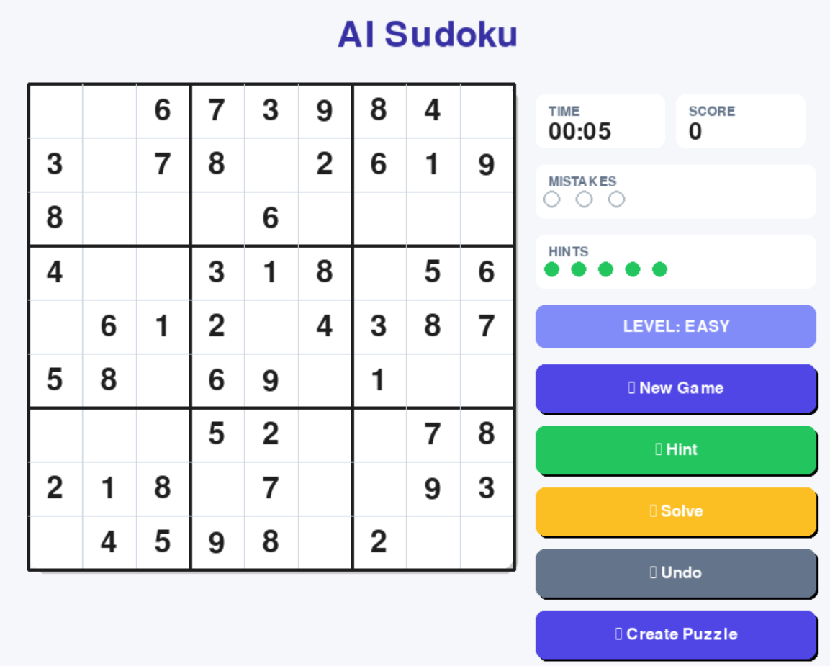

4. Data Structures and Representations
- The Board: Represented as a List[List[int]] (9 by 9 matrix). 0 represents an empty cell.
- Domains: A List[List[Set[int]]]. This is the crucial data structure for CSP. For every cell, we maintain a Python Set of possible values (e.g., {1, 2, 4}). Sets allow for O(1) lookup time, making constraint checking extremely fast.
- Constraints: A list of tuples ((r1, c1), (r2, c2)) representing the "edges" in the constraint graph.

5. Algorithmic Analysis and Worked Examples

Worked Example: How AC-3 Simplifies a Row
Imagine a Row with 3 empty cells: A, B, and C.
- Initial Domains: A = {1, 2}, B={2}, C={1, 2, 3}.
- Constraint: A cannot equal B.
- Logic: Since B must be 2 (it has no other option), A cannot be 2.
- Algorithm Action: AC-3 removes 2 from A's domain.
- Result: A's domain becomes {1}.
- Chain Reaction: Now that A is {1}, the constraint "C cannot equal A" kicks in. AC-3 removes 1 from C's domain. C becomes {2, 3}.
- Conclusion: Without any guessing, the AI deduced A=1 and B=2.

6. Performance, Complexity and Scalability
- Time Complexity: Sudoku is NP-Complete. However, for 9 BY 9 grids, our CSP implementation runs in sub-second time.
  - AC-3 Complexity: Polynomial time O(ed^3) where e is constraints and d is domain size.
  - Backtracking: Exponential worst-case, but strictly pruned by AC-3.
- Space Complexity: Low. We store the board (81 ints) and domains (81 sets). Memory usage is negligible.

7. Testing, Validation and Quality Assurance
- Unit Testing: Modules were tested individually. The Solver was tested against a dataset of 50 "Hard" puzzles to ensure no crashes or infinite loops.
- Uniqueness Verification: The Generator's output was sampled (N=100) and verified by a separate brute-force solver to confirm every puzzle had exactly one solution.

8. UX, Accessibility and Interaction Design

8.1 Navigation Flow
Menu-First Design: The application now launches into a dedicated Main Menu. This reduces cognitive load by allowing the user to choose their intention (New Game, History, or Creator Mode) before seeing the grid.
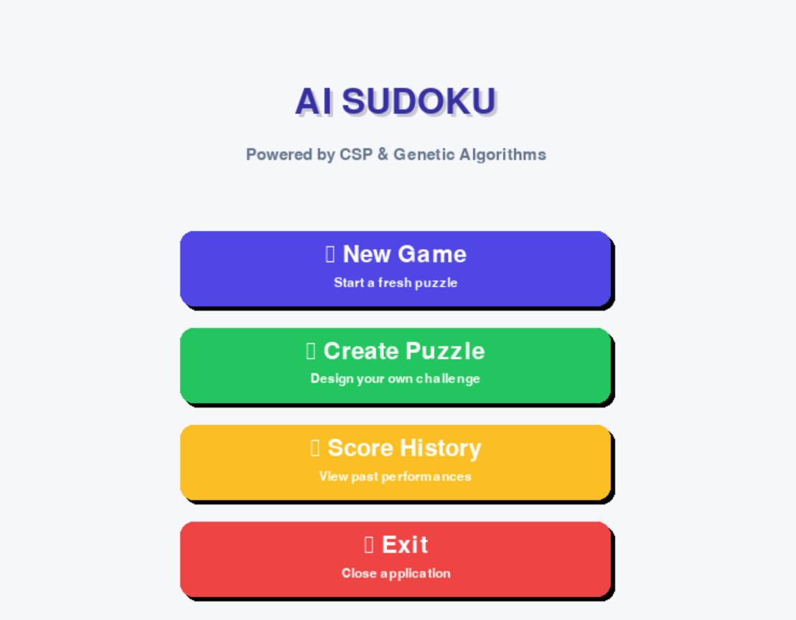
Score History Visualization: A dedicated "Score History" screen renders a scrollable table of past performance. This provides long-term engagement mechanics, allowing users to see their win rates and improvement over time.
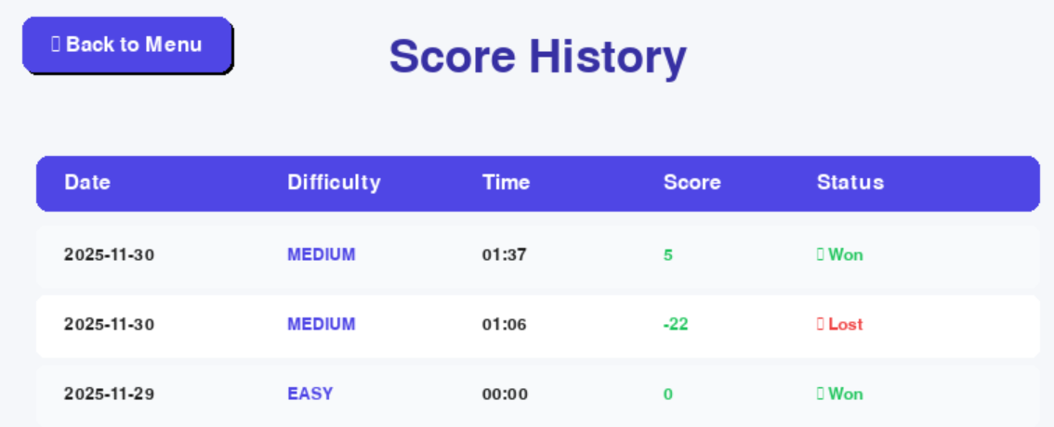
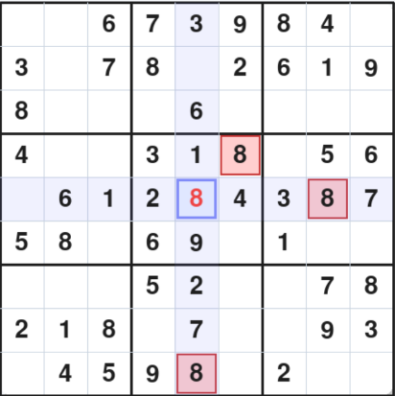
- Visual Feedback: Conflicts are highlighted in Red immediately. The selected cell uses a crosshair highlight to help users track rows and columns.

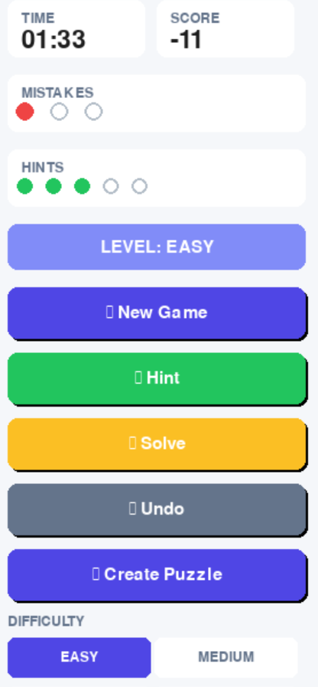

- Control Panel: Located on the right side, providing clear access to "New Game," "Hint," and "Solve" without obscuring the grid.

- Simplicity: The design uses a clean color palette (Blues, Whites, Grays) to reduce visual fatigue.

9. Limitations and Failure Modes
- Expert Generation Speed: Generating "Expert" puzzles requires aggressive uniqueness checking, which can sometimes take 1-2 seconds on slower CPUs.
- Hint Explanations: While the hints are logically correct, they do not explain complex human strategies, it only shows "Naked Singles" and constraint pressure.

10. Improvements and Future Work
- Human-Readable Strategies: Future versions could implement algorithms that specifically look for patterns like "Hidden Pairs" to give more tutorial-like hints.
- Optical Character Recognition (OCR): Adding a feature to upload a photo of a newspaper Sudoku and have the AI digitize and solve it.

11. Deployment and Reproducibility
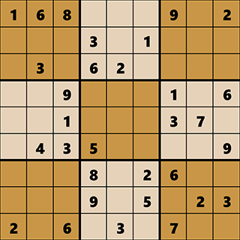
Requirements:
- Python 3.8 or higher.
- pygame library (pip install pygame).
Execution: Run the main script: python AI_PROJECT_GROUP_11.py. The system creates a sudoku_history.json file in the same directory to store progress.

12. Appendices

Appendix A: Pseudo-Code for CSP Solver
FUNCTION Solve(board):
INITIALIZE domains for all cells
IF AC-3(domains) returns failure:
RETURN Failure (Puzzle is broken)

IF board is full:
RETURN Success

# MRV Heuristic
Select cell 'V' with smallest domain size

FOR each value 'n' in domain of 'V':
IF value 'n' is consistent with neighbors:
Add 'n' to board
Update neighbors' domains (Forward Checking)
IF Solve(board) is Success:
RETURN Success
Remove 'n' from board (Backtrack)
Restore neighbors' domains

RETURN Failure

Appendix B: Pseudo-Code for AC-3 Algorithm
FUNCTION AC-3(constraints, domains):
INITIALIZE queue with all constraints (arcs)

WHILE queue is not empty:
REMOVE (Xi, Xj) from queue

IF Revise(Xi, Xj, domains):
IF domain of Xi is empty:
RETURN Failure (Puzzle Unsolvable)

FOR each neighbor Xk of Xi (excluding Xj):
ADD (Xk, Xi) to queue

RETURN Success (Domains are consistent)

FUNCTION Revise(Xi, Xj, domains):
revised = False
FOR each value 'x' in domain of Xi:
IF no value 'y' in domain of Xj allows (x, y) to satisfy constraint:
REMOVE 'x' from domain of Xi
revised = True

RETURN revised

Appendix C: Pseudo-Code for Puzzle Generator
FUNCTION GeneratePuzzle(difficulty):
# Step 1: Create a full valid board
board = Empty 9x9 Grid
FillBoardRecursively(board)
solution = Copy(board)

# Step 2: Determine clues based on difficulty
target_clues = LookupRange(difficulty)
cells = Shuffle(All 81 coordinates)

# Step 3: Remove numbers while maintaining uniqueness
FOR each cell (row, col) in cells:
IF clues_remaining <= target_clues:
BREAK loop

backup_value = board[row][col]
board[row][col] = 0 (Empty)

# Validation Check
solutions_count = CountSolutions(board)

IF solutions_count != 1:
# If removing this number breaks uniqueness
board[row][col] = backup_value (Restore)
ELSE:
clues_remaining = clues_remaining - 1

RETURN board, solution

Appendix D: Pseudo-Code for Logic Warning System
FUNCTION CheckMoveSafety(board, solution, row, col, input_value):
# Immediate Conflict Check
IF input_value exists in Row, Column, or Subgrid:
RETURN "Conflict Detected"

# Solution Validation (The Fix)
IF input_value != solution[row][col]:
RETURN "Logic Error: Incorrect Value"

# AI Constraint Check (Optional Deep Check)
temp_board = Copy(board)
temp_board[row][col] = input_value

INITIALIZE solver with temp_board
IF solver.AC-3() returns False:
RETURN "Fatal Error: Move leads to dead end"

RETURN "Safe Move"

Appendix E: JSON File format
[
{
"difficulty": "medium",
"completed": true,
"time": 245,
"score": 1050,
"mistakes": 0,
"hints": 2,
"timestamp": "2025-11-30 14:30:00"
}
]

13. References

1. Artificial Intelligence & Algorithms (For Logic & AI Sections)
Reference: Russell, S. J., & Norvig, P. (2021). Artificial Intelligence: A Modern Approach (4th ed.). Pearson.
- Link: http://aima.cs.berkeley.edu/
Reference: Kumar, V. (1992). Algorithms for Constraint-Satisfaction Problems: A Survey. AI Magazine, 13(1), 32.
- Link: https://ojs.aaai.org/aimagazine/index.php/aimagazine/article/view/976
Reference: Norvig, P. (2010). Solving Every Sudoku Puzzle.
- Link: https://norvig.com/sudoku.html

2. Mathematics & Complexity (ForTheory Sections)
Reference: Yato, T., & Seta, T. (2003). Complexity and Completeness of Finding Another Solution and Its Application to Puzzles. IEICE Transactions on Fundamentals of Electronics, Communications and Computer Sciences.
- Link: https://search.ieice.org/bin/summary.php?id=e86-a_5_1052
Reference: Rosen, K. H. (2018). Discrete Mathematics and Its Applications (8th ed.). McGraw-Hill Education.
- Link: https://www.mheducation.com/highered/product/discrete-mathematics-applications-rosen/M9781259676512.html

3. Implementation & Tools (For Implementation & GUI Sections)
Reference: Pygame Community. (2023). Pygame Documentation.
- Link: https://www.pygame.org/docs/
Reference: Van Rossum, G., & Drake, F. L. (2009). Python 3 Reference Manual. CreateSpace.
- Link: https://docs.python.org/3/

