|  |  |  |  |
| --- | --- | --- | --- |
| Evaluation date | 12 Oct 2020 | Delta model no. | ECD25010013 |
| Customer | RENAULT | Design phase | PV |
| Customer model name | 5DH DCDC | Firmware revision no. | 20.21.99 |
| Customer model no. | DCDC 2.2KW | Hardware revision no. | C0 |
| Customer specs rev. no. date | Safety Test DOORS Update on: 16/10/2019 | Sample serial no. | 292A03981RTA01210003  292A03981RTA01210005  292A03981RTA01210006 |

Safety Test after LT/03 Thermal Life Test and Combined Load Actuation Endurance

(LEG2D-wt PV C0)

RENAULT

5DH DCDC CONVERTER 2.2KW

(ECD25010013)

|  |  |  |
| --- | --- | --- |
|  | *Jaray P.* | *Phaiboon C.* |
| Prepared | Checked | Approved |

# 

# Abstract

This is safety test report generates for the new DUTs which’s never past through environment test. The DUTs will be subjected to the following safety tests in sequentially:

Step 3. HV capacitor Discharge – DUT2

Step 4. Common mode capacitor – DUT2

Step 5. Electrical risk – DUT2

Step 6. Marking – DUT2

Step 8. Alternative voltage withstand test – DUT3

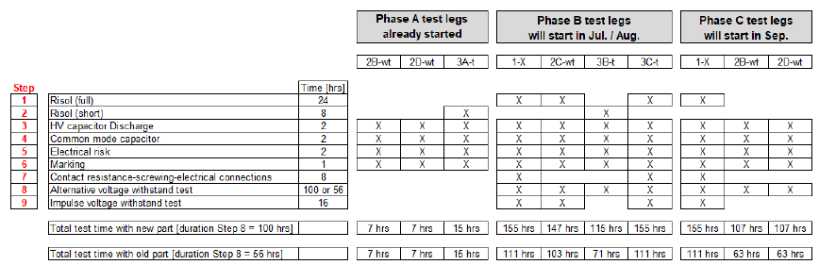

# 

# Revision History

|  |  |  |
| --- | --- | --- |
| **REV.:** | **Change description** | **Release / Date** |
| a | First release for Safety Test after LEG2D-wt PV LT/03. | 19. Oct. 2020 |
|  |  |  |
|  |  |  |

# 

# Content

1 Abstract 2

2 Revision History 3

3 Content 4

4 General information 5

5 Test flowchart 5

6 Summary of Test results 6

7 Specimen 6

8 Applicable Document/Standards 6

9 Test Deviation 6

10 Test Equipment 7

11 HV Capacitor discharge (Step 3) 8

12 Common mode capacitor (Step 4) 9

13 Electrical risk (Step 5) 10

14 Making/Visual Inspection (Step 6) 11

15 Alternative voltage withstand test (Step 8) 12

16 Evaluation result 13

17 Verdict 13

18 Appendix 13

# General information

Test date: 08.Oct.2020 – 12.Oct.2020

Test engineer: Patiphan.Phak / Jaray. P

Test place: Delta Electronics Thailand Public Co., Ltd.

# Test flowchart

# 

# Summary of Test results

|  |  |  |  |  |
| --- | --- | --- | --- | --- |
| **Test Description** | **DUT1 292A03981RTA01210003** | **DUT2 292A03981RTA01210005** | **DUT3 292A03981RTA01210006** | **Jira ticket / Remark** |
| Step 3. HV capacitor Discharge | No required | Pass | No required |  |
| Step 4. Common mode capacitor | No required | Pass | No required |  |
| Step 5. Electrical risk | No required | Pass | No required |  |
| Step 6. Marking [visual inspection] | No required | Pass | No required | Label, Signal wires discolored is accepted by R&D |
| Step 8. Alternative voltage withstand test | No required | No required | Pass |  |

# 

# Specimen

Quantity: 3 units

Type: DCDC Converter

Part Number: ECD25010013 (C0)

Serial Number(s) 292A03981RTA01210003

292A03981RTA01210005

292A03981RTA01210006

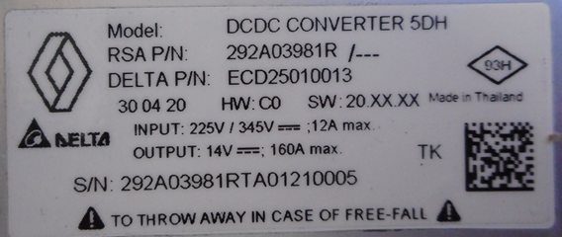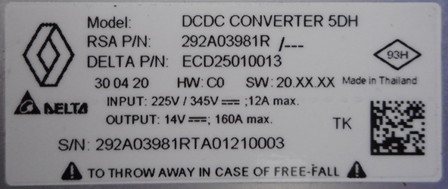

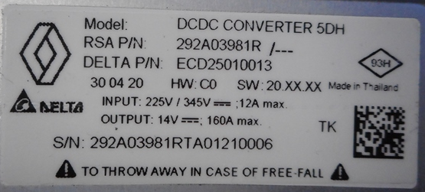

# Applicable Document/Standards

* PRODUCT SPECIFICATIONS 36 - 00 – 802 / --Q[RENAULT 2016]
* 5DM-DCDC Technical Specification. V3.2 Update on: 10/05/2017
* Renault 5DH DC/DC Converter: Safety Test DOORS Baseline: 0.1 Export date: 05.06.2020

20200605_Renault-5DH-DCDC_ENV_TS_Safety_Rev04.pdf

# Test Deviation

* n/a

# 

# Test Equipment

List of test equipment used for PTL/PTS test

|  |  |  |  |
| --- | --- | --- | --- |
| **Instrument** | **Model** | **Serial No.** | **Cal Due Date** |
| Climatic Chamber | Vötsch C7-1000E series | 54260022700010 | 17-Apr-2021 |
| E&A Prog.Bi-Di DC Load | EA PSI 9500-30 3U 19"3HE 5000W | 1901680003 | 7-Aug-2021 |
| E&A Prog.Bi-Di DC Load | EA PSI 9500-30 3U 19"3HE 5000W | 1901680005 | 7-Aug-2021 |
| E&A Prog.Bi-Di DC Load | EA PSI 9500-30 3U 19"3HE 5000W | 1901680010 | 7-Aug-2021 |
| E&A Prog.Bi-Di DC Load | EA PSB 9080-360 3U 15000W | 1907720001 | 7-Aug-2021 |
| E&A Prog.Bi-Di DC Load | EA PSB 9080-360 3U 15000W | 1907720005 | 7-Aug-2021 |
| E&A Prog.Bi-Di DC Load | EA PSB 9080-360 3U 15000W | 1907720008 | 7-Aug-2021 |
| Cooling system | Lauda XT-950W | S190002061 | NCR |
| Computer | HP ProDesk 600 G2 | CZC912B6Y5 | NCR |
| Computer | Vector IPC | AS236-1800033 | NCR |

List of test equipment use for Safety test

|  |  |  |  |
| --- | --- | --- | --- |
| **Instrument** | **Model** | **Serial No.** | **Cal Due Date** |
| Climatic chamber | CTS C-70/1000 | 198003 | 21-May-2021 |
| Climatic chamber | Vötsch C7-1000E | 54260022700010 | 18-Feb-2021 |
| Oscilloscope | Tektronix MDO3014 | DT307-594 | 18-Jun-2021 |
| HVDC Input source | EA-PSI 9500-30 3U | 62150EB00450 | 01-Nov-2020 |
| LVDC Output Load | EA-PSB 9080-360 3U | 620100EA00103 | 31-Jan-2021 |
| Multi-meter | Fluke 115 True RMS Multi-meter | DT310-3192 | 10-Dec-2020 |

# HV Capacitor discharge (Step 3) – DUT2

Action HV capacitor discharge:

Wire the DUT as shown in wiring figure below. Apply 430VDC.

Open the switch and determine the discharge the HV capacitor.

HV capacitor discharge wiring figure:

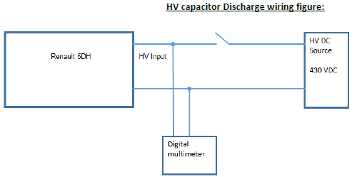

Test setup: Step 3

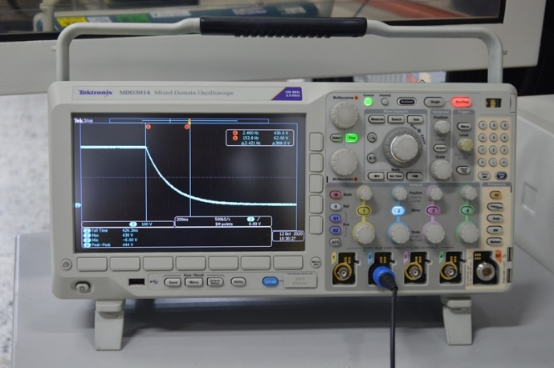

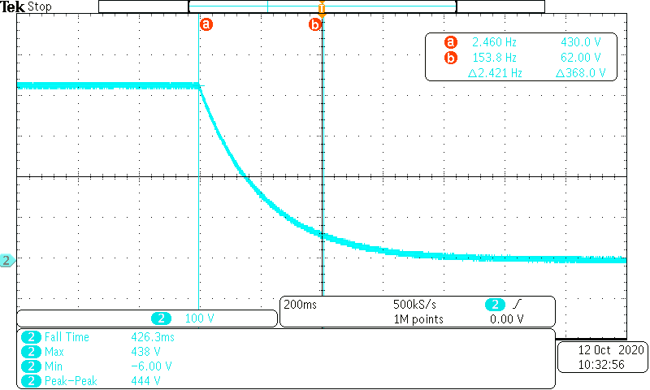

Reaction HV capacitor discharge:

Input capacitors should be below 60VDC/30VAC within 1 minute.

Step 3. Test result:

|  |  |  |  |
| --- | --- | --- | --- |
| Serial Number | Discharge Voltage within 1 minute.(V) | Discharge time to 60V take (minute) | Result |
| 292A03981RTA01210005 | 430-60 | 0.425 | PASS |

# 

# Common mode capacitor (Step 4) – DUT2

Action common mode capacitor:

Wire the DUT as shown in wiring figure below

Determine the common mode capacitor

Common mode capacitor wiring figure:

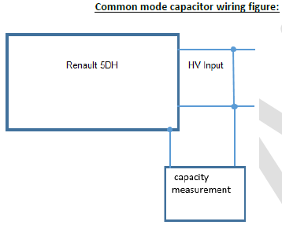

Test setup: Step 4

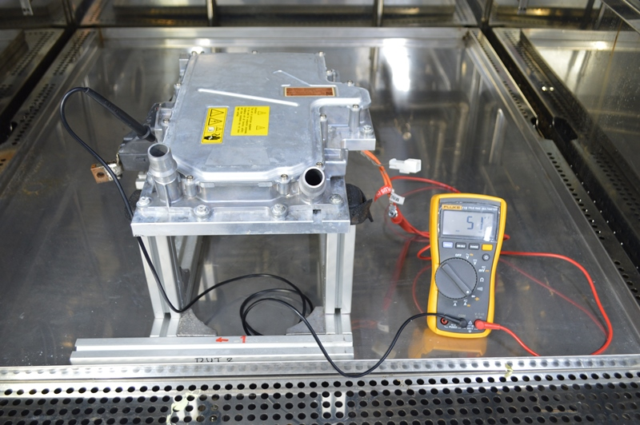

Reaction HV capacitor discharge:

The maximum value of this Y capacitor shall be 80nF.

Step 4. Test result:

|  |  |  |  |
| --- | --- | --- | --- |
| Serial Number | Maximum value of Y-Capacitor (nF) | Measurement value (nF) | Result |
| 292A03981RTA01210005 | 80 | 51 | PASS |

# 

# Electrical risk (Step 5) – DUT2

Action Electrical risk (Step 5):

Wire the EUT as shown in wiring figure below

Apply the test current 1 ADC between measurement point 1.GND and 2.Cover Center.

Determine the voltage on the measuring instrument

Switch off the applied voltage and changed the measurement point

Set measurement point between 1.GND and 3.Cover Edge

Apply the test current 1 ADC.

Determine the voltage again on the measuring instrument.

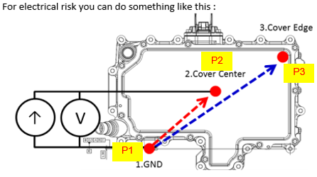

**Reaction Electrical risk (Step 5):**

The measured voltage in both case must be less than 20mV (20mV/1A = 20mΩ)

Test setup: Step 5

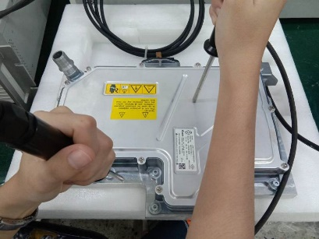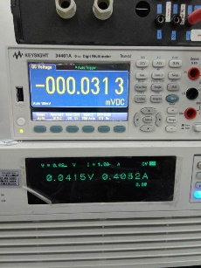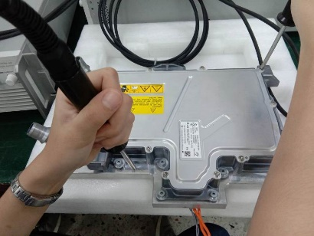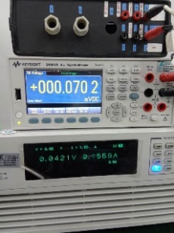

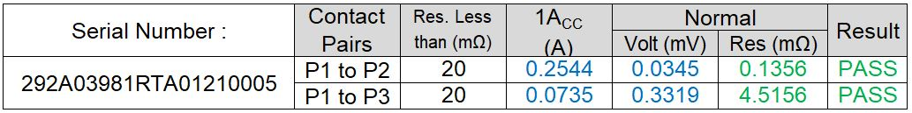

# 

# Making/Visual Inspection (Step 6) – DUT2

Perform visual inspection with the naked eye and shaken to check for loose or ratting parts. Outer appearance (e.g. Chassis / Cover / Front-Panel) results as following:

|  |  |
| --- | --- |
| Check if product surface is free of scratches | PASS |
| Check if product surface is free of discoloring | PASS |
| Check if bottom cover are free of excess glue (FIPG bonding) | PASS |
| Check if front cover are free of excess glue (FIPG bonding) | PASS |
| Check if inspection by the naked eye and shaken to check for loose or ratting parts. | PASS |
| Check if product is free of mechanical damage (sink marks, deformation, cracks, rust etc.) | PASS |
| Check if product and subassembly labelling is not damaged but complete bonded | PASS |
| Check if label is readable easily (also barcodes) | PASS |
| Check the required wiping resistance with thumb or finger (no fingernails) back and forth 10 times | PASS |
| Check if the label has been placed dimensionally accurate in the correct place (type label, HV-label, Hot surface label) | PASS |
|  |  |

Step 6. Result:

|  |  |  |
| --- | --- | --- |
| Serial Number | Visual | Result |
| 292A03981RTA01210005 |  | PASS |

# 

# Alternative voltage withstand test (Step 8) – DUT3

Alternative voltage withstand test conditioning with OLD part: [Step 8]:

Place the EUT at the Room Temperature directly in the chamber

Set the Chamber temperature to 30°C ± 2°C / with Relative Humidity 0% HR ± 5% and 96 ± 10kPa. Wait until chamber temperature is reached and stabilized

After stabilization time wait further for 4hours.

Set the Chamber temperature to 23°C ± 2°C / with Relative Humidity 93% HR ± 5% and 96 ± 10kPa. Wait until chamber temperature is reached and stabilized

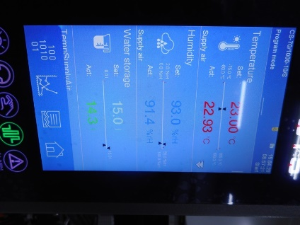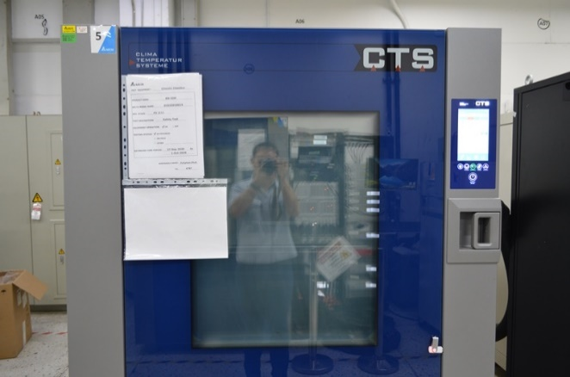After stabilization time wait further for 48hours.

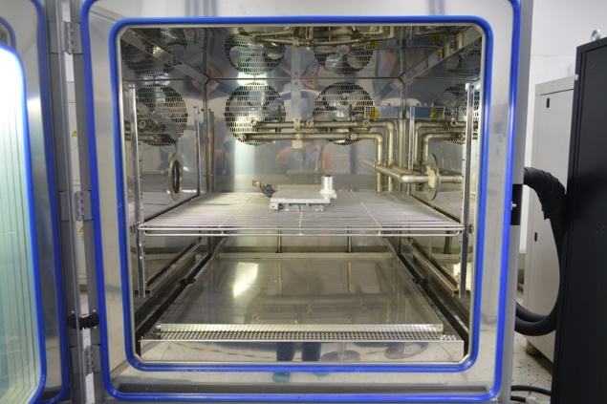

Action Alternative voltage withstand test [Step 8]:

Wire the EUTEUT as follows

Short circuiting the LVDC, Signals and Chassis as shown in figure below

Apply the test voltage 2687VDC (1900 VAC x √2) between short‐circuiting connecters and HVDC input. The **positive** terminal is connected to HVDC. Hold the test Voltage for 60s.

Determine the upper current limit.

Apply the test voltage 2687VDC (1900 VAC x √2) between short‐circuiting connecters and HVDC input. The **negative** terminal is connected to HVDC. Hold the test Voltage for 60s.

Determine the upper current limit.

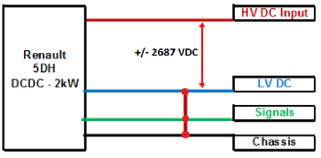

**Reaction Alternative voltage withstand test [Step 8]:**

The upper current limit should be max. 1mA

Step 8. Test result:

|  |  |  |  |  |  |
| --- | --- | --- | --- | --- | --- |
| Serial Number | Upper current limit (mA) | Measurement value (mA) Positive | Measurement value (mA) Negative | Measurement file | Result |
| 292A03981RTA01210006 | 1 | 0.004 | 0.004 |  | PASS |

# Evaluation result

SN:292A03981RTA01210003. Final confirmed by basic power On, DUT output is good in condion.

SN:292A03981RTA01210005. Final confirmed by basic power On, DUT output is good in condion.

SN:292A03981RTA01210006. Final confirmed by basic power On, DUT output is good in condion.

# Verdict

The final result shall judgment by R&D.

# Appendix

n/a

**- End -**