
HUMAN COMPUTER INTERACTION

University Proficiency Exam System

Date: Supervisor :
Dec 14,2024 Dr Mohammad
Abushariah

Name | Number | Section
Haneen Rapah | 0222081 | 1
Haneen Alajaleen | 0226320 | 1
Dania Shurbaji | 2213559 | 1
Shahed Alemian | 2221209 | 1
Toqa Alrthoom | 0224255 | 1
Sara Al-Bukhari | 0228765 | 1

Contents
1.0 Introduction 4
1.1 Need Analysis and Description 4
1.2 Project Constraints 5
1.3 System Environment 7
1.4 Project Software and Hardware Requirements 7
1.5 Project Schedule 8
2.0 Project Background and Existing Technologies 9
3.0 Software Requirements Document. 10
3.1 Targeted Users 10
3.3 Functional Requirements 11
3.4 Non-Functional Requirements 12
3.5 Usability and User Experience Goals 13
4.0 System Design Document 13
4.1 Low-Fidelity Prototyping 13
4.2 Medium-Fidelity Prototyping 19
4.3 Database Design 26
5.0 System Implementation 27
5.2 Database Implementation (Optional + Bonus) 35
6.0 System Testing and Installation 37
6.1 Heuristic Evaluation 37

1.0 Introduction
As students, we’ve all faced moments of stress and confusion when preparing for major exams like the University Proficiency Exam. Whether it’s searching for announcements in multiple places, worrying about being marked absent due to mismanaged attendance, or struggling to figure out how to register for a retake, the current system often feels more like a hurdle than a help. These manual processes not only frustrate students but also create a heavy workload for staff, who have to manage everything with limited tools.
Our project aims to change this by building a dedicated website that simplifies the entire process. This website will provide clear announcements, automatically track attendance, and offer a straightforward way to register for retakes. The goal is to make the system so user-friendly that students and staff can focus on what really matters: preparing for and conducting the exams.
In this report, we will dive into the problems with the current system, explain how our solution addresses them, and provide examples to show how the new system will work. This project is more than just a technical upgrade; it’s about making the exam process smoother, less stressful, and more efficient for everyone involved.

1.1 Need Analysis and Description
The University Proficiency Exam is a pivotal milestone for students, measuring their readiness and ensuring that universities meet national academic standards. Currently, students can access a form on the university’s website to check for updates or register for retakes. However, this approach still presents several challenges. The form lacks integration with other exam-related functions, making it a disjointed and inefficient experience. Students must rely on multiple platforms to track announcements, attendance, and retakes, often resulting in missed deadlines or duplicated efforts.
Additionally, the existing system places significant strain on administrative staff, who must manually cross-check submissions and manage attendance records. For instance, errors in attendance tracking can lead to students being mistakenly marked absent, creating unnecessary disputes and delays in retake registration.
Our proposed system will replace the current form with a fully integrated platform that brings all exam-related processes into one place. Students will no longer need to search across multiple websites; instead, they will have access to a centralized dashboard for announcements, attendance tracking, and retake registration. For administrators, the new system will automate many of their tasks, improving accuracy and saving time.
By addressing these gaps, the proposed system will provide a seamless experience for students while reducing the workload for staff. This ensures that the University Proficiency Exam process is efficient, transparent, and stress-free for all stakeholders.

1.2 Project Constraints
The development of the University Proficiency Exam System is subject to several constraints to ensure its effectiveness and fairness. These constraints focus on maintaining security, accessibility, and compliance with university policies:
- Security Requirements: The system must include robust measures to protect sensitive data.
- Identity Verification: Only registered students should be able to access the exam. This will be achieved through a multi-step verification process that matches uploaded student IDs against university records.
- Fixed Exam Schedules: The system will adhere to pre-determined exam schedules, including strict start and end times, to ensure consistency and fairness.
- Scalability: The platform must handle peak traffic during exams, with an infrastructure capable of supporting simultaneous logins from thousands of users without performance issues.
- Compliance with Policies: The system must align with university examination regulations, including procedures for attendance tracking, handling absences, and managing retake registrations.
- Device Compatibility: The platform must be accessible across various devices, including desktops, laptops, and mobile phones, to accommodate all students.
- Accessibility Standards: The system must follow accessibility guidelines, ensuring that it is usable by students with disabilities, including those who rely on assistive technologies.
By addressing these constraints, the University Proficiency Exam System will provide a secure, reliable, and equitable solution that meets the needs of students and staff while upholding the integrity of the examination process.

1.3 System Environment
The University Proficiency Exam System is being developed using industry-standard tools and technologies to ensure reliability, scalability, and user-friendliness. The system environment includes:
- Design Tools: We used Figma to create wireframes and prototypes, enabling iterative design improvements.
- Development Tools: Visual Studio 2019 serves as the primary Integrated Development Environment (IDE).
- Backend Development: VB.NET is employed for developing server-side logic.
- Frontend Development :CSS3, JavaScript and VB.NET tools are used to build a responsive and interactive interface.
- Database Management: SQL Server 2019 is utilized for efficient handling of exam schedules, attendance data, and student records.
- Hosting Infrastructure: The system is hosted on a high-performance server capable of handling high traffic volumes during exams.
The exams themselves will be conducted under the supervision of the Accreditation and Quality Assurance Center at The University of Jordan. The system facilitates the registration process and status tracking online, while the physical exams remain in designated university labs or testing centers to maintain integrity.

1.4 Project Software and Hardware Requirements

Software Requirements:
- Design Tools: Figma for wireframe and prototype creation.
- Development Tools: Visual Studio 2019 as the primary IDE.
- Backend Development: vb.net
- Frontend Development: vb,net tools, CSS3, and JavaScript.
- Database Management: SQL Server 2019 for data handling.
Hardware Requirements:
- Server-Side:
  - Minimum of 16GB RAM and 500GB SSD storage.
  - High-speed internet connection to ensure smooth access during peak exam times.
- Client-Side:
  - Compatibility with modern devices (desktops, laptops, tablets, and smartphones).
  - Support for browsers such as Chrome, Firefox, and Safari.

1.5 Project Schedule
Week | Task
1 | Requirements gathering and analysis.
2 | System design and prototyping.
3 | Backend and database integration.
4 | High-fidelity prototyping and testing.
5 | Final adjustments, documentation, and presentation preparation.

Key Milestones
- User Requirements and System Specifications (Week 1): Gathered requirements from stakeholders and defined functional and technical specifications for the system.
- Wireframes and Prototypes Approval (Week 2): Created and refined prototypes in Figma, receiving approval after stakeholder feedback.
- Backend and Database Integration (Week 3): Successfully connected the backend with SQL Server, ensuring secure and efficient data operations.
- User Testing and Error Resolution (Week 4): Conducted user testing, identified issues, and resolved errors to enhance system performance and usability.
- Final Deployment and Documentation Submission (Week 5): Deployed the complete system and submitted comprehensive project documentation for review.

2.0 Project Background and Existing Technologies
This examination system is designed for efficiency, easy usage, and scaling. The architecture design shall ensure a centralized platform where all exam-related processes shall be made, while the students' and administrators' access to the system has been kept in a secure perspective.
Description of System Features and Functionalities
Key features include:
- Central Announcements: Real time dashboard showing announcing and scheduling with relation to exams.
- Attendance Record: automatically keep track and reporting of attendance throughout all sessions taken.
- Retake Management: Easy application and tracking of status for students seeking retake examinations.
- Security : To prevent SQL injection, I implemented parameterized queries and one-time parameters, ensuring user inputs are treated as data, not executable code. Additionally, input validation, stored procedures, and error handling further secure the database and maintain data integrity.
- Data Analytics: Administrative functionality to monitor statistics on exams, attendance trends, and requests for retakes.
- The system is divided into the following modules:

- Student Module: Student access to announcements, attendance records, and applications for retakes.
- Admin Module: This enables administrators to handle scheduling, take the attendance, and process the retake request.
- Reporting Module: The detailed reports of stakeholders' performance of examination and attendance will be obtained.
- User Interface Design
- The interface of this system is designed while focusing on simplicity and ease of use. Key considerations:
- Intuitive simplicity: Menus are simple to use and navigated.
- Responsiveness: The interface changes according to a device and screen size.

3.0 Software Requirements Document.

3.1 Targeted Users
The website is designed to cater to three main user groups, each with specific roles and functionalities:
1) Students
- Access a personalized dashboard for exam-related services.
- Submit applications for Proficiency Exam Certificates and Make-Up Exams.
- Monitor the status of their applications in real time.
- Receive notifications and access approved certificates or make-up approvals.
- Print necessary documents such as certificates and approvals.
2) Director of Accreditation and Quality Assurance Center (AQAC)
- Review and manage all pending applications submitted by students.
- Forward applications to the Director of Follow-up, Assessment, and Training Department for approval.
- Communicate application decisions and approvals back to students.
- Oversee the overall progress and status of all applications.
- Generate and print required certificates and documents.
3) Director of Follow-up, Assessment, and Training Department
- Process applications forwarded by the AQAC Director.
- Approve or reject applications based on established criteria.

3.3 Functional Requirements
This section describes the key functionalities of the system that must be implemented to meet user needs:
- Student Features:
  - Register for the University Proficiency Exam and Make-Up Exams.
  - Access a personalized dashboard to view exam schedules and application statuses.
  - Submit requests for Proficiency Exam Certificates.
  - Download and print approved certificates and exam-related documents.
  - Receive notifications for application approvals or rejections.
- Director of AQAC Features:
  - Manage applications for Proficiency Exams and Make-Up Exams.
  - Forward applications to the Follow-Up Department for approval.
  - Notify students of the status of their applications.
  - Oversee and monitor the progress of submitted requests.
- Director of Follow-up, Assessment, and Training Department Features:
  - Approve or reject applications for Proficiency Exams and Make-Up Exams.
  - Provide feedback or additional instructions to the Director of AQAC.
  - Monitor the flow of applications and generate necessary documents.

3.4 Non-Functional Requirements
This section highlights the overall performance and quality standards the system must meet:
- Usability:
  - User-friendly interface with clear navigation for all user groups.
  - Multilingual support for ease of access by a diverse student base.
- Performance:
  - Ability to handle simultaneous logins from up to 5,000 users without performance degradation.
  - Response time for all key actions (e.g., login, form submission) under two seconds.
- Scalability:
  - Designed to accommodate future increases in users and exam volume.
  - Easily integrable with additional modules or features in the future.
- Security:
we prevent SQL injection using parameterized queries and one-time parameters.
- Reliability:
  - 99.9% uptime during peak exam periods.
  - Robust error-handling mechanisms to ensure uninterrupted service.
- Accessibility:
  - Compatibility with assistive technologies like screen readers.

3.5 Usability and User Experience Goals
The usability and design of the University Proficiency Exam System were informed by four consultations with our professor, who guided us on key requirements and system functionalities. These discussions provided clarity on how the system should address user needs and align with university processes. This detailed testing and validation process ensures the system is robust, secure, and user-friendly, ready to enhance the University Proficiency Exam process.
Goals:
- Clear User Roles: Features were designed based on guidance about the distinct needs of students, the AQAC Director, and the Follow-up Department Director.
- Simplified Processes: Feedback emphasized streamlining complex tasks, such as application approvals and tracking, into clear workflows.
- Practical Insights: Input from senior students informed features like notification alerts and downloadable documents to ease administrative burdens.
- Professional Aesthetic: The system was designed to be user-friendly while maintaining a professional and academic appearance.
- Regression Testing: Ensured that recent changes did not introduce new issues.
- Acceptance Testing: Verified that the system meets the expectations of all stakeholders.

4.0 System Design Document

4.1 Low-Fidelity Prototyping
This phase involves sketching out the basic design of the University Proficiency Exam System on paper. These rough, hand-drawn prototypes help visualize the layout and functionality, giving us a starting point for the system’s key features.
1. Login page
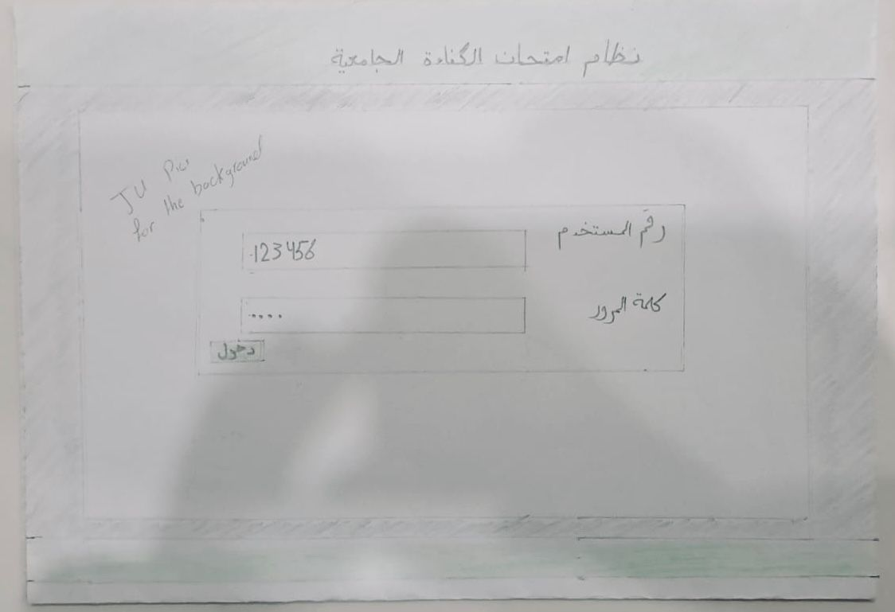

2. Main page
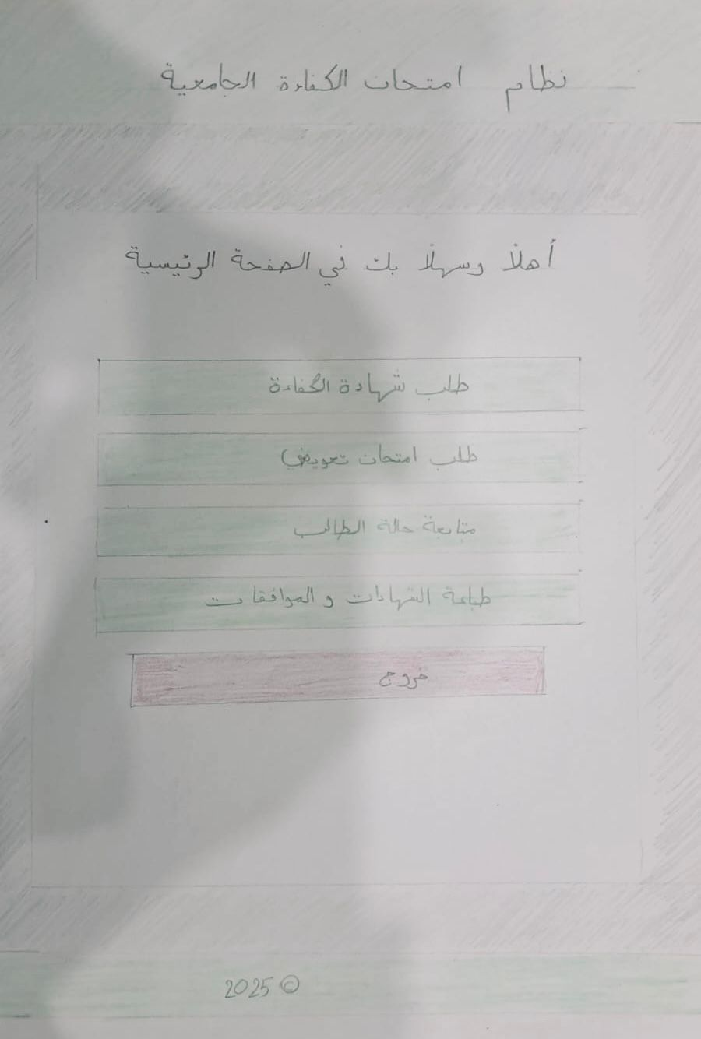
3. Request the competency examination certificate
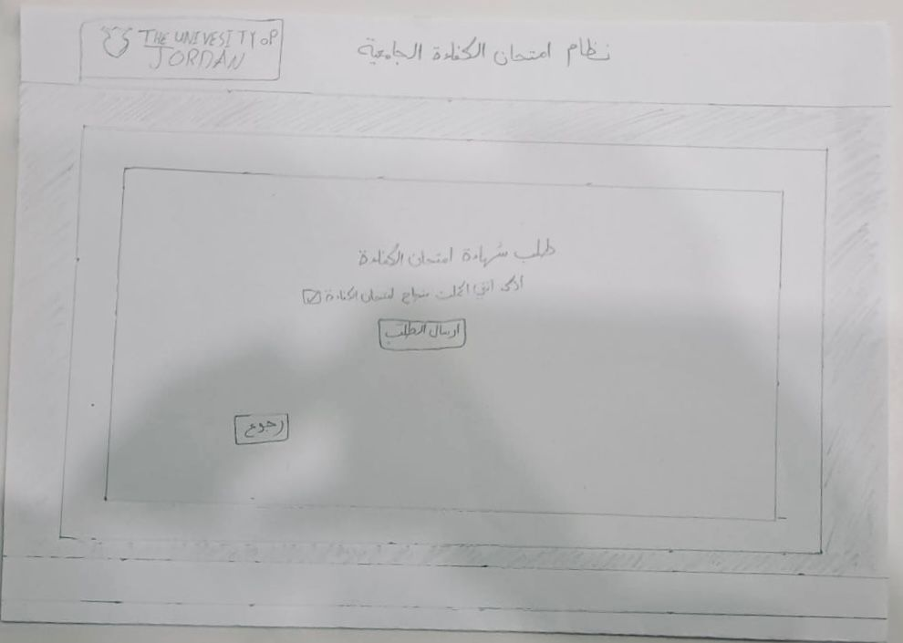
4. Request a make-up proficiency exam
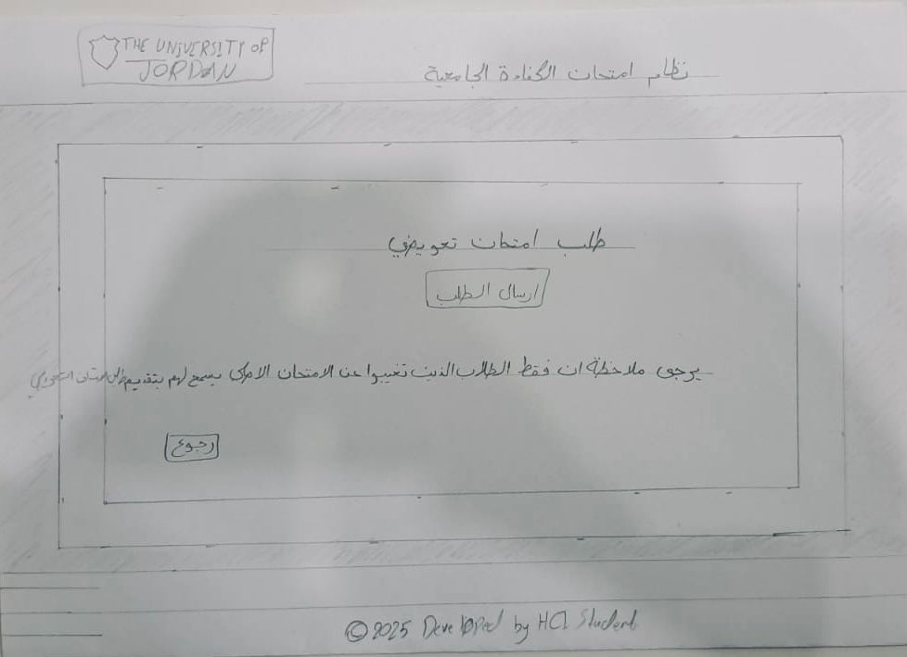

5. Follow up on the status of the request
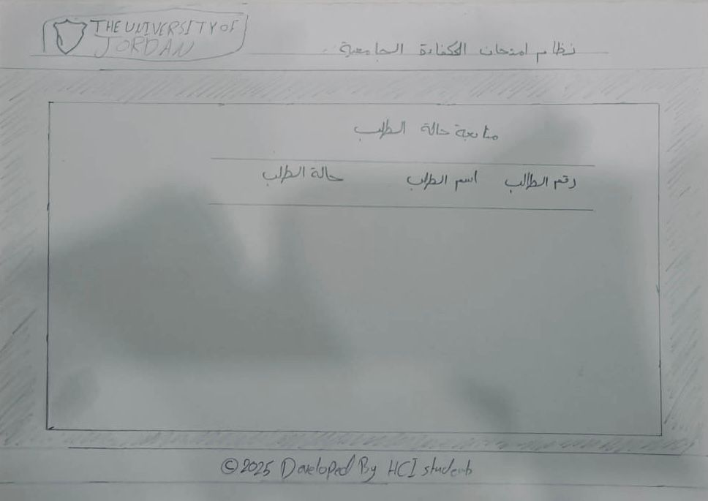

6. Printing certificates and approvals
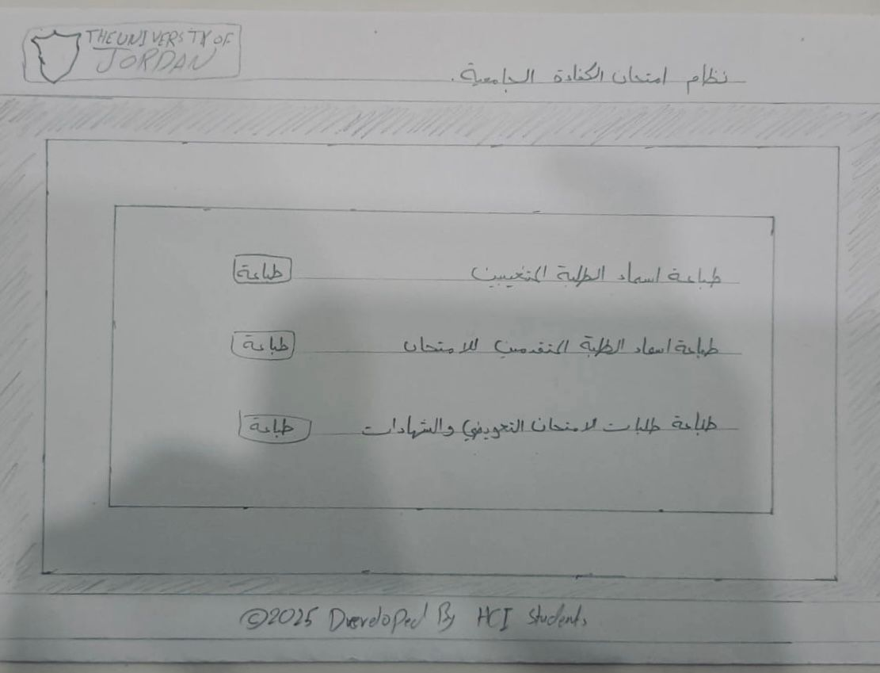
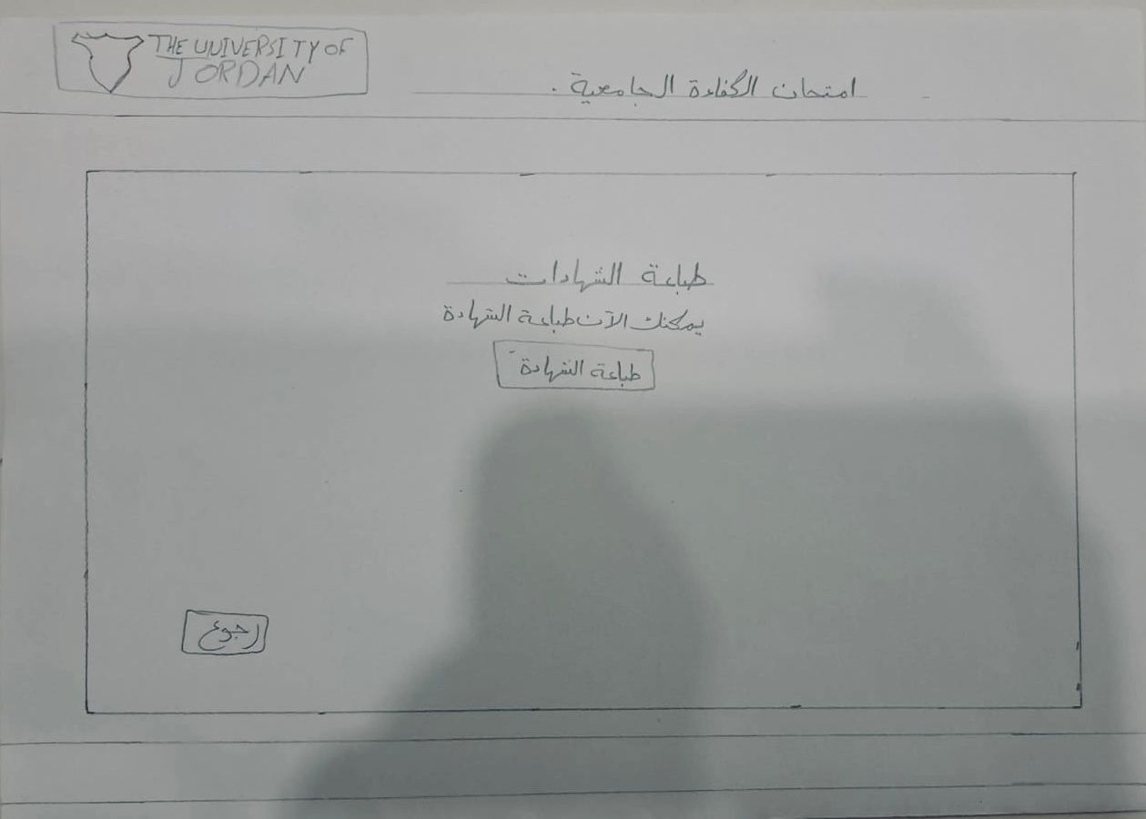

- Additional pages we thought about
7. Make-up exam date
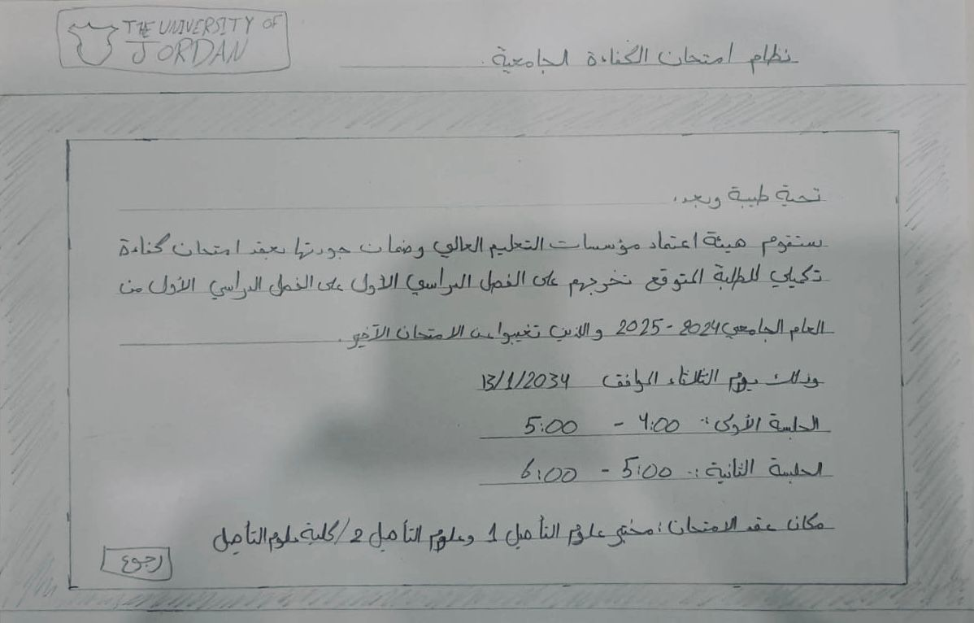
8. Student data page
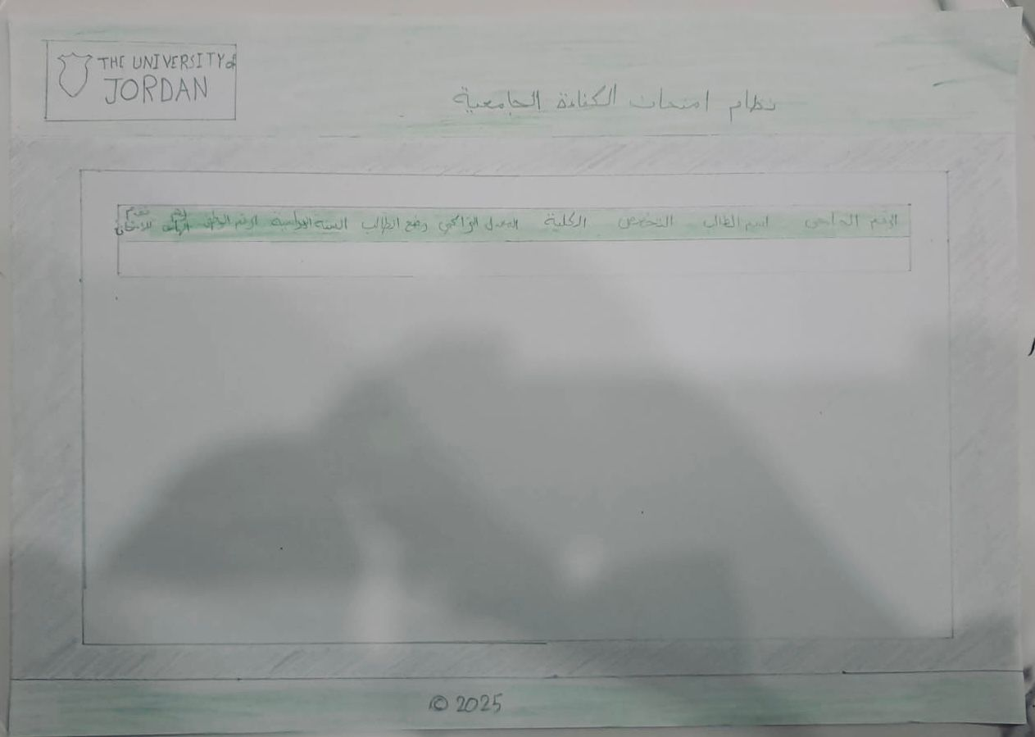
9. Page to schedule the exam
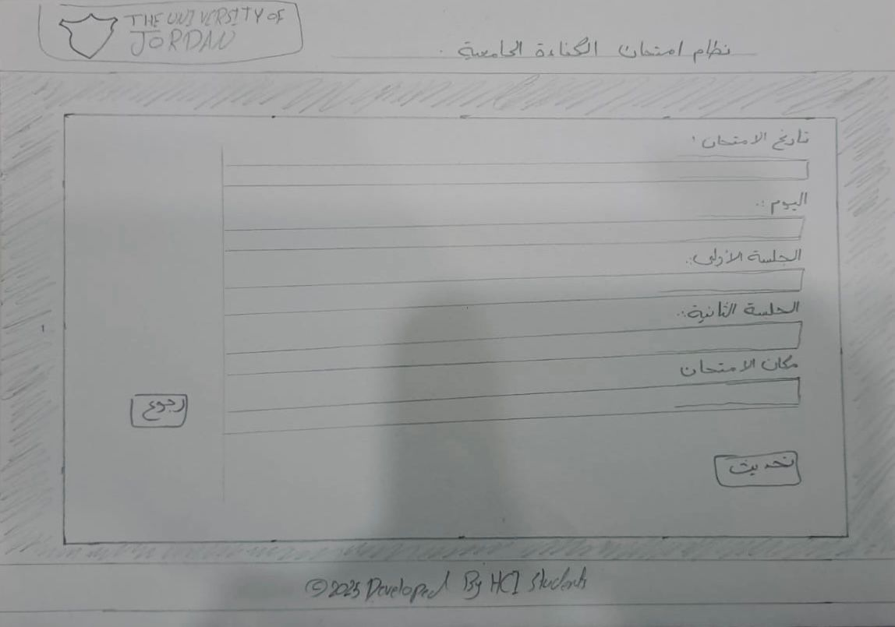

4.2 Medium-Fidelity Prototyping
In this stage, we take our paper sketches and create more polished digital versions using design software. These interactive wireframes provide a clearer picture of the user interface and how the system will function, allowing us to test and refine the design. You can explore the Figma designs here. The images are also included in the report for a closer look.

1. Login page
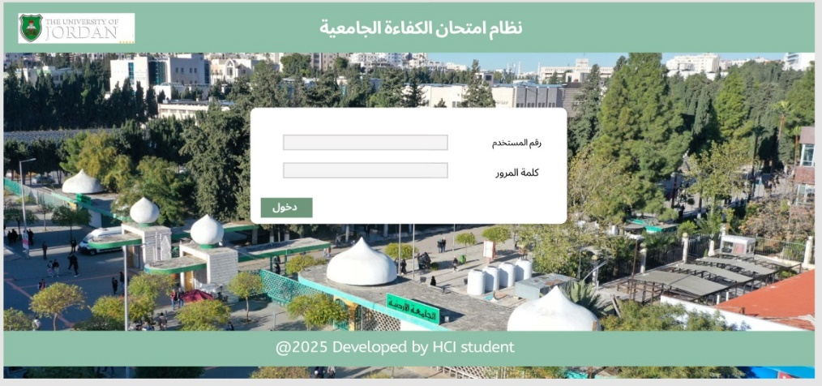
2. Main page
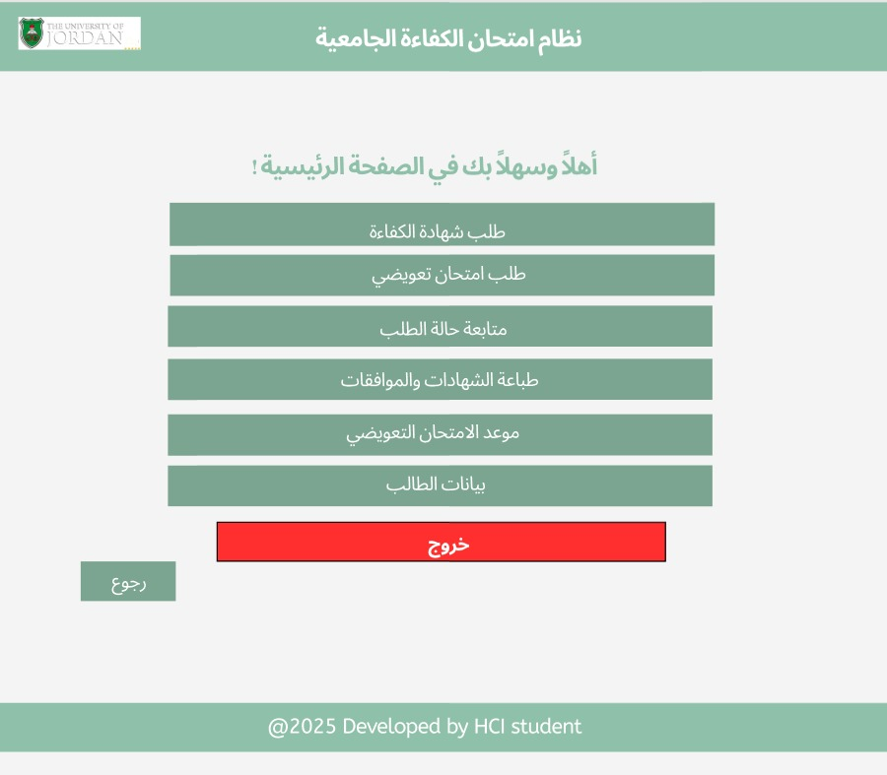

3. Request the competency examination certificate
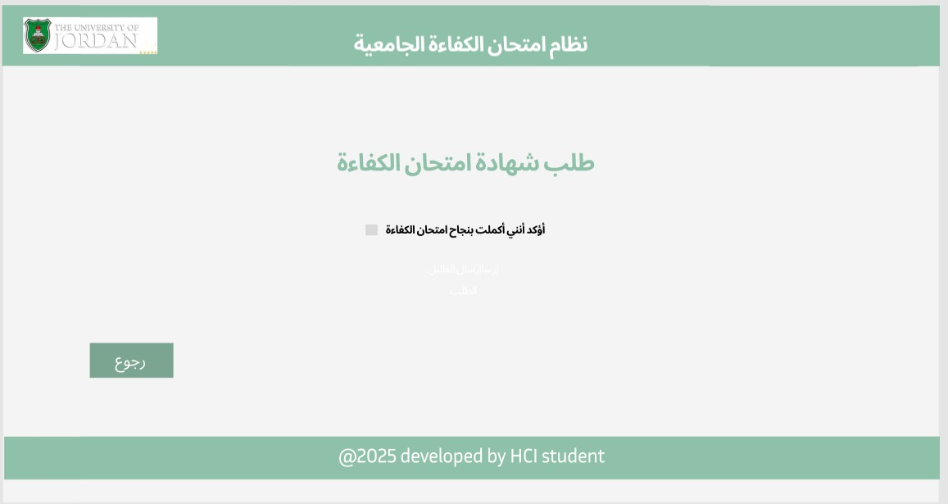
4. Request a make-up proficiency exam
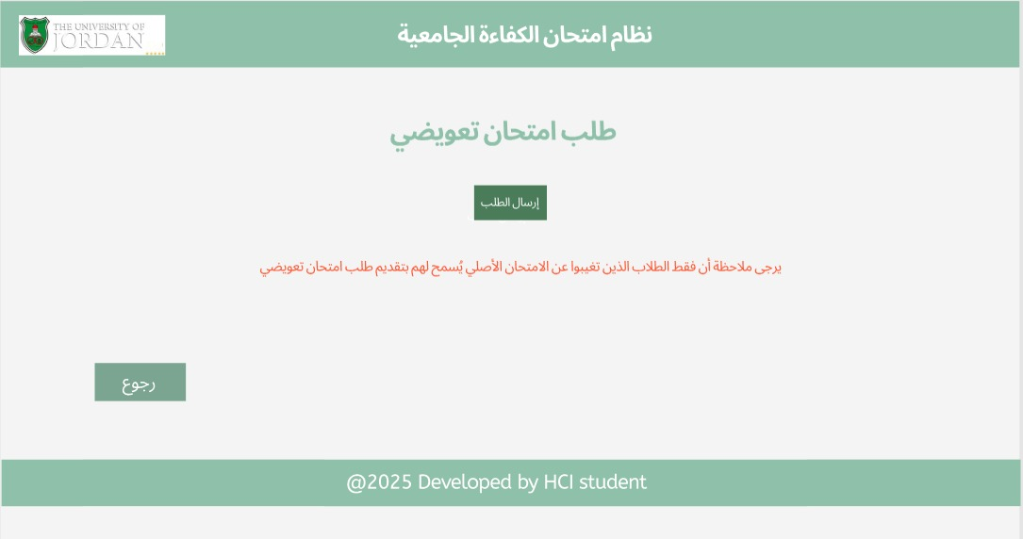

5. Follow up on the status of the request
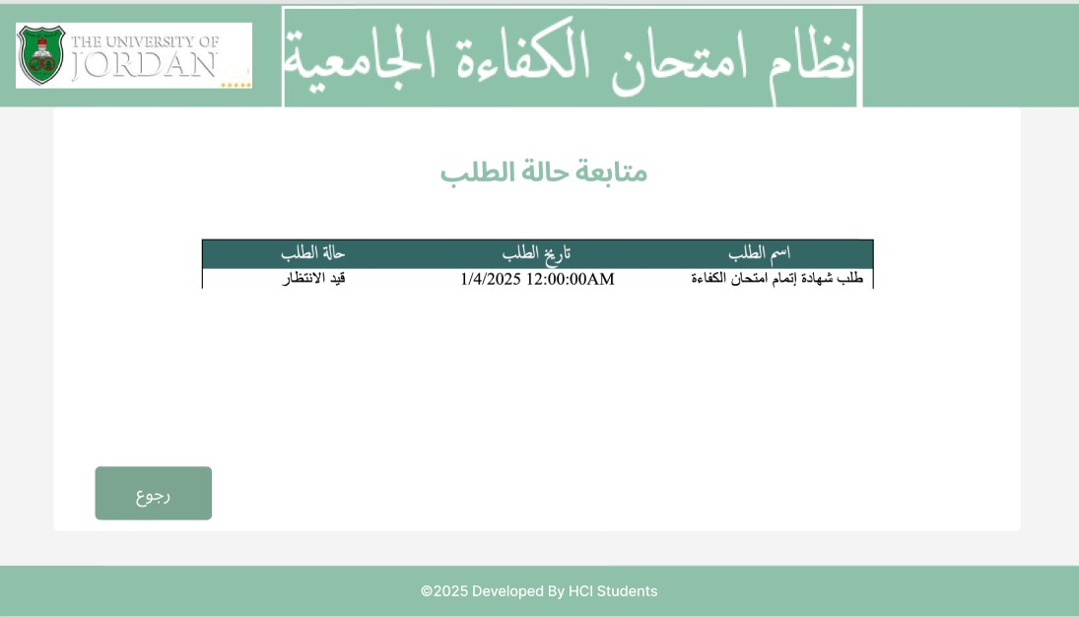
6. Printing certificates and approvals


7. Make-up exam date
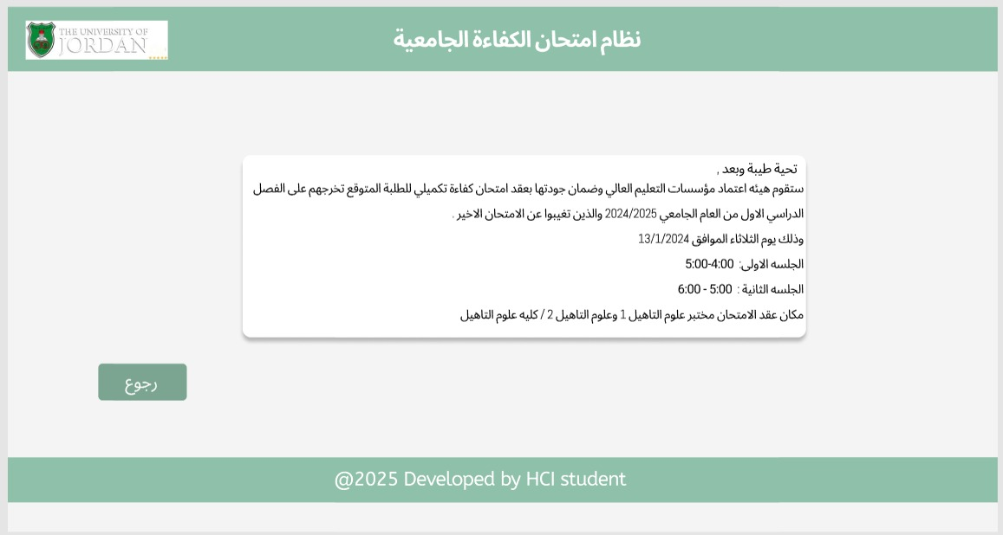
8. Student data page
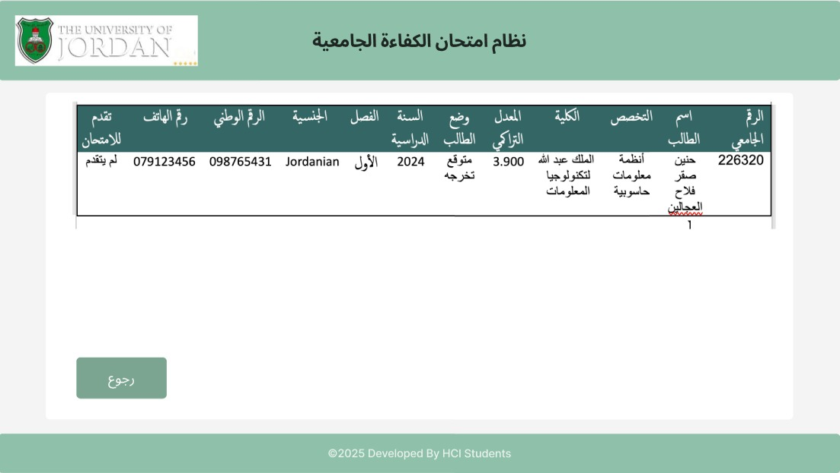

- Now after showing the follow pages, we also did AQAC pages
1. Main page
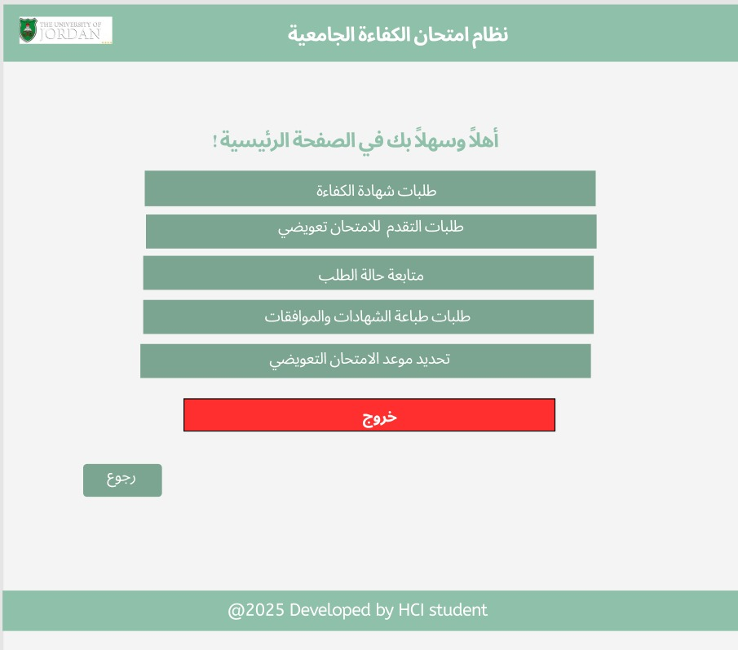
2. Request the competency examination certificate
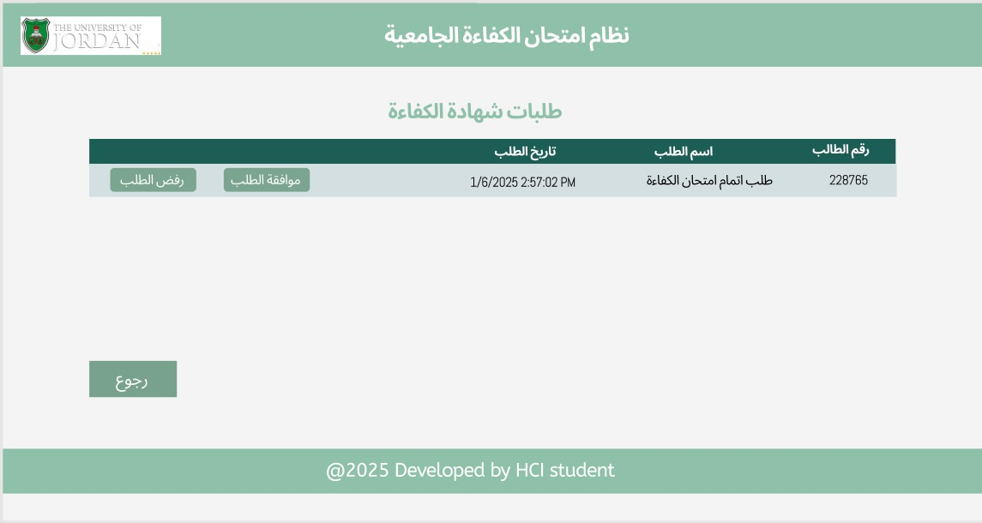

3. Request a make-up proficiency exam
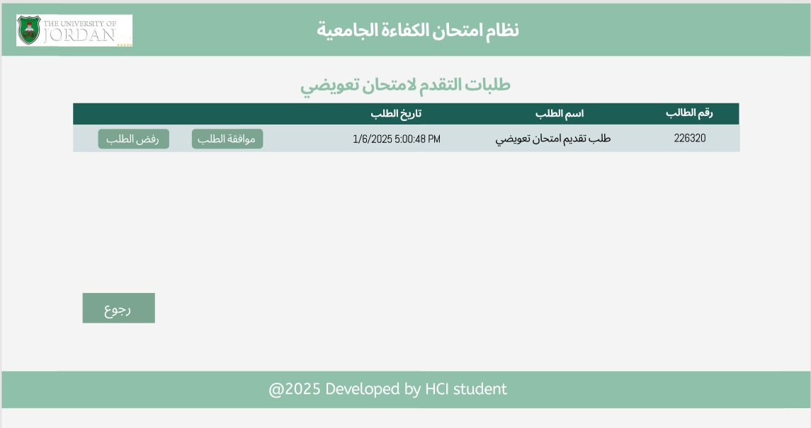
4. Follow up on the status of the request
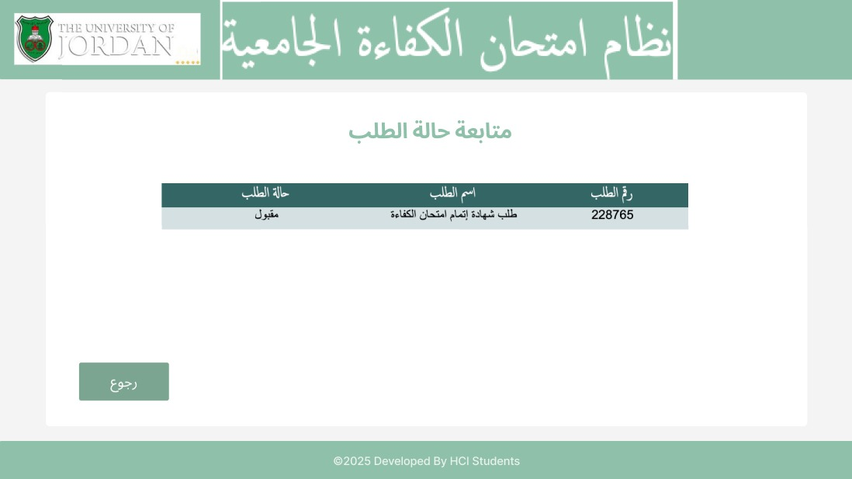

5. Printing certificates and approvals
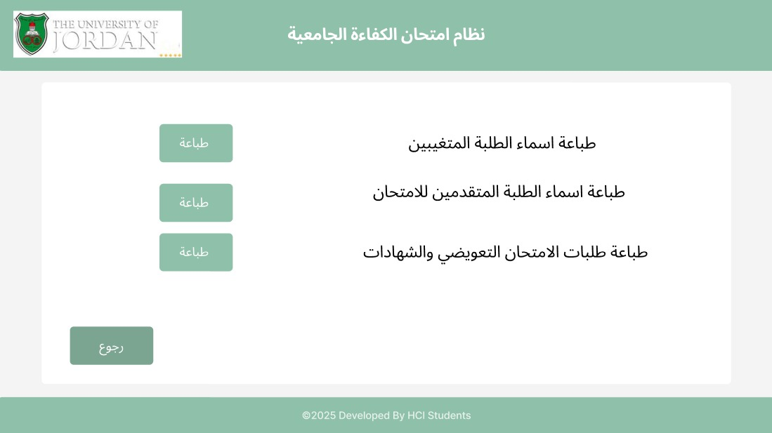
6. Make-up exam date
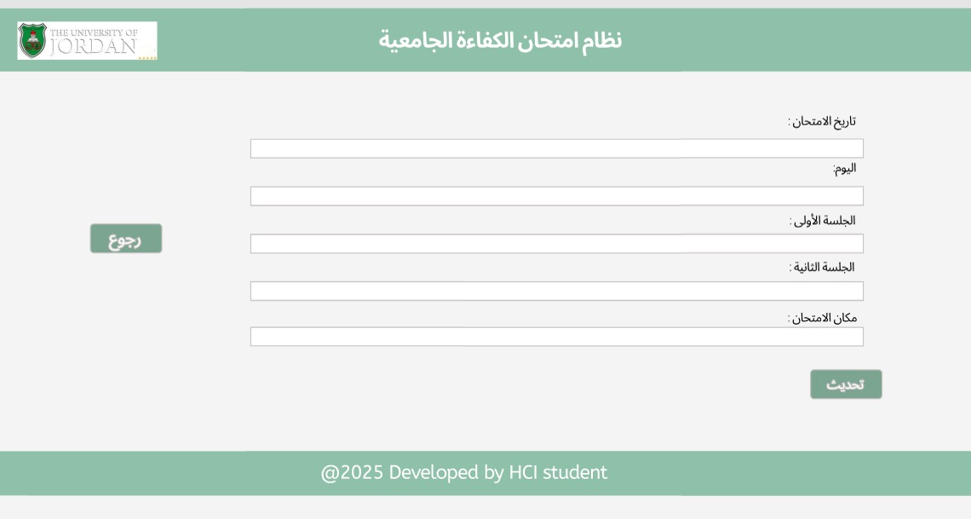

4.3 Database Design
Here, we plan the database structure that will hold all the system’s data, like student records and exam details. A solid database design ensures smooth operation and quick access to important information when users need it most.
- Data Base Design:
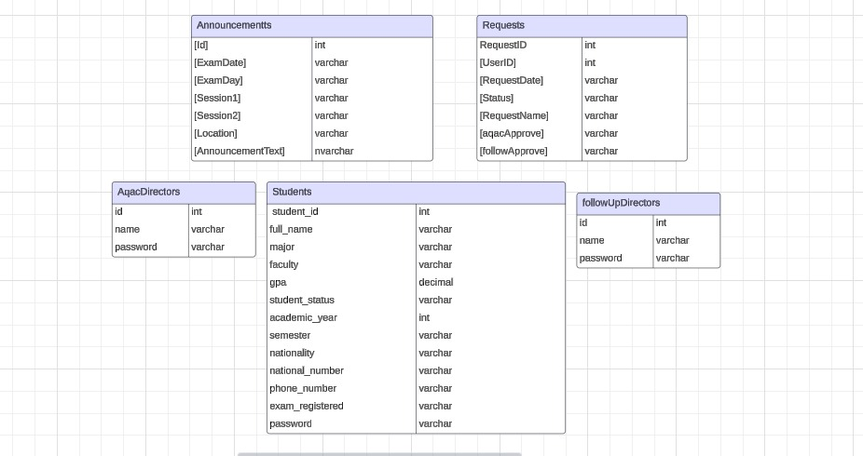

5.0 System Implementation
This section covers the practical aspects of implementing the system, from high-fidelity prototyping to the optional database implementation. It illustrates how the design concept was translated into a working model, with attention to usability and functionality.

5.1 High-Fidelity Prototyping
In this subsection, we explain the process of creating high-fidelity prototypes using code-based interfaces. These prototypes simulate real interactions and provide a closer representation of the final product. We include the relevant images of the prototypes created during this phase below:
1. Login page
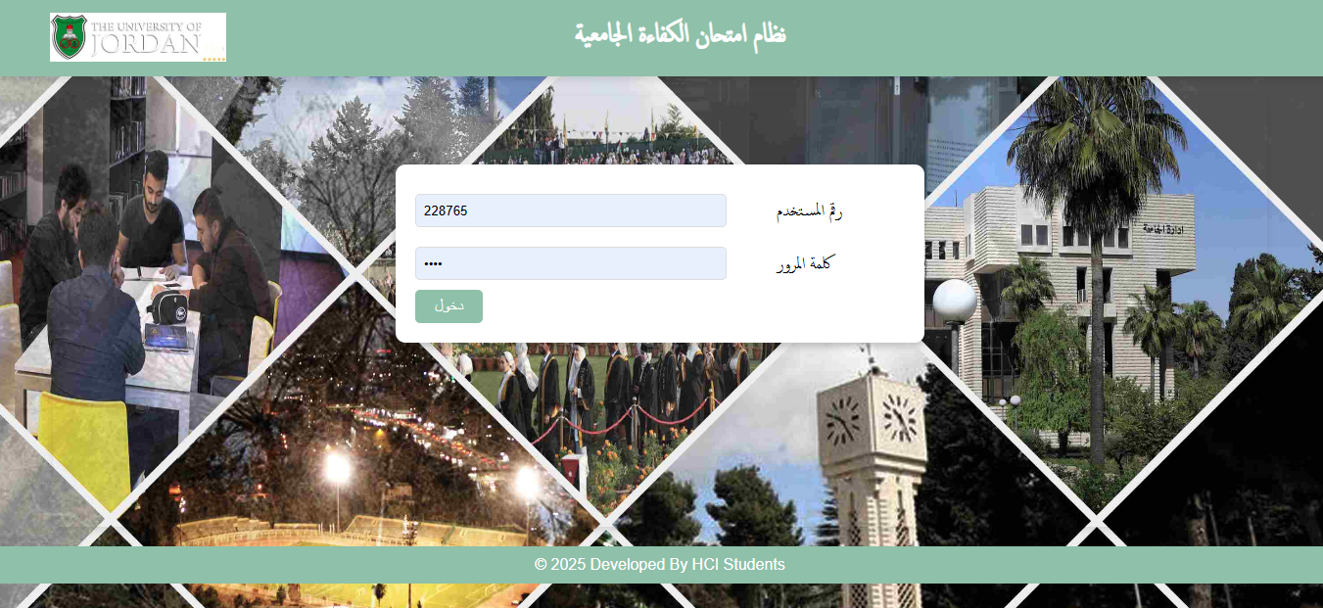
2. Main page
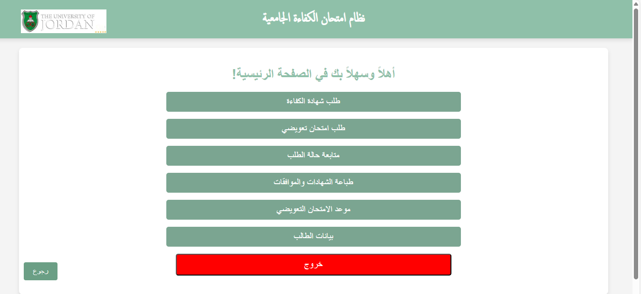
3. Request the competency examination certificate
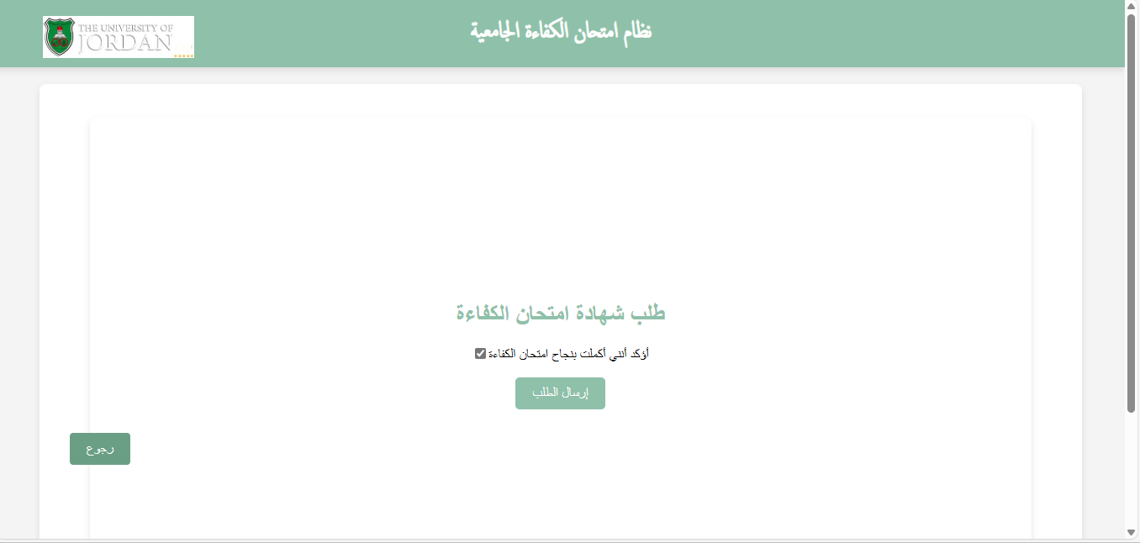
4. Request a make-up proficiency exam
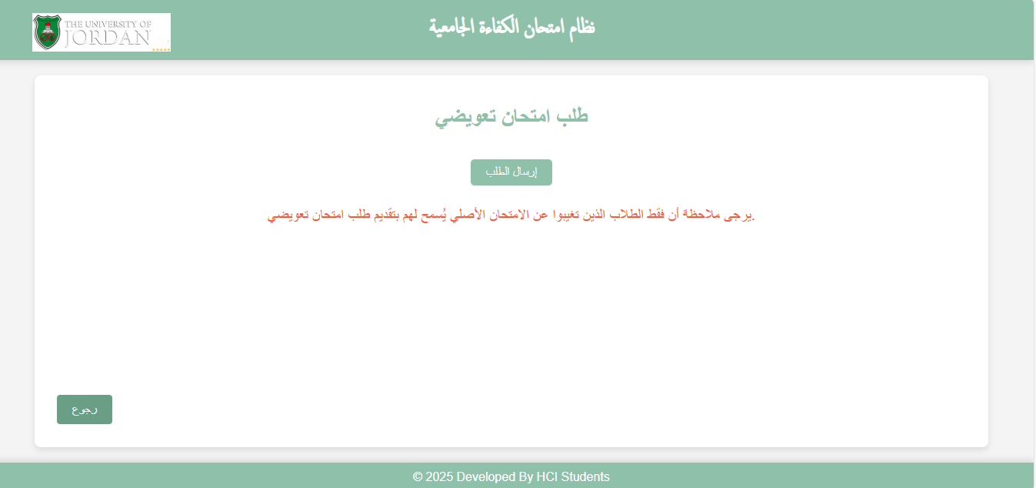

5. Follow up on the status of the request
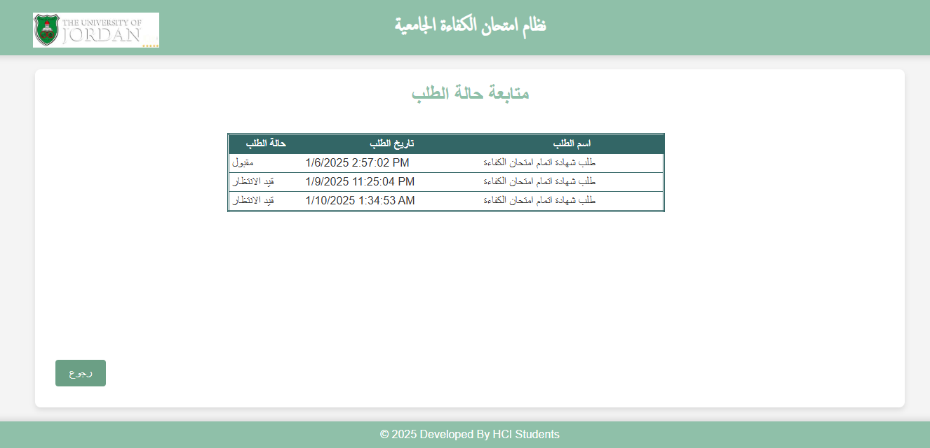
6. Printing certificates and approvals
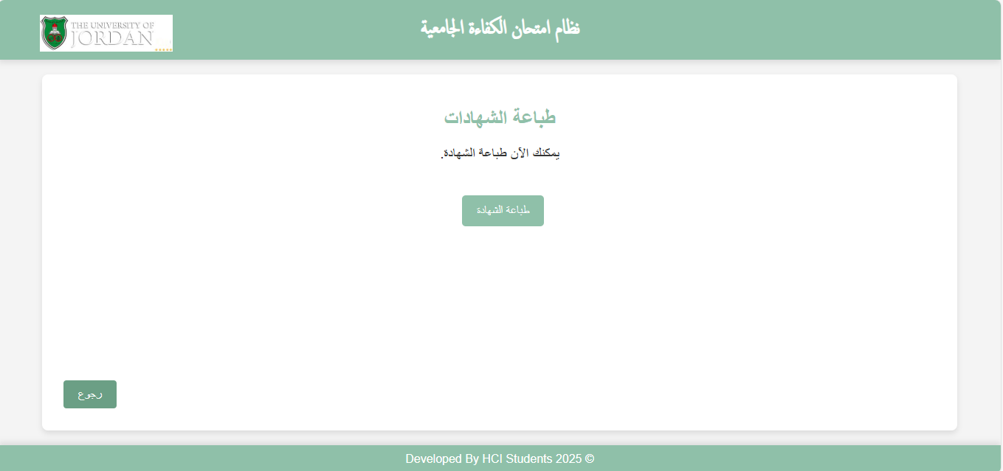

7. Make-up exam date
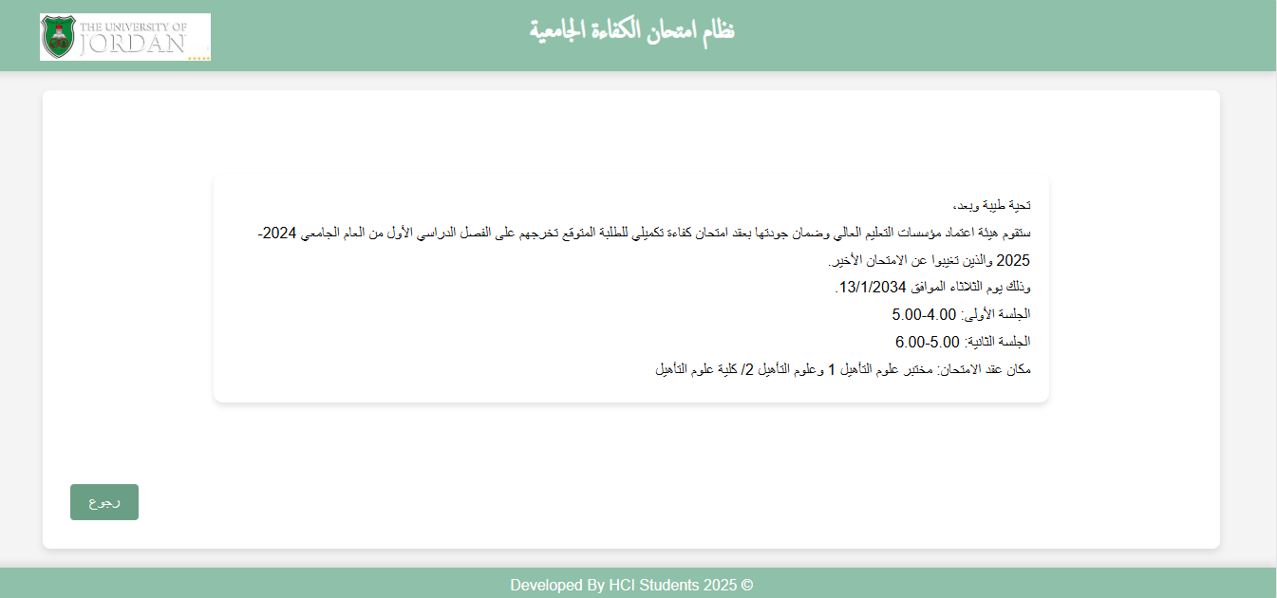
8. Student data page
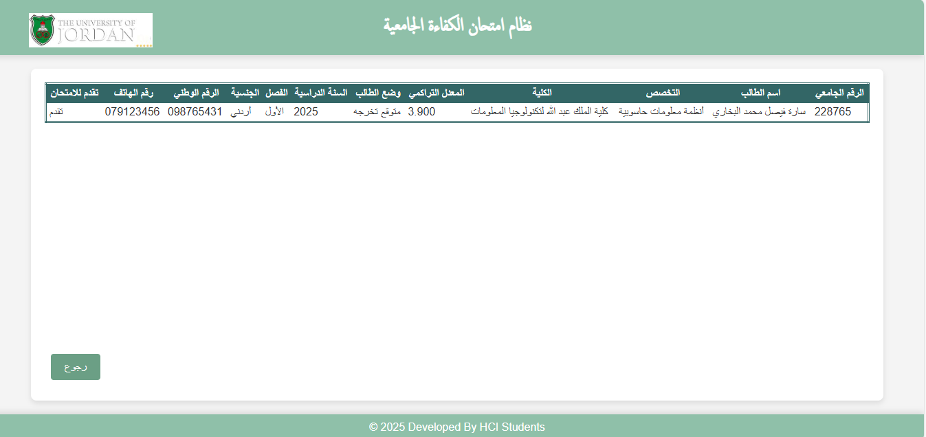

- Now after showing the follow pages, we also did AQAC pages
1. Main page
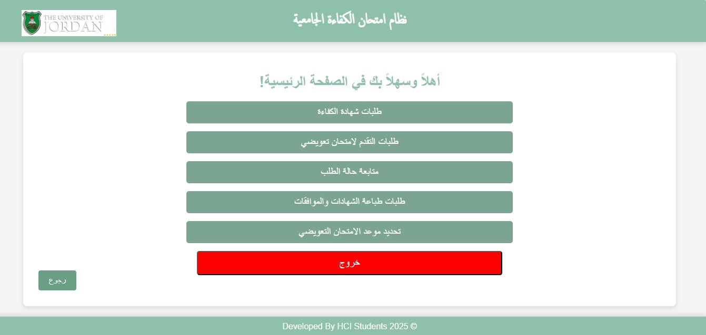
2. Request the competency examination certificate
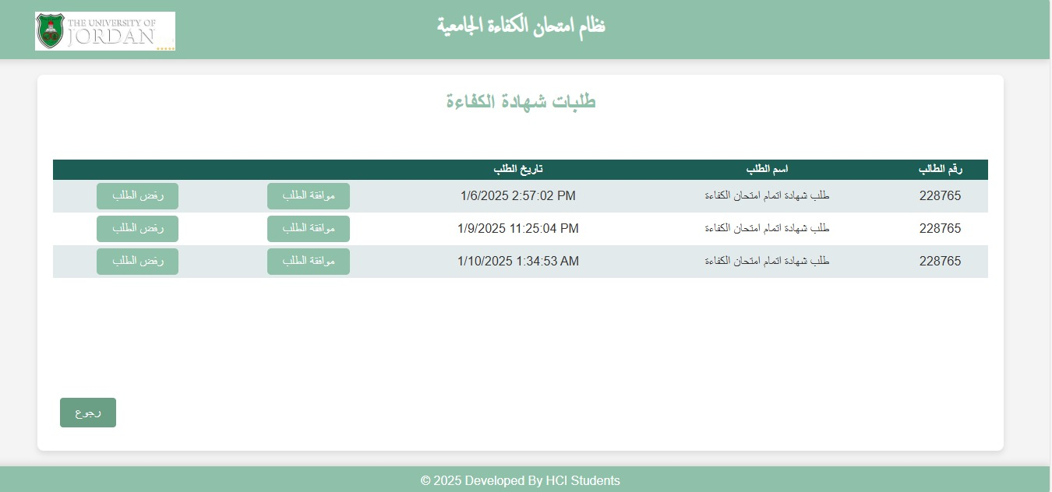

3. Request a make-up proficiency exam
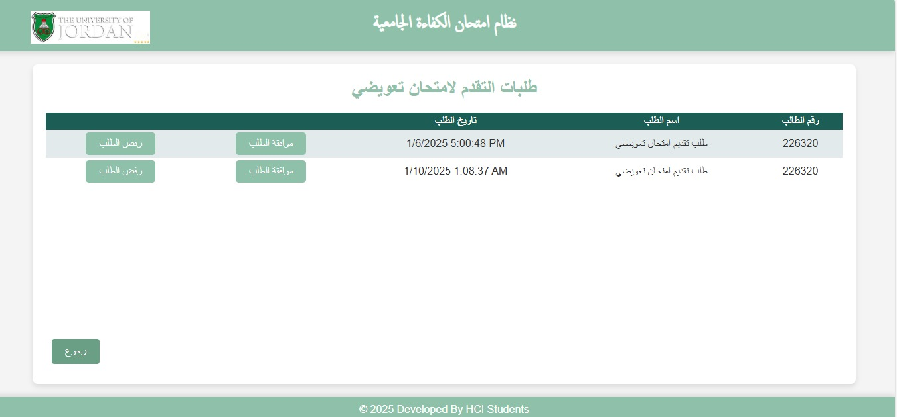
4. Follow up on the status of the request
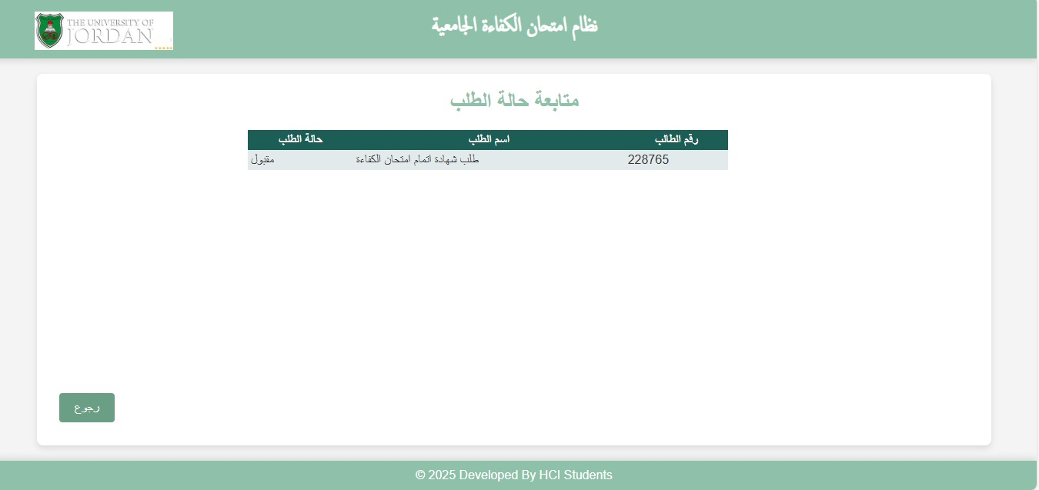

5. Printing certificates and approvals
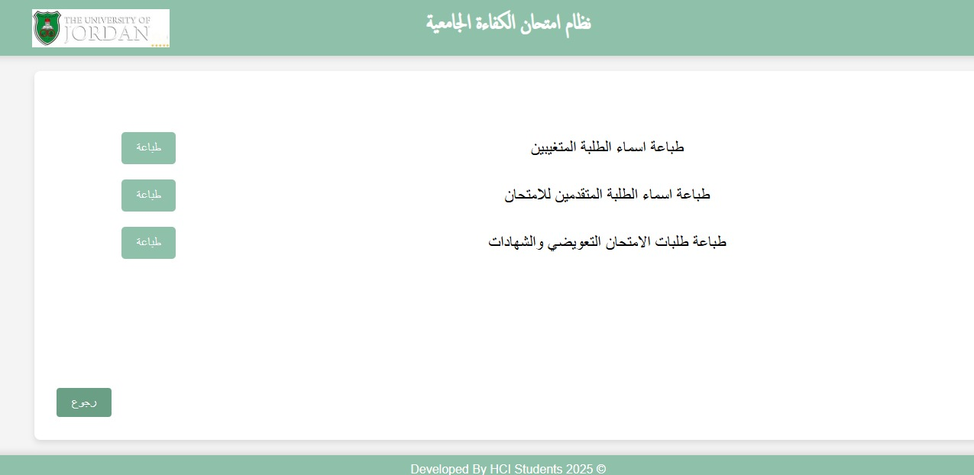
6. Make-up exam date
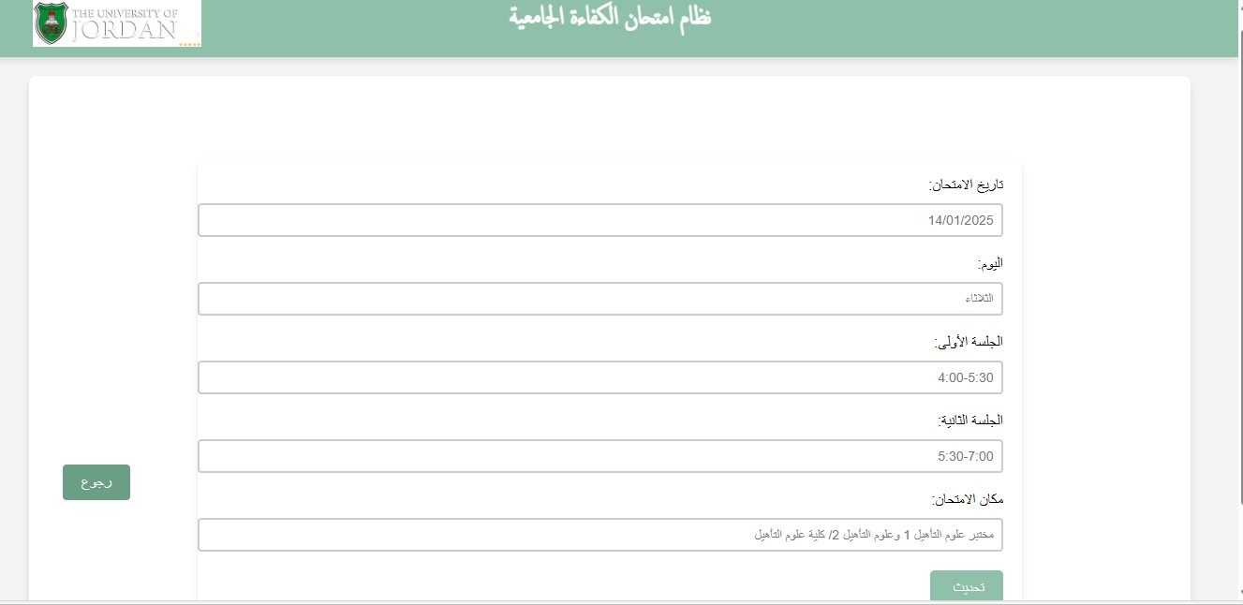

5.2 Database Implementation (Optional + Bonus)
This optional bonus section explores the implementation of a database to support the system's functionality. While not a core requirement, integrating a database enhances the system by enabling data storage, retrieval, and manipulation. Below is a visual representation of the database architecture:

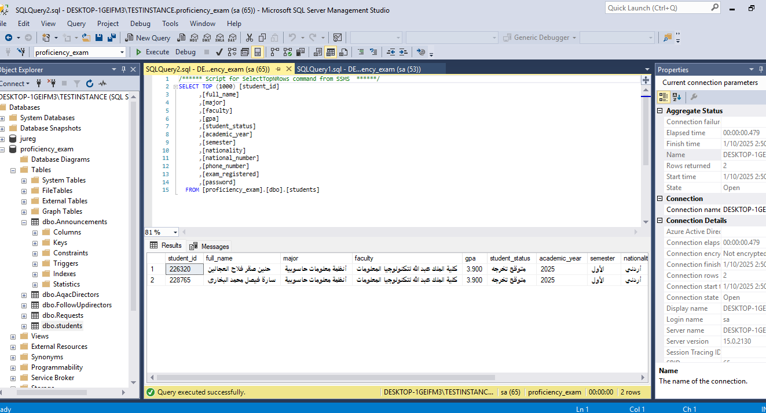
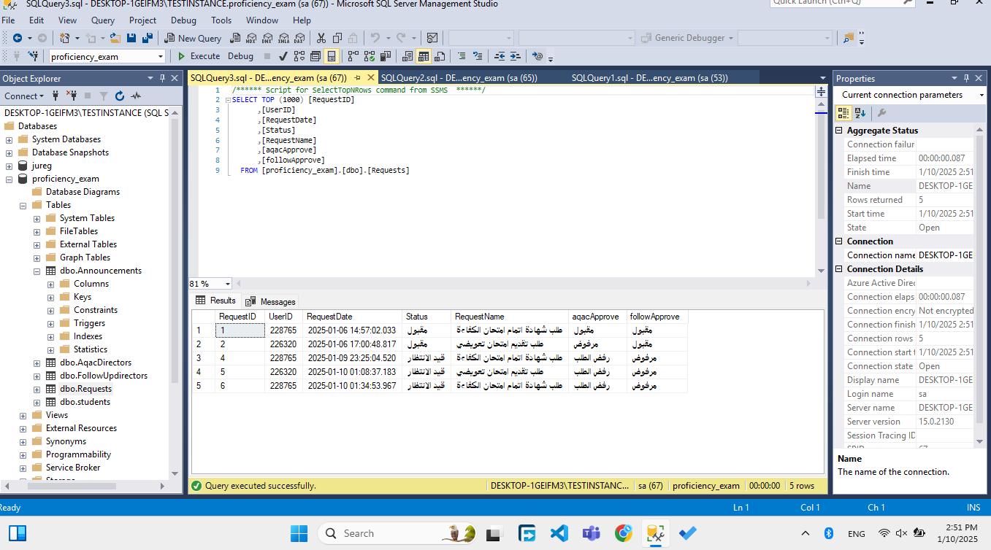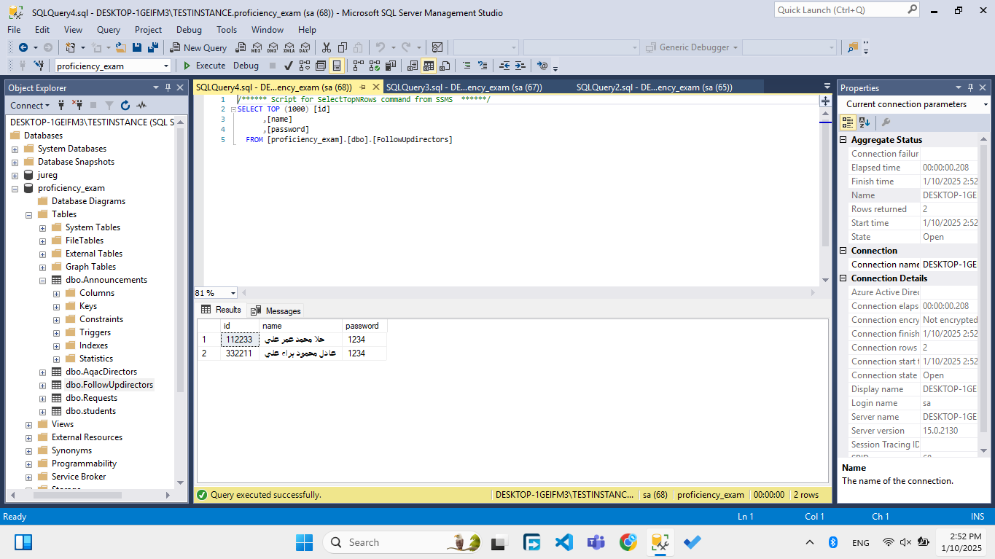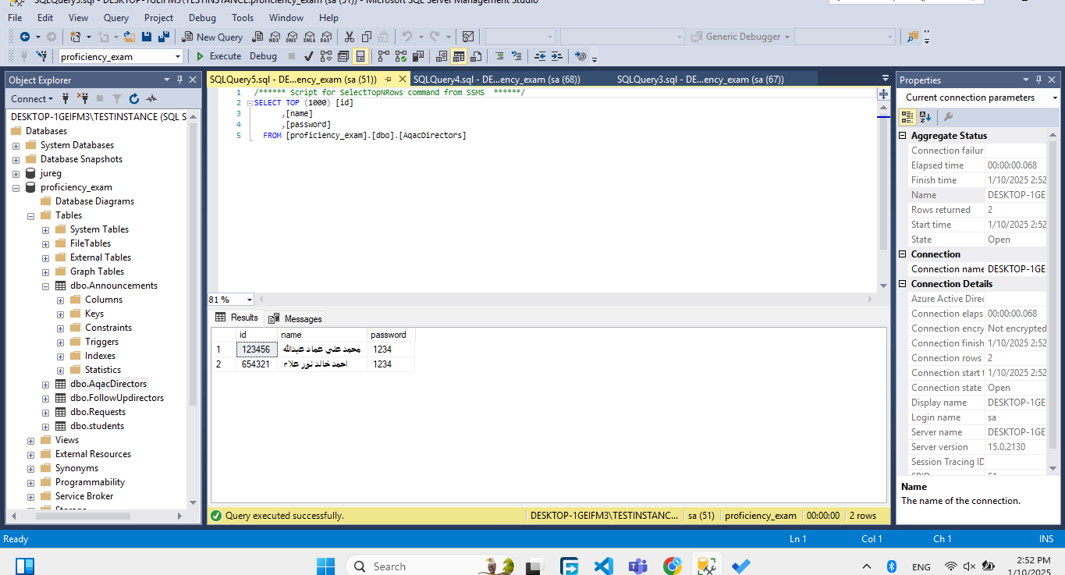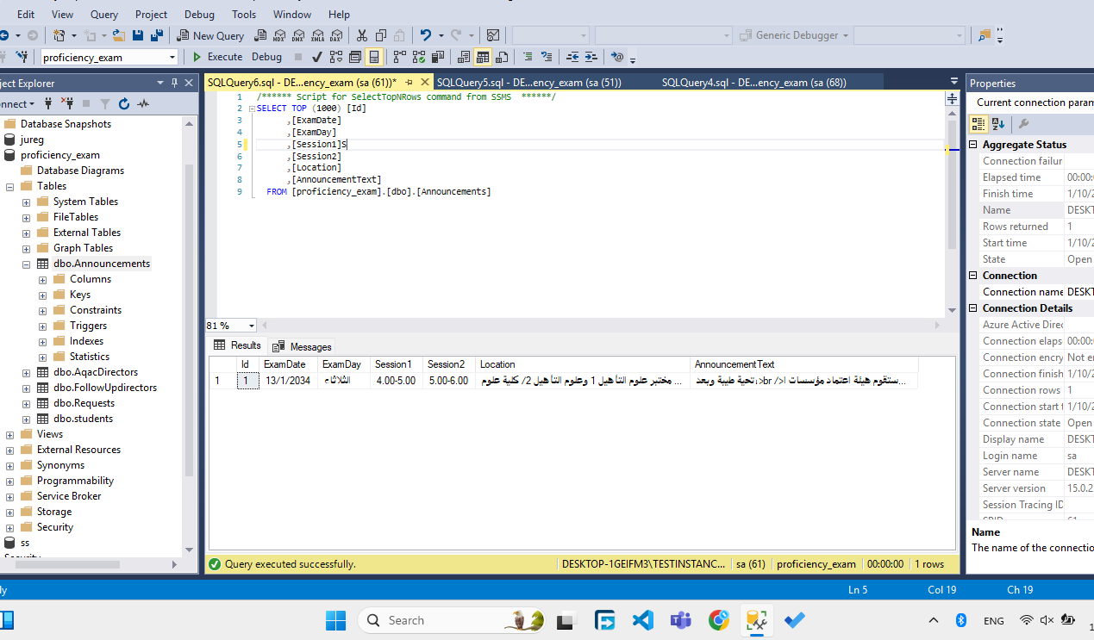

6.0 System Testing and Installation

6.1 Heuristic Evaluation
According to Wikipedia, heuristic evaluation is a discount usability inspection method for computer software that helps to identify usability problems in the user interface (UI) design. It specifically involves evaluators examining the interface and judging its compliance with recognized usability principles (the "heuristics").
Heuristic evaluation is an informal usability inspection technique developed by Jakob Nielsen and his colleagues in 1994 in which experts, guided by a set of usability principles known as heuristics, evaluate whether user-interface elements, such as dialog boxes, menus, navigation structure, online help, etc., conform to the principles.
Table 1: List of Heuristics of Usability Evaluation and their Descriptions
Numbering Scheme | Heuristics | Description
H1 | Visibility of system status | The system should always keep users informed about what is going on, through appropriate feedback within reasonable time.
H2 | Match between system and the real world | The system should speak the users' language, with words, phrases and concepts familiar to the user, rather than system-oriented terms. Follow real-world conventions, making information appear in a natural and logical order.
H3 | User control and freedom | Users often choose system functions by mistake and will need a clearly marked "emergency exit" to leave the unwanted state without having to go through an extended dialogue. Support undo and redo.
H4 | Consistency and standards | Users should not have to wonder whether different words, situations, or actions mean the same thing. Follow platform conventions.
H5 | Error prevention | Even better than a good error message is a careful design that prevents a problem from occurring in the first place.
H6 | Recognition rather than recall | Make objects, actions, and options visible. The user should not have to remember information from one part of the dialogue to another. Instructions for use of the system should be visible or easily retrievable whenever appropriate.
H7 | Flexibility and efficiency of use | Accelerators -- unseen by the novice user -- may often speed up the interaction for the expert user such that the system can cater to both inexperienced and experienced users. Allow users to tailor frequent actions.
H8 | Aesthetic and minimalist design | Dialogues should not contain information that is irrelevant or rarely needed. Every extra unit of information in a dialogue competes with the relevant units of information and diminishes their relative visibility.
H9 | Help users recognize, diagnose, and recover from errors | Error messages should be expressed in plain language (no codes), precisely indicating the problem, and constructively suggesting a solution.
H10 | Help and documentation | Even though it is better if the system can be used without documentation, it may be necessary to provide help and documentation. Any such information should be easy to search, focused on the user's task, list concrete steps to be carried out, and not be too large.

Please fill in the evaluation form below, which is a form of checklist, by writing “X” in the appropriate place which mostly describes the best answer to the corresponding criterion. This form is to be filled after you have investigated the system interface i.e. have looked at, and examined the interface. The answer to each criterion is either:

"0" which means "I don’t agree that this is a usability problem at all".
"1" which means " Cosmetic problem only: need not be fixed unless extra time is available on project".
"2" which means " Minor usability problem: fixing this should be given low priority ".
"3" which means " Major usability problem: important to fix, so should be given high priority".
"4" which means " Usability catastrophe: imperative to fix this before product can be released".

Thank you for your willingness to evaluate this system. Your time and effort are highly appreciated.

Group Members’ Names

H1. Visibility of System Status
The system should always keep user informed about what is going on, through appropriate feedback within reasonable time.
# | Review Checklist | 0 1 2 3 4 | Comments
1.1 | Does every display begin with a title or header that describes screen contents? | ( ) (x ) ( ) ( ) ( )
1.2 | Do menu instructions, prompts, and error messages appear in the same place(s) on each menu? | ( x ) ( ) ( ) ( ) ( )
1.3 | Is there some form of system feedback for every operator action? | ( x ) ( ) ( ) ( ) ( )
1.4 | Are response times appropriate to the user's cognitive processing? | ( x ) ( ) ( ) ( ) ( )
1.5 | Is there visual feedback in menus or dialog boxes about which choices are selectable? | ( ) ( ) ( x ) ( ) ( )
H2. Match Between System and the Real World
The system should speak the user’s language, with words, phrases and concepts familiar to the user, rather than system-oriented terms. Follow real-world conventions, making information appear in a natural and logical order.
# | Review Checklist | 0 1 2 3 4 | Comments
2.1 | Are icons concrete and familiar? | ( x ) ( ) ( ) ( ) ( )
2.2 | Are menu choices ordered in the most logical way, given the user, the item names, and the task variables? | ( x ) ( ) ( ) ( ) ( )
2.3 | Do related and interdependent fields appear on the same screen? | ( ) ( x ) ( ) ( ) ( )
2.4 | When prompts imply a necessary action, are the words in the message consistent with that action? | ( x ) ( ) ( ) ( ) ( )
2.5 | On data entry screens, are tasks described in terminology familiar to users? | ( ) (x ) ( ) ( ) ( )

H3. User Control and Freedom
Users should be free to select and sequence tasks (when appropriate), rather than having the system do this for them. Users often choose system functions by mistake and will need a clearly marked “emergency exit” to leave the unwanted state without having to go through an extended dialogue. Users should make their own decisions (with clear information) regarding the costs of exiting current work. The system should support undo and redo.
# | Review Checklist | 0 1 2 3 4 | Comments
3.1 | When a user's task is complete, does the system wait for a signal from the user before processing? | ( ) ( x ) ( ) ( ) ( )
3.2 | Are users prompted to confirm commands that have drastic, destructive consequences? | ( ) ( ) (x ) ( ) ( )
3.3 | Are character edits allowed in data entry fields? | ( x ) ( ) ( ) ( ) ( )
3.4 | If menu lists are long (more than seven items), can users select an item either by moving the cursor or by typing a mnemonic code? | ( ) ( ) ( x ) ( ) ( )
3.5 | If the system uses a pointing device, do users have the option of either clicking on menu items or using a keyboard shortcut? | ( ) ( ) ( ) ( x ) ( )

H4. Consistency and Standards
Users should not have to wonder whether different words, situations, or actions mean the same thing. Follow platform conventions.
# | Review Checklist | 0 1 2 3 4 | Comments
4.1 | Has a heavy use of all uppercase letters on a screen been avoided? | ( x ) ( ) ( ) ( ) ( )
4.2 | Are icons labeled? | ( x ) ( ) ( ) ( ) ( )
4.3 | Are there no more than twelve to twenty icon types? | ( x ) ( ) ( ) ( ) ( )
4.4 | Does each window have a title? | ( x ) ( ) ( ) ( ) ( )
4.5 | Are vertical and horizontal scrolling possible in each window? | ( x ) ( ) ( ) ( ) ( )
4.6 | Are menu choice lists presented vertically? | ( x ) ( ) ( ) ( ) ( )
4.7 | Are menu titles either centered or left-justified? | ( x ) ( ) ( ) ( ) ( )
4.8 | Are menu items left-justified, with the item number or mnemonic preceding the name? | ( ) (x ) ( ) ( ) ( )
4.9 | Do embedded field-level prompts appear to the right of the field label? | ( ) ( x ) ( ) ( ) ( )
4.10 | Are attention-getting techniques used with care? | ( x) ( ) ( ) ( ) ( )

H5. Help Users Recognize, Diagnose, and Recover From Errors
Error messages should be expressed in plain language (NO CODES).
# | Review Checklist | 0 1 2 3 4 | Comments
5.1 | Is sound used to signal an error? | ( ) ( ) ( ) ( ) (x )
5.2 | Are error messages worded so that the system, not the user, takes the blame? | ( x ) ( ) ( ) ( ) ( )
5.3 | Do error messages suggest the cause of the problem? | ( x) ( ) ( ) ( ) ( )
5.4 | Do error messages indicate what action the user needs to take to correct the error? | ( ) ( x) ( ) ( ) ( )
5.5 | If the system supports both novice and expert users, are multiple levels of error-message detail available? | ( ) ( x ) ( ) ( ) ( )
5.6 | If an error is detected in a data entry field, does the system place the cursor in that field or highlight the error? | ( ) ( x ) ( ) ( ) ( )
5.7 | Do error messages inform the user of the error's severity? | ( x ) ( ) ( ) ( ) ( )
H6. Error Prevention
Even better than good error messages is a careful design which prevents a problem from occurring in the first place.
# | Review Checklist | 0 1 2 3 4 | Comments
6.1 | Are menu choices logical, distinctive, and mutually exclusive? | ( x ) ( ) ( ) ( ) ( )
6.2 | Are data inputs case-blind whenever possible? | ( ) ( x ) ( ) ( ) ( )
6.3 | Does the system prevent users from making errors whenever possible? | (x ) ( ) ( ) ( ) ( )
6.4 | Does the system warn users if they are about to make a potentially serious error? | ( ) ( x ) ( ) ( ) ( )
6.5 | Do data entry screens and dialog boxes indicate the number of character spaces available in a field? | ( ) ( ) ( ) ( ) ( x )
6.6 | Do fields in data entry screens and dialog boxes contain default values when appropriate? | ( x ) ( ) ( ) ( ) ( )

H7. Recognition Rather Than Recall
Make objects, actions, and options visible. The user should not have to remember information from one part of the dialogue to another. Instructions for use of the system should be visible or easily retrievable whenever appropriate.
# | Review Checklist | 0 1 2 3 4 | Comments
7.1 | For question and answer interfaces, are visual cues and white space used to distinguish questions, prompts, instructions, and user input? | ( ) ( x ) ( ) ( ) ( )
7.2 | Are inactive menu items grayed out or omitted? | ( x ) ( ) ( ) ( ) ( )
7.3 | Do data entry screens and dialog boxes indicate when fields are optional? | ( ) ( x ) ( ) ( ) ( )
7.4 | Are prompts, cues, and messages placed where the eye is likely to be looking on the screen? | ( x ) ( ) ( ) ( ) ( )
7.5 | Are field labels close to fields, but separated by at least one space? | (x ) ( ) ( ) ( ) ( )
7.6 | Have items been grouped into logical zones, and have headings been used to distinguish between zones? | ( x ) ( ) ( ) ( ) ( )
7.7 | Are borders used to identify meaningful groups? | ( ) ( x ) ( ) ( ) ( )
7.8 | Is color coding consistent throughout the system? | ( x ) ( ) ( ) ( ) ( )

H8. Flexibility and Minimalist Design
Accelerators-unseen by the novice user-may often speed up the interaction for the expert user such that the system can cater to both inexperienced and experienced users. Allow users to tailor frequent actions. Provide alternative means of access and operation for users who differ from the “average” user (e.g., physical or cognitive ability, culture, language, etc.)
# | Review Checklist | 0 1 2 3 4 | Comments
8.1 | If menu lists are short (seven items or fewer), can users select an item by moving the cursor? | ( x ) ( ) ( ) ( ) ( )
8.2 | If the system uses a pointing device, do users have the option of either clicking on fields or using a keyboard shortcut? | ( ) ( x ) ( ) ( ) ( )
8.3 | On data entry screens, do users have the option of either clicking directly on a field or using a keyboard shortcut? | ( ) ( x ) ( ) ( ) ( )
8.4 | On menus, do users have the option of either clicking directly on a menu item or using a keyboard shortcut? | ( ) ( x ) ( ) ( ) ( )
8.5 | In dialog boxes, do users have the option of either clicking directly on a dialog box option or using a keyboard shortcut? | ( ) ( ) ( x ) ( ) ( )

H9. Aesthetic and Minimalist Design
Dialogues should not contain information which is irrelevant or rarely needed. Every extra unit of information in a dialogue competes with the relevant units of information and diminishes their relative visibility.
# | Review Checklist | 0 1 2 3 4 | Comments
9.1 | Are all icons in a set visually and conceptually distinct? | ( x ) ( ) ( ) ( ) ( )
9.2 | Does each icon stand out from its background? | ( ) ( x ) ( ) ( ) ( )
9.3 | Does each data entry screen have a short, simple, clear, distinctive title? | ( x ) ( ) ( ) ( ) ( )
9.4 | Are field labels brief, familiar, and descriptive? | (x ) ( ) ( ) ( ) ( )
9.5 | Are there pop-up or pull-down menus within data entry fields that have many, but well-defined, entry options? | ( ) (x ) ( ) ( ) ( )

H10. Help and Documentation
Even though it is better if the system can be used without documentation, it may be necessary to provide help and documentation. Any such information should be easy to search, focused on the user’s task, list concrete steps to be carried out, and not be too large.
# | Review Checklist | 0 1 2 3 4 | Comments
10.1 | Are on-line instructions visually distinct? | ( x ) ( ) ( ) ( ) ( )
10.2 | If menu choices are ambiguous, does the system provide additional explanatory information when an item is selected? | ( ) ( ) ( x ) ( ) ( )
10.3 | Is the help function visible; for example, a key labeled HELP or a special menu? | ( ) ( x ) ( ) ( ) ( )
10.4 | Navigation: Is information easy to find? | ( x ) ( ) ( ) ( ) ( )
10.5 | Presentation: Is the visual layout well designed? | ( x ) ( ) ( ) ( ) ( )
10.6 | Conversation: Is the information accurate, complete, and understandable? | ( x ) ( ) ( ) ( ) ( )
10.7 | Is the information relevant? | ( x ) ( ) ( ) ( ) ( )
10.8 | Can users easily switch between help and their work? | ( ) ( x ) ( ) ( ) ( )
10.9 | Is it easy to access and return from the help system? | ( ) ( x ) ( ) ( )
10.10 | Can users resume work where they left off after accessing help? | ( ) ( x ) ( ) ( )

Heuristic Evaluation
A System Checklist
System Title: Project Title :Proficiency Exam System
Release Number 1
Evaluator: Laith albustanji
Date :10/1/2024

