Open Core Network
Work stream # 2
Orchestration

5G Core Container orchestration using deployment python script

5G Orchestrations – Edge Orchestrator


Copyright © 2020 Telecom Infra Project, Inc. A TIP Participant, as that term is defined in TIP’s Bylaws, may make copies, distribute, display or publish this Specification solely as needed for the Participant to produce conformant implementations of the Specification, alone or in combination with its authorized partners. All other rights reserved.
The Telecom Infra Project logo is a trademark of Telecom Infra Project, Inc. (the “Project”) in the United States or other countries and is registered in one or more countries. Removal of any of the notices or disclaimers contained in this document is strictly prohibited.
The publication of this Specification is for informational purposes only. THIS SPECIFICATION IS PROVIDED
“AS IS,” AND WITHOUT ANY WARRANTY OF ANY KIND, INCLUDING WITHOUT LIMITATION, ANY
EXPRESS OR IMPLIED WARRANTY OF NONINFRINGEMENT, MERCHANTABILITY, OR FITNESS FOR A
PARTICULAR PURPOSE. UNDER NO CIRCUMSTANCES WILL THE PROJECT BE LIABLE TO ANY PARTY
UNDER ANY CONTRACT, STRICT LIABILITY, NEGLIGENCE OR OTHER LEGAL OR EQUITABLE THEORY, FOR
ANY INCIDENTAL INDIRECT, SPECIAL, EXEMPLARY, PUNITIVE, OR CONSEQUENTIAL DAMAGES OR FOR
ANY COMMERCIAL OR ECONOMIC LOSSES, WITHOUT LIMITATION, INCLUDING AS A RESULT OF PRODUCT LIABILITY CLAIMS, LOST PROFITS, SAVINGS OR REVENUES OF ANY KIND IN CONNECTION WITH THE USE OR IMPLEMENTATION OF THIS SPECIFICATION.
TIP does not own or control patents. Contributors to this Specification, as defined in the TIP IPR Policy, have undertaken patent licensing obligations as set forth in the TIP’s IPR Policy which can be found at https://telecominfraproject.com/wp-content/uploads/sites/12/2016/09/IPR-Policy-Adopted-May- 272016.pdf

Authors:
- Mansoor Khan
- CEO, Wavelabs Technologies, Inc.
- mansoor@wavelabs.ai

- Parthiban Nalliamudali
- Architect, Wavelabs Technologies, Inc.
- parthiban@wavelabs.ai

Contributors:
- Naga Siva Ganesh Irrinki
- Senior Engineer, Wavelabs Technologies , Inc.
- ganesh.irrinki@wavelabs.ai

Table of Contents
1 Document Overview: 5
2 PREREQUISITES: 6
2.1) Install and Configure Ubuntu 20.04 on Oracle Virtual Box( Version 6.1 ) : 6
2.2) Install Single node Kubernetes Cluster( Version 1.19.2 ) on VM: 8
2.3) Install Helm Chart ( Version 3.3.1 ) on Kubernetes Cluster: 10
2.4) Install git: 10
2.5) clone the magma git repository: 10
3) Running the 5G core Orchestrator deployment python script: 10

1 Document Overview:
5G Core container orchestration deployment script needs the below hardware prerequisites:
Basic hardware requirements:
At least 4GB of memory and at least 2 CPUs
We have tested the deployment script 5G_Orc8r_deployment_script.py on the below environment.
Ubuntu-20.04, 64-bit PC (AMD64) desktop install image on Oracle virtual box version 6.1 with 6GB RAM, 60GB Hard disk and 2vCPUs.
Virtual Box | Oracle Virtual Box(6.1)
Operating System | Ubuntu-20.04, 64-bit PC(AMD64) desktop install image
RAM | 6 GB
Hard Disk | 60 GB
CPUs | 2 vCPUs

2 PREREQUISITES:

5G Core container orchestration deployment script needs the below software prerequisites:

2.1) Install and Configure Ubuntu 20.04 on Oracle Virtual Box( Version 6.1 ).
2.2) Install Single node Kubernetes Cluster( Version 1.19.2 ) on VM.
2.3) Install Helm Chart ( Version 3.3.1 ) on Kubernetes Cluster.
2.4) Install git
2.5) clone the magma git repository
Below are the detailed steps for how to achieve above software prerequisites.

2.1) Install and Configure Ubuntu 20.04 on Oracle Virtual Box( Version 6.1 ) :
Download 64-bit PC (AMD64) server/desktop install image from http://www.releases.ubuntu.com/20.04/.
1) Create and setup new VM with 6GB RAM and 60GB Hard Disk I have taken for this application.
2) Before starting our VM need some setup under settings. Under General > Advance > Shared Clipboard and Drag’n Drop Both - “Bidirectional”.
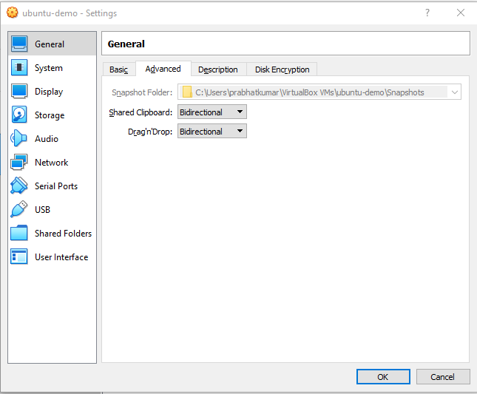
3) Under storage section select Empty and choose Downloaded ubuntu 20.04 image.
4) Under Network section select Bridge Adapter under attached to drop down.
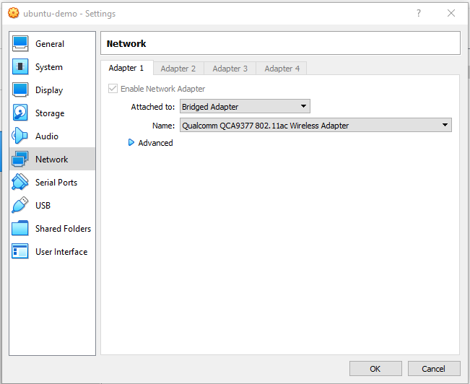
5) Now Start our VM and select iso image from drop down. And follow installation steps.
6) Once installed ubuntu VM, We need to SSH our VM from local machine. For that we need to install openssh-server on our VM.
$ sudo apt update -y && sudo apt upgrade -y && sudo apt install openssh-server -y && sudo systemctl reboot
$ sudo apt install net-tools
$ ifconfig
This will give you Our VM IP address.
7) Now ssh to ubuntu VM from local machine.
$ ssh ubuntu@192.168.1.118
Enter password for ubuntu VM.

2.2) Install Single node Kubernetes Cluster( Version 1.19.2 ) on VM:
1) Now install Docker on our Ubuntu Virtual Machine.
sudo apt install curl
curl -fsSL https://download.docker.com/linux/ubuntu/gpg | sudo apt-key add -
sudo add-apt-repository "deb [arch=amd64] https://download.docker.com/linux/ubuntu $(lsb_release -cs) stable"
sudo apt update && sudo apt install docker-ce
2) Host file entry for Virtual Machine
sudo hostnamectl set-hostname k8cluster
sudo vi /etc/hosts
# Host file entry for VM ip
192.168.1.118 k8cluster
3) Swap Off. (This will have to do every time when we restart our VM along with kubelet restart)
$ sudo swapoff -a
$ sudo sed -i '/ swap / s/^\(.*\)$/#\1/g' /etc/fstab
4) Install single node Kubernetes cluster.
$ sudo apt-get update && sudo apt-get install -y apt-transport-https && curl -s https://packages.cloud.google.com/apt/doc/apt-key.gpg | sudo apt-key add -
$ echo "deb http://apt.kubernetes.io/ kubernetes-xenial main" | sudo tee -a /etc/apt/sources.list.d/kubernetes.list && sudo apt-get update
$ sudo apt install -y kubeadm kubelet kubernetes-cni
$ sudo kubeadm init --pod-network-cidr=10.244.0.0/16 --apiserver-advertise-address=192.168.1.118 //This is your VM IP address
/* This will be printed at the end of execution, will required to add nodes to master.
kubeadm join 192.168.1.118:6443 --token 0nuv3h.y3i8e09bkm98pscn \
--discovery-token-ca-cert-hash sha256:1330af123e5538ddec573fa3f08b4c2c1dc912b55b2dac12d93312f091073e5e
*/
5) To make “kubectl” work for your non-root user, run the following commands.
$ mkdir $HOME/.k8s
$ sudo cp /etc/kubernetes/admin.conf $HOME/.k8s/
$ sudo chown $(id -u):$(id -g) $HOME/.k8s/admin.conf
$ export KUBECONFIG=$HOME/.k8s/admin.conf
$ echo "export KUBECONFIG=$HOME/.k8s/admin.conf" | tee -a ~/.bashrc
6) Apply flannel as we need to install a networking model for Kubernetes.
$ kubectl apply -f https://raw.githubusercontent.com/coreos/flannel/master/Documentation/kube-flannel.yml
$ kubectl apply -f https://raw.githubusercontent.com/coreos/flannel/master/Documentation/k8s-manifests/kube-flannel-rbac.yml
$ kubectl taint nodes --all node-role.kubernetes.io/master-
7) Now we can check version using below commands.
$ kubectl version --client && kubeadm version
$ kubectl config get-contexts
$ kubectl config use-context < context name >
After running all the above steps “kubeadm version” command should display output as shown in the below screen shot.
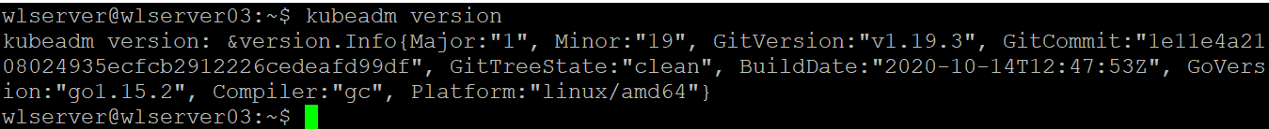

2.3) Install Helm Chart ( Version 3.3.1 ) on Kubernetes Cluster:
$ cd /tmp
$ curl -fsSL -o get_helm.sh https://raw.githubusercontent.com/helm/helm/master/scripts/get-helm-3
$ chmod u+x get_helm.sh
$ ./get_helm.sh
$ helm repo add stable https://charts.helm.sh/stable
After running all the above steps “helm version” command should display output as shown in the below screen shot.

2.4) Install git:
$ sudo apt-get install git

2.5) clone the magma git repository:
$ git clone https://github.com/magma/magma.git

3) Running the 5G core Orchestrator deployment python script:

From the git clone directory go to the scripts directory with the below command.
$ cd magma/cn/deploy/scripts/

Below is the help/usage of the script how we can install and un-install monitoring stack.
$ chmod 777 MVC1_5G_Orc8r_deployment_script.py
$ ./MVC1_5G_Orc8r_deployment_script.py -h
(OR)
$ ./MVC1_5G_Orc8r_deployment_script.py --help
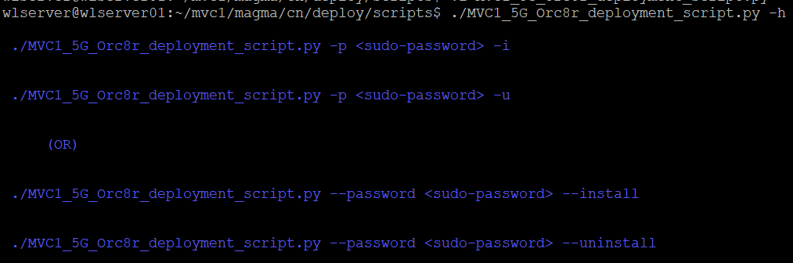
To install monitoring stack we need to run the script with either -i (or) --install option
$ ./MVC1_5G_Orc8r_deployment_script.py -p <sudo-password> -i
(OR)
$ ./MVC1_5G_Orc8r_deployment_script.py -p <sudo-password> --install
Once we run the script with any one of the above two commands, we could see checking for all the prerequisites like kubeadm, helm,...etc If prerequisites are already installed script will continue to install monitoring stack, else it will exit, then you need to install all the prerequisites manually, which can be installed by following the steps mentioned in the section 2) PREREQUISITES.
Below is the screen shot where prerequisites was already installed.

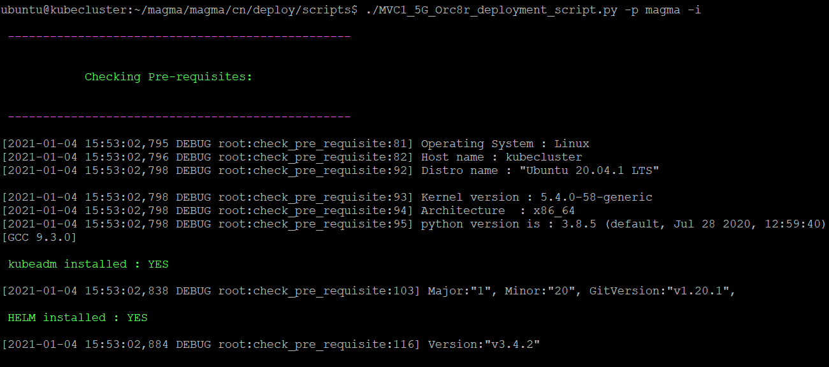

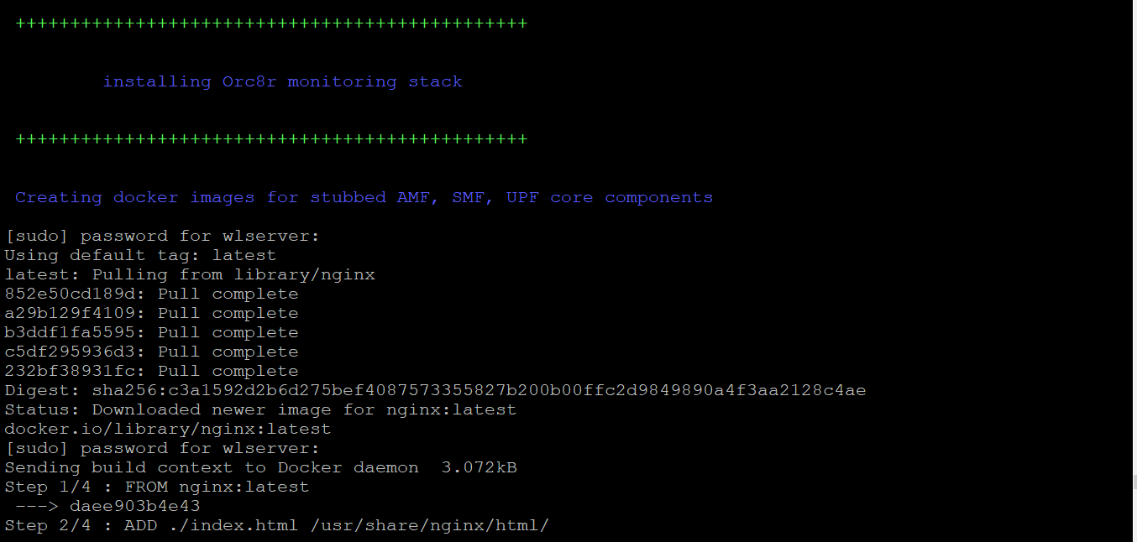

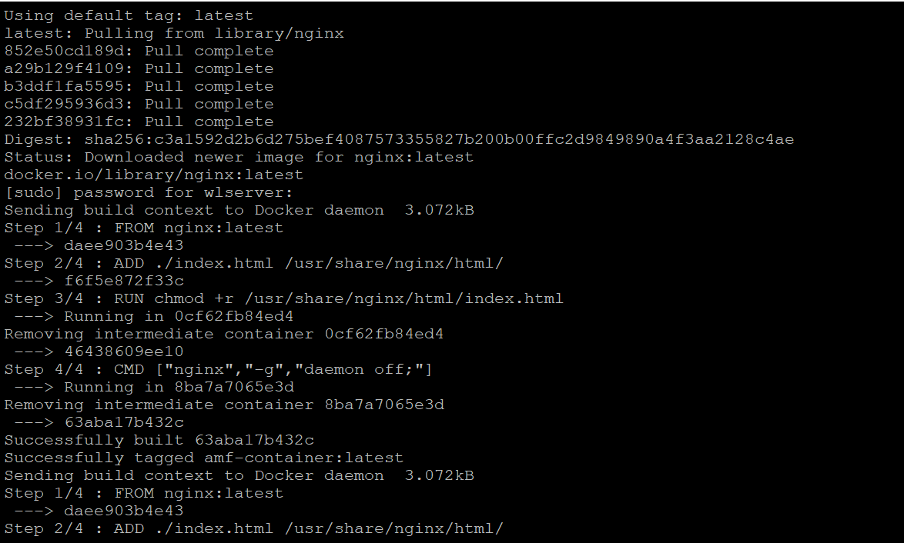

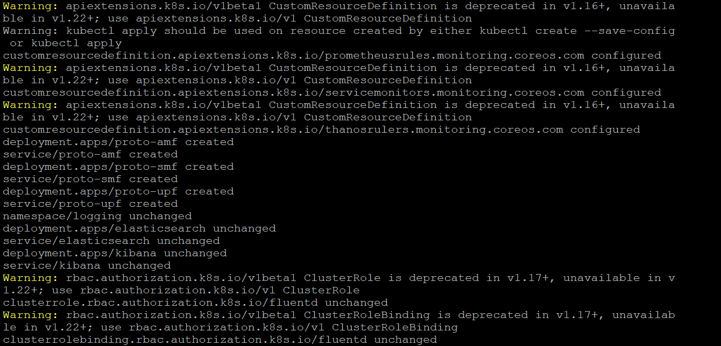

Then after few seconds you could see below message
One yaml file would be open and waiting for you to modify the “type” attribute value from “ClusterIP” to “NodePort” which will be almost at the end of the file. Once you edit the yaml file you need to save it using “:wq” option. This procedure we have to do for three k8s services which are listed below.
i) service/prometheus-monitoring-kube-prometheus
ii) service/prometheus-monitoring-grafana
iii) service/prometheus-monitoring-kube-alertmanager
Note: As kubectl edit will open the yaml files dynamically in the temp filesystem with random file names we cannot predict the file names, so we have to edit these yaml files interactively as suggested in the above text. Below is the example screen shot for temporary file “/tmp/kubectl-edit-5bf0d.yaml”

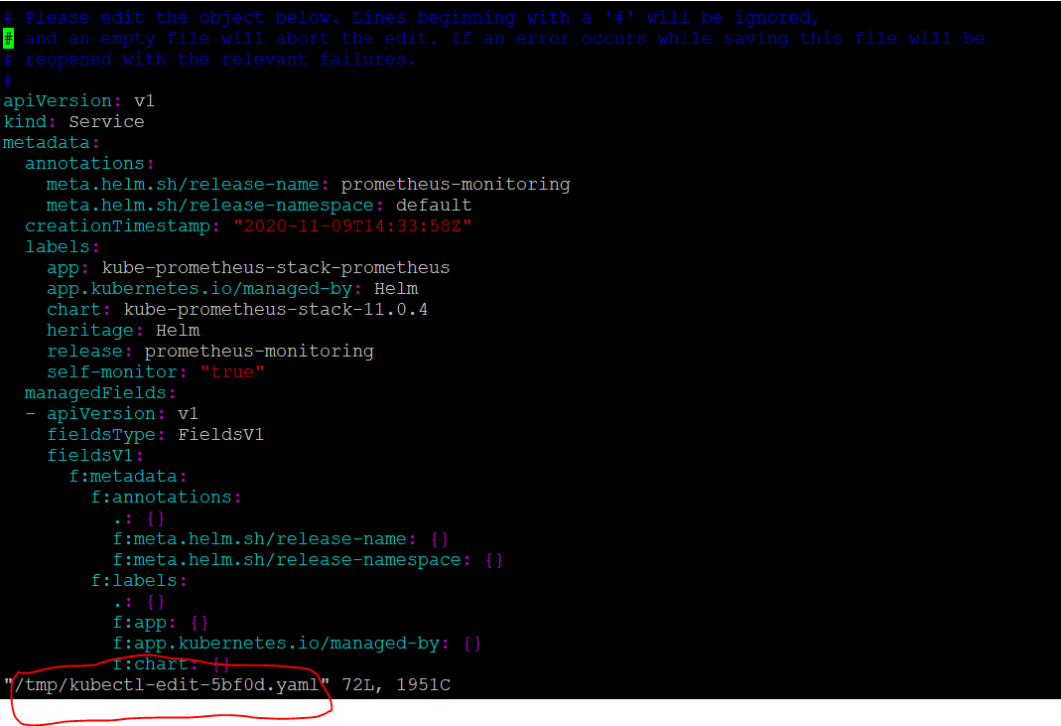
You can directly go to the end of the file by entering “:$” and then press enter command, below is the screen shot for this step
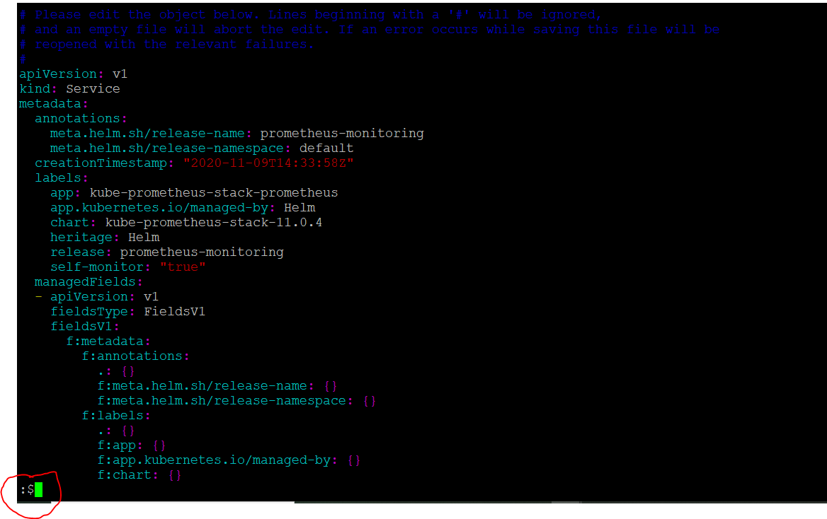
Now you can see the “type” attribute value set to “ClusterIP” as shown in the below screen shot
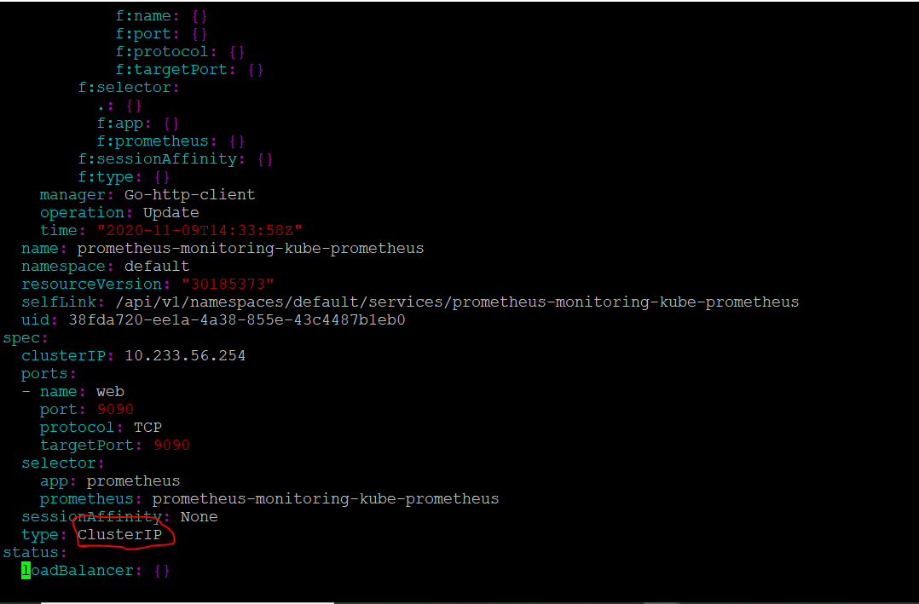
Now you can change the “type” attribute value from “ClusterIP” to “NodePort” and then save it using “:wq” as shown in below screen shot
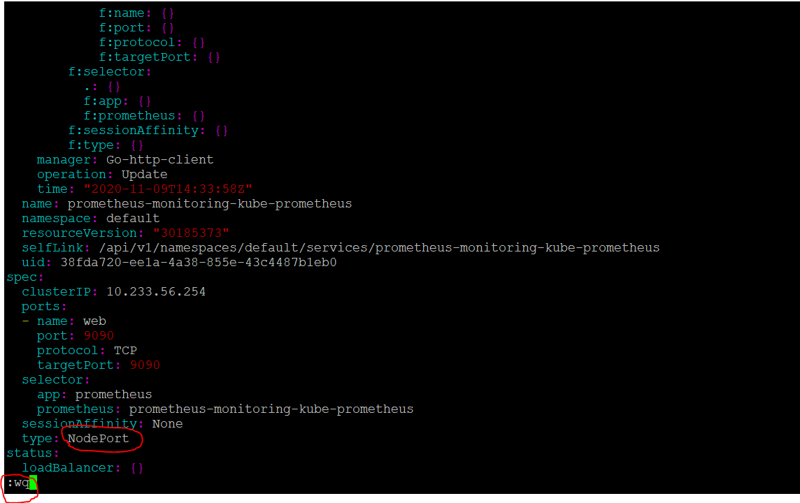
Now you could see the yaml file edited for the service “service/prometheus-monitoring-kube-prometheus “ and it will prompt for another yaml file
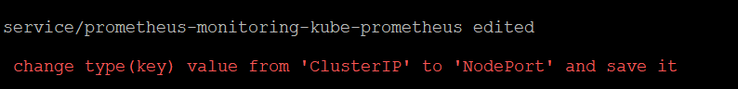
Now you could see second yaml file with random name for example “/tmp/kubectl-edit-rce78.yaml” as shown in the below screen shot
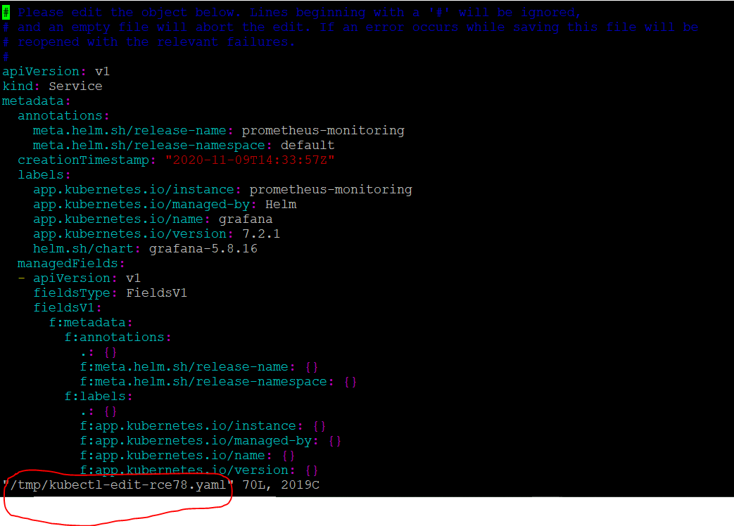
Now You can directly go to the end of the file by entering “:$” and then press enter command, below is the screen shot for this step
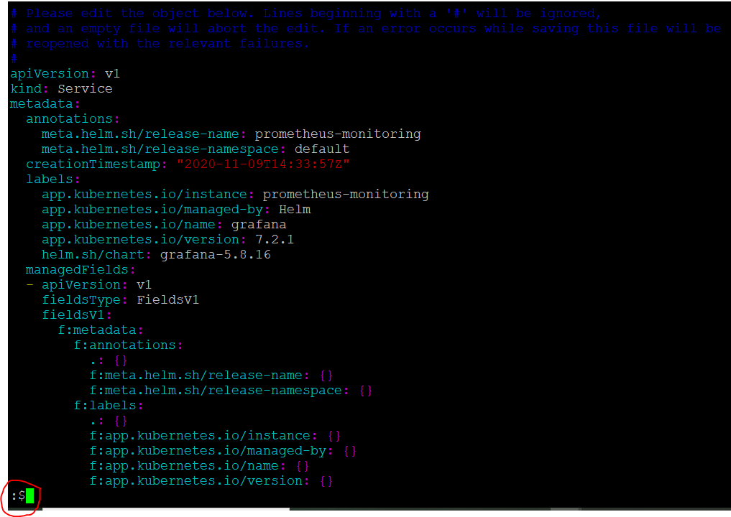
Now you can see the “type” attribute value set to “ClusterIP” as shown in the below screen shot

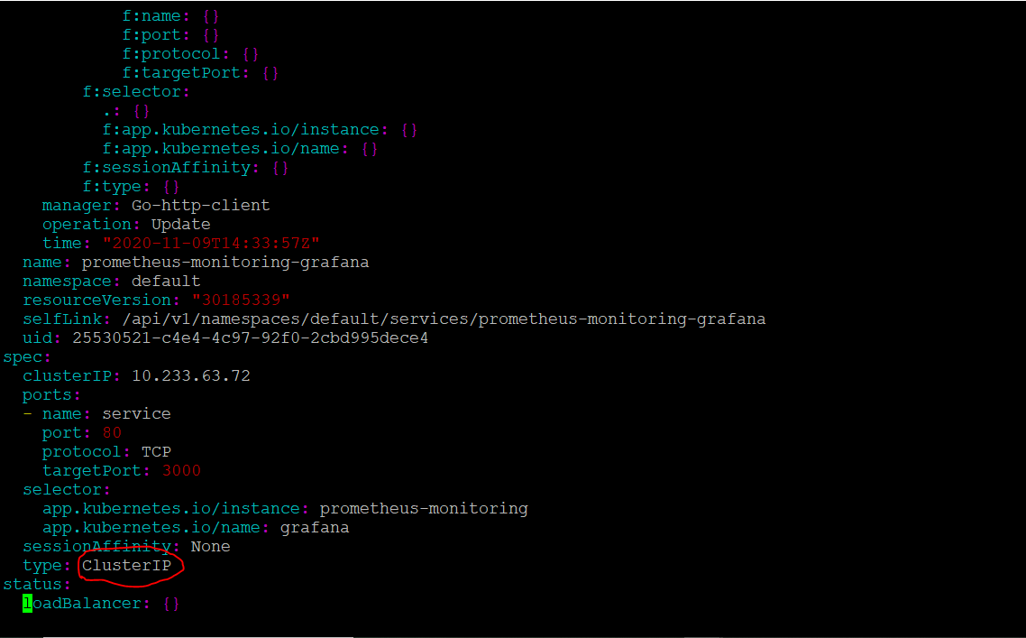
Now you can change the “type” attribute value from “ClusterIP” to “NodePort” and then save it using “:wq” as shown in below screen shot
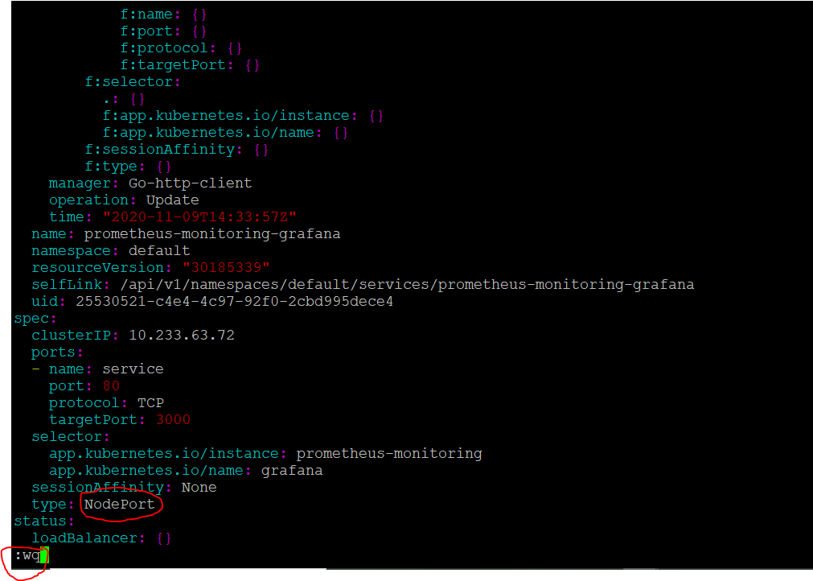
Now you could see the yaml file edited for the service “service/prometheus-monitoring-grafana“ and it will prompt for another yaml file

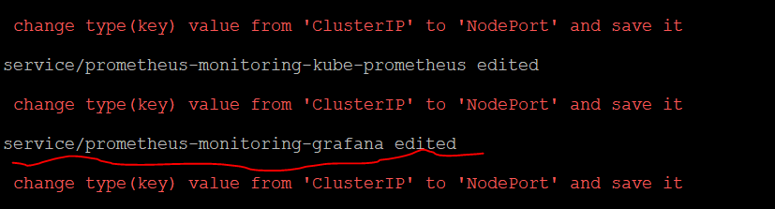
Now you could see third yaml file with random name for example “/tmp/kubectl-edit-bhr1g.yaml” as shown in the below screen shot

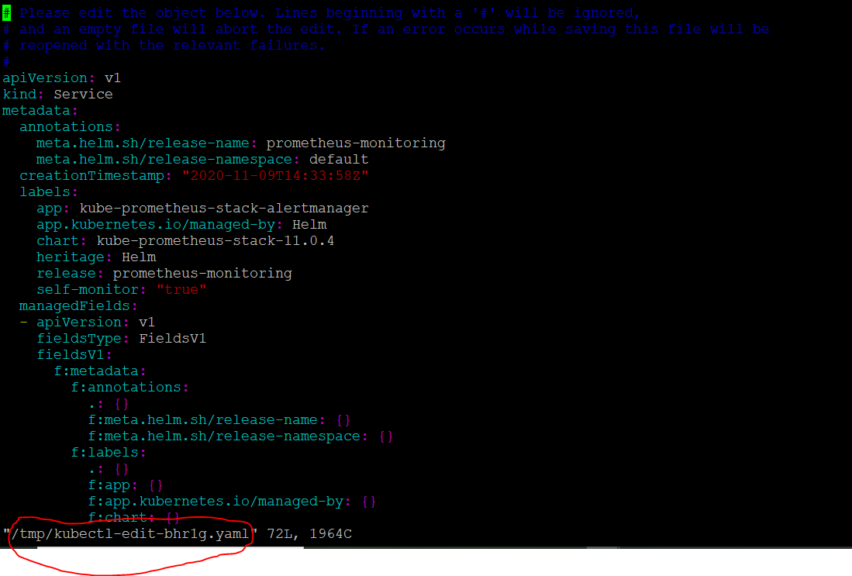
You can directly go to the end of the file by entering “:$” and then press enter command, below is the screen shot for this step

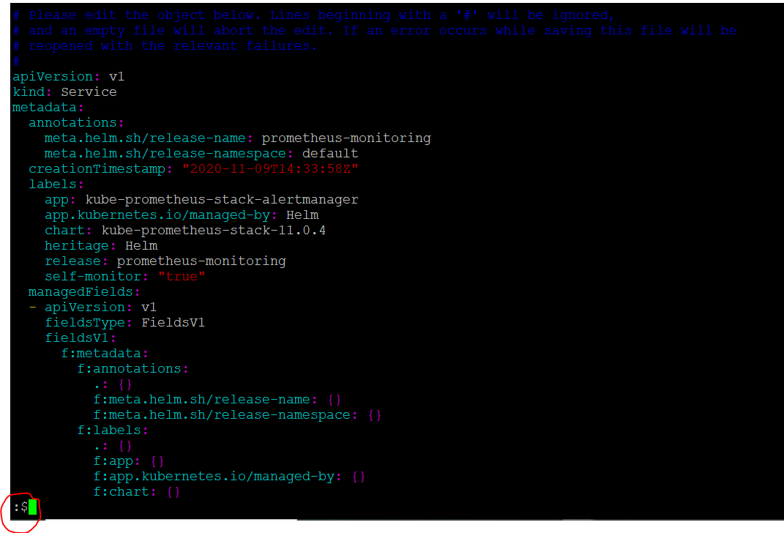
Now you can see the “type” attribute value set to “ClusterIP” as shown in the below screen shot

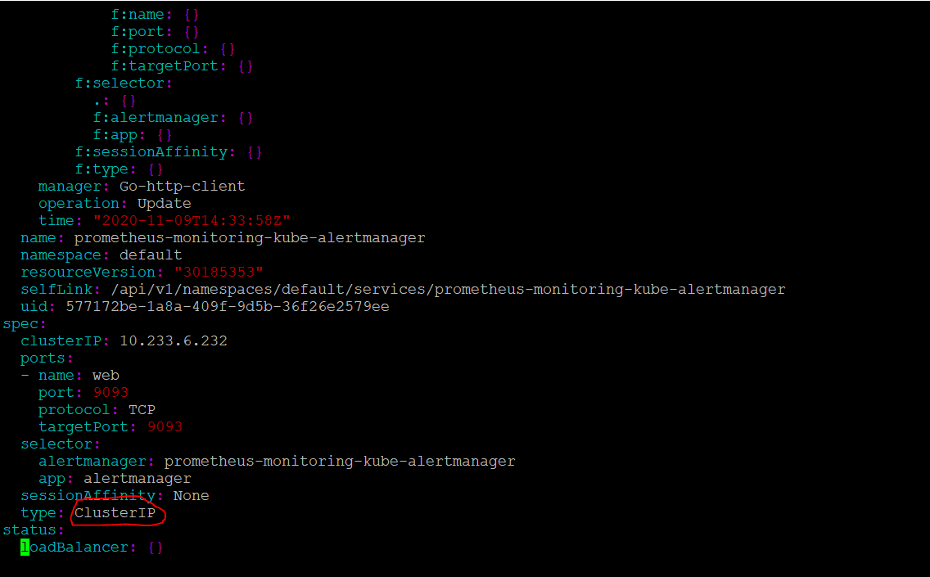
Now you can change the “type” attribute value from “ClusterIP” to “NodePort” and then save it using “:wq” as shown in below screen shot
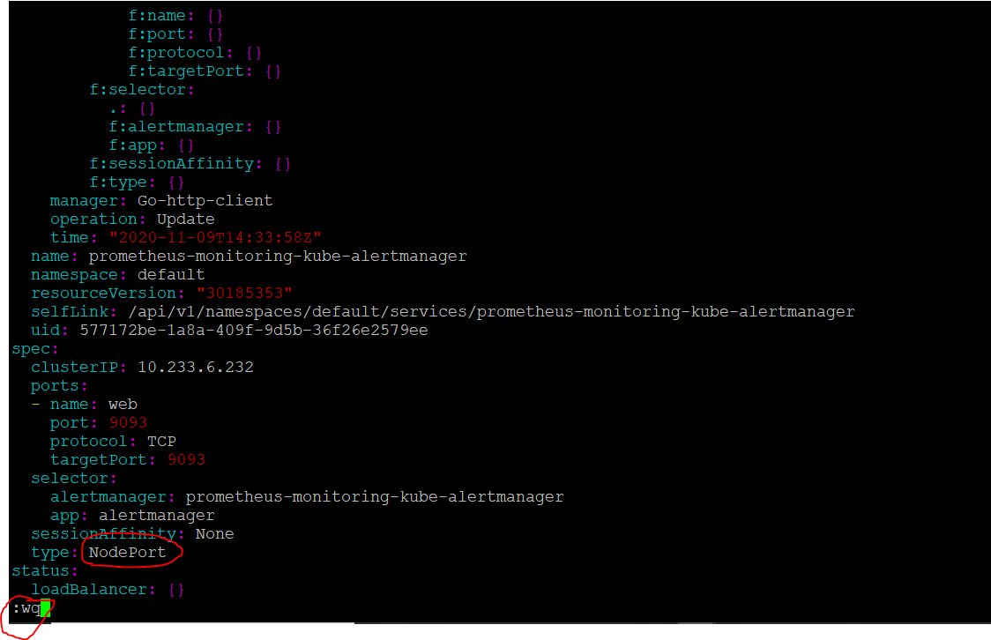
Now you could see the yaml file edited for the service “service/prometheus-monitoring-kube-alertmanager “

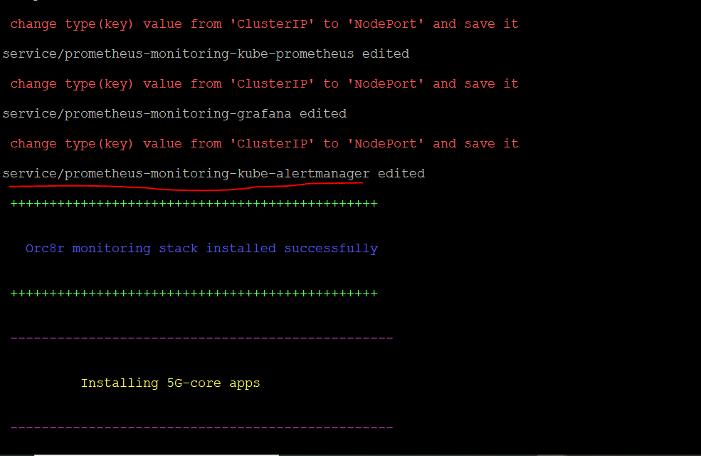
At the end we can see the URL for all 5G core components
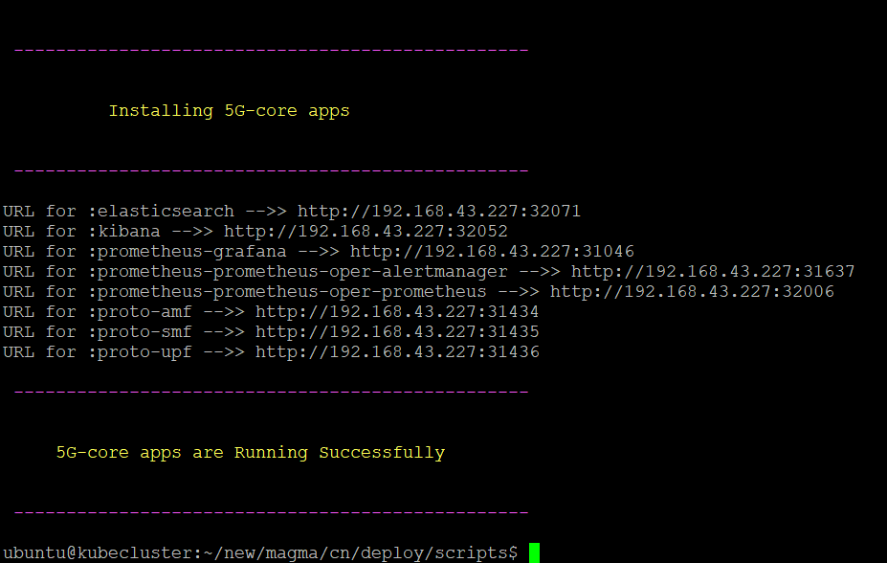
We can check the services which are running using below command:
kubectl get service
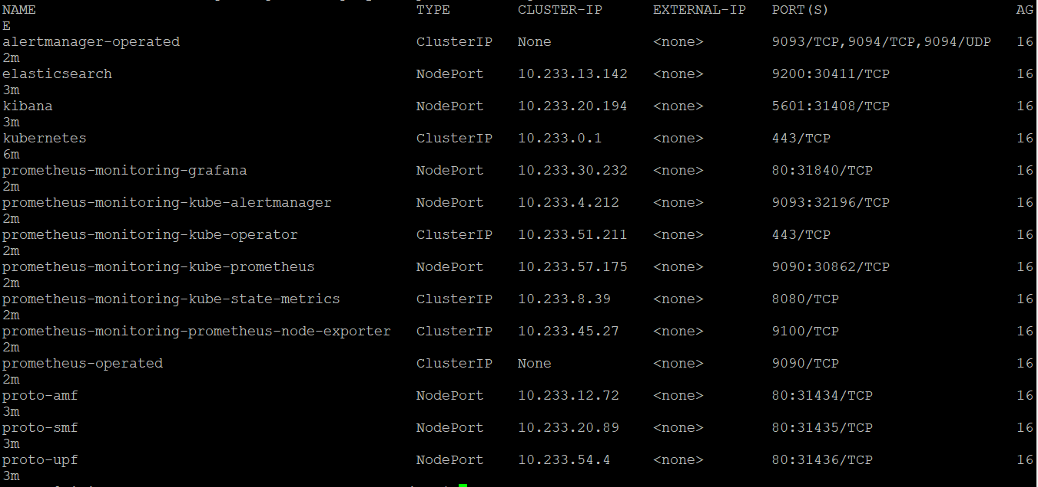
We can check the pods which are running using below command:
Kubectl get pods
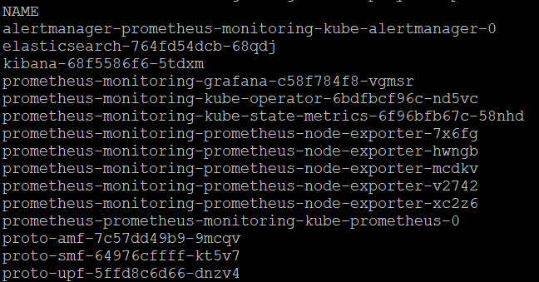
You can type below command to see all k8s objects and its status:
Kubectl get all
Accesing Dash boards:
you can open the Grafana dash board with username: admin and password : prom-operator as shown in below screen shot
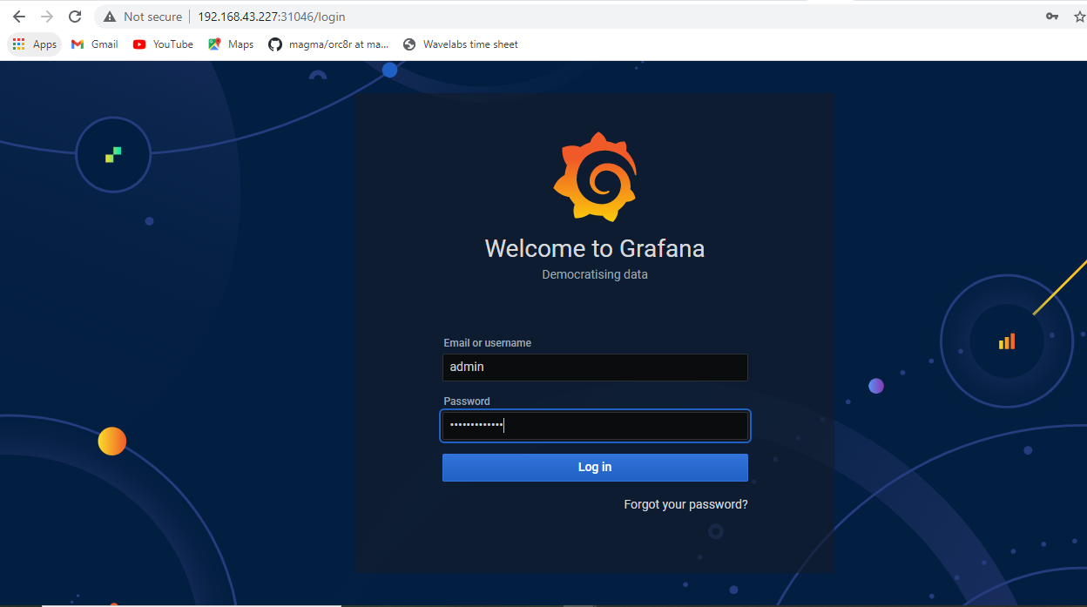

Then chose Dashboards and then click on manage as shown in below screen shot.
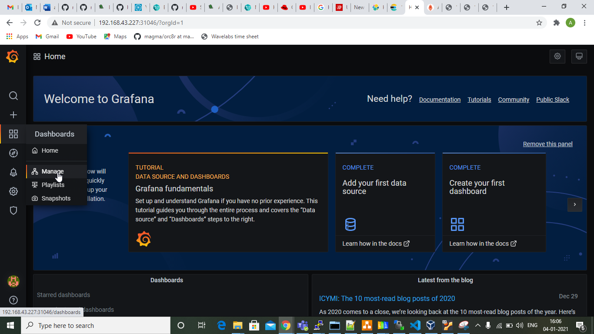

Then click on “import” button as highlighted in below screen shot:
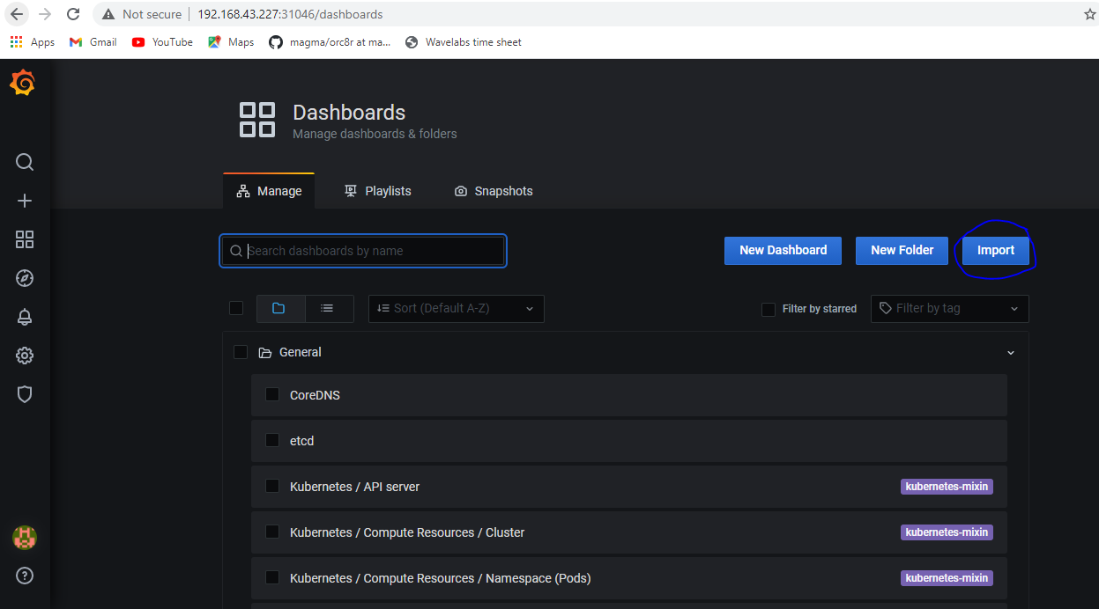
Then enter “11663” in the text box and then click on “load” button as shown in the below screen shot.
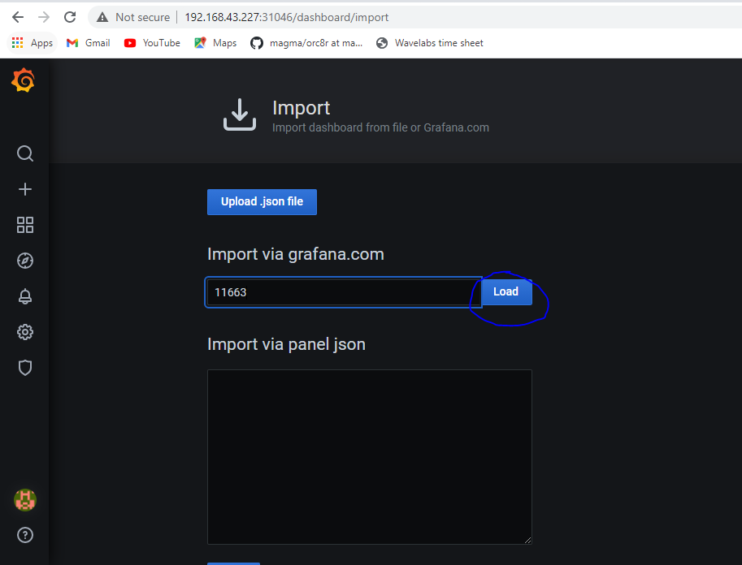

Then chose “Prometheus” from the drop down and then click on “Import” button as shown in the below screen shot.

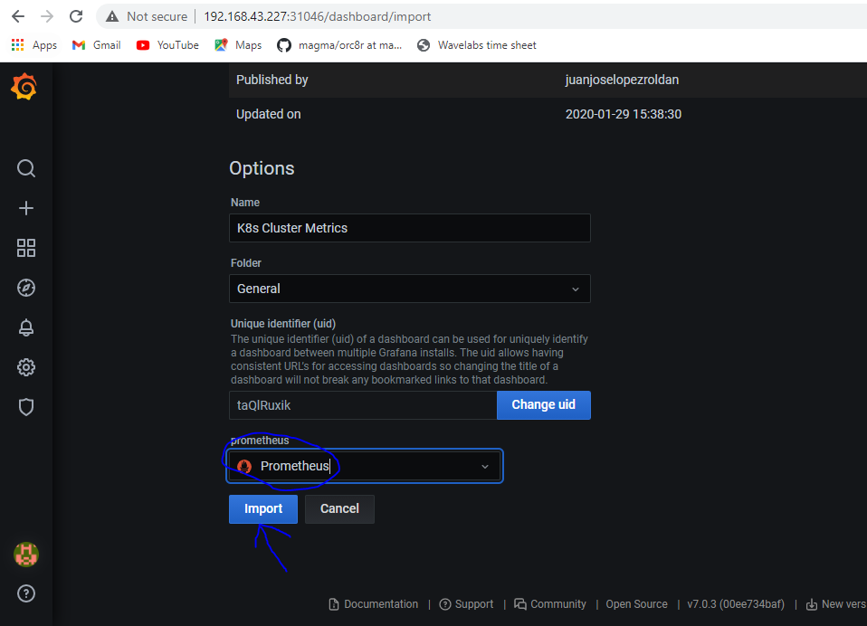
Then check each & every dash boards , few are as shown below:
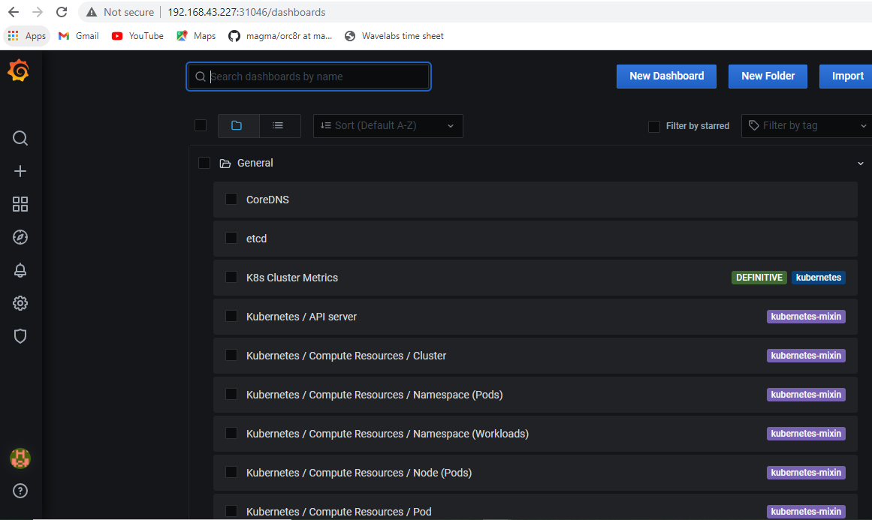

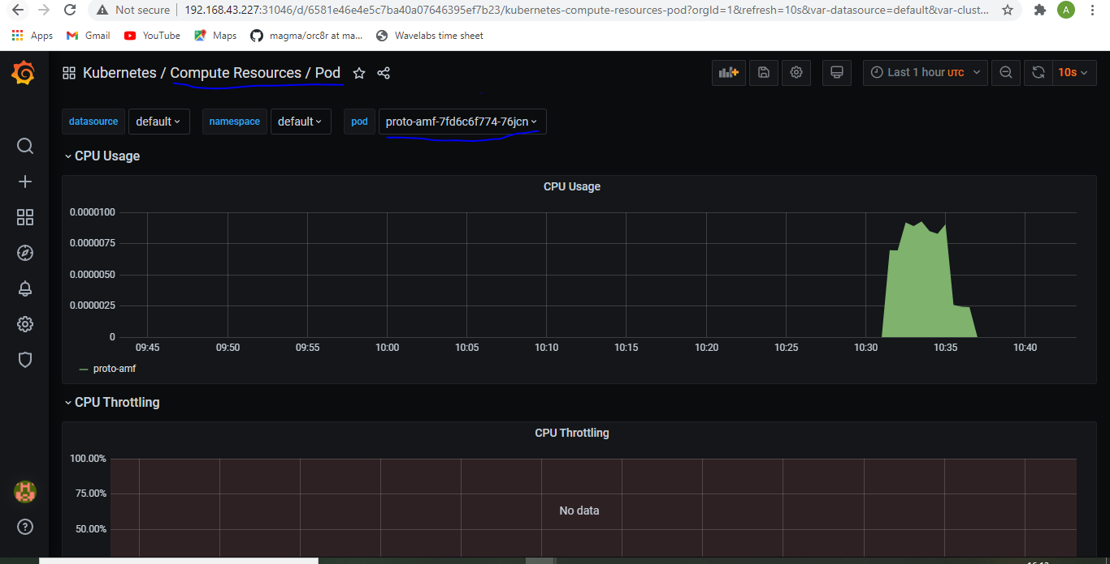

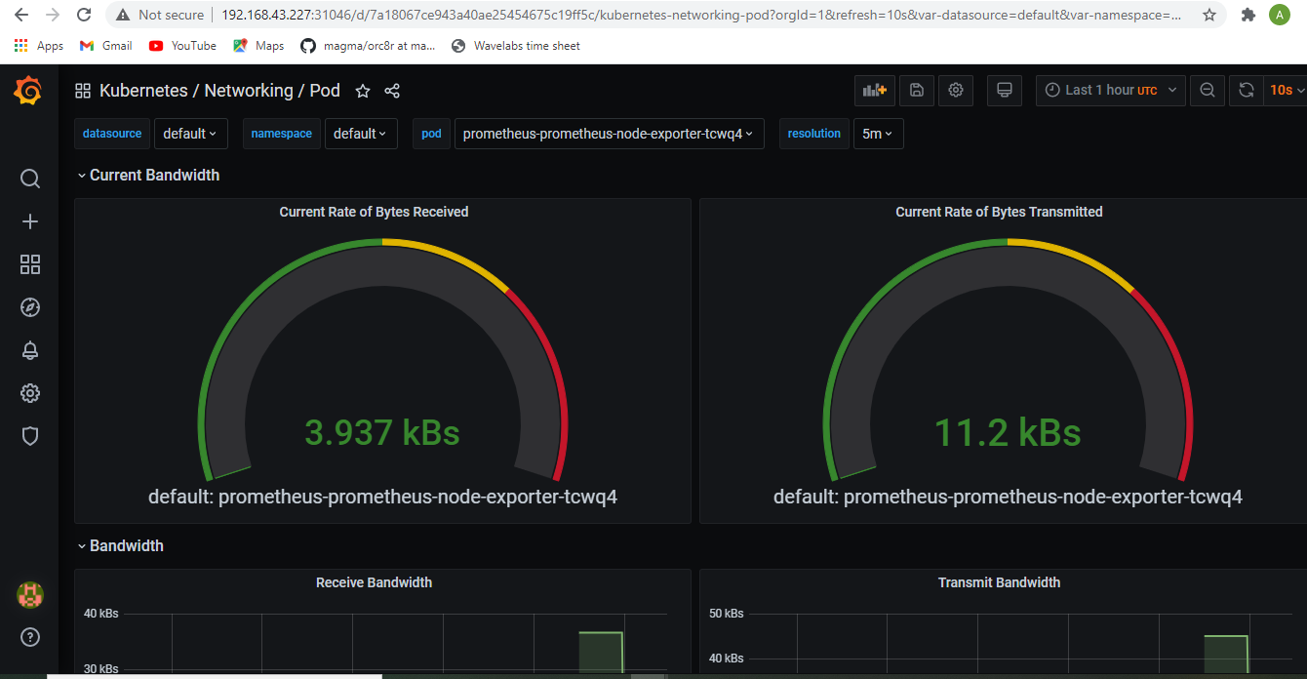

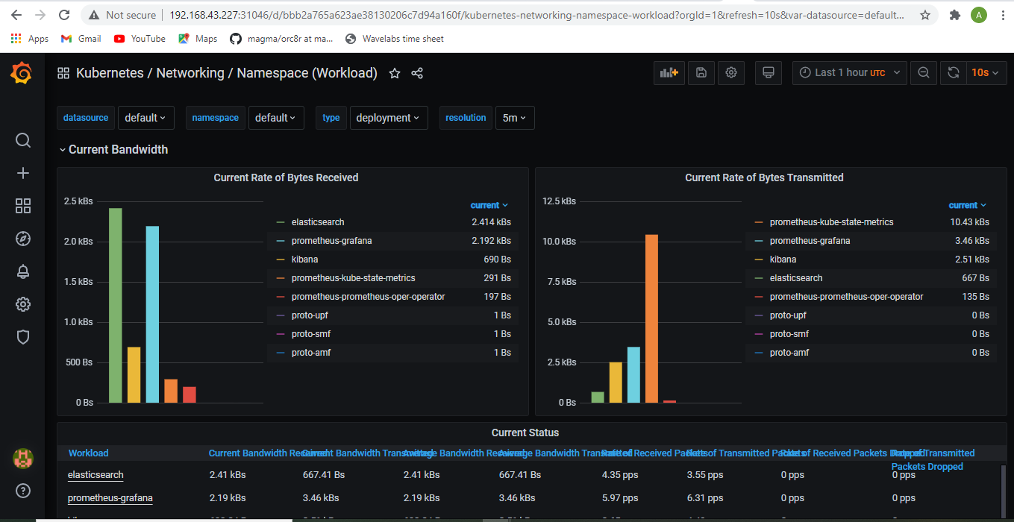
Below is the alert-manger dashboard having some alerts:
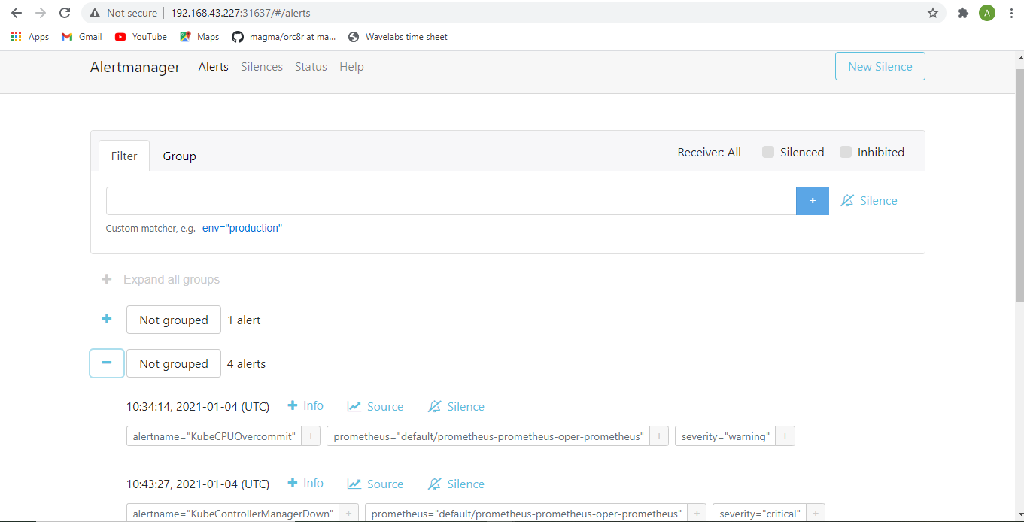

Below is the dashboard for AMF container:
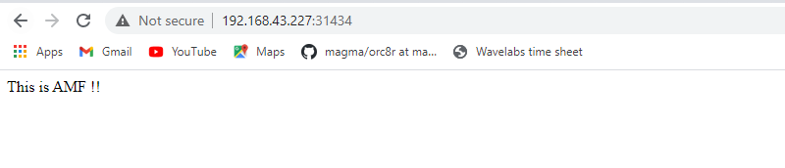

Below is the dashboard for SMF container:
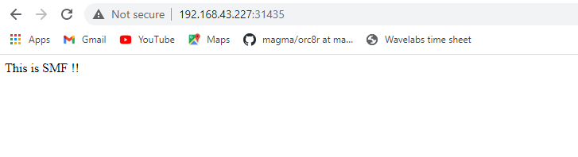

Below is the dashboard for UPF container:

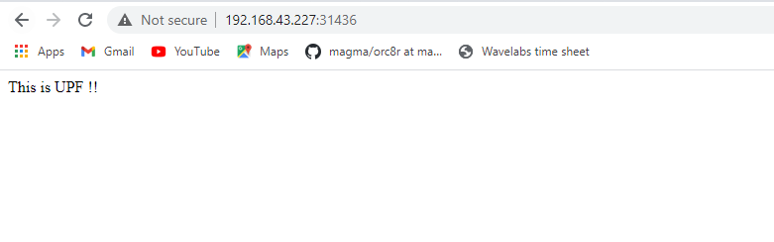

Below is the dashboard for elasticsearch:
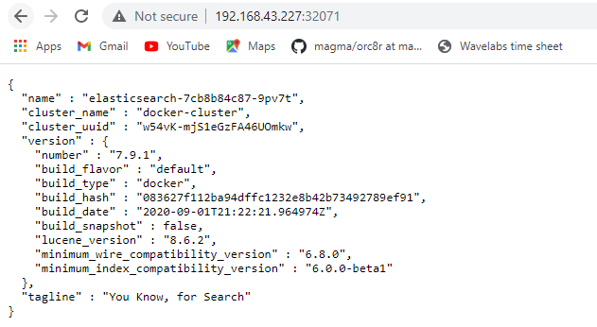

Below is the dashboard for Kibana:
click on “Eplore my own” button as shown below:
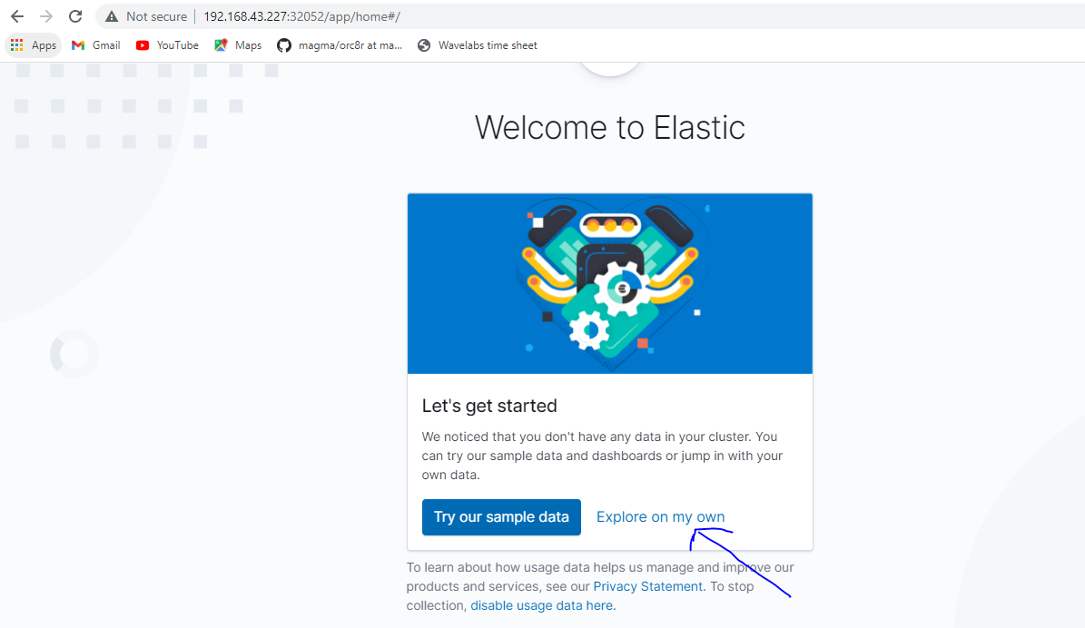
Then on Left hand side chose “Management” section and then click on “Stack Management” button as shown in below screen shot:

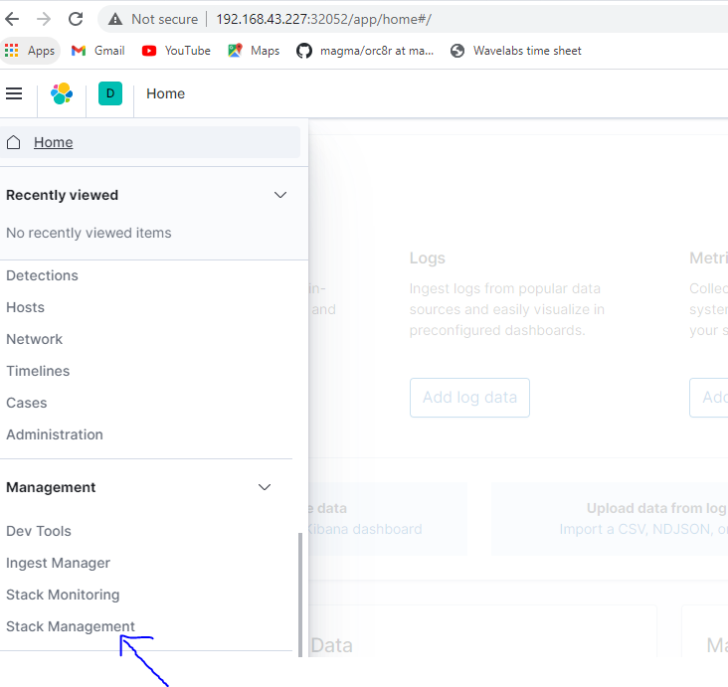

Then again on Left had side chose “Kibana” section and click on “Index Patterns” button as shown below:
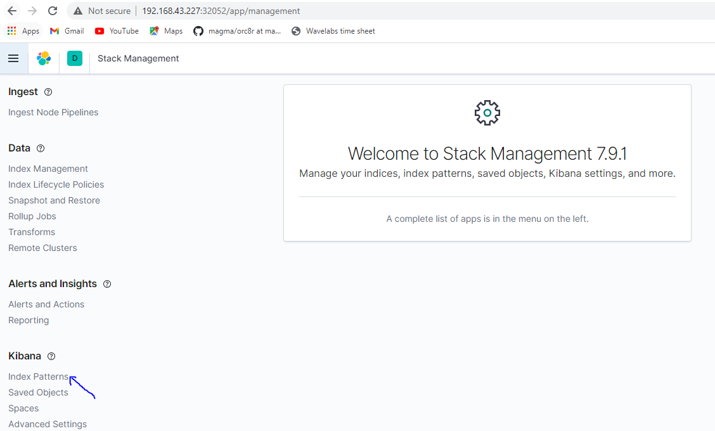

Then right hand side click on “Create index pattern” button as shown in the below screen shot:
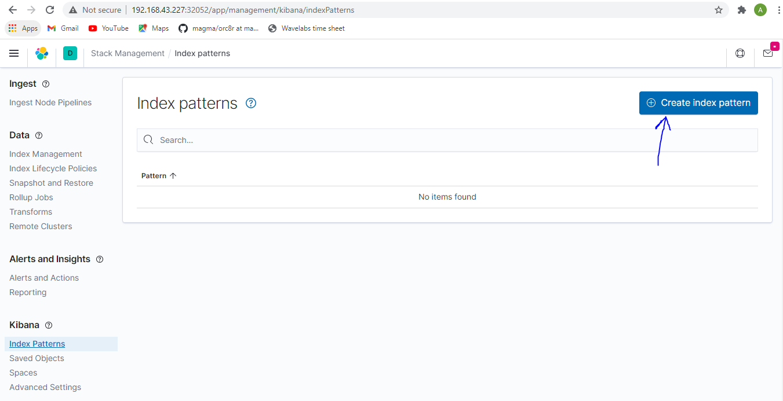

Then enter “logstash*” in the text box and then click on “Next step” button as shown in the below screen shot:
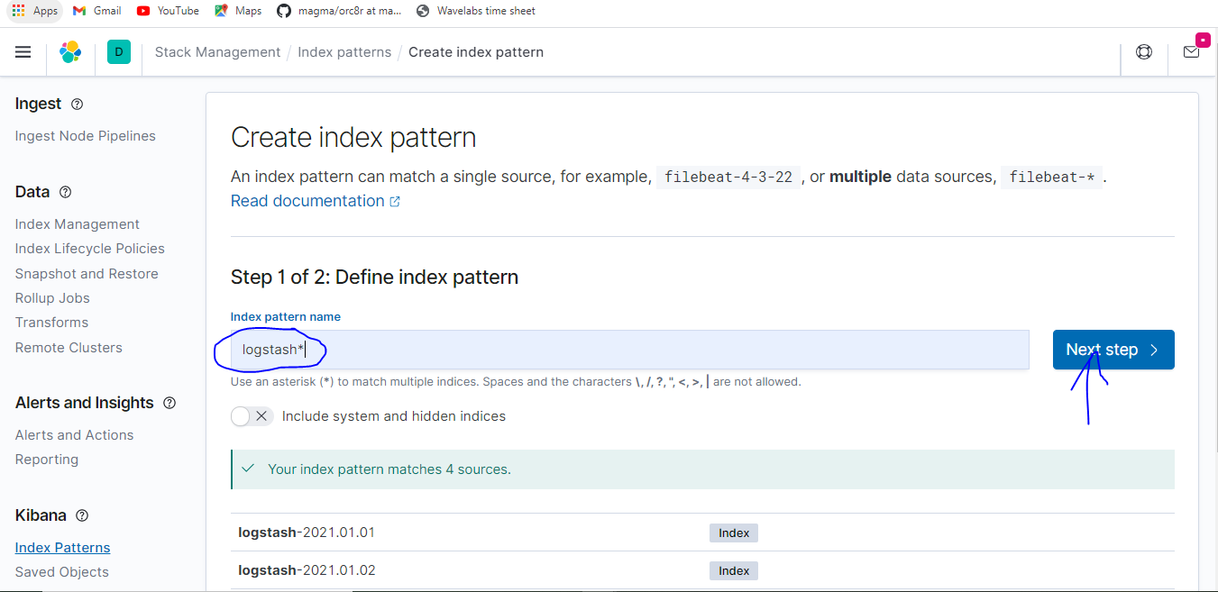

Then chose the “@timestamp” from the drop down and then click on “Create index pattern” button as shown in the below screen shot.
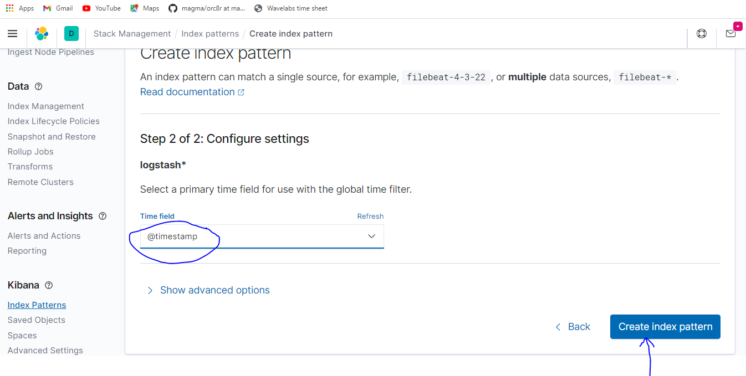
Now on left hand side chose “kibana” and then click on “Discover” option as shown in the below screen shot.

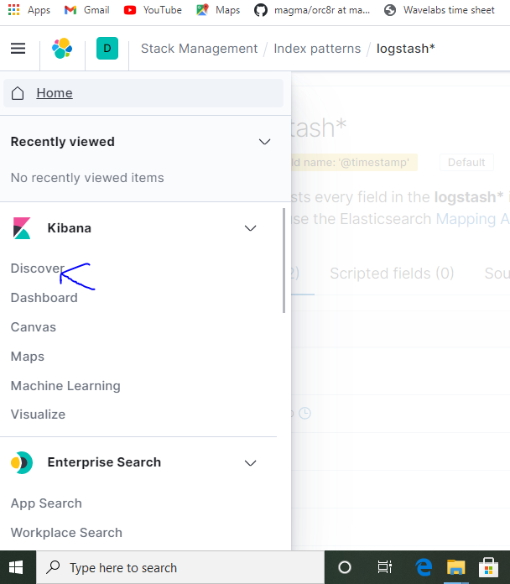

Then you will see the logs as shown below:
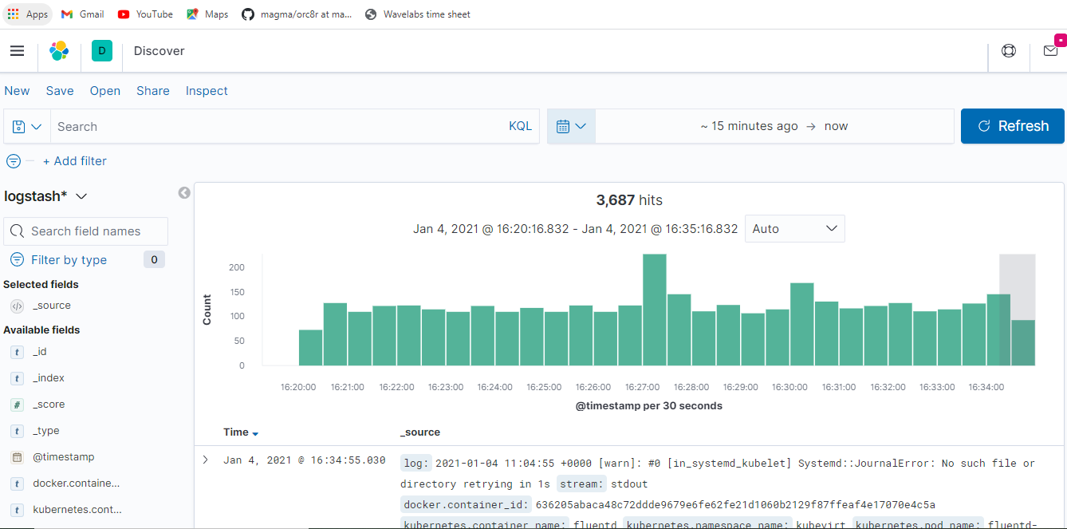

Un-install monitoring stack and k8s objects:
We can un-install all the monitoring stack and 5G core apps created by deployment python script 5G_Orc8r_deployment_script.py by using either “-u” or “--uninstall” option as listed below:
./MVC1_5G_Orc8r_deployment_script.py -p <sudo-password> -u
(OR)
./MVC1_5G_Orc8r_deployment_script.py -p <sudo-password> --uninstall
Once we run any one of the above command, we could see below information on the screen console
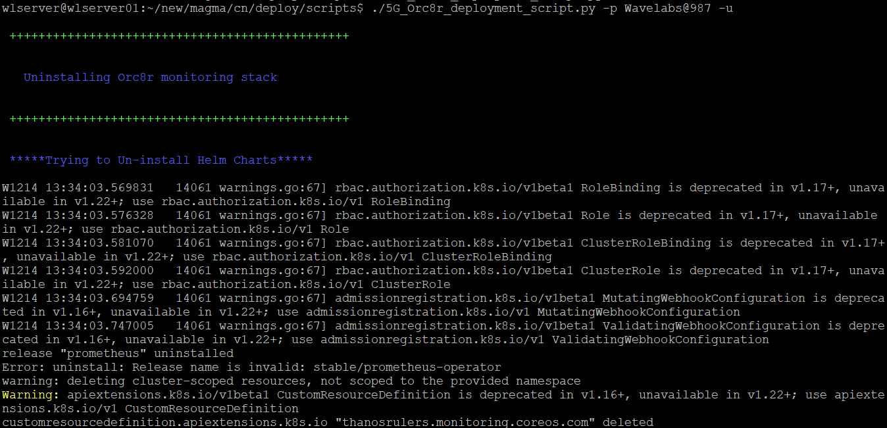
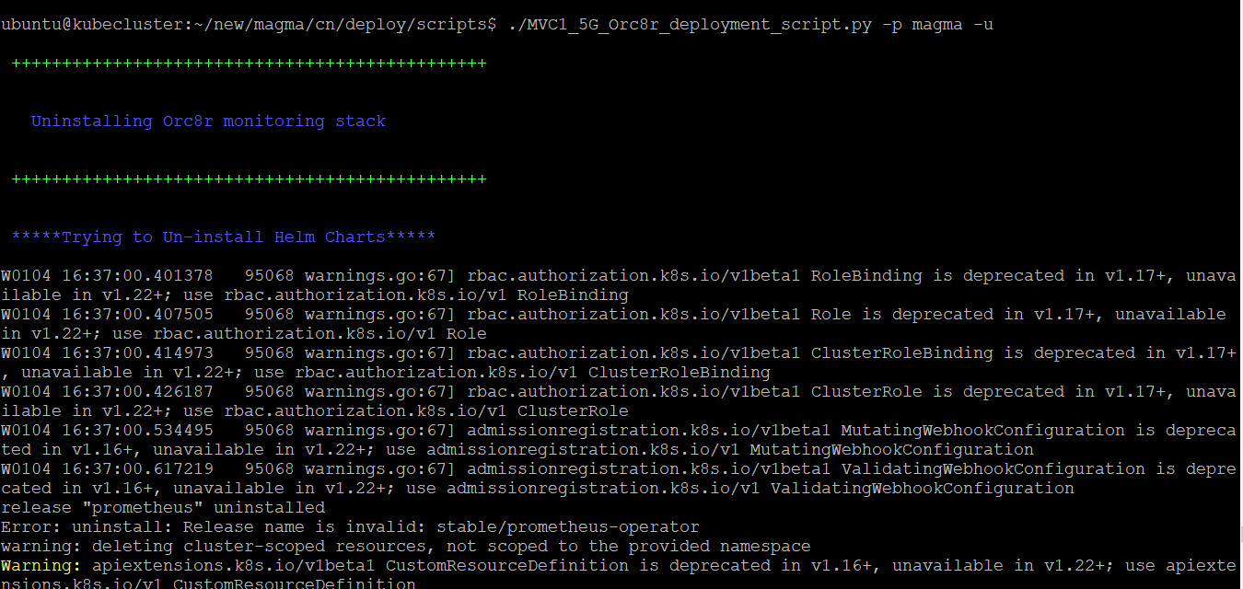

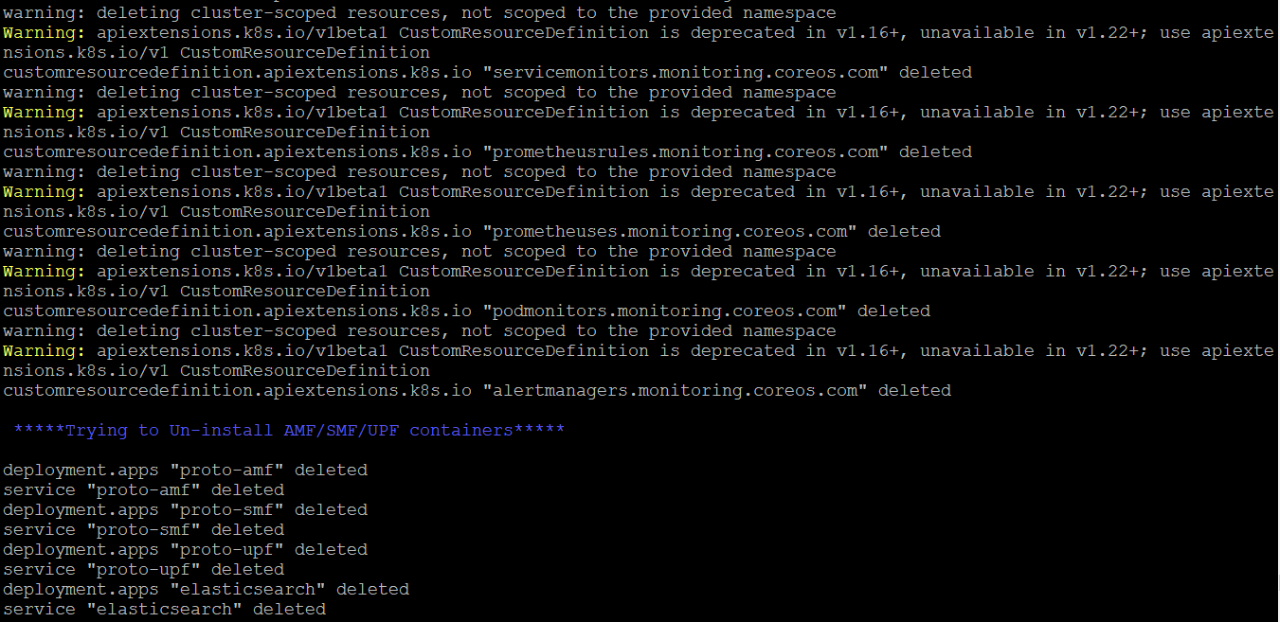

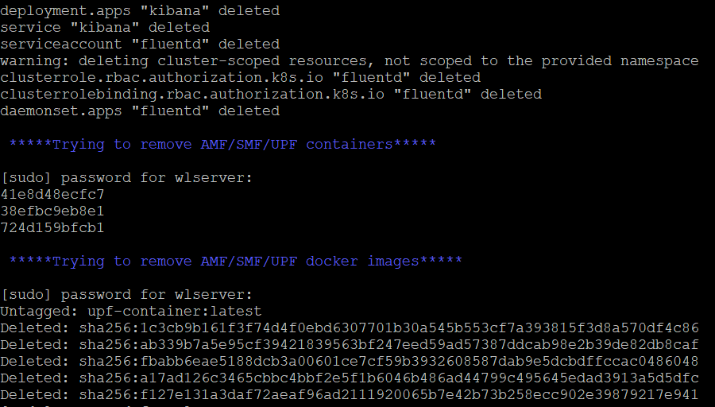

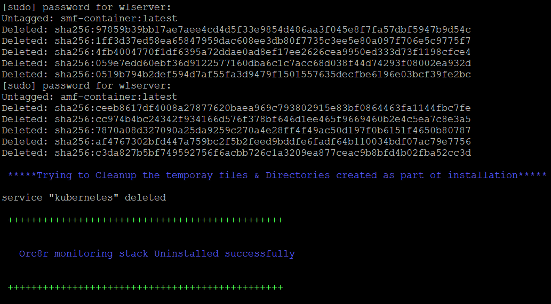

Once Un-installation completes we can check whether all the k8s objects got deleted or not with the below command
Kubectl get all
You could see monitoring stack related k8s objects are no longer and deleted, below is the screen shot after un-installing the monitoring stack

