Solutions to extra credit problems in lab 4.
4.

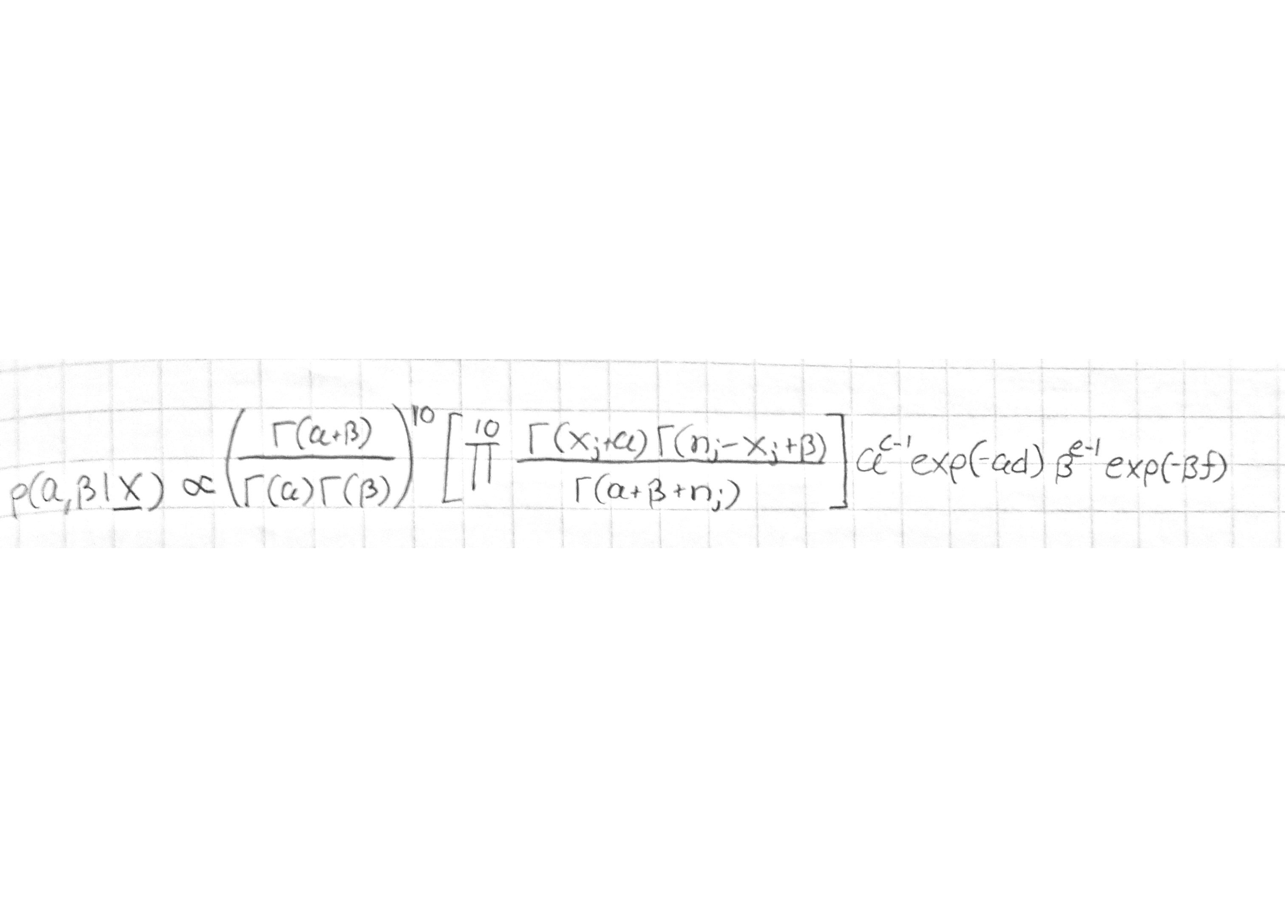
In the R-code, I re-used (+modified) the same code that was given in bikes.R (I guess this was ok). However I encountered some problems, which were due to the updated proposal distribution and undefined logarithm values (log(<0)). I’m not sure that was it even purpose to use bikes.R with slight modifications, so my code might be wrong from the beginning. Anyway, I didn’t have time to fix it. The only changes I made were to update the ab.lprior, aprime and bprime-functions.
5.
a)
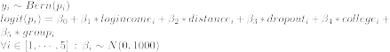
b)
Due to the output of the Gibbs sampler, especially the factors , and are relatively small (in terms of mean and quantiles). Therefore the corresponding explanatory variables (income, distance, group) might not be very informative in this model.
1. Empirical mean and standard deviation for each variable,
plus standard error of the mean:

Mean SD Naive SE Time-series SE
b0 -1.835201 1.02483 0.0187107 0.0505936
b1 0.339143 0.14434 0.0026352 0.0064973
b2 -0.139797 0.08273 0.0015104 0.0018760
b3 -0.696892 0.45036 0.0082225 0.0085419
b4 1.735697 0.70319 0.0128385 0.0133433
b5 -0.002299 0.01181 0.0002157 0.0002477

2. Quantiles for each variable:

2.5% 25% 50% 75% 97.5%
b0 -3.79408 -2.53117 -1.826000 -1.129390 0.18370
b1 0.05770 0.24109 0.339154 0.434290 0.61478
b2 -0.31125 -0.19472 -0.136056 -0.082585 0.01596
b3 -1.57676 -1.01448 -0.692069 -0.385753 0.15906
b4 0.42150 1.26107 1.699027 2.193413 3.18430
b5 -0.02643 -0.01013 -0.002183 0.005716 0.02033

6.
