Bayesian Analysis II, Fall 2020
Lab Exercise 5:
1.
R-code in H5T1.R
a)
Iterations = 10:10000
Thinning interval = 10
Number of chains = 3
Sample size per chain = 1000

1. Empirical mean and standard deviation for each variable,
plus standard error of the mean:

Mean SD Naive SE Time-series SE
b0 3.798e+01 8.546e+00 1.560e-01 1.651e-01
b1 5.403e-02 2.993e-01 5.465e-03 5.738e-03
tau 1.205e+03 5.924e+02 1.082e+01 1.082e+01
tauinv 8.452e-04 7.613e-05 1.390e-06 1.389e-06

2. Quantiles for each variable:

2.5% 25% 50% 75% 97.5%
b0 2.982e+01 3.527e+01 3.805e+01 4.103e+01 4.686e+01
b1 -2.819e-01 -6.811e-02 4.815e-02 1.637e-01 3.728e-01
tau 1.006e+03 1.116e+03 1.187e+03 1.255e+03 1.411e+03
tauinv 7.088e-04 7.971e-04 8.428e-04 8.957e-04 9.936e-04

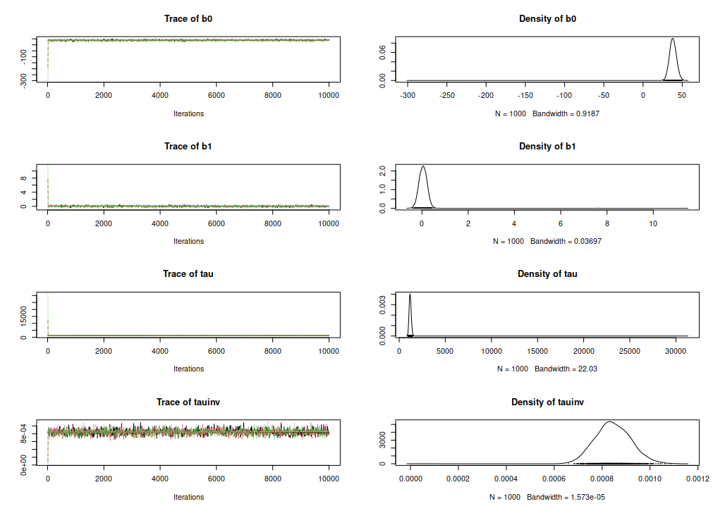
b)

2.
R-code in H5T2.R
a)
Iterations = 2010:12000
Thinning interval = 10
Number of chains = 3
Sample size per chain = 1000

1. Empirical mean and standard deviation for each variable,
plus standard error of the mean:

Mean SD Naive SE Time-series SE
b1 10.999 4.69961 0.085803 0.408146
b2 -0.174 0.06906 0.001261 0.006008

2. Quantiles for each variable:

2.5% 25% 50% 75% 97.5%
b1 2.1419 7.6017 10.9866 14.2437 20.34839
b2 -0.3109 -0.2206 -0.1726 -0.1249 -0.04585

b)
Iterations = 2010:12000
Thinning interval = 10
Number of chains = 3
Sample size per chain = 1000

1. Empirical mean and standard deviation for each variable,
plus standard error of the mean:

Mean SD Naive SE Time-series SE
LD50 64.4492 8.4593 0.154445 0.154487
b1 -1.2487 0.6250 0.011411 0.011353
b2 -0.2873 0.1275 0.002328 0.002328

2. Quantiles for each variable:

2.5% 25% 50% 75% 97.5%
LD50 56.4768 63.0996 65.060 66.6479 69.31317
b1 -2.5872 -1.6366 -1.230 -0.8264 -0.09144
b2 -0.5738 -0.3611 -0.272 -0.1948 -0.07796

c)
Iterations = 2010:12000
Thinning interval = 10
Number of chains = 3
Sample size per chain = 1000

1. Empirical mean and standard deviation for each variable,
plus standard error of the mean:

Mean SD Naive SE Time-series SE
p.new[1] 0.98854 0.06045 0.001104 0.001103
p.new[2] 0.98723 0.06263 0.001144 0.001143
p.new[3] 0.98563 0.06510 0.001189 0.001188
p.new[4] 0.98366 0.06791 0.001240 0.001240
p.new[5] 0.98120 0.07112 0.001298 0.001298
p.new[6] 0.97811 0.07484 0.001366 0.001366
p.new[7] 0.97415 0.07919 0.001446 0.001446
p.new[8] 0.96904 0.08433 0.001540 0.001540
p.new[9] 0.96235 0.09045 0.001651 0.001651
p.new[10] 0.95347 0.09777 0.001785 0.001785
p.new[11] 0.94153 0.10653 0.001945 0.001945
p.new[12] 0.92527 0.11691 0.002134 0.002135
p.new[13] 0.90285 0.12896 0.002354 0.002355
p.new[14] 0.87163 0.14240 0.002600 0.002600
p.new[15] 0.82792 0.15625 0.002853 0.002853
p.new[16] 0.76698 0.16829 0.003073 0.003073
p.new[17] 0.68379 0.17431 0.003182 0.003183
p.new[18] 0.57587 0.16843 0.003075 0.003007
p.new[19] 0.44920 0.14773 0.002697 0.002630
p.new[20] 0.32288 0.12086 0.002207 0.002179
p.new[21] 0.21932 0.10051 0.001835 0.001755
p.new[22] 0.14626 0.08574 0.001565 0.001529
p.new[23] 0.09825 0.07316 0.001336 0.001311

2. Quantiles for each variable:

2.5% 25% 50% 75% 97.5%
p.new[1] 0.89761 0.99875 0.99994 1.0000 1.0000
p.new[2] 0.88245 0.99815 0.99989 1.0000 1.0000
p.new[3] 0.86544 0.99728 0.99981 1.0000 1.0000
p.new[4] 0.84560 0.99592 0.99967 1.0000 1.0000
p.new[5] 0.82487 0.99398 0.99943 1.0000 1.0000
p.new[6] 0.79527 0.99103 0.99901 0.9999 1.0000
p.new[7] 0.75971 0.98651 0.99826 0.9998 1.0000
p.new[8] 0.73468 0.97988 0.99696 0.9997 1.0000
p.new[9] 0.70004 0.97045 0.99465 0.9993 1.0000
p.new[10] 0.66191 0.95665 0.99086 0.9986 1.0000
p.new[11] 0.61985 0.93616 0.98434 0.9969 1.0000
p.new[12] 0.56559 0.90801 0.97319 0.9937 0.9999
p.new[13] 0.50577 0.86918 0.95423 0.9874 0.9995
p.new[14] 0.46797 0.81441 0.92329 0.9739 0.9985
p.new[15] 0.42097 0.74518 0.87555 0.9487 0.9954
p.new[16] 0.37380 0.66093 0.80197 0.9027 0.9864
p.new[17] 0.31739 0.55921 0.70122 0.8237 0.9592
p.new[18] 0.25913 0.45053 0.57443 0.7035 0.8913
p.new[19] 0.18622 0.34038 0.44032 0.5531 0.7477
p.new[20] 0.11751 0.23528 0.31229 0.4019 0.5826
p.new[21] 0.05589 0.14340 0.20837 0.2834 0.4393
p.new[22] 0.02297 0.08083 0.13226 0.1986 0.3535
p.new[23] 0.00873 0.04244 0.08078 0.1386 0.2783

3.
R-code in H5T3.R
a)
Iterations = 10:10000
Thinning interval = 10
Number of chains = 3
Sample size per chain = 1000

1. Empirical mean and standard deviation for each variable,
plus standard error of the mean:

Mean SD Naive SE Time-series SE
gam 4.025 1.9944 0.036412 0.036414
tau 2.832 0.2912 0.005317 0.005307

2. Quantiles for each variable:

2.5% 25% 50% 75% 97.5%
gam 1.682 2.723 3.553 4.742 9.223
tau 2.317 2.626 2.812 3.014 3.456

b)
Iterations = 10:10000
Thinning interval = 10
Number of chains = 3
Sample size per chain = 1000

1. Empirical mean and standard deviation for each variable,
plus standard error of the mean:

Mean SD Naive SE Time-series SE
gam[1] 6.286e+02 2.167e+04 3.956e+02 4.712e+02
gam[2] 3.573e+04 1.387e+06 2.532e+04 2.532e+04
gam[3] 1.570e+05 5.809e+06 1.061e+05 1.061e+05
gam[4] 2.056e+02 5.884e+03 1.074e+02 1.079e+02
tau 8.818e+00 3.057e+00 5.582e-02 5.505e-02

2. Quantiles for each variable:

2.5% 25% 50% 75% 97.5%
gam[1] 0.007815 0.07055 0.4174 3.40 326.63
gam[2] 5.068172 21.46989 64.2235 304.62 23249.85
gam[3] 9.961604 40.31632 123.2771 544.59 49780.33
gam[4] 0.008400 0.06104 0.2842 1.90 176.58
tau 4.626265 6.70667 8.1981 10.28 16.46

