Code outputs from midterm exam
1.
MC-etimate using uniform dist: 0.9828225
MC-etimate using normal dist: 1.006985

2.
a)
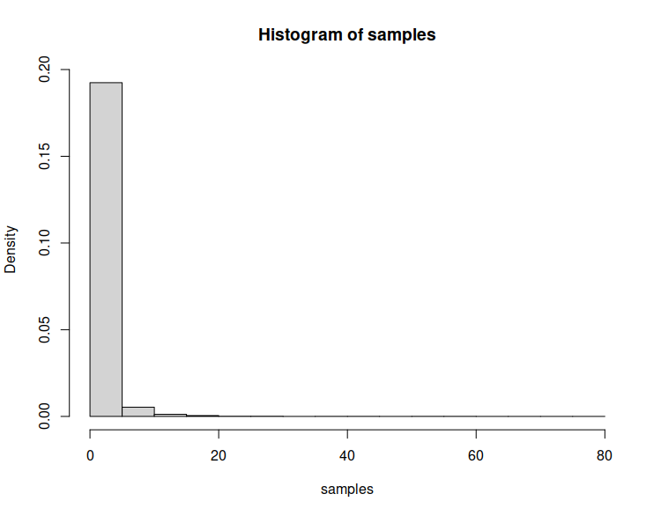

b)
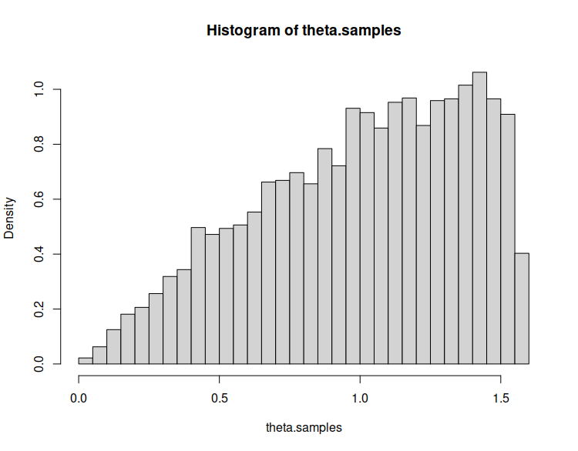
3.
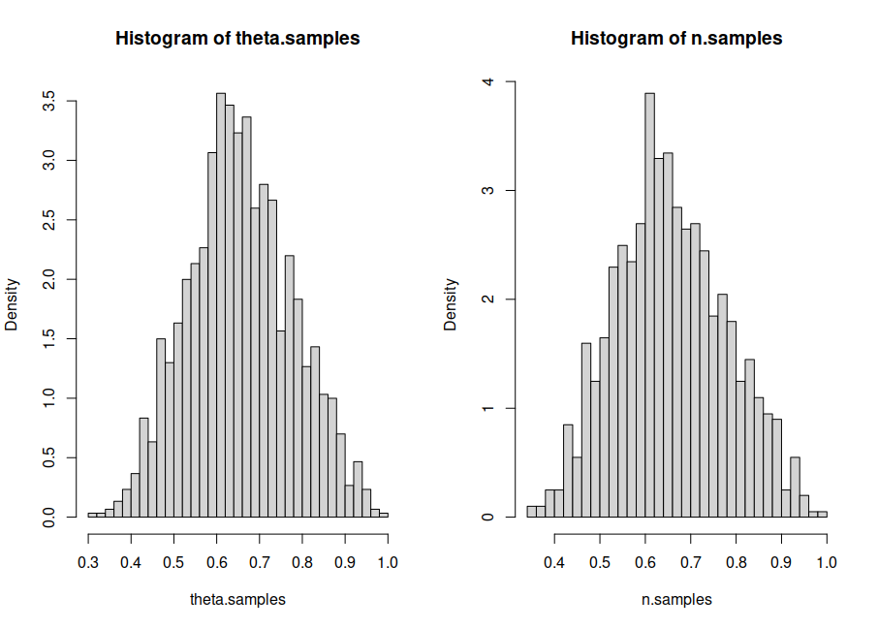
4.
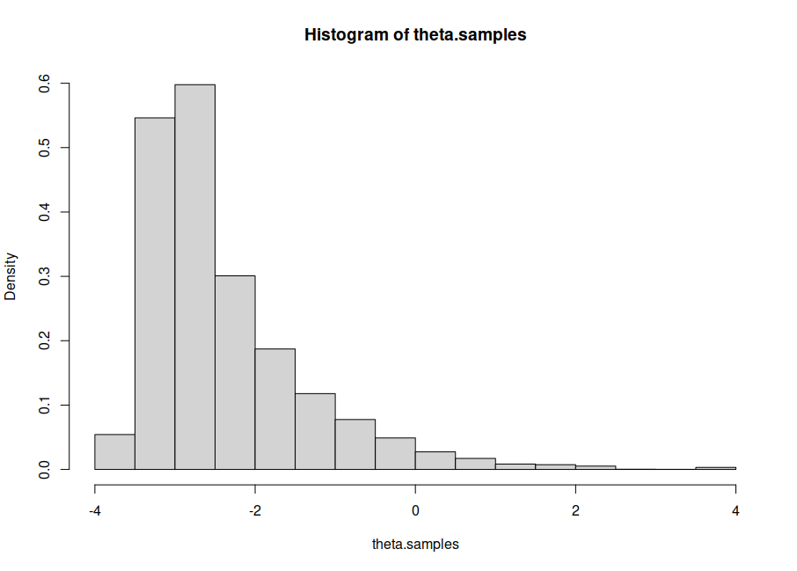
5.
a)
Iterations = 2010:12000
Thinning interval = 10
Number of chains = 3
Sample size per chain = 1000

1. Empirical mean and standard deviation for each variable,
plus standard error of the mean:

Mean SD Naive SE Time-series SE
b11 -1.90043 0.045983 8.395e-04 8.393e-04
b12 0.08181 0.004270 7.796e-05 7.501e-05
b21 -1.91940 0.058587 1.070e-03 1.055e-03
b22 0.08970 0.004800 8.763e-05 8.541e-05
b31 -1.61372 0.017689 3.229e-04 3.044e-04
b32 0.08190 0.001939 3.540e-05 3.541e-05
b41 -1.35647 0.020915 3.819e-04 3.820e-04
b42 0.08687 0.002279 4.161e-05 4.104e-05

2. Quantiles for each variable:

2.5% 25% 50% 75% 97.5%
b11 -1.98890 -1.93112 -1.90113 -1.86996 -1.81023
b12 0.07320 0.07901 0.08169 0.08461 0.09022
b21 -2.03696 -1.95833 -1.91909 -1.87934 -1.80724
b22 0.08033 0.08646 0.08971 0.09279 0.09951
b31 -1.64800 -1.62550 -1.61360 -1.60195 -1.57873
b32 0.07810 0.08056 0.08193 0.08317 0.08581
b41 -1.39759 -1.37048 -1.35639 -1.34260 -1.31468
b42 0.08228 0.08538 0.08689 0.08841 0.09127

