User’s statisfaction:
(Equation 1)
(Equation 2)
(Equation 3)
Where
- = Sequence of group recommendations in iteration
- = Sequence of recommendations for individual user in iteration
- = Predicted score of item for user

Problem definition
The Fair Sequential Group Recommendation Problem
How to calculate score for item for group in iteration .
My solution:
Basic approach is to use the group average only (Naive solution):
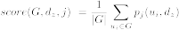

Instead of traditional mean, consider a weighted average:
Where
- 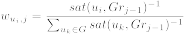
Or alternatively
- 