DATA.ML.420
Lab 0

1.
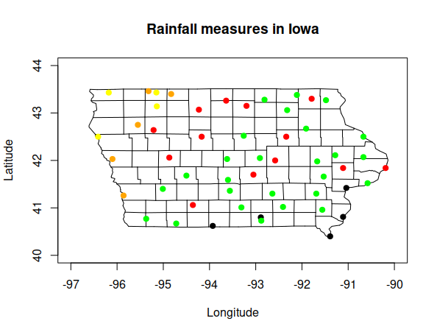
It seems that generally there rains more in south-east and less in north-west areas.
2.
