Spatial Data Analysis
Lab Exercise 2
R-problem 1.

1.
i)
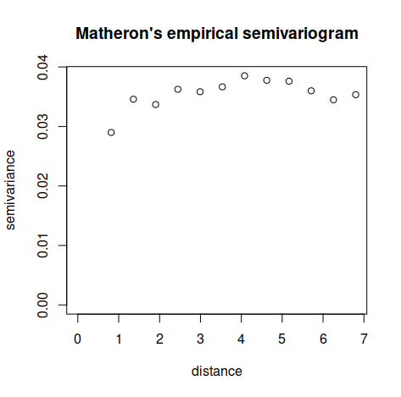
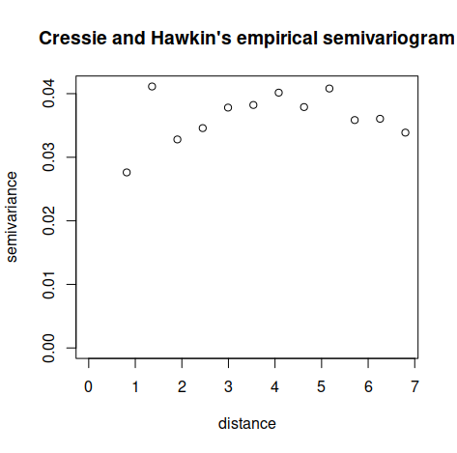

There doesn’t seem to be that much difference in estimated semivariograms above, expect for the distance between 1 and 2. Because the difference is quite meaningless, I would select the Metheron’s estimate.
ii)
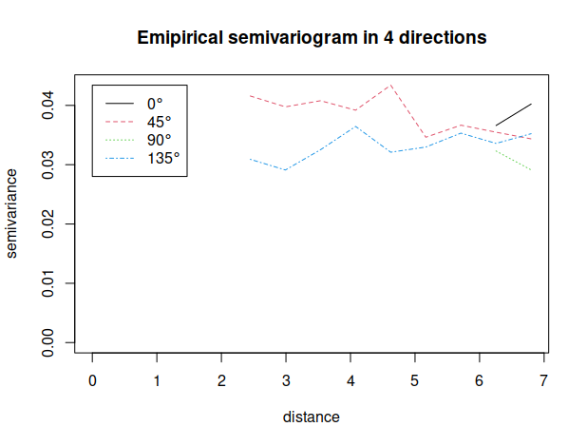
In the graph above, the plotted semivariograms seem to ‘start’ only after some distance. This is probably because R couldn't calculate values for smaller distances because of the lack of distance pairs. For example, for 0 degrees the estimated semivariance values are the following
soil.variog.dir$"0"$v
[1] NA 0.02990611 NA 0.03470022 NA 0.03212933 NA
[8] 0.03558882 NA 0.03569729 NA 0.03661086 0.04023282
There are many missing values and due to this, R can plot only the last two. However, if we inspect the reported numerical values, we can see that for 0 degrees there is nugget effect of (about) 0.02-0.03. For other directions, say 45, 90 and 135, the effects are about as large as 0 degrees. For other directions, calculated semivariances are
> soil.variog.dir$"45"$v
[1] NA NA 0.03676056 NA 0.04158666 0.03975628 0.04079205
[8] 0.03919115 0.04341525 0.03463532 0.03666553 0.03548265 0.03435654
> soil.variog.dir$"90"$v
[1] NA 0.02807940 NA 0.03268141 NA 0.04047521 NA
[8] 0.04185305 NA 0.04241585 NA 0.03231035 0.02911941
> soil.variog.dir$"135"$v
[1] NA NA 0.03239966 NA 0.03090614 0.02910794 0.03252446
[8] 0.03645377 0.03210474 0.03297673 0.03532446 0.03359046 0.03523009
There seem to be some kind of anisotropy on 90 degree’s small distances, because they are relatively larger than on other directions.

iii)

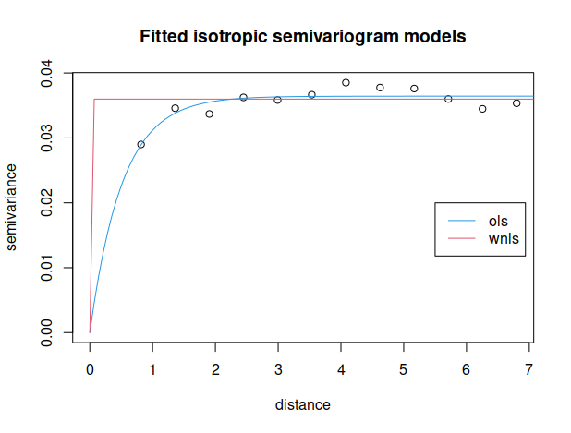

Both semivariograms seem to fit to the data resonably well. From both models we can deduce that there isn’t that much dependence between samples on small distances, but in the case of wnls fitting, there seem to be none dependence.

iv)
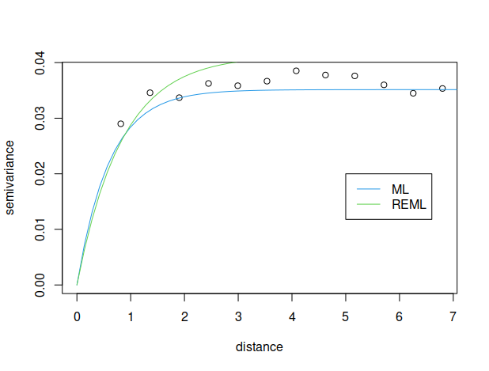

The ML and REML fitting methods gives similar results on small distances but REML fitting seems to produce overly large sill compared to the empirical semivariogram estimates.

v)
Beta.hat
[,1]
(Intercept) 4.303324322
soil.data$r 0.081082910
soil.data$c 0.022435624
I(soil.data$r^2) -0.007119610
I(soil.data$c^2) -0.001294937
soil.data$r:soil.data$c -0.001581349

Beta.hat (REML)
intercept,x,y,x2,xy,y2
4.279895665, 0.088936433, 0.023609392, -0.007438492, -0.001117389, -0.002224233

Estimated beta factors seem to have similar magnitudes in both cases.

