Spatial Data Analysis
Lab Exercise 2
R-problem 2.

2.
i)
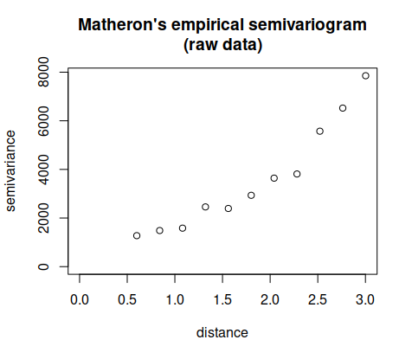
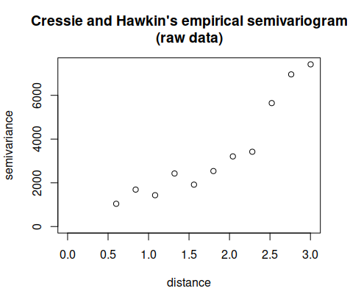
ii)
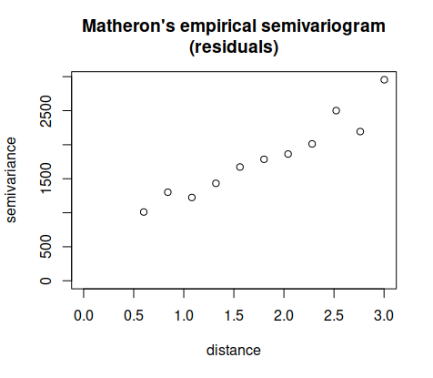
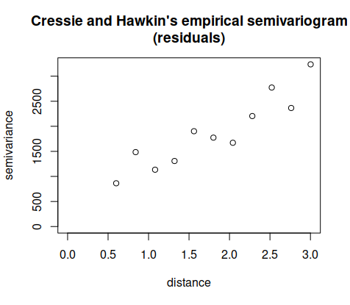
There seem to be large differences in empirical semivariances regarding when the semivariogram is calculated on raw values or fitted residuals. Moreover, when the global trend is removed, we can see that in general there are more dependence between obtained samples in given distance range of 0 to 3.

iii)
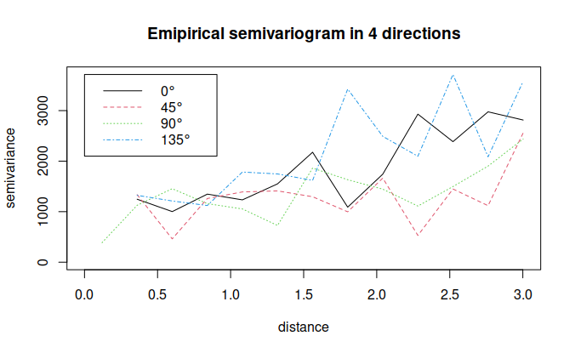
There seem to be more correlation between samples whose semivariances are calculated along the directions of 45 and 90 degrees.

iv)
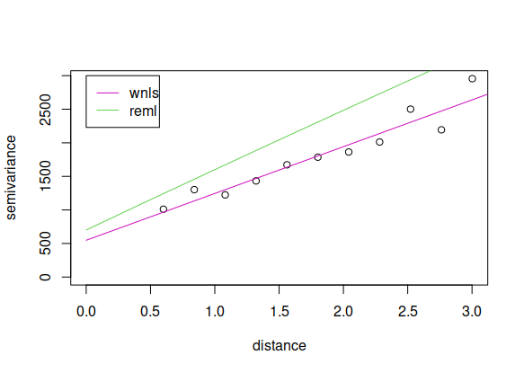
The weighted nonlinear fitting procedure seems to be fitted better to the empirical semivariogram compared to the restricted maximum likelihood procedure.

