Spatial Data Analysis
Lab Exercise 2
Pen & paper problems
1.
a) Show that is intrinsic stationary
i) The mean is constant
By definition, the mean is constant, say .
ii) depends only on the lag difference.
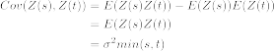
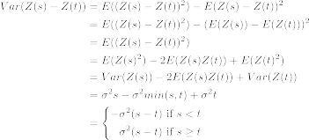
Variance of difference depend only on the lag difference and hence is intrinsic stationary.
Here is not second-order stationary since the covariance depends also on the actual positions, say, in general it holds that
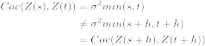

b) Show that is second order stationary
i) The mean is constant.
ii) Covariance between variate at two sites depends only on the site’s relative positions.
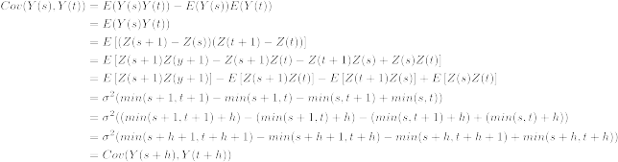

c)
Derive covariance function of
If
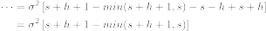
If
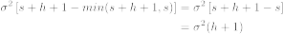
If

If
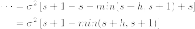
If
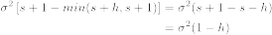
If
Therefore the covariance function takes the form of
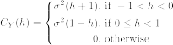

Because of the second-order stationary of the random field, the semivariogram is
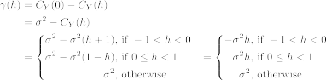

Properties of semivariogram:
nugget effect: 0
sill:
range: 1

