DATA.ML.420
Lab Exercise 5
1.
a)
Show .
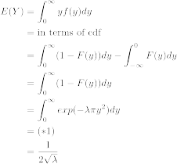
is the kernel of . Hence and 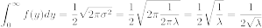

Show .
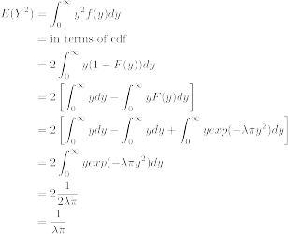

b)

c)
