Statistical Modeling 2
Weekly assignments 1

1. Output from Task1.R
# a)
Restricted MLE for phi = 0.3966289

# b)
Likelihood ratio test statistic = 108.6823
p-value = 2.511577e-24
Model H1 should be selected

# c)
Empirical blup for new obs. Y = 86.58952

# d)
From this part I got following error
Error in solve.default(t(X) %*% solve(V) %*% X) :
system is computationally singular: reciprocal condition number = 2.34382e-17
when I was calculating the variance of the prediction error.
Unfortunately I didn’t had time to fix it.

2. Output from Task2.R
# a)
RMLE for sigma2.z = 2.767964

# b)
Forest area with largest random effect:
Clark Fork
2.356447

# c)
ML prediction for mu = 27.79635

3.
a)
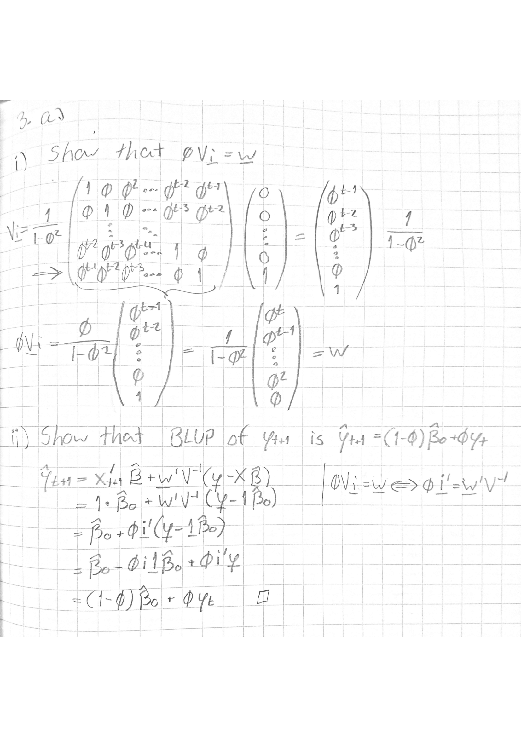

b)
Matrix :
Model matrix that consist all explanatory variable values. In the case of this matrix has 542 rows (observations) and 3 columns (intercept, and )
Matrix :
Second set of dummy explanatory variables corresponding to random effects. Matrix diagonally consist of blocks of where each corresponds to equivalent variable combination in . In the case of we have unique random effects corresponding to variable Tree.ID, and Forest.ID and hence the columns of block consist Tree.ID-values and measured diameters for that tree. Overall we have 66 different tree species and therefore 66 different submatrices. The Forest.ID-values are not fixed for specific tree only so they doesn’t belong to block but somewhere else in matrix (?). Overall, the size of matrix is 542x141, where 542 is number of samples and 141 comes from 66 Tree.ID-values times 2 random effects corresponding to those, plus 9 different Forest.ID-values.
Matrix :
We assume that , where ’s diagonal elements are matrices of form , where 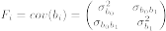
Matrix :
The marginal distribution of response variables is assumed to be , where . Moreover, for each sampling unit , , where
Vector :
This vector consist the unknown fixed parameters for explanatory variables, say .
Vector :
This vector consist the unknown random effect parameters, say , where

c)
