Statistical Modelling 2
Weekly assignments 3

1.
# a)
> B.hat
Y10 Y11
(Intercept) 142.169231 147.4641026
factor(gender)girl -1.402564 0.0451567

Y12 Y13
(Intercept) 153.238462 160.3641026
factor(gender)girl 1.118946 -0.7844729

Y14 Y15
(Intercept) 167.941026 174.007692
factor(gender)girl -5.089174 -9.396581

Y16 Y17 Y18
(Intercept) 177.55385 179.28974 180.22308
factor(gender)girl -12.05199 -13.29715 -13.92863

# b)
> Sigma.hat
Y10 Y11 Y12 Y13 Y14 Y15 Y16 Y17 Y18
Y10 36.53476 40.01169 42.72714 42.46429 40.29497 36.15285 33.53185 32.07214 31.85426
Y11 40.01169 44.69973 48.23412 47.60308 44.57584 39.45511 36.07686 34.23065 33.80676
Y12 42.72714 48.23412 53.69170 54.40557 51.07151 44.52664 39.92608 37.46712 36.70651
Y13 42.46429 47.60308 54.40557 58.89052 57.73302 50.55827 44.47744 41.32228 40.21820
Y14 40.29497 44.57584 51.07151 57.73302 59.76406 53.85623 47.45977 44.02733 42.88768
Y15 36.15285 39.45511 44.52664 50.55827 53.85623 50.33935 45.43651 42.62030 41.81831
Y16 33.53185 36.07686 39.92608 44.47744 47.45977 45.43651 42.92579 41.29068 41.10013
Y17 32.07214 34.23065 37.46712 41.32228 44.02733 42.62030 41.29068 40.40893 40.54271
Y18 31.85426 33.80676 36.70651 40.21820 42.88768 41.81831 41.10013 40.54271 40.96459

# c)
> BP
Y10 Y11 Y12 Y13 Y14 Y15 Y16 Y17 Y18
1 140.7667 147.5093 154.3574 159.5796 162.8519 164.6111 165.5019 165.9926 166.2944
2 142.1692 147.4641 153.2385 160.3641 167.9410 174.0077 177.5538 179.2897 180.2231

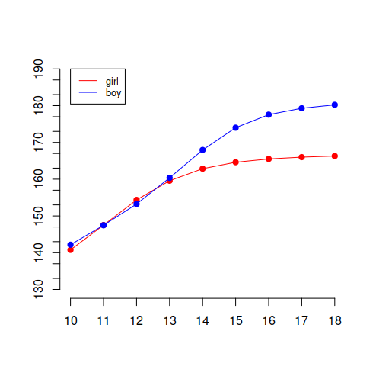

# d)
> anova(model.H0, model)
Analysis of Variance Table

Model 1: Y ~ 1
Model 2: Y ~ factor(gender)
Res.Df Df Gen.var. Pillai approx F num Df den Df Pr(>F)
1 92 1.14179
2 91 -1 0.96562 0.79944 36.76 9 83 < 2.2e-16 ***
---
Signif. codes: 0 ‘***’ 0.001 ‘**’ 0.01 ‘*’ 0.05 ‘.’ 0.1 ‘ ’ 1

> Gender is statistically significant variable

# e)
> lb
[,1]
Y13 168.4604
Y14 169.2501
Y15 169.0688
Y16 169.0881
Y17 168.9461
Y18 168.8734
> BP.yf2
[,1]
Y13 170.1792
Y14 172.7627
Y15 173.1339
Y16 173.0139
Y17 172.9713
Y18 173.0809
> ub
[,1]
Y13 171.8980
Y14 176.2752
Y15 177.1991
Y16 176.9396
Y17 176.9966
Y18 177.2884

2.
# a)
> lb
creatinine chloride chlorine
1 10.40143 5.232236 4.394969
> BP
creatinine chloride chlorine
1 15.05839 7.215861 11.81878
> ub
creatinine chloride chlorine
1 19.71535 9.199485 19.24258

# b)
> anova(model.H0, model.H1)
Analysis of Variance Table

Model 1: cbind(creatinine, chloride) ~ factor(obesity)
Model 2: cbind(creatinine, chloride) ~ gravity + factor(obesity)
Res.Df Df Gen.var. Pillai approx F num Df den Df Pr(>F)
1 41 6.7201
2 40 -1 4.7544 0.52357 21.43 2 39 5.259e-07 ***
---
Signif. codes: 0 ‘***’ 0.001 ‘**’ 0.01 ‘*’ 0.05 ‘.’ 0.1 ‘ ’ 1

> Model H1 should be preferred

# c)
> anova(model.H0, model.H1)
Analysis of Variance Table

Model 1: cbind(creatinine, chloride) ~ chlorine
Model 2: cbind(creatinine, chloride) ~ factor(obesity) + chlorine
Res.Df Df Gen.var. Pillai approx F num Df den Df Pr(>F)
1 43 7.4990
2 40 -3 6.5099 0.37314 3.0582 6 80 0.009574 **
---
Signif. codes: 0 ‘***’ 0.001 ‘**’ 0.01 ‘*’ 0.05 ‘.’ 0.1 ‘ ’ 1

> The Y_3 alone is not enough to explain the values of Y1 and Y2.
3.
# a)
> anova(model.H0,model.H1)
Analysis of Variance Table

Model 1: YL ~ X.star - 1
Model 2: YL ~ factor(gender)
Res.Df Df Gen.var. Pillai approx F num Df den Df Pr(>F)
1 92 0.36575
2 91 -1 0.33443 0.182 10.012 2 90 0.0001186 ***
---
Signif. codes: 0 ‘***’ 0.001 ‘**’ 0.01 ‘*’ 0.05 ‘.’ 0.1 ‘ ’ 1

> It seems that we cant assume that the average height level stays at same for 16, 17 and 18 year old girls.

b)
