Statistical Modelling 2
Exercises 2

1.
a) Firstly, I selected to use log link since cd4 is always positive and other link functions caused some errors. After fitting the models, I obtained following residual plots
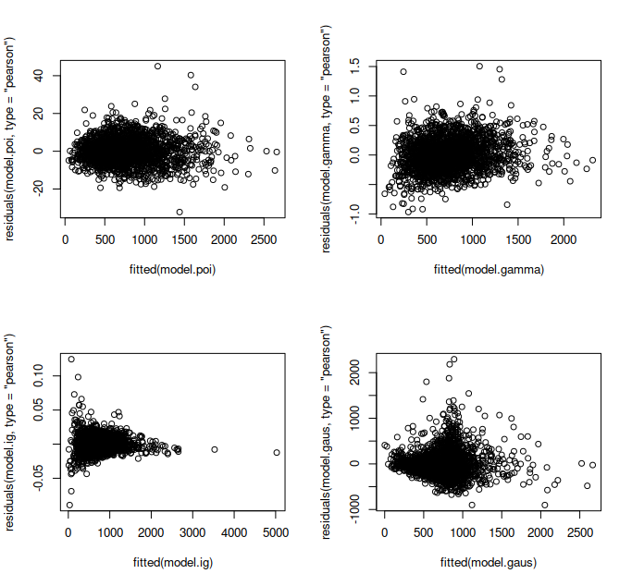
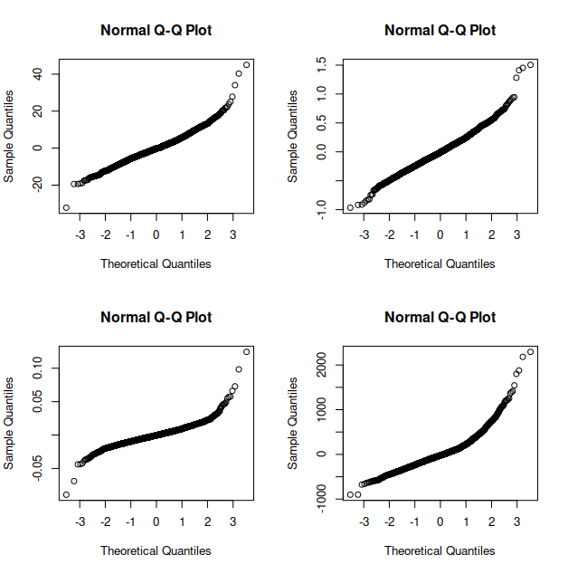

Based on the above plots, it seems that Gamma model is the preferred one since it’s residuals are quite well behaving and relatively small.
# b)
> new.data = data.frame(time=2.02, drugs=1, age=13.72)
> mu.hat = predict(model.gamma, newdata=new.data, re.form=NA, type='response')
> mu.hat
1
541.8597

# c)
> lb = quantile(yf.star, 0.1)
> ub = quantile(yf.star, 0.9)
> lb
10%
522.424
> ub
90%
1152.824

2.
# a)
> beta1.hat = summary(model.bin)$coef[2]
> beta1.hat
[1] 1.703157

# b)
> new.data = data.frame(id=24, sex=0, time=1.35, feed=0)
> mu.pred = predict(model.bin, newdata=new.data, type='response')
> mu.pred
1
0.7891318

# c)
> p.val = anova(model.H0, model.bin)$"Pr(>Chisq)"[2]
> p.val
[1] 4.81858e-09
X_2 is statistically significant

# d)
> cov.bi
[,1] [,2]
[1,] 1.298861 -1.127345
[2,] -1.127345 2.385338

# e)
> lb = YS.pred-z*sqrt(var.error)
> ub = YS.pred+z*sqrt(var.error)
> lb
1
68.41443
> ub
1
80.15473

3.
a)
Let , where
i) Calculate , when

ii) Calculate , when
can be considered as the moment generating function of . The moment function of normally distributed rv. is defined as
Therefore
and

b)
Let , where
Write log likelihood of as simply as possible.
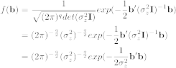
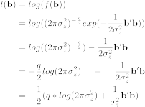

c)
Consider logistic mixed effects model
Formalize .
