Statistical Modelling 2
Weekly assignments 4
1.
# a)
> Theta
t
factor(gender)boy 295.3 -46.0 4.15 -0.1085
factor(gender)girl -76.3 37.6 -1.92 0.0319

# b)
> mu.10
[,1]
[1,] 166

# c) Plot given below
> BP = T%*%t(Theta)
> BP
factor(gender)boy factor(gender)girl
[1,] 142 140
[2,] 147 148
[3,] 154 154
[4,] 161 159
[5,] 167 162
[6,] 173 165
[7,] 178 166
[8,] 180 166
[9,] 180 166

# e)
> anova(model.H0, model.H1)
Analysis of Variance Table

Model 1: Y.star ~ 1
Model 2: Y.star ~ factor(gender) - 1
Res.Df Df Gen.var. Pillai approx F num Df den Df Pr(>F)
1 92 0.192
2 91 -1 0.133 0.781 78.6 4 88 <2e-16 ***
---
Signif. codes: 0 ‘***’ 0.001 ‘**’ 0.01 ‘*’ 0.05 ‘.’ 0.1 ‘ ’ 1

→ Gender should be used in the model.

# e)
> mean(residuals(model.H0)^2)
[1] 56.6
> mean(residuals(model.H1)^2)
[1] 46.7
>
> AIC(model.H0)
[1] 5764
> AIC(model.H1)
[1] 5611
→ model H1 fits better

# f)
> lb
[,1]
Y13 168
Y14 169
Y15 169
Y16 170
Y17 170
Y18 169
> BP
[,1]
Y13 170
Y14 173
Y15 174
Y16 174
Y17 174
Y18 174
> ub
[,1]
Y13 172
Y14 177
Y15 178
Y16 178
Y17 179
Y18 179

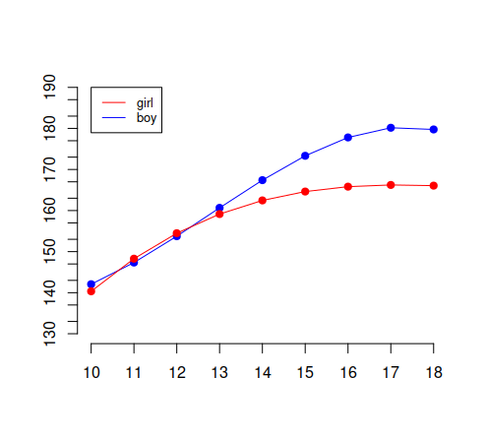
3.
a)
> mu.hat
1
0.172

b)
Based on the classilac LM’s OLS , we can deduce the following:
